College Management System
Abstract
College Management System consists of different operations such as a student can search his attandance his score in exams and an employee can see their students score etc
Entities
Student
Staff
Attandance
Branch
Course
Hod
Fee_report
Exam_branch
Roles
Student
score Student can see their profile and chenge their details such as mobile number etc Staff
A professor can create a student account and can check any student details and check and update their details

Hod
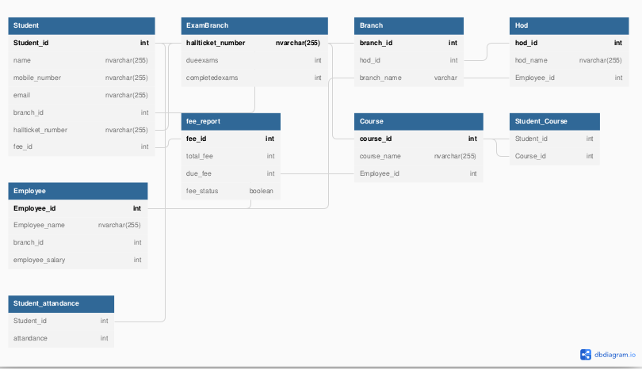
A Hod can create a Staff account and a student account and can check any details

