ANSWERS

1. Select name, dept_name,insurance_name FROM EMPLOYEE e
inner join Department d on e.dept_id=d.dept_id
inner join Insurance i on i.insurance_id=e.insurance_id;


2. select dept_name from Department d
inner join Employee e on e.dept_id=d.dept_id
inner join Employee_office eo on e.emp_id=eo.emp_id
inner join Office o on o.office_id=eo.office_id
where place='Madhapur';
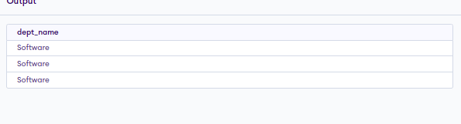
3. select place,count(*) as Employee_count from Employee e
inner join Employee_office eo on e.emp_id=eo.emp_id
inner join Office o on o.office_id=eo.office_id
group by o.place;


4. select distinct(salary),name,insurance_name from Employee_info ei
inner join Employee e on e.employee_info=ei.id
inner join Insurance i on i.insurance_id=e.insurance_id
order by salary desc limit 2,1;


5. select avg(salary) from Employee_info ei
inner join Employee e on e.employee_info=ei.id
group by dept_id;
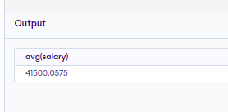

6. select sum(salary) from Employee_info ei
inner join Employee e on e.employee_info=ei.id
inner join Employee_office eo on eo.emp_id=e.emp_id
inner join Office o on o.office_id=eo.office_id
where place='Madhapur' and DOJ>02/01/2022


7 SELECT NAME, DEPT_NAME, SALARY FROM EMPLOYEE E
INNER JOIN DEPARTMENT D ON E.DEPT_ID=D.DEPT_ID
INNER JOIN EMPLOYEE_INFO EI ON E.EMPLOYEE_INFO=EI.ID
INNER JOIN INSURANCE I ON I.INSURANCE_ID=E.INSURANCE_ID
WHERE SALARY>'20000' AND (I.INSURANCE_NAME='LIC' OR I.INSURANCE_NAME='ICICI')

8. SELECT E.NAME AS NAME, I.NAME AS IMMEDIATE_HEAD FROM EMPLOYEE E, EMPLOYEE I WHERE E.IMMEDIATE_HEAD_ID=I.EMP_ID;


9. SELECT E.NAME AS Emp_name, D.dept_name as emp_dept_name,
H.NAME as Head_name , D.dept_name as Head_dept_name FROM Employee e, Employee h, Department d
WHERE E.IMMEDIATE_HEAD_ID=h.EMP_ID AND D.DEPT_ID=E.DEPT_ID;
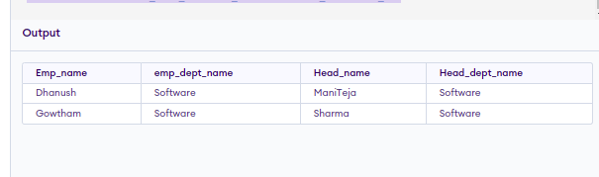

10. SELECT A.NAME, A.SALARY FROM
(SELECT * FROM EMPLOYEE JOIN EMPLOYEE_INFO ON EMPLOYEE.employee_info=EMPLOYEE_INFO.id ) AS A
JOIN
(SELECT * FROM EMPLOYEE JOIN EMPLOYEE_INFO ON EMPLOYEE.employee_info=EMPLOYEE_INFO.id
where EMP_ID IN
(select emp_id from Office o join Employee_office eo on o.office_id=eo.office_id where place='Madhapur') AND immediate_head_id IS NULL ) AS B
WHERE A.immediate_head_id = B.EMP_ID AND
A.SALARY<2*B.SALARY ;


1 create table Department(dept_id varchar(50) primary key, dept_name varchar(50));

insert into Department values('10','Accounts');
insert into Department values('20','HR');
insert into Department values('30','Sales');
insert into Department values('40','Software');

2. Create table Insurance(insurance_id varchar(50) primary,
insurance_name varchar(50) not null)

Insert into insurance values('LIC01', 'LIC');
Insert into insurance values('ICICI01', 'ICICI');
Insert into insurance values('HDFC01', 'HDFC');
Insert into insurance values('LIC02', 'LIC');

3. CREATE TABLE EMPLOYEE_INFO( id varchar(50) primary key,
doj date not null, salary float not null)

insert into employee_info values('ME023', '06/06/2022','21000.0');
insert into employee_info values('ME024', '06/06/2022','30000.0');
insert into employee_info values('ME001', '21/07/2018','75000.42');
insert into employee_info values('ME055', '23/11/2019','40000.23');

4. create table Office(office_id varchar(50) primary key,
office_name varchar(50) not null,
place varchar(50) not null)

insert into Office values('HYD05', 'Medplus','Madhapur');
insert into Office values('HYD04', 'Optival','Moosepet');
insert into Office values('HYD03', 'MEIL','Balanage');
insert into Office values('HYD06', 'Milestone','Madhapur');

5. create table Employee(emp_id varchar(50) primary key,
name varchar(50) not null,
immediate_head_id varchar(50),
dept_id varchar(50),
insurance_id varchar(50),
foreign key (dept_id) references Department(dept_id),
foreign key (insurance_id) references insurance(insurance_id));

insert into employee values('ME023','Dhanush','ME055','40','LIC01');
insert into employee values('ME024','Gowtham','ME055','40','HDFC01');
insert into employee values('ME055','Mani Teja','ME001','40','ICICI01');
insert into employee values('ME001','Sharma','','40','LIC02');

6. CREATE TABLE Employee_office
(
id varchar(50) not null,
emp_id varchar(50),
office_id varchar(50),
foreign key(emp_id) references Employee(emp_id),
foreign key(office_id) references Office(office_id)
);
INSERT INTO EMPLOYEE_OFFICE VALUES('01','ME001','HYD05');
INSERT INTO EMPLOYEE_OFFICE VALUES('02','ME055','HYD05');
INSERT INTO EMPLOYEE_OFFICE VALUES('03','ME023','HYD05');
INSERT INTO EMPLOYEE_OFFICE VALUES('04','ME024','HYD04');

