Library System Management

Abstract :
Library system management is designed to manage all the data of books and memebers of the the library.
It helps librarian to maintain database of books that are already exist. books which could be added later to the collection, members who borrowed books along with the borrowed duration, maintaining data of number of books issued and returned on daily basis, maintaining library membership subscription and profile and easy search of books based on name of book, ISBN, Authors and published year.

Model:
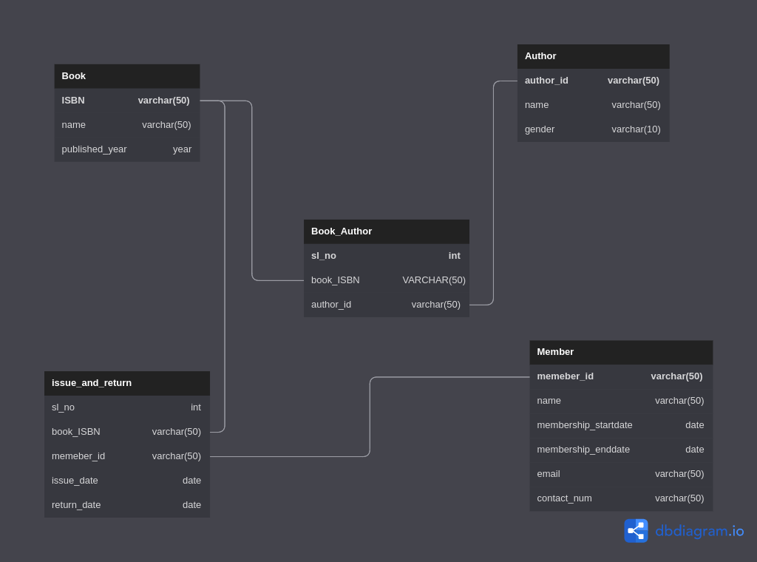

Description:
This system have 5 tables namely
1. Book -
ISBN (pk)
Name
Published year.

In this table we adding datas of book which are already exist and which could be added further

2. Author -
Name
Author ID (pk)
Geder

In this table all the data’s of Authors will be added

3. Book_Author –
Sl_no (pk)
Book_ISBN (fk to Book (ISBN)
Author_id (fk to Author (author_id). (many to many)
This is relation table between Books and Authors.

4. Member –
Member_id (pk)
Name
Membeship start date
Membership end
Date
\ Email
Contact number.

5. Issur and Return –
Sl_no(pk)
Book_ISBN (fk to Book(ISBN))
Member_id (fk to Member(member_id) ), book issue date, returned Date

