COLLEGE MANAGEMENT SYSTEM

# ABSTRACT:

The college management system is mainly to manage the database of the employees and students in the college ,The main database in this system is about the students and professors ,To store the new student data like student id , student name ,student department and to manage the attendance of the existing students and professors .

All the payments details like students tution fee , due amount ,Fee paid are to be stored in database .

# VARIOUS MODULES:-

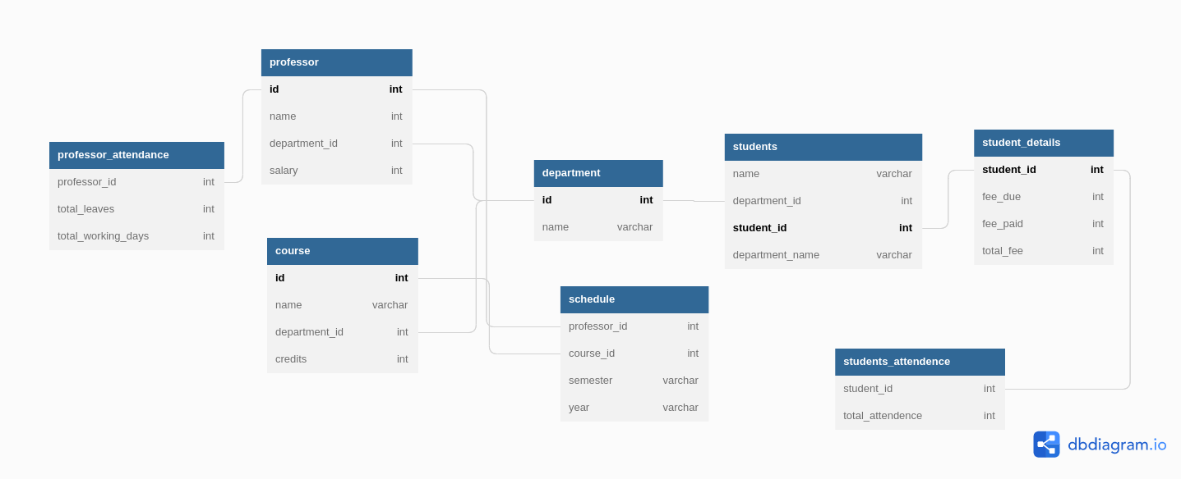 COLLEGE MANAGEMENT SYSTEM SCHEMA

# MYSQL SYNTAX :

CREATE DATABASE COLLEGE_MANAGEMENT_SYSTEM;

USE COLLEGE_MANAGEMENT_SYSTEM;

CREATE TABLE `professor` (

`id` int PRIMARY KEY,

`name` int,

`department_id` int,

`salary` int

);

CREATE TABLE `department` (

`id` int PRIMARY KEY,

`name` varchar(255)

);

CREATE TABLE `student_details` (

`student_id` int PRIMARY KEY,

`fee_due` int,

`fee_paid` int,

`total_fee` int

);

CREATE TABLE `course` (

`id` int PRIMARY KEY,

`name` varchar(255),

`department_id` int,

`credits` int

);

CREATE TABLE `schedule` (

`professor_id` int,

`course_id` int,

`semester` varchar(255),

`year` varchar(255)

);

CREATE TABLE `students` (

`name` varchar(255),

`department_id` int,

`student_id` int PRIMARY KEY,

`department_name` varchar(255)

);

CREATE TABLE `students_attendence` (

`student_id` int,

`total_attendence` int

);

CREATE TABLE `professor_attendance` (

`professor_id` int,

`total_leaves` int,

`total_working_days` int

);

ALTER TABLE `professor` ADD FOREIGN KEY (`department_id`) REFERENCES `department` (`id`);

ALTER TABLE `schedule` ADD FOREIGN KEY (`professor_id`) REFERENCES `professor` (`id`);

ALTER TABLE `schedule` ADD FOREIGN KEY (`course_id`) REFERENCES `course` (`id`);

ALTER TABLE `course` ADD FOREIGN KEY (`department_id`) REFERENCES `department` (`id`);

ALTER TABLE `students` ADD FOREIGN KEY (`department_id`) REFERENCES `department` (`id`);

ALTER TABLE `students` ADD FOREIGN KEY (`student_id`) REFERENCES `student_details` (`student_id`);

ALTER TABLE `students_attendence` ADD FOREIGN KEY (`student_id`) REFERENCES `student_details` (`student_id`);

ALTER TABLE `professor_attendance` ADD FOREIGN KEY (`professor_id`) REFERENCES `professor` (`id`);