

# 

# REQUISITION FORM SOFTWARE

**Under Guidance of** Mr. Paritosh Ch. Dey

Senior Software Developer

Marathon Electric Motors (India) Limited (A Regal Rexnord Company)

1, Taratala Rd, Ram Nagar, Garden Reach, Kolkata, West Bengal 700024

A Project Report

Submitted In Partial Fulfilment of The Requirements

For The Award Of the

Bachelor of Technology

## Project Carried Out At

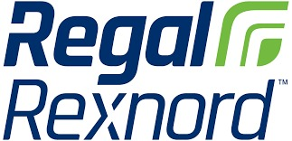

**Submitted By**

**Saimanti Mullick**, Roll No: 12621002062,

Registration No: 211260100220001 (2021-22)

**Soumika Sarkar**, Roll No: 12620002052,

Registration No: 201260100210061 (2020-21)

**Department Of Information Technology**

**Heritage Institute of Technology**

Kolkata - 700107

West Bengal | INDIA | Dec, 2023

## Project Responsibility Form

**Requisition Form Software**

|  |  |  |
| --- | --- | --- |
| **SERIAL-NO** | **NAME OF THE STUDENT** | **RESPONSIBILITY** |
| 1 | SOUMIKA SARKAR | DATABASE CONNECTION, REPORT PAGE, UI DESIGN |
| 2 | SAIMANTI MULLICK | WELCOME PAGE, LOGIN PAGES, REQUISITION PAGE |

## 

## Self-Certificate

This is to certify that the dissertation/project proposal entitled **“REQUISION FORM SOFTWARE”** is done by us, is an Authentic work carried out for the partial fulfilment of the requirements for the award of the certificate of **Bachelor of Information Technology** under the guidance of **Mr. Paritosh Ch. Dey**. The matter embodied in this project work has not been submitted earlier for award of any certificate to the best of our knowledge and belief.

Name of the Student

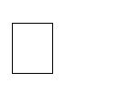**Soumika Sarkar**

 **Saimanti Mullick**

Signature of the students

a.

b.



### Certificate of Approval

This is to certify that this proposal of Minor project, entitled **“Requisition Form Software ”** is a record of bona-fide work, carried out by: 1. Soumika Sarkar, 2. Saimanti Mullick under my supervision and guidance through the Marathon Electric Motors (India) Limited (A Regal Rexnord Company). In my opinion, the report in its present form is in partial fulfilment of all the requirements, as specified by the Heritage Institute of Technology as per regulations of the ***Marathon*** . In fact, it has attained the standard, necessary for submission. To the best of my knowledge, the results embodied in this report, are original in nature and worthy of incorporation in the present version of the report for Bachelor of Technology.

_______________________ ____________________________

**Internal Examiner(s) Head of the Department**

Department of Information Technology

**Kolkata, W.B**

**(Affiliated to MAKAUT,WB)**



**ACKNOWLEDGEMENT**

I would like to express my special thanks to my Internship Manager **Mr. Paritosh Ch. Dey** and Head of the Department **Dr. Siuli Roy** who gave me the golden opportunity to do this wonderful Internship at Marathon Electric Motors (India) Limited (A Regal Rexnord Company), which provided me an opportunity to explore new horizons.

I sincerely express my gratitude towards the Organization for providing me with this opportunity. I also wish to express my sincere thanks to all department faculties and staff members for their support.

Lastly, I would also like to thank my parents and friends who helped me a lot in

finalizing this report within the limited time frame.

Date: 10th February, 2022

Name: Saimanti Mullick

Roll No: 2045077

Name: Soumika Sarkar

Roll No: 2045077

Dept: Information Technology (4th Year)

**TABLE OF CONTENTS**

|  |  |  |
| --- | --- | --- |
| **CHAPTER**  **NO** | **TITLE** | **PAGE NO.** |
| **1.** | **Company Introduction** | 7 |
| **2.** | **Introduction of Project**  2.1 Introduction  2.2 Objective | 8 |
| **3.** | **Preliminary Project works**  **3.1** Work Flow  **3.2** Study of the System  **3.3** Input and Output  **3.4** Software requirement and Specification | 10 |
| **4.** | **Database**  **4.1** Database design  **4.2** Data Dictionary | 17 |
| **5.** | **User Interface and Design**  **5.1** Frontend  **5.2** Login Page Screen Shot and Output  **5.3** Welcome Page Screen Shot and Output  **5.4** Requisition Form Page Screen Shot and Output  **5.5** Report Page Screen Shot and Output | 19 |
| **6.** | **Security**  **6.1** Database Security  **6.2** System Security  **6.3** Limitation | 31 |
| **7.** | **Future Scope**  **7.1** Conclusion  **7.2** Further Enhancement | 32 |
| **8.** | **Bibliography** | 33 |

1. **Marathon Electric Motors (India) Limited (A Regal Rexnord Company)**

Founded in 1913, the Marathon Electric Motors India Limited has more than 100 years of experience in manufacturing high quality and reliable electric motors and fans in India. Marathon Electric has built on a rich history of some of the well-known electric companies. Marathon Electric Motors started its journey as GEC UK, after the European Union was formed GEC of UK and Alcatel Alstom of France merged to become GEC Alstom, then this Company became Alstom. In 2007, Regal Rexnord corporation USA acquired Alstom India Motors and Fans business and named as Marathon Electric Motors India Limited.

Our product range consists of various type of LT & HT induction motors in enclosures such as TEFC, CACA, CACW, TETV and SPDP from 1KW to 4500KW and in Voltages 415V, 690V, 3.3KV, 6.6KV and 11KV for safe area and hazardous area e.g. Exd and Exn.

We have supplied more than 15000+ HT motor & many LT motor to almost all the major customer in Power, Steel, Mining, Water, Oil & Gas, Cement and Paper. Some of our esteemed customers are NTPC, MPPGCL, Orrisa irrigation, KNNL, UP Irrigation, PHED Rajasthan, SAIL, Western coal fields, NALCO, NMDC, PRED Mysore, Megha Engineering & Infrastructure Limited etc. Our High-end IEC/IS design motor can cater various industrial application such as pump, fan, crusher, compressor, conveyors and Kiln etc.

Apart from India we are also catering international market. We supplied motors to Netherlands, South Africa, Australia, Turkey, Middle east, Philippines and SAARC countries.

# 2a. INTRODUCTION

The Requisition Form Software developed in VB.NET serves as a comprehensive solution tailored for Marathon Motors, providing a streamlined process for managing machinery requisitions. This software encompasses a user-friendly interface, featuring a welcoming home page that sets the tone for a seamless user experience. The incorporation of a secure login and sign-up page ensures access control, safeguarding sensitive information related to machinery requisitions.

The heart of the software lies in its sophisticated Requisition Form module, where users can input and manage intricate details regarding machinery requirements. From specifications to quantity, each requisition is meticulously recorded and stored in a robust database system. The utilization of VB.NET enhances the software's efficiency and functionality, offering a dynamic and responsive environment for users to interact with the requisition process.

This project not only showcases the technical prowess of VB.NET but also demonstrates its practical application in addressing real-world business needs. Marathon Motors can now benefit from an integrated software solution that not only facilitates a smoother requisition workflow but also ensures the security and accuracy of essential machinery data. As we delve into the details of this project report, we will explore the intricacies of the software development process, the technologies employed, and the overall impact of this innovative solution on Marathon Motors' operational efficiency.

# 

# 

# 2b. OBJECTIVE

1. Automation of Requisition Process: Develop a VB.NET-based software to automate and streamline the manual machinery requisition process at Marathon Motors, reducing paperwork and manual efforts.
2. Enhanced User Experience: Create a user-friendly interface with a welcome page, login, and sign-up features to ensure a positive and intuitive experience for users interacting with the requisition software.
3. Access Control and Security: Implement a secure login and sign-up system to control access to the requisition software, safeguarding sensitive information and ensuring data security.
4. Efficient Data Input: Design a requisition form module that allows users to input detailed information about machinery requisitions, including specifications, quantities, and other relevant details, ensuring accuracy and completeness of data.
5. Database Integration: Develop a robust database system to store and manage requisition data efficiently, providing a centralized repository for easy retrieval and analysis of machinery information.
6. Technology Advancement: Showcase the capabilities of VB.NET in developing a dynamic and responsive software solution, leveraging the latest technologies to enhance operational efficiency.
7. Practical Application: Demonstrate the practical application of the developed software in addressing Marathon Motors' specific business needs, contributing to improved workflow and overall organizational efficiency.
8. Documentation and Reporting: Generate detailed documentation outlining the software development process, technologies used, and provide comprehensive reporting features for analysis and decision-making.
9. User Training and Adoption: Facilitate user training sessions to ensure a smooth transition to the new requisition system, promoting user adoption and minimizing disruptions during the implementation phase.

# 3a. WORK FLOW

This Document plays a vital role in the development life cycle (SDLC) as it describes the complete requirement of the system. It is meant for use by the developers and will be the basic during testing phase. Any changes made to the requirements in the future will have to go through formal change approval process.

The Waterfall Model was first Process Model to be introduced. It is also referred to as a linear-sequential life cycle model. It is very simple to understand and use. In a waterfall model, each phase must be completed before the next phase can begin and there is no overlapping in the phases. Waterfall model is the earliest SDLC approach that was used for software development .

The waterfall Model illustrates the software development process in a linear sequential flow; hence it is also referred to as a linear-sequential life cycle model. This means that any phase in the development process begins only if the previous phase is complete. In waterfall model phases do not overlap.

Waterfall approach was first SDLC Model to be used widely in Software Engineering to ensure success of the project. In "The Waterfall" approach, the whole process of software development is divided into separate phases. In Waterfall model, typically, the outcome of one phase acts as the input for the next phase sequentially.

Following is a diagrammatic representation of different phases of waterfall model.

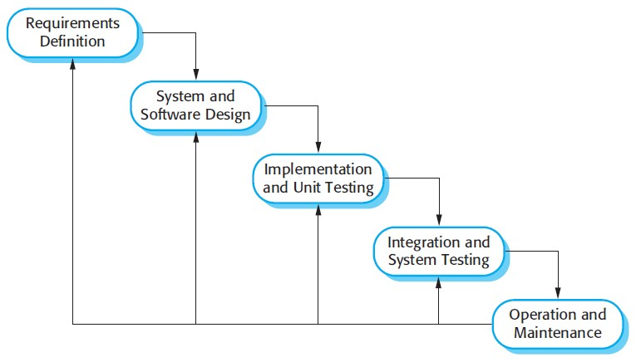

The sequential phases in Waterfall model are:

* **Requirement Gathering and analysis:** All possible requirements of the system to be developed are captured in this phase and documented in a requirement specification doc.
* **System Design:** The requirement specifications from first phase are studied in this phase and system design is prepared. System Design helps in specifying hardware and system requirements and also helps in defining overall system architecture.
* **Implementation:** With inputs from system design, the system is first developed in small programs called units, which are integrated in the next phase. Each unit is developed and tested for its functionality which is referred to as Unit Testing.
* **Integration and Testing:** All the units developed in the implementation phase are integrated into a system after testing of each unit. Post integration the entire system is tested for any faults and failures.
* **Deployment of system:** Once the functional and non-functional testing is done, the product is deployed in the customer environment or released into the market.
* **Maintenance:** There are some issues which come up in the client environment. To fix those issues patches are released. Also to enhance the product some better versions are released. Maintenance is done to deliver these changes in the customer environment.

All these phases are cascaded to each other in which progress is seen as flowing steadily downwards (like a waterfall) through the phases. The next phase is started only after the defined set of goals are achieved for previous phase and it is signed off, so the name "Waterfall Model". In this model phases do not overlap.

Waterfall Model Application

Every software developed is different and requires a suitable SDLC approach to be followed based on the internal and external factors. Some situations where the use of Waterfall model is most appropriate are:

* Requirements are very well documented, clear and fixed.
* Product definition is stable.
* Technology is understood and is not dynamic.
* There are no ambiguous requirements.
* Ample resources with required expertise are available to support the product.
* The project is short.

The advantage of waterfall development is that it allows for departmentalization and control. A schedule can be set with deadlines for each stage of development and a product can proceed through the development process model phases one by one.

Development moves from concept, through design, implementation, testing, installation, troubleshooting, and ends up at operation and maintenance. Each phase of development proceeds in strict order.

# 3b. STUDY OF THE SYSTEM

Modules:

1. Welcome Page:

- Display a welcome message and introduction to the Requisition Form Software upon launch.

- Include navigation buttons providing access to other modules: Login Page, Requisition Form, and Exit.

- Users can choose a specific module by clicking on the corresponding button.

2. Login Page:

- Users access the Login Page by clicking the "Login" button on the Welcome Page.

- Enter valid credentials (username and password) to log in.

- Successful login redirects users to the Requisition Form module.

3. Requisition Form:

- Users access the Requisition Form by clicking the "Requisition Form" button on the Welcome Page or upon successful login.

- Fill in the required details of the machinery requisition, including specifications, quantities, and other relevant information.

- Upon submission, the data is validated and stored in the database.

4. Report Page:

- Clicking the "Report Page" button on the Welcome Page directs users to a summary of requisitions.

- The Report Page displays a list of previous requisitions with details such as requisition ID, date, and machinery information.

# 3c. INPUT AND OUTPUT

The main inputs, outputs and the major function the details are :

**INPUT**

* User can login using the same user-id and password which they are used in sign-in.
* Display a welcome message and introduction to the Requisition Form, Report, Exit.
* User can purchase from the Requisition form.

**OUTPUT**

* User can see his/her Requisition Details to put his/her Requisition number.
* User can view the details of the product.
* User can also see his/her report.

# 3d. SOFTWARE REQUIREMENT SPECIFICATIONS

Software Requirements Specification provides an overview of the entire project. It is a description of a software system to be developed, laying out functional and non-functional requirements. The software requirements specification document enlists enough and necessary requirements that are required for the project development. To derive the requirements, we need to have clear and thorough understanding of the project to be developed. This is prepared after the detailed communication with project team and the customer.

The developer is responsible for:-

* Developing the system, which meets the SRS and solving all the requirements of the system?
* Demonstrating the system and installing the system at client’s location after acceptance testing is successful.
* Submitting the required user manual describing the system interfaces to work on it and also the documents of the system.
* Conducting any user training that might be needed for using the system.
* Maintain the system for a period of one year after installation.

**HARDWARE REQUIREMENTS:**

* + Computer that has a 1.6GHz or faster processor

* + 1 GB (32 Bit) or 2 GB (64 Bit) RAM (Add 512 MB if running in a virtual machine)

* + HDD 20 GB Hard Disk Space and Above Hardware Requirements
  + 5400 RPM hard disk drive

* + DVD-ROM Drive

**SOFTWARE REQUIREMENTS:**

•WINDOWS OS (7/10/11)

•Visual Studio 2017

•Microsoft Office Access 2007

# 4a. DATABASE DESIGN

A database is an organized mechanism that has capability of storing information through which a user can retrieve stored information in an effective and efficient manner. The data is the purpose of any database and must be protected.

The database design is two level processes. In the first step, user requirements are gathered together and a database is designed which will meet these requirements as clearly as possible. This step is called information Level design and it is taken independent of any individual DBMS.

In the following snapshots we display the way we have used SQL Server as the back-end RDBMS for our project and the various entities that have been used along with their table definition and table data.

# DATA DICTIONARY

## User Data:

## 

1. **Requisition Form Data:**

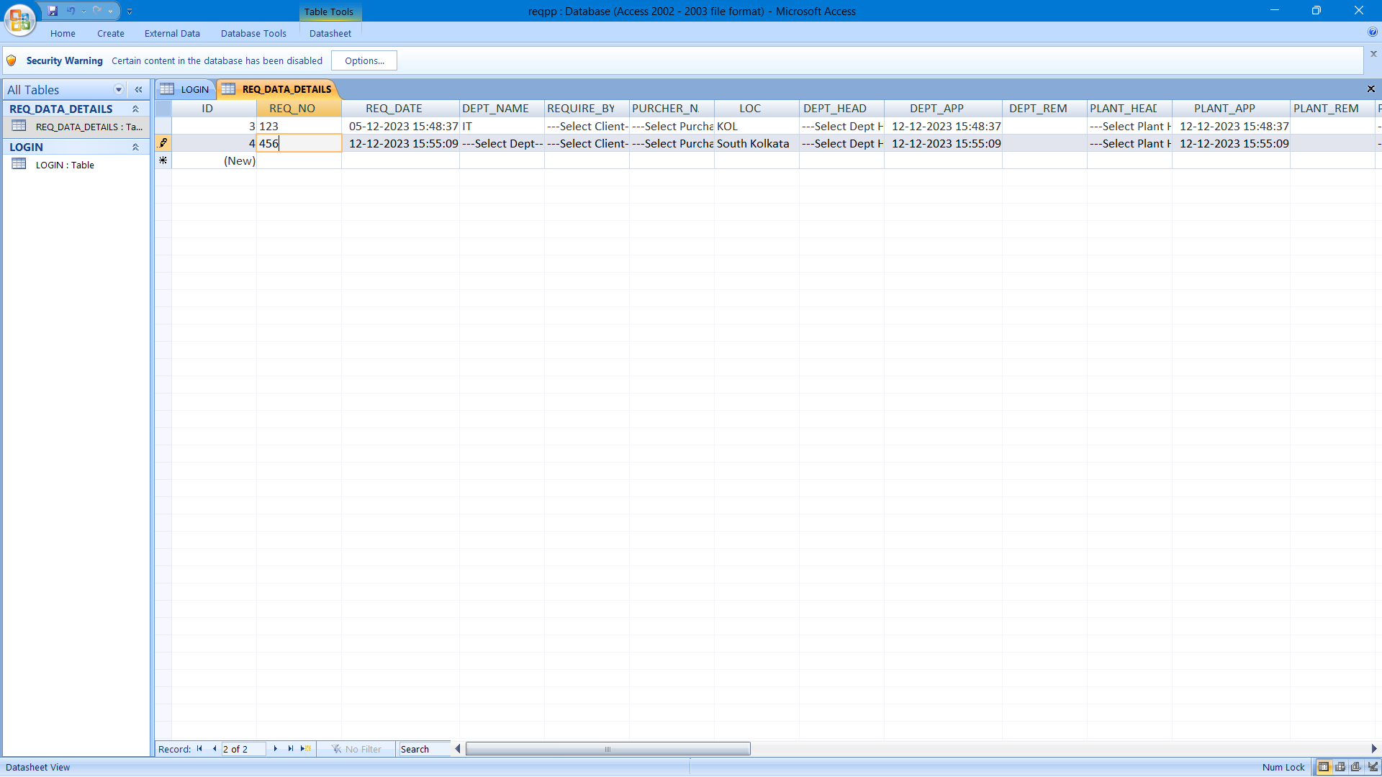

## 5a. USER INTERFACE DESIGN

**User interface design (UID)** or **user interface engineering** is the [design](http://en.wikipedia.org/wiki/Design) ofuser interface[s](http://en.wikipedia.org/wiki/User_interface) for [machines](http://en.wikipedia.org/wiki/Machine) and [software,](http://en.wikipedia.org/wiki/Software) such as computers, [home appliances,](http://en.wikipedia.org/wiki/Home_appliance) [mobile devices,](http://en.wikipedia.org/wiki/Mobile_device) and other [electronic devices,](http://en.wikipedia.org/wiki/Electronics) with the focus on maximizing the [user experience.](http://en.wikipedia.org/wiki/User_experience) The goal of user interface design is to make the user's interaction as simple and efficient as possible, in terms of accomplishing user goals (user entered[)](http://en.wikipedia.org/wiki/User-centered_design).

Good user interface design facilitates finishing the task at hand without drawing unnecessary attention to it. [Graphic design](http://en.wikipedia.org/wiki/Graphic_design) and typography are utilized to support its [usability,](http://en.wikipedia.org/wiki/Usability) influencing how the user performs certain interactions and improving the aesthetic appeal of the design; design aesthetics may enhance or detract from the ability of users to use the functions of the interface. The design process must balance technical functionality and visual elements (e.g., [mental model)](http://en.wikipedia.org/wiki/Mental_model) to create a system that is not only operational but also usable and adaptable to changing user needs.

Interface design is involved in a wide range of projects from computer systems, to cars, to commercial planes; all of these projects involve much of the same basic human interactions yet also require some unique skills and knowledge. As a result, designers tend to specialize in certain types of projects and have skills cantered on their expertise, whether that besoftware desig[n,](http://en.wikipedia.org/wiki/Software_design) user research,web desig[n,](http://en.wikipedia.org/wiki/Web_design) or [industrial design.](http://en.wikipedia.org/wiki/Industrial_design)

**FRONTEND**

**Login Page**

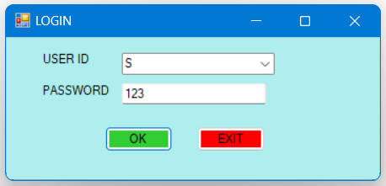

**Login Page Code**

Public Class Frmlogin

Private Sub CMDOK_Click(sender As Object, e As EventArgs) Handles CMDOK.Click

Dim RS As New ADODB.Recordset

RS.Open("SELECT * FROM LOGIN where USER_NAME='" & Trim(cmbusername.Text) & "'", cnMainData, ADODB.CursorTypeEnum.adOpenKeyset, ADODB.LockTypeEnum.adLockBatchOptimistic)

If rs.RecordCount = 0 Then

rs.Close()

MsgBox("Record Not Found", MsgBoxStyle.Information)

Else

If RS.Fields("PASSWORD").Value = TXTpassword.Text Then

FrmWelcome.Show()

Else

MsgBox("Password Mismatch", MsgBoxStyle.Information)

End If

rs.Close()

End If

End Sub

Private Sub CMDEXIT_Click(sender As Object, e As EventArgs) Handles CMDEXIT.Click

End

End Sub

Private Sub Frmlogin_Load(sender As Object, e As EventArgs) Handles MyBase.Load

If cnMainData.State = 0 Then Module1.connect()

End Sub

End Class

**Welcome Page**

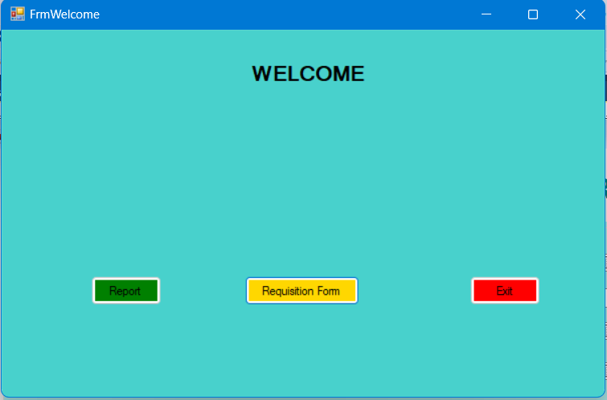

**Welcome Page Code**

Public Class FrmWelcome

Private Sub CMDREQ_Click(sender As Object, e As EventArgs) Handles CMDREQ.Click

FrmReq.Show()

End Sub

Private Sub Button1_Click(sender As Object, e As EventArgs) Handles Button1.Click

End

End Sub

Private Sub FrmWelcome_Load(sender As Object, e As EventArgs) Handles MyBase.Load

End Sub

End Class

**Requisition Form Page**

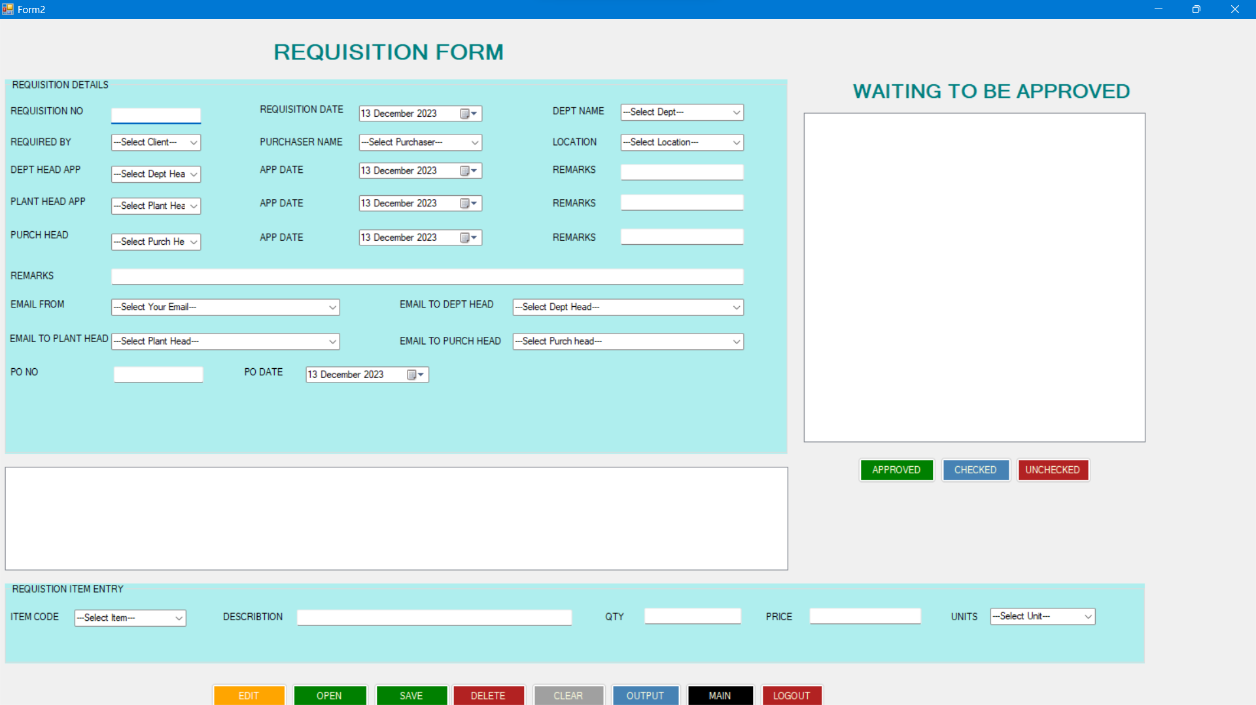

**Requisition Form Page Code**

Public Class FrmReq

Private Sub CMDCLEAR_Click(sender As Object, e As EventArgs) Handles CMDCLEAR.Click

TXTREQNO.Text = ""

DTPREQDATE.Value = Today

CMBDEPTNAME.Text = "---Select Dept---"

CMBREQ.Text = "---Select Client---"

CMBPUR.Text = "---Select Purchaser---"

CMBLOC.Text = "---Select Location---"

CMBDEPTAPP.Text = "---Select Dept Head---"

DTPAPPDATE1.Value = Today

TXTREM1.Text = ""

CMBPLANTAPP.Text = "---Select Plant Head---"

DTPAPPDATE2.Value = Today

TXTREM2.Text = ""

CMBPURCHHEAD.Text = "---Select Purch Head---"

DTPAPPDATE3.Value = Today

TXTREM3.Text = ""

TXTREM4.Text = ""

CMBEMAIL.Text = "---Select Your Email---"

CMBDEPTHEAD.Text = "---Select Dept Head---"

CMBPLANTHEAD.Text = "---Select Plant Head---"

CMBPURHEAD.Text = "---Select Purch head---"

TXTPONO.Text = ""

DTPPODATE.Value = Today

CMBITEMCODE.Text = "---Select Item---"

TXTDES.Text = ""

TXTQTY.Text = ""

TXTPRICE.Text = ""

CMBUNITS.Text = "---Select Unit---"

End Sub

Private Sub CMDSAVE_Click(sender As Object, e As EventArgs) Handles CMDSAVE.Click

Dim RS As New ADODB.Recordset

Dim RS1 As New ADODB.Recordset

If Trim(TXTREQNO.Text) = "" Then

MsgBox("ENTRY JOB NO ", MsgBoxStyle.Information)

TXTREQNO.Focus()

Exit Sub

Else

End If

'if new project then

RS1.Open("SELECT *FROM REQ_DATA_DETAILS where REQ_NO='" & Trim(TXTREQNO.Text) & "'", cnMainData, ADODB.CursorTypeEnum.adOpenKeyset, ADODB.LockTypeEnum.adLockBatchOptimistic)

If RS1.RecordCount = 0 Then

RS.Open("SELECT *FROM REQ_DATA_DETAILS", cnMainData, ADODB.CursorTypeEnum.adOpenKeyset, ADODB.LockTypeEnum.adLockBatchOptimistic)

With RS

.AddNew()

'RS.Fields("ID_NO").value = Val(TXTIDNO.Text)

RS.Fields("REQ_NO").Value = Trim(TXTREQNO.Text)

RS.Fields("REQ_DATE").Value = Trim(DTPREQDATE.Value)

RS.Fields("DEPT_NAME").Value = Trim(CMBDEPTNAME.Text)

RS.Fields("REQUIRE_BY").Value = Trim(CMBREQ.Text)

RS.Fields("PURCHER_NAME").Value = Trim(CMBPUR.Text)

RS.Fields("LOC").Value = Trim(CMBLOC.Text)

RS.Fields("DEPT_HEAD").Value = Trim(CMBDEPTAPP.Text)

RS.Fields("DEPT_APP").Value = Trim(DTPAPPDATE1.Value)

RS.Fields("DEPT_REM").Value = Trim(TXTREM1.Text)

RS.Fields("PLANT_HEAD").Value = Trim(CMBPLANTAPP.Text)

RS.Fields("PLANT_APP").Value = Trim(DTPAPPDATE2.Value)

RS.Fields("PLANT_REM").Value = Trim(TXTREM2.Text)

RS.Fields("PURCH_HEAD").Value = Trim(CMBPURCHHEAD.Text)

RS.Fields("PURCH_APP").Value = Trim(DTPAPPDATE3.Value)

RS.Fields("PURCH_REM").Value = Trim(TXTREM3.Text)

RS.Fields("REMARKS").Value = Trim(TXTREM4.Text)

RS.Fields("EMAIL").Value = Trim(CMBEMAIL.Text)

RS.Fields("EMAIL_DEPT_HEAD").Value = Trim(CMBDEPTHEAD.Text)

RS.Fields("EMAIL_PLANT_HEAD").Value = Trim(CMBPLANTHEAD.Text)

RS.Fields("EMAIL_PURCH_HEAD").Value = Trim(CMBPURHEAD.Text)

RS.Fields("PO_NO").Value = Trim(TXTPONO.Text)

RS.Fields("PO_DATE").Value = Trim(DTPPODATE.Value)

RS.Fields("ITEM_CODE").Value = Trim(CMBITEMCODE.Text)

RS.Fields("DESCRIBTION").Value = Trim(TXTDES.Text)

RS.Fields("QTY").Value = Val(TXTQTY.Text)

RS.Fields("PRICE").Value = Val(TXTPRICE.Text)

RS.Fields("UNITS").Value = Trim(CMBUNITS.Text)

.UpdateBatch()

End With

RS.Close()

MsgBox("DATA IS SAVED", MsgBoxStyle.Information)

Else

End If

RS1.Close()

End Sub

Private Sub FrmReq_Load(sender As Object, e As EventArgs) Handles MyBase.Load

If cnMainData.State = 0 Then Module1.connect()

End Sub

Private Sub CMDOPEN_Click(sender As Object, e As EventArgs) Handles CMDOPEN.Click

Dim rs As New ADODB.Recordset

rs.Open("SELECT *FROM REQ_DATA_DETAILS where REQ_NO='" & Trim(TXTREQNO.Text) & "'", cnMainData, ADODB.CursorTypeEnum.adOpenKeyset, ADODB.LockTypeEnum.adLockBatchOptimistic)

If rs.RecordCount = 0 Then

rs.Close()

MsgBox("Record Not Found", MsgBoxStyle.Information)

Else

DTPREQDATE.Value = rs.Fields("REQ_DATE").Value

CMBDEPTNAME.Text = Trim(rs.Fields("DEPT_NAME").Value)

CMBREQ.Text = Trim(rs.Fields("REQUIRE_BY").Value)

CMBPUR.Text = Trim(rs.Fields("PURCHER_NAME").Value)

CMBLOC.Text = Trim(rs.Fields("LOC").Value)

CMBDEPTAPP.Text = Trim(rs.Fields("DEPT_HEAD").Value)

DTPAPPDATE1.Value = rs.Fields("DEPT_APP").Value

TXTREM1.Text = Trim(rs.Fields("DEPT_REM").Value)

CMBPLANTAPP.Text = Trim(rs.Fields("PLANT_HEAD").Value)

DTPAPPDATE2.Value = rs.Fields("PLANT_APP").Value

TXTREM2.Text = Trim(rs.Fields("PLANT_REM").Value)

CMBPURCHHEAD.Text = Trim(rs.Fields("PURCH_HEAD").Value)

DTPAPPDATE3.Value = rs.Fields("PURCH_APP").Value

TXTREM3.Text = Trim(rs.Fields("PURCH_REM").Value)

TXTREM4.Text = Trim(rs.Fields("REMARKS").Value)

CMBEMAIL.Text = Trim(rs.Fields("EMAIL").Value)

CMBDEPTHEAD.Text = Trim(rs.Fields("EMAIL_DEPT_HEAD").Value)

CMBPLANTHEAD.Text = Trim(rs.Fields("EMAIL_PLANT_HEAD").Value)

CMBPURHEAD.Text = Trim(rs.Fields("EMAIL_PURCH_HEAD").Value)

TXTPONO.Text = Trim(rs.Fields("PO_NO").Value)

DTPPODATE.Value = rs.Fields("PO_DATE").Value

CMBITEMCODE.Text = Trim(rs.Fields("ITEM_CODE").Value)

TXTDES.Text = Trim(rs.Fields("DESCRIBTION").Value)

TXTQTY.Text = Val(rs.Fields("QTY").Value)

TXTPRICE.Text = Val(rs.Fields("PRICE").Value)

CMBUNITS.Text = Trim(rs.Fields("UNITS").Value)

rs.Close()

End If

End Sub

Private Sub CMDMAIN_Click(sender As Object, e As EventArgs) Handles CMDMAIN.Click

FrmWelcome.Show()

Me.Close()

End Sub

Private Sub CMDLOGOUT_Click(sender As Object, e As EventArgs) Handles CMDLOGOUT.Click

End

End Sub

Private Sub CMDEDIT_Click(sender As Object, e As EventArgs) Handles CMDEDIT.Click

Dim RS As New ADODB.Recordset

Dim RS1 As New ADODB.Recordset

RS1.Open("SELECT *FROM REQ_DATA_DETAILS where REQ_NO='" & Trim(TXTREQNO.Text) & "'", cnMainData, ADODB.CursorTypeEnum.adOpenKeyset, ADODB.LockTypeEnum.adLockBatchOptimistic)

If RS1.RecordCount = 0 Then

Else

RS.Open("SELECT *FROM REQ_DATA_DETAILS where REQ_NO='" & Trim(TXTREQNO.Text) & "'", cnMainData, ADODB.CursorTypeEnum.adOpenKeyset, ADODB.LockTypeEnum.adLockBatchOptimistic)

With RS

.Update()

'RS.Fields("ID_NO").value = Val(TXTIDNO.Text)

RS.Fields("REQ_NO").Value = Trim(TXTREQNO.Text)

RS.Fields("REQ_DATE").Value = Trim(DTPREQDATE.Value)

RS.Fields("DEPT_NAME").Value = Trim(CMBDEPTNAME.Text)

RS.Fields("REQUIRE_BY").Value = Trim(CMBREQ.Text)

RS.Fields("PURCHER_NAME").Value = Trim(CMBPUR.Text)

RS.Fields("LOC").Value = Trim(CMBLOC.Text)

RS.Fields("DEPT_HEAD").Value = Trim(CMBDEPTAPP.Text)

RS.Fields("DEPT_APP").Value = Trim(DTPAPPDATE1.Value)

RS.Fields("DEPT_REM").Value = Trim(TXTREM1.Text)

RS.Fields("PLANT_HEAD").Value = Trim(CMBPLANTAPP.Text)

RS.Fields("PLANT_APP").Value = Trim(DTPAPPDATE2.Value)

RS.Fields("PLANT_REM").Value = Trim(TXTREM2.Text)

RS.Fields("PURCH_HEAD").Value = Trim(CMBPURCHHEAD.Text)

RS.Fields("PURCH_APP").Value = Trim(DTPAPPDATE3.Value)

RS.Fields("PURCH_REM").Value = Trim(TXTREM3.Text)

RS.Fields("REMARKS").Value = Trim(TXTREM4.Text)

RS.Fields("EMAIL").Value = Trim(CMBEMAIL.Text)

RS.Fields("EMAIL_DEPT_HEAD").Value = Trim(CMBDEPTHEAD.Text)

RS.Fields("EMAIL_PLANT_HEAD").Value = Trim(CMBPLANTHEAD.Text)

RS.Fields("EMAIL_PURCH_HEAD").Value = Trim(CMBPURHEAD.Text)

RS.Fields("PO_NO").Value = Trim(TXTPONO.Text)

RS.Fields("PO_DATE").Value = Trim(DTPPODATE.Value)

RS.Fields("ITEM_CODE").Value = Trim(CMBITEMCODE.Text)

RS.Fields("DESCRIBTION").Value = Trim(TXTDES.Text)

RS.Fields("QTY").Value = Val(TXTQTY.Text)

RS.Fields("PRICE").Value = Val(TXTPRICE.Text)

RS.Fields("UNITS").Value = Trim(CMBUNITS.Text)

.UpdateBatch()

End With

RS.Close()

MsgBox("DATA IS UPDATED", MsgBoxStyle.Information)

End If

RS1.CLOSE

End Sub

Private Sub CMDDEL_Click(sender As Object, e As EventArgs) Handles CMDDEL.Click

Dim ANS As String

Dim rs As New ADODB.Recordset

ANS = MsgBox("DO YOU WANT TO DELETE THIS DATA?", MsgBoxStyle.Question + MsgBoxStyle.YesNo)

rs.Open("SELECT *FROM REQ_DATA_DETAILS where REQ_NO='" & Trim(TXTREQNO.Text) & "'", cnMainData, ADODB.CursorTypeEnum.adOpenKeyset, ADODB.LockTypeEnum.adLockBatchOptimistic)

If rs.RecordCount = 0 Then

rs.Close()

MsgBox("Record Not Found", MsgBoxStyle.Information)

Else

cnMainData.Execute("DELETE * FROM REQ_DATA_DETAILS WHERE REQ_NO='" & Trim(TXTREQNO.Text) & "'")

rs.Close()

End If

End Sub

Private Sub Label1_Click(sender As Object, e As EventArgs) Handles Label1.Click

End Sub

Private Sub GRPREQDET_Enter(sender As Object, e As EventArgs) Handles GRPREQDET.Enter

End Sub

End Class

**Report Page**

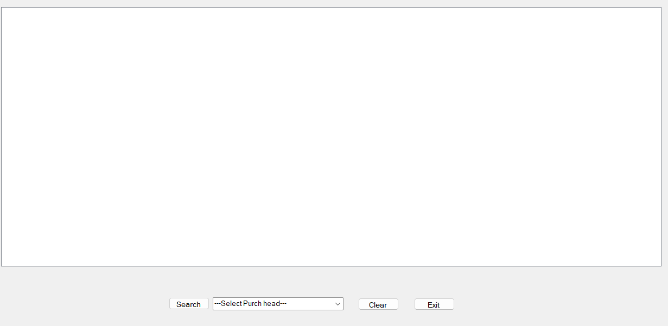

**Report Page Code**

Public Class Form2

Private Sub Form2_Load(sender As Object, e As EventArgs) Handles MyBase.Load

End Sub

Private Sub Button2_Click(sender As Object, e As EventArgs) Handles Button2.Click

End Sub

Private Sub Button1_Click(sender As Object, e As EventArgs) Handles Button1.Click

End Sub

Private Sub ListView1_SelectedIndexChanged(sender As Object, e As EventArgs) Handles ListView1.SelectedIndexChanged

End Sub

End Class

## 6.a DATABASE SECURITY

System security measure is meant to be provided to make your system reliable and secured from unauthorized user may create threats to the system. So, you should follow some security measures. We have used security levels in database level at system level.

**6.b SYSTEM SECURITY**

If we talk about the system security in our proposed system we have implemented with the help of maintain the session throughout the system’s use. Once a user has logged out than he/she will not be able to perform any task before signing back again.

A high level of authentic login is given to the system so this is a very tedious task to enter without authorization and authentication.

**6c. LIMITATIONS**

* Since it is an online project, customers need internet connection to use it.
* People who are not familiar with computers can’t use this software.
* Customer must have debit card or credit card to purchase a product.

**7a. CONCLUSION**

This project has been appreciated by all the users in the organization. It is easy to use, since it uses the GUI provided in the user dialog. User friendly screens are provided. The usage of software increases the efficiency, decreases the effort. It has been efficiently employed as a Site management mechanism. It has been thoroughly tested and implemented.

## 7b. FURTHER ENHANCEMENTS

In future we would like to keep working on this project and make new additions to provide users with more advanced features and more detailed information. We have set our sights on the following additions in future:-

1. Forget Password for admin and user
2. Customer Experience
3. Mobile Friendliness
4. The transformation from image recognition to product recognition.
5. A high degree of individualization in all aspects.
6. Online payment process through debit and credit cards.
7. Auto-mail will be sent to the user email-id when they are purchased some products.

### 8. BIBLIOGRAPHY

* <https://www.youtube.com/>
* <https://www.tutorialspoint.com/vb.net/index.htm>
* <https://www.javatpoint.com/vb-net>
* <https://learn.microsoft.com/en-us/dotnet/visual-basic/>
* <https://en.wikipedia.org/wiki/Visual_Basic_(.NET)>