**Assignment03**

Programming Fundamentals

Submission deadline: 25th May, 2021 – 10.00 PM

**Submission Guidelines:**

* Submit the assignment only on **google classroom within deadline.**
* Late submissions upto **15** mins are allowed with a penalty of **30%** on google classroom. After that **no** submission will be entertained
* Name the source file as “assign01-roll#.cpp”. For example **assig01-i200561.cpp**
* Submit three files as explained at the end
* Failing to follow the submission guidelines will result in penalties.

**Department Management System**

Given below is a class diagram for a Department Management System in a university. Some of the class relationships are shown, while some are left for you to decide.

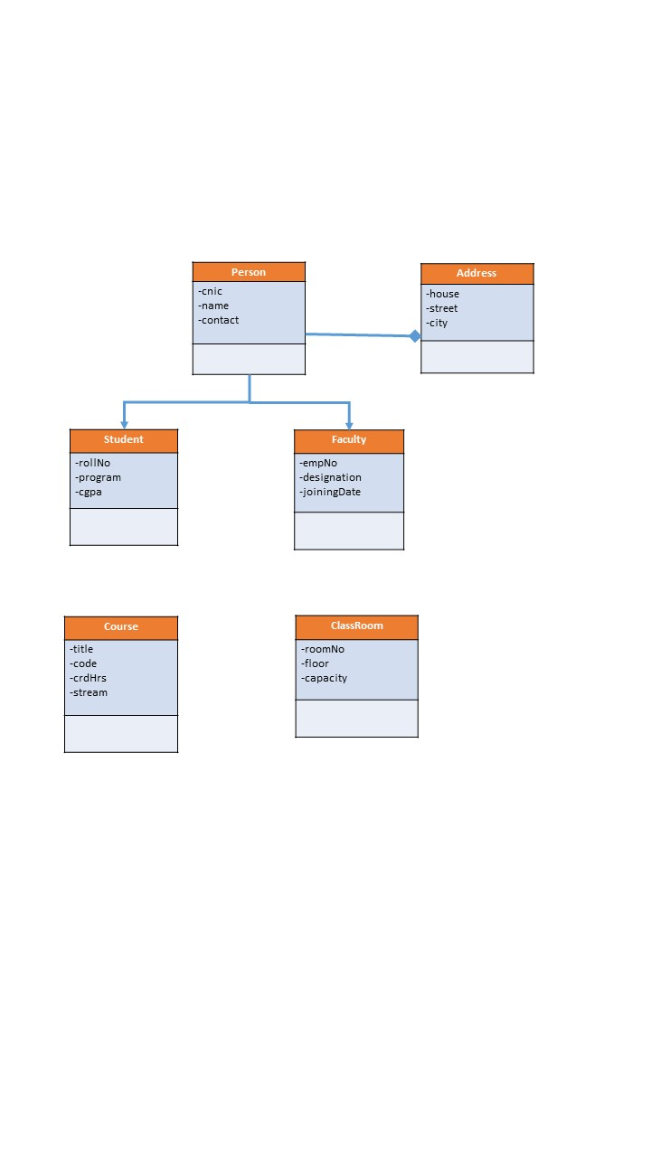

After completing the class relationship diagram, you need to implement this model. Data is being provided alongwith this document in the form of text files. You will need to create arrays for above classes in order to load data into your program from the given text files.

Differnet reports needs to be generated with this program. Provide suitable menu for the following:

* Print Students list hailing from a specific city (Take Input city name) (10 marks)
* Print courses taken by a Student (Take Input Roll#) (20 marks)
* Print courses being taught by a faculty (Take Input empId) (10 marks)
* Print students enrolled in a course (Take Input courseID) (10 marks)