|  |  |  |  |
| --- | --- | --- | --- |
| National University of Computer & Emerging Sciences  **EE2004: Electrical Network Analysis**  **Section: A,B (Fall 2021)** | | | **A-01**  [Marks: 60] |
| **Instructor:** Engr. Azhar Rauf  **TA:** M. Aisam Irshad ([i190847@nu.edu.pk](mailto:i190847@nu.edu.pk)) | **Lectures:**  01-06 | **Launch:**  Thu, Sep 23 ‘21 | **Submit Date:**  As per GCR |
|  | | | |
| **CLO-01:** **Apply** the concept of Phasors to find power & power-factor in single- & poly-phase sinusoidal systems in steady-state. | | | |

|  |  |  |
| --- | --- | --- |
| **Submit on GCR by Submit Date –** Late Assignments not accepted | | |
| **Submitted by:** | **Roll #:** | **Section:** |
| **Check here:**  I agree that there is ZERO Tolerance Policy for plagiarism and cheating in all assessments. First plagiarism case gets zero. Subsequent plagiarism cases get ZERO in all assignments. A gross violation may be reported to the Department Discipline Committee (DDC). | | |

**Assignment Submission: Terms & Conditions**

1. This is a graded assignment; students are advised to revise all concepts before attempting.
2. Submit a **single PDF** in **GCR** by the submit date mentioned in GCR; SLATE/email not accepted.
3. Any pics or images used in the PDF must be scanned with **ClearScanner** app.
4. Do not use CamScanner or MS Lens as it deteriorates the image quality and the writing at the back of the page is also visible.
5. Submitting individual pictures or attaching multiple files not accepted.
6. Late submission not accepted.
7. Be sure to fill and checkmark the agreement in the submission box. If not filled or checked, submission not accepted.

**Assignment Collaboration: Terms & Conditions**

1. Collaboration is permitted with limitations as defined below.
2. All collaboration to be strictly done on GCR -> Assignment Collaboration Channel. May not post/discuss on any other forum.
3. Permitted forms of collaboration include (but not limited to) asking questions, answering questions, explaining intent of the question, explaining concepts, highlighting methods, discussion of all types, etc.
4. Forbidden forms of collaboration include (but not limited to) uploading solutions or partial solutions, letting know the partial or final answers, etc.

This Channel will be monitored continuously. Anyone indulging in forbidden activities will be removed from the channel, their posts deleted, and zero marks assigned in the assignment.

**Assignment Problem:**

**For the first few assignments and quizzes, to develop students’ complex number solving skills on their calculators, correct answers will be very important and weighted highly. Later in the course, the focus will mainly be on selection of appropriate tool to solve the problem, writing correct equations, etc.**

1. Answer the questions below
2. Find the amplitude, phase, period, and frequency of the sinusoid. (3)

**v(t)= 12cos(50t+10o) V**

1. Draw a phasor diagram for **V** = Vm< ϕ and **I** = Im<−θ. (2)
2. If *v*1 = −10 sin (*ωt* − 30°) V and *v*2 = 20 cos (*ωt* + 45°) V, find *v* =*v*1 + *v*2. (5)
3. Find *v*(*t*) and *i*(*t*) in the circuit. (5)

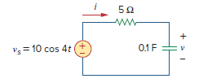

1. Find the input impedance of the circuit at w=5 rad/s and w=5000 rad/s. Interpret the results in the light of the fact that impedance is a function of (jw); i.e., z(jw). (10)

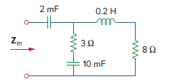

1. Calculate vx and ix using mesh analysis. (12)

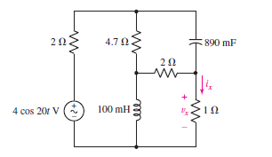

1. Find IB using superposition method given that **I**1 = 5*<*−18oA and **I**2 = 2*<*5o A. (15)

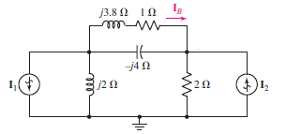

1. Answer the following short-answer type questions qualitatively (i.e., no calculations are involved):
2. How does a circuit operate at sinusoidal steady state? (3)
3. In how many forms a phasor can be represented? Mention them. (2)
4. What are the differences between v(t) and **V**? (3)