Tutorial

1. Install mysql, please use brew install mysql to install mysql. Then run mysql.server restart to initialize mysql.
2. Download mysql workbench from <https://www.mysql.com/products/workbench/>. And then connect to the mysql (make sure mysql has runnning on port 3306)create schema called climate with a username/password as climate/climate. No tables needed to be created because they will be created automatically by backend using JPA.
3. cd into [ApacheCMDA-](https://github.com/cmusv-sc/SOC-Fall-2015-Team13-Bowen-Zhang/tree/master/ApacheCMDA-Frontend)Backend, run ./activator "run 9034", then will see the following picture

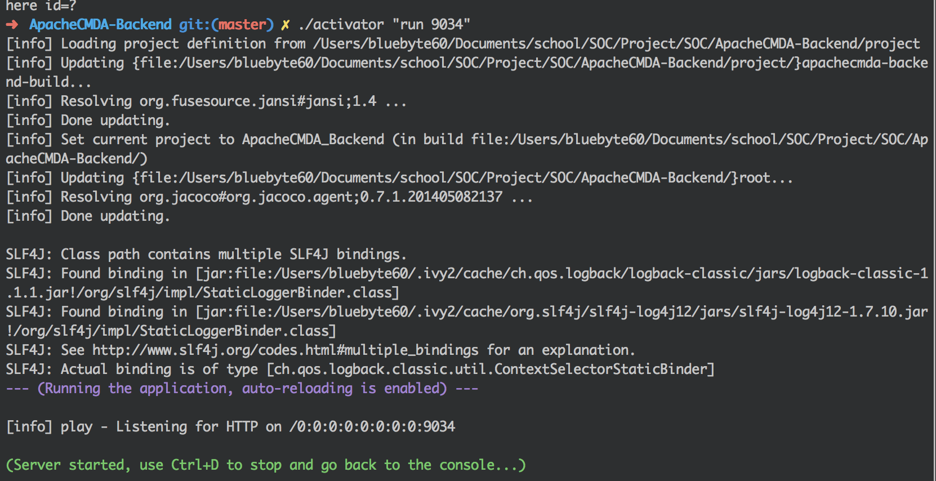

4) cd into [ApacheCMDA-](https://github.com/cmusv-sc/SOC-Fall-2015-Team13-Bowen-Zhang/tree/master/ApacheCMDA-Frontend)Frontend, run sbt run, then will see the following picture

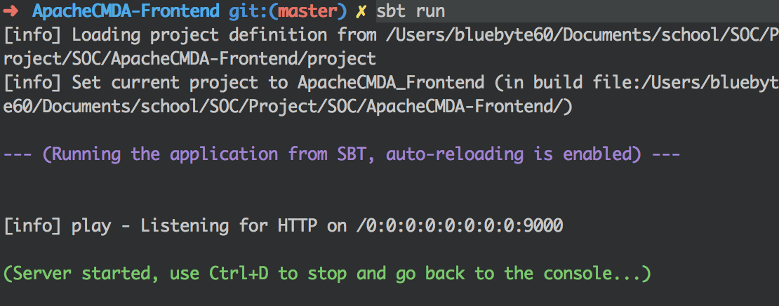

5) Then go to 127.0.0.1:9090 to view the main page

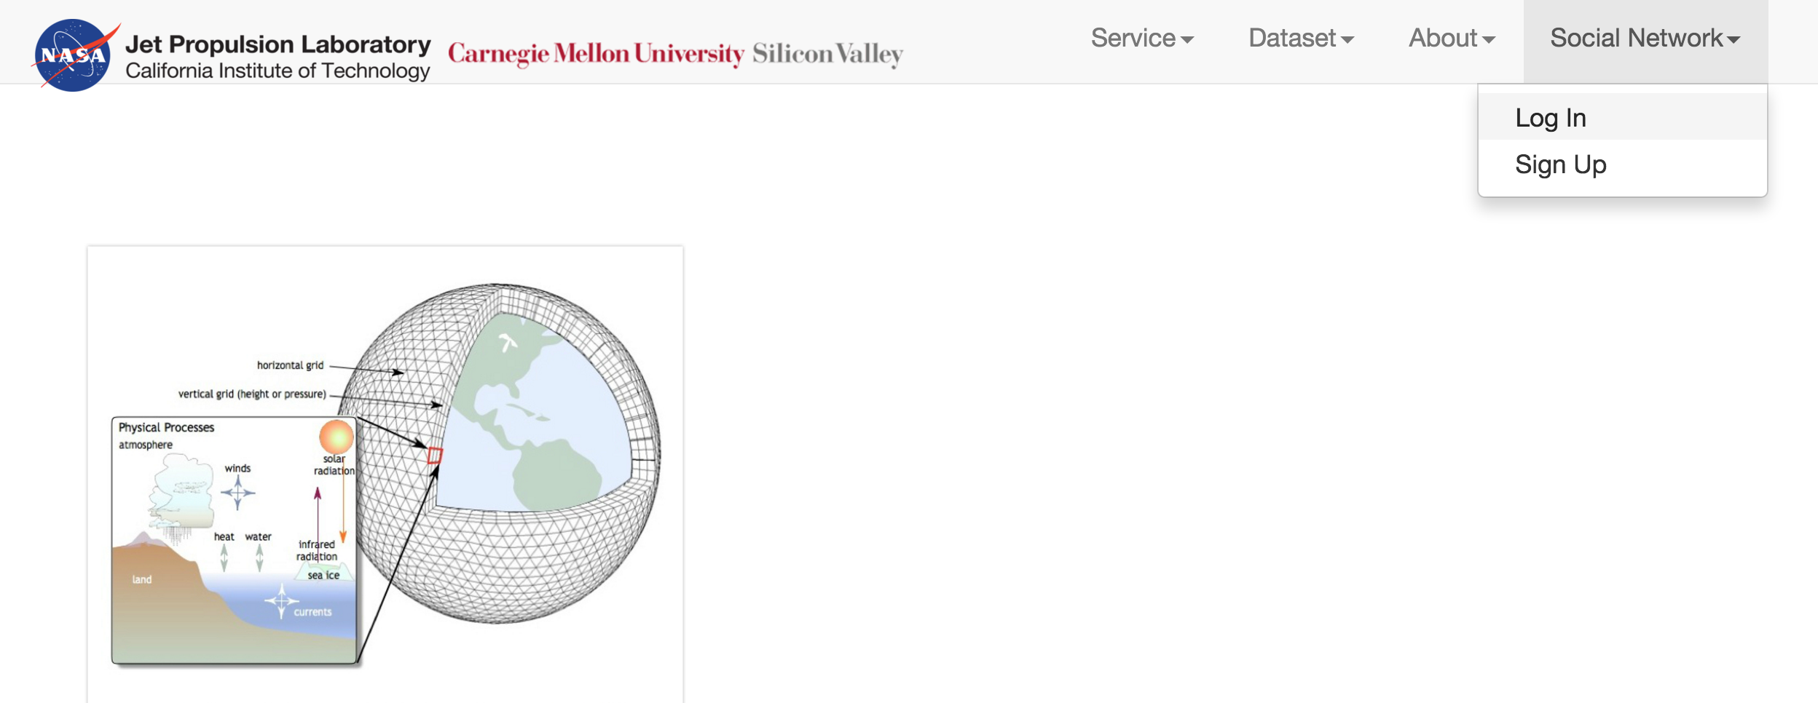

then please click social network, then you can login