**Tensorflow 1.13 Smoke Test**

**Login to JupyterHub Web UI**

1. From the Cluster page under Services, click on **Jupterhub**

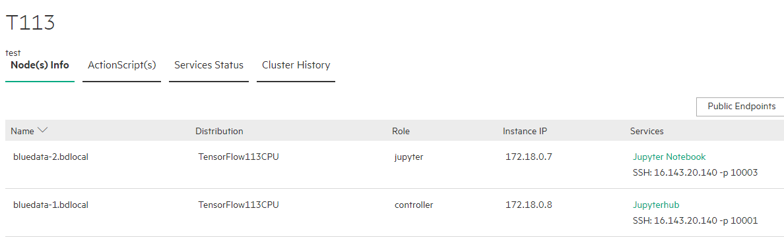

1. It will open-up a new tab with JupyterHub login page, login using your credentials

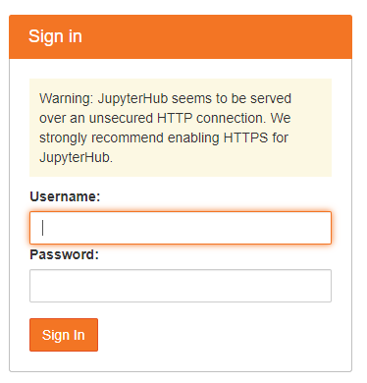

**Create Notebook**

1. You will get JupyterHub dashboard as below:

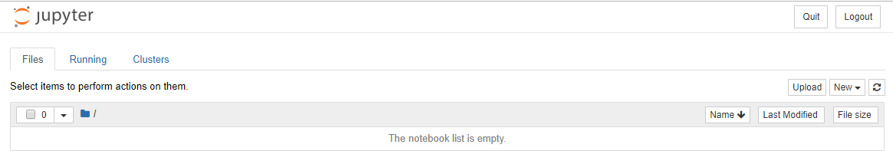

1. Click on **New** drop-down button, to create a new notebook

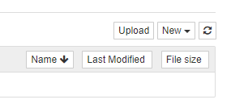

1. Select **Python3**, for upcoming tasks

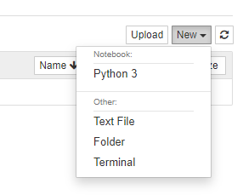

1. **Tensorflow in Python3 Testing using JupyterHub:**

**Testing Linear Regression Example**

1. In Python3 notebook, add the following code in the code cell.

import tensorflow as tf

import numpy

import matplotlib.pyplot as plt

rng = numpy.random

# Parameters

learning_rate = 0.01

training_epochs = 1000

display_step = 50

# Training Data

train_X = numpy.asarray([3.3,4.4,5.5,6.71,6.93,4.168,9.779,6.182,7.59,2.167,7.042,10.791,5.313,7.997,5.654,9.27,3.1])

train_Y = numpy.asarray([1.7,2.76,2.09,3.19,1.694,1.573,3.366,2.596,2.53,1.221,2.827,3.465,1.65,2.904,2.42,2.94,1.3])

n_samples = train_X.shape[0]

# tf Graph Input

X = tf.placeholder("float")

Y = tf.placeholder("float")

# Set model weights

W = tf.Variable(rng.randn(), name="weight")

b = tf.Variable(rng.randn(), name="bias")

# Construct a linear model

pred = tf.add(tf.multiply(X, W), b)

# Mean squared error

cost = tf.reduce_sum(tf.pow(pred-Y, 2))/(2*n_samples)

# Gradient descent

optimizer = tf.train.GradientDescentOptimizer(learning_rate).minimize(cost)

# Initialize the variables (i.e. assign their default value)

init = tf.global_variables_initializer()

# Start training

with tf.Session() as sess:

sess.run(init)

# Fit all training data

for epoch in range(training_epochs):

for (x, y) in zip(train_X, train_Y):

sess.run(optimizer, feed_dict={X: x, Y: y})

#Display logs per epoch step

if (epoch+1) % display_step == 0:

c = sess.run(cost, feed_dict={X: train_X, Y:train_Y})

print ("Epoch:", '%04d' % (epoch+1), "cost=", "{:.9f}".format(c), "W=", sess.run(W), "b=", sess.run(b))

print ("Optimization Finished!")

training_cost = sess.run(cost, feed_dict={X: train_X, Y: train_Y})

print ("Training cost=", training_cost, "W=", sess.run(W), "b=", sess.run(b), '\n')

#Graphic display

plt.plot(train_X, train_Y, 'ro', label='Original data')

plt.plot(train_X, sess.run(W) * train_X + sess.run(b), label='Fitted line')

plt.legend()

plt.show()

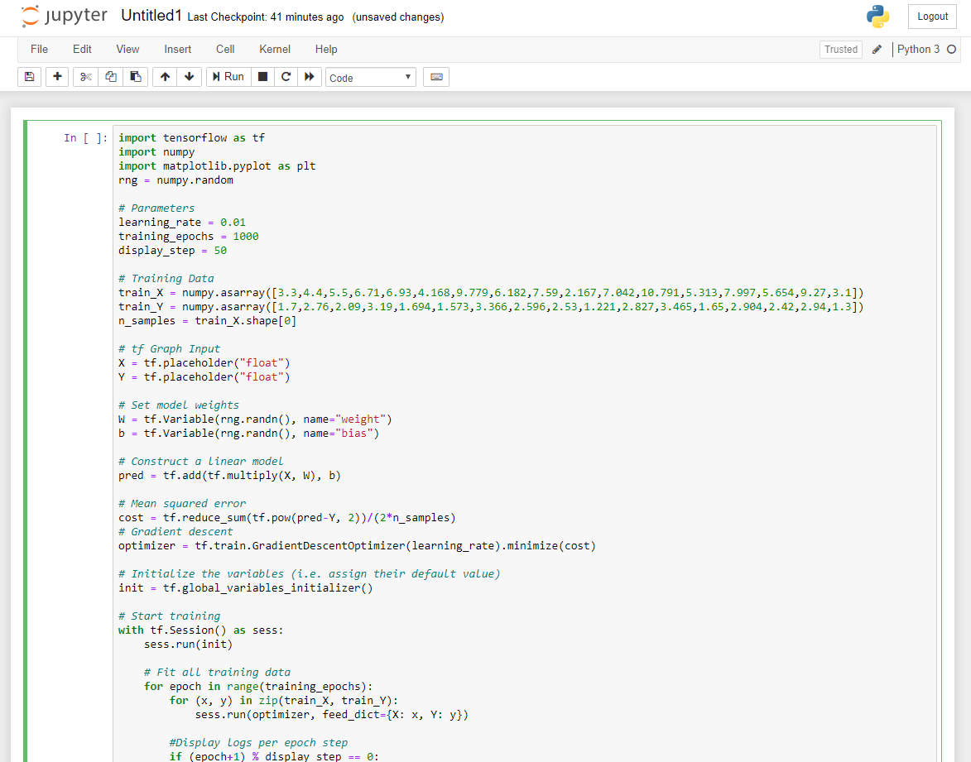

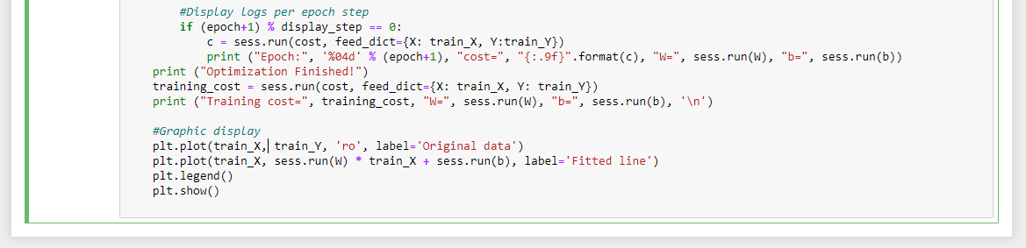

1. Click on **Run**, to view the output

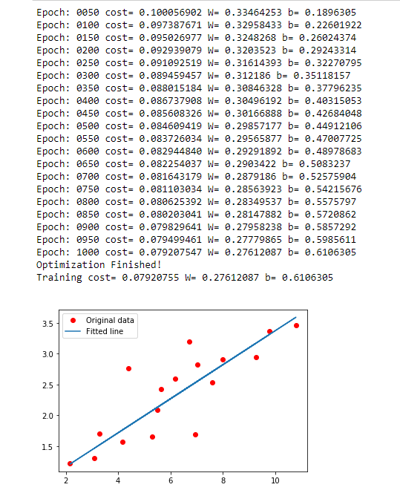

**Note:** Try adding **%matplotlib inline** at the top of the code if you get, <Figure size 640x480 with 1 Axes> instead of graph.

**2**. **Tensorflow in Python3 Testing using Jupyter-notebook:**

**Neural Network**

1. Add the below code in the code cell

import numpy as np

class NeuralNetwork():

def __init__(self):

# seeding for random number generation

np.random.seed(1)

#converting weights to a 3 by 1 matrix with values from -1 to 1 and mean of 0

self.synaptic_weights = 2 * np.random.random((3, 1)) - 1

def sigmoid(self, x):

#applying the sigmoid function

return 1 / (1 + np.exp(-x))

def sigmoid_derivative(self, x):

#computing derivative to the Sigmoid function

return x * (1 - x)

def train(self, training_inputs, training_outputs, training_iterations):

#training the model to make accurate predictions while adjusting weights continually

for iteration in range(training_iterations):

#siphon the training data via the neuron

output = self.think(training_inputs)

#computing error rate for back-propagation

error = training_outputs - output

#performing weight adjustments

adjustments = np.dot(training_inputs.T, error * self.sigmoid_derivative(output))

self.synaptic_weights += adjustments

def think(self, inputs):

#passing the inputs via the neuron to get output

#converting values to floats

inputs = inputs.astype(float)

output = self.sigmoid(np.dot(inputs, self.synaptic_weights))

return output

if __name__ == "__main__":

#initializing the neuron class

neural_network = NeuralNetwork()

print("Beginning Randomly Generated Weights: ")

print(neural_network.synaptic_weights)

#training data consisting of 4 examples--3 input values and 1 output

training_inputs = np.array([[0,0,1],

[1,1,1],

[1,0,1],

[0,1,1]])

training_outputs = np.array([[0,1,1,0]]).T

#training taking place

neural_network.train(training_inputs, training_outputs, 15000)

print("Ending Weights After Training: ")

print(neural_network.synaptic_weights)

user_input_one = str(input("User Input One: "))

user_input_two = str(input("User Input Two: "))

user_input_three = str(input("User Input Three: "))

print("Considering New Situation: ", user_input_one, user_input_two, user_input_three)

print("New Output data: ")

print(neural_network.think(np.array([user_input_one, user_input_two, user_input_three])))

print("Wow, we did it!")

1. Click on **Run**, to execute the code (Code will prompt for input)

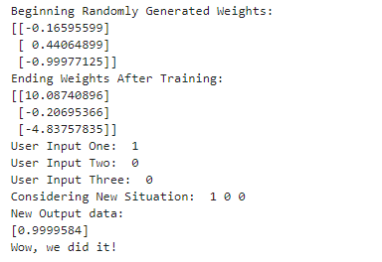

**Single Neuron Neural Network**

1. Add the below code in the code cell

# Python program to implement a

# single neuron neural network

# import all necessery libraries

from numpy import exp, array, random, dot, tanh

# Class to create a neural

# network with single neuron

class NeuralNetwork():

def __init__(self):

# Using seed to make sure it'll

# generate same weights in every run

random.seed(1)

# 3x1 Weight matrix

self.weight_matrix = 2 * random.random((3, 1)) - 1

# tanh as activation fucntion

def tanh(self, x):

return tanh(x)

# derivative of tanh function.

# Needed to calculate the gradients.

def tanh_derivative(self, x):

return 1.0 - tanh(x) ** 2

# forward propagation

def forward_propagation(self, inputs):

return self.tanh(dot(inputs, self.weight_matrix))

# training the neural network.

def train(self, train_inputs, train_outputs,

num_train_iterations):

# Number of iterations we want to

# perform for this set of input.

for iteration in range(num_train_iterations):

output = self.forward_propagation(train_inputs)

# Calculate the error in the output.

error = train_outputs - output

# multiply the error by input and then

# by gradient of tanh funtion to calculate

# the adjustment needs to be made in weights

adjustment = dot(train_inputs.T, error *

self.tanh_derivative(output))

# Adjust the weight matrix

self.weight_matrix += adjustment

# Driver Code

if __name__ == "__main__":

neural_network = NeuralNetwork()

print ('Random weights at the start of training')

print (neural_network.weight_matrix)

train_inputs = array([[0, 0, 1], [1, 1, 1], [1, 0, 1], [0, 1, 1]])

train_outputs = array([[0, 1, 1, 0]]).T

neural_network.train(train_inputs, train_outputs, 10000)

print ('New weights after training')

print (neural_network.weight_matrix)

# Test the neural network with a new situation.

print ("Testing network on new examples ->")

print (neural_network.forward_propagation(array([1, 0, 0])))

1. Click on **Run**, to execute the code

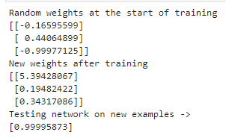

**One Dimensional Vector**

1. In a Python3 notebook, add the below code in the code cell

import numpy as np

input_vector = np.array([2, 4, 11])

print(input_vector)

1. To see the output, click on **Run**

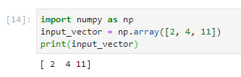

**Two Dimensional Array with one column**

1. Add the below code in the code cell

import numpy as np

input_vector = np.array([2, 4, 11])

input_vector = np.array(input_vector, ndmin=2).T

print(input_vector, input_vector.shape)

1. Click on **Run**

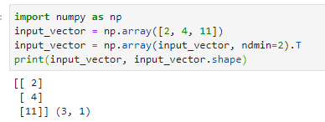

**Weight Matrices**

1. Add the below code in the code cell

import numpy as np

number_of_samples = 1200

low = -1

high = 0

s = np.random.uniform(low, high, number_of_samples)

# all values of s are within the half open interval [-1, 0) :

print(np.all(s >= -1) and np.all(s < 0))

#Histogram

import matplotlib.pyplot as plt

plt.hist(s)

plt.show()

1. Click on **Run**

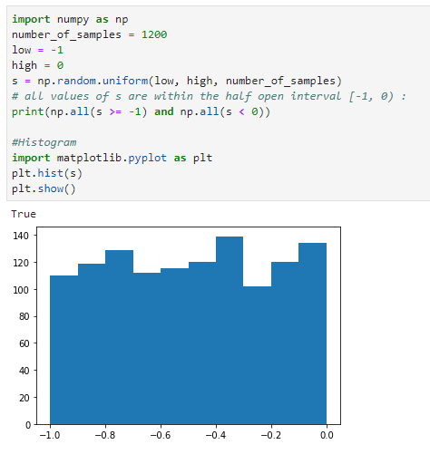

**Note:** Try adding **%matplotlib inline** at the top of the code if you don’t get the graph.

1. To test the binomial function, execute this code

s = np.random.binomial(100, 0.5, 1200)

plt.hist(s)

plt.show()

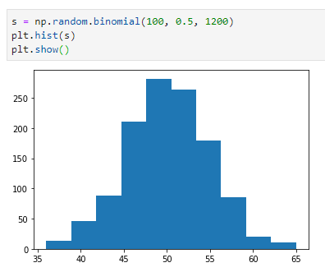

**Sigmoid Function**

1. Execute the below code

import numpy as np

import matplotlib.pyplot as plt

def sigma(x):

return 1 / (1 + np.exp(-x))

X = np.linspace(-5, 5, 100)

plt.plot(X, sigma(X),'b')

plt.xlabel('X Axis')

plt.ylabel('Y Axis')

plt.title('Sigmoid Function')

plt.grid()

plt.text(4, 0.8, r'$\sigma(x)=\frac{1}{1+e^{-x}}$', fontsize=16)

plt.show()

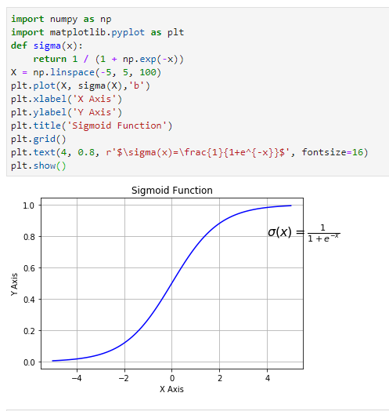

**3. CPU Consumption Test in Python3 using JupyterHub:**

1. In a Python3 notebook, add the below code for CPU consumption code

from __future__ import print_function

import matplotlib

import matplotlib.pyplot as plt

import tensorflow as tf

import time

with tf.Session(config=tf.ConfigProto(log_device_placement=True)) as session:

start_time = time.time()

time_taken = time.time() - start_time

#print(result)

def get_times(maximum_time):

device_times = {

"/cpu:0":[]

}

matrix_sizes = range(500,50000,50)

for size in matrix_sizes:

for device_name in device_times.keys():

print("####### Calculating on the " + device_name + " #######")

shape = (size,size)

data_type = tf.float16

with tf.device(device_name):

r1 = tf.random_uniform(shape=shape, minval=0, maxval=1, dtype=data_type)

r2 = tf.random_uniform(shape=shape, minval=0, maxval=1, dtype=data_type)

dot_operation = tf.matmul(r2, r1)

with tf.Session(config=tf.ConfigProto(log_device_placement=True)) as session:

start_time = time.time()

result = session.run(dot_operation)

time_taken = time.time() - start_time

print(result)

device_times[device_name].append(time_taken)

print(device_times)

if time_taken > maximum_time:

return device_times, matrix_sizes

device_times, matrix_sizes = get_times(1.5)

cpu_times = device_times["/cpu:0"]

plt.plot(matrix_sizes[:len(cpu_times)], cpu_times, 'o-')

plt.ylabel('Time')

plt.xlabel('Matrix size')

plt.show()

1. Click on **Run**, to execute the code

