


Software Requirements Specification
for
PAC-MANIPAL
Version 1.0

Prepared by
Raghu Nandan D | 170953262 | rndakka12@gmail.com
Vedant Valia | 170953254 | vedantvalia@gmail.com
Mokshesh Jain | 170953442 | moksh191998@gmail.com

Instructor: | Mr. Rajesh Rao
Course: | CCE – RUP LAB
Lab Section: | B2
Date: | 18th September, 2019
Contents
Revisions iii
1 Introduction 1
1.1 Document Purpose 1
1.2 Product Scope 1
1.3 Intended Audience and Document Overview 1
1.4 Definitions, Acronyms and Abbreviations 1
1.5 Document Conventions 1
1.6 References and Acknowledgments 2
2 Overall Description 3
2.1 Product Perspective 3
2.2 Product Functionality 3
2.3 Users and Characteristics 3
2.4 Operating Environment 3
2.5 Design and Implementation Constraints 4
2.6 User Documentation 4
2.7 Assumptions and Dependencies 4
3 Specific Requirements 5
3.1 External Interface Requirements 5
3.2 Functional Requirements 6
3.3 Behaviour Requirements 6
4 Other Non-functional Requirements 7
4.1 Performance Requirements 7
4.2 Safety and Security Requirements 7
4.3 Software Quality Attributes 7
5 Other Requirements 8
Appendix A – Data Dictionary 9

Revisions
Version | Primary Author(s) | Description of Version | Date Completed
Final Draft Version 1 | Raghu Nandan D,  Vedant Valia,  Mokshesh Jain | The first version of the document depicts the basic overview of our project. It contains the functionalities of each actor and highlights the relations amongst them. | 18/09/19

Introduction

Document Purpose
- The product specified in this document is named ‘Pac-Manipal’. It is a game which was developed by us to learn software developing in a professional manner.
- The purpose of this document is to give a complete overview of our Java application ‘Pac-
Manipal’, which includes the game mechanics, user interface, and gameplay. The SRS
document explains all features and revisions of the game ‘Pac-Manipal’ that have currently
decided with reference to the manner and importance of their implementation.

Product Scope
- The purpose of the Game ‘Pac-Manipal’ is to create an interactive and enjoyable game in
Java, which will be quick to learn and play on-the-go. Above all, we hope to provide a
comfortable user experience along with good colours and UI.
- The software can be integrated into our Android/iOS mobile phones/tablets. This project
has the potential to be very interesting and could become a sensation in Manipal if the right
resources are used.

Intended Audience and Document Overview
- This document is intended for our professor. This SRS contains the basic overview of the application, Use-Case Diagrams, Swimlane and Class Diagrams and all our approaches to our application development.

Document Conventions
- The font used in this Document is Arial.
- The font size is 11.
- Any highlighting, or any special significance given anywhere in this document will be highlighted in YELLOW or UNDERLINED.

References and Acknowledgments

- IEEE STD 830-1998, IEEE Recommended Practice for Software Requirements Specifications.
- http://zetcode.com/tutorials/javagamestutorial/pacman/
- Making Games in Scratch – PacMan by Mr. Dimmick’s Channel.

Overall Description

Product Perspective
The game that we are creating here ‘PACMANIPAL’ is a follow on product of the original globally renowned game ‘PACMAN’. We always wanted to create something which is fun and addictive and nothing else could do justice to it other than a game. PACMAN is one of our all time favourite game and we wanted to relive the process of creating arguably the best arcade game ever. The new game we are creating imbibes the ideas of the game PACMAN i.e. it has customised characters, power-ups, traps, levels as the self tailored functionalities for the game. The idea behind its name is that, it is going to be PACMAN which is based in Manipal and has the essence and flavour of it.

Product Functionality
PACMANIPAL system will provide the following functions:
- Record the moves made by the user.
- Random traps assessment.
- Change the level
- Respawn.
- Record the score every time.

User will be provided with the following functionalities:
- Navigation of the player
- Using powerups
- Restarting game

Users and Characteristics
The user of PACMANIPAL doesn’t need any prior requirements, basically anyone who’s willing to have a little fun can play this game. Users will have access to the user manual to get familiarized with the game and the ones who already know it can skip it. This game doesn’t distinguish its users in any form whatsoever because it does not limit its usage to any specific group, instead it can be played by an entire spectrum of users.

Operating Environment
The program is made for Windows Operating System. The software can be made platform independent, but for this version it is currently restricted to Windows OS only.

Minimum Hardware Requirements:
Processor: Intel core i3 @ 2GHz or greater
Video card: Intel HD 3000 graphics or greater
Sound Card: DirectX 10 compatible
Memory: 256Mb or greater

Design and Implementation Constraints
- This product should be played by a single player at a time.
- Only one game can be played at a time.
- Game cannot be paused in between, as the flow of the game cannot be stopped admidst the working of engine.
- Product required a convenient and high-resolution display for a better experience.

User Documentation
The user will be provided with a user manual in which the instructions are given as to how you go about playing the game. The user will be given all the necessary information about the game if he/she opts for it.

Assumptions and Dependencies
- User has the basic understanding of computers.
- User knows the basic operation of a keyboard and has the minimum hardware specifications.
- System has an acceptable colour range and resolution.

Specific Requirements

External Interface Requirements

User Interfaces
- Title Screen: This is the main screen where you press any button to start the game.
- In-Game UI: After you enter the game, you can use the array keys to control the game. Mouse can also be used to Exit, Reset High Score, or New game.
- Win / Game-over Screen: Win screen or Game-over screen will be displayed according to the player’s game.

Title Screen:
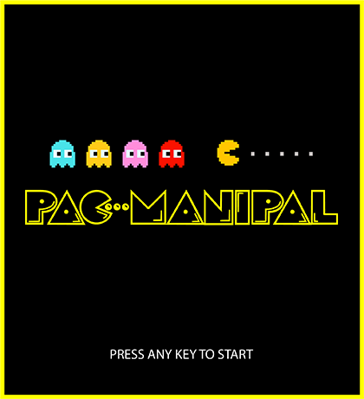

Hardware Interfaces
The only hardware used in this program is Mouse and Keyboard compatible with Windows OS. The program uses them to control the character and browse through the menu.

Software Interfaces
Operating System: Windows
Tools used: Java AWT, Java Swings, Java Forms

IDE Used: NetBeans, Eclipse
Software planning tool: IBM RSA Tools

Communications Interfaces
NO Communication functions are required for this application. It is a standalone application which runs offline.

Functional Requirements
- Player:
  - Movement: User can move the character using arrow keys to escape ghosts and eat pellets.
  - Get score: Score is generated by eating pellets.
  - Can quit game. “Quit” will exit the game.
  - Can reset high-score. An option is given to reset high-score.
- System:
  - Can generate score.
  - Generates Ghost movement randomly.
  - Will reduce one life every time player gets eaten.
  - Update high-score.

Behaviour Requirements

Use Case View
The actors involved in the software are –
1) Player
2) System.
Player:
  - Move using arrow keys.
  - Eat pellets for score.
  - Quit game.
  - Reset high-score.
System:
  - Generate score.
  - Generate Ghost movement randomly.
  - Reduce one life every time player gets eaten.
  - Update high-score.

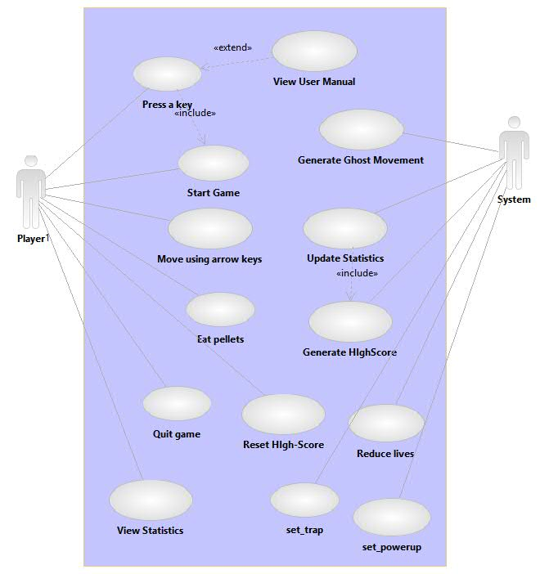

SWIMLANE DIAGRAM and CLASS DIAGRAM have been attached at the end of this document.

Other Non-functional Requirements

Performance Requirements
- User needs to press any key to start.
- There should not be any delay in key input and character movement.
- Character should move in the same direction if no key input is given.
- The system should respond to each user input within 1 second.
- The game must be able to run at 20-30 frames per second on Windows platform OS.

Safety and Security Requirements
- Safety measures: Safety measures need to be taken when playing the game. The contains vivid set of bright colours and effects that may cause damage to eyes if exposed for a lot of time.
- Addiction: User needs to play the game responsibly. Playing the game for long hours can cause addiction.
- Timer: Game automatically closes after 30 minutes to prevent addiction.
- Input Device Damage: Even though the game uses mouse and arrow keys, there still are chances of device damage, where the user needs to handle the devices with care.

Software Quality Attributes
- Usability: Even though a User-Manual is provided, the application is very much easy to understand and is also presented in a simple yet interesting manner.
- Reusability: The components and design used in this application is highly reusable.
- Portability: The same size of the application is the key for Portability. The application is highly portable and can be used anywhere anytime.
- Correctness: The game system is developed in such a way that the input and output will be in great sync.
- Simple: The application is simple with less complex coding techniques used as the application is very light.

Appendix A – Data Dictionary
Yet to update after the coding phase.

Appendix B - Group Log
Total count - 2 meetings.

- Finalized the basic gameplay and name of the product.
- Came up with new ideas like traps and power-ups, and different characters and maps for the game.

