**CS 5343 - HW1**

**Jaehyun Park**

**Github Address : https://github.com/blueed9696/Algorithm_hws.git**

**Q1.**

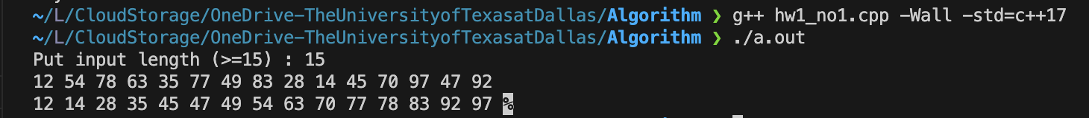

**Q2.**

