**INSTALLATION STEPS**

1. **MONGODB DOWNLOAD**

**STEP 1: Download the MongoDB MSI installer.**

**Link:** <https://www.mongodb.com/download-center/community>

**A screenshot of a cell phone

Description generated with very high confidence**

**STEP 2: Install MongoDB using the Installation wizard and follow the On-Screen instructions**

Select “Run service as Network Service user” and make a note of the data directory

**STEP 3: Create the data folder to store the databases**

Navigate to location where MongoDB folder is installed and then create a data folder

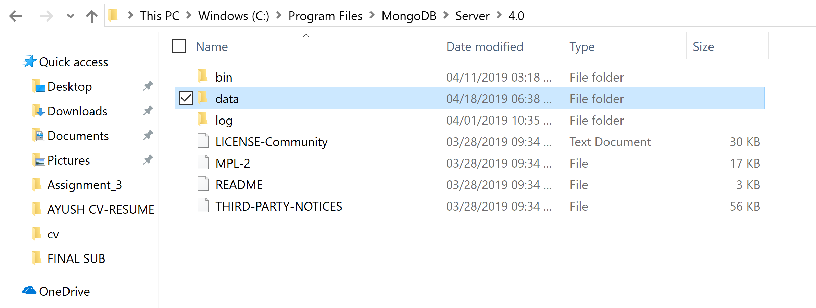

**STEP 4: Verify the setup was successful**

Open the cmd

Traverse to the MongoDB bin

Run mongo command

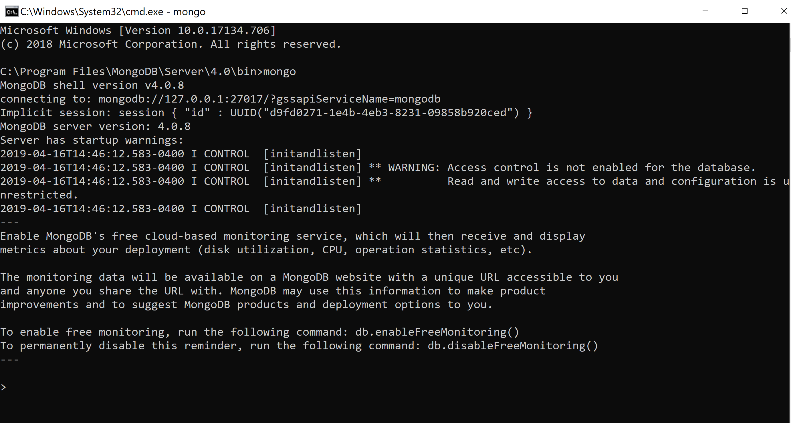

1. **POWER BI**

**STEP 1: Download the Power BI MSI installer and run the installer. Follow the on-screen steps to complete installation.**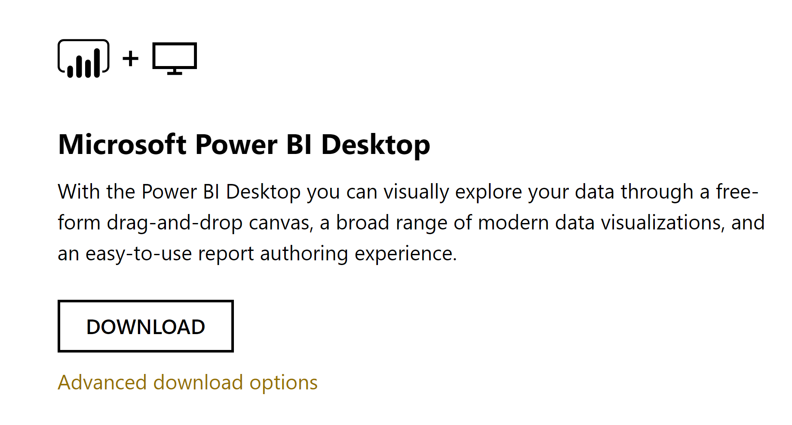

1. **DOWNLOAD ODBC CONNECTOR FOR MONGODB**

**STEP 1: Download the MongoDB ODBC connector for BI from this link:**

<https://www.mongodb.com/blog/post/odbc-driver-for-the-mongodb-connector-for-business-intelligence>



1. **DOWNLOAD MongoDB BI CONNECTOR**

**STEP 1: Download the MongoDB BI connector from this link.**

<https://www.mongodb.com/products/bi-connector>

