ofs文件直连JRemote解决方案

V1.0

|  |  |  |  |
| --- | --- | --- | --- |
| 版本 | 日期 | 描述 | 作者 |
| 1.0 | 2011-08-20 | 文档建立 | 蔡炎华 |
|  |  |  |  |
|  |  |  |  |

## 模块需求：

在WAS上部署一个应用(File2JRemote.war)，该应用的功能是扫描并读取指定的文件夹中的 ofs format的文件，并通过配置相应的JRmote Connection Factory 来连接JRemote, 将文件内容发送到JRemote与其进行交互。如下图：

WAS

T24

jBase_Agent

File2JRemote.war

jca/jRemoteConnectionFactory

OFS文件

## 实现方案：

### File2JRmote.war

编写了监听器、定时器模块和JRemote连接模块。在Web应用加载时便启动监听器，该监听器调用定时器模块去定时扫描文件夹并发送文件内容到JRemote.

注：源码 采用 NETBEANS编写。

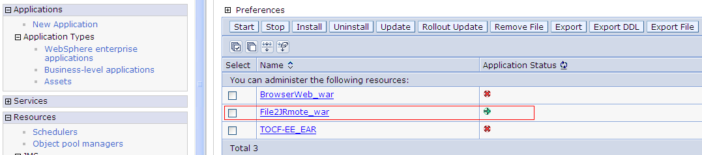

### WAS上的配置

#### [Resource adapters](https://cyhgopc:9043/ibm/console/navigatorCmd.do?forwardName=J2CResourceAdapter.content.main&WSC=true): 安装 jremote-ra.rar

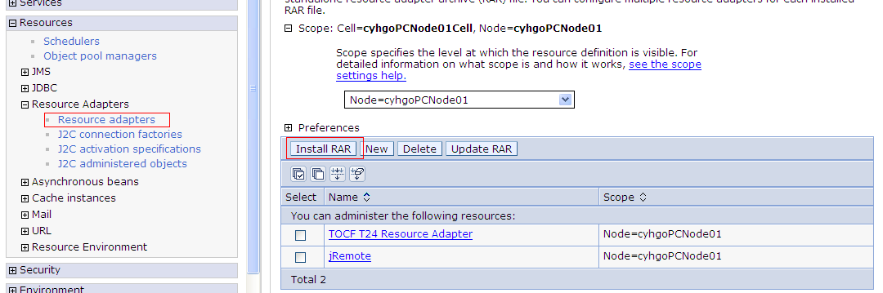

#### [J2C connection factories](https://cyhgopc:9043/ibm/console/navigatorCmd.do?forwardName=J2CConnectionFactory.content.main&WSC=true): 创建 [jRemote Connection factory](https://cyhgopc:9043/ibm/console/j2CConnectionFactoryCollection.do?EditAction=true&refId=J2CConnectionFactory_1311068905453&contextId=cells%3AcyhgoPCNode01Cell%3Anodes%3AcyhgoPCNode01&resourceUri=resources.xml&perspective=tab.configuration)

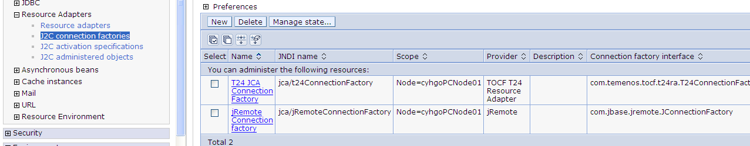

#### [jRemote Connection factory](https://cyhgopc:9043/ibm/console/j2CConnectionFactoryCollection.do?EditAction=true&refId=J2CConnectionFactory_1311068905453&contextId=cells%3AcyhgoPCNode01Cell%3Anodes%3AcyhgoPCNode01&resourceUri=resources.xml&perspective=tab.configuration)：配置 [Custom properties](https://cyhgopc:9043/ibm/console/com.ibm.ws.console.resources.forwardCmd.do?forwardName=J2EEResourceProperty.valueEditable.content.main&sfname=propertySet&resourceUri=resources.xml&parentRefId=J2CConnectionFactory_1311068905453&contextId=cells%3AcyhgoPCNode01Cell%3Anodes%3AcyhgoPCNode01&perspective=tab.configuration)

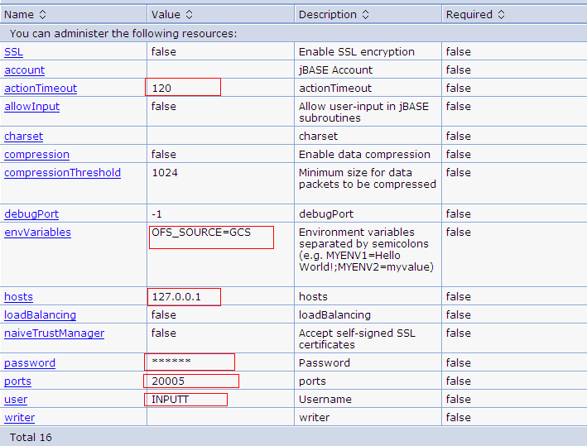

#### [J2C activation specifications](https://cyhgopc:9043/ibm/console/navigatorCmd.do?forwardName=J2CActivationSpec.content.main&WSC=true) 创建[jRemote activation spec](https://cyhgopc:9043/ibm/console/j2CActivationSpecCollection.do?EditAction=true&refId=J2CActivationSpec_1311069175781&contextId=cells%3AcyhgoPCNode01Cell%3Anodes%3AcyhgoPCNode01&resourceUri=resources.xml&perspective=tab.configuration)

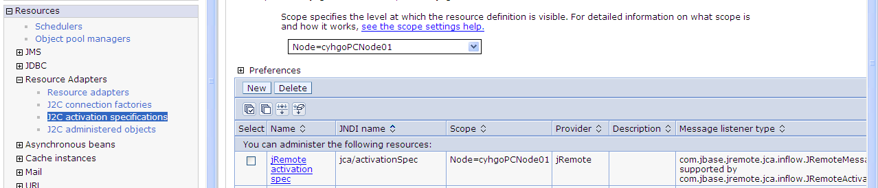

### 启动 JBASE_AGENT ,端口号为20005

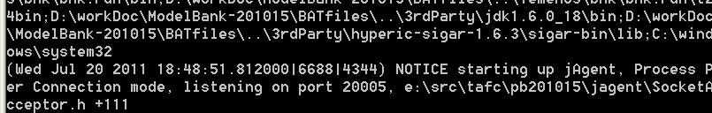

### 建立测试文件夹并放置测试文件

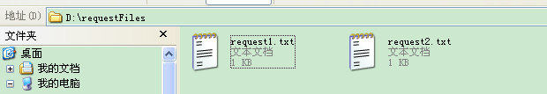

Request1内容如下：

ENQUIRY.SELECT,,INPUTT/123456,CURRENCY-LIST,NUMERIC.CCY.CODE:EQ=32

Request2内容如下：

ACCOUNT,/S,AUTHOR/123123,61069

### 测试结果如下：

D:\IBM\WebSphere\AppServer\profiles\AppSrv01\logs\server1\SystemOut.log 片段

