**RESUME**

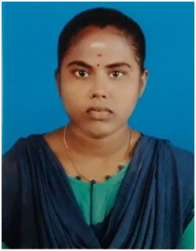

**Phone No: 1234567890**

**Email ID:tharshiniselvam03122003it@gmail.com**

S.THARSHINI

D/O: selvam, 125,

Mahibalanpatti-630203,

Tirupattur-T k,

Sivagangai (DT)

**CAREER OBJECTIVE:**

Seeking a position to utilise my skills and abilities in the INFORMATION TECHNOLOGY field that offers educational growth while being resourceful, innovation and flexible.

**ACADEMIC PERFORMANCE:**

**HIGHER EDUCATION**

* Awarded with 90.8% marks in HR.SEC.SCHOOL, Mahibalanpatti.

**HIGHER SECONDARY EDUCATION:**

* Awarded with 90.7% marks in Siththappa Govt Hr.Sec.School Nerkuppai, Sivaganga DT nerkuppai.

**SKILLS**

* I know basic computer knowledge
* MS office
* C Programming Language
* Python
* Java

**PERSONAL DETAILS**

NAME : S. THARSHINI

DATE OF BIRTH : 03/ 12/ 2003

GENDER : FEMALE

AGE : 19

RELIGION : HINDU

NATIONALITY : INDIAN

LANGUAGES KNOWN : TAMIL,English

MARITAL STATUS : UNMARRIED

**DECLARATION**

I hereby declare that the above given details are true to the best of my knowledge.

YoursFaithfully,

**S.Tharshini**