Insights from tracking a 19 month non-stop flight of a sub-adult common swift

Lyndon Kearsley^{1,5}, Christoph M. Meier⁵, James W. Fox³, Stef Vercauteren⁴, Ann Van Gysel⁴, Koen Hufkens^{1,*}

¹ BlueGreen Labs (bv), Kloetstraat 48, 9120 Melsele, Belgium (orcid: 0000-0002-5070-8109)
² Swiss Ornithological Institute, Seerose 1, 6204 Sempach, Switzerland (orcid: 0000-0001-9584-2339)
³ Migrate Technology Ltd, Cambridge, UK (orcid: 0000-0002-3107-696X)
⁴ Locus Developments bv, Gent, Belgium
⁵ Belgian Ornithological Research Association, Steenweg Hulst-Lessen 29, 9140 Temse, Belgium (orcid: 0000-0003-4526-1872)

*corresponding author

Abstract
We present a 19 months of continuous monitored flight in a combined dataset collected through a Multi-DataLogger (MDL) geolocator on a single sub-adult common swift through serendipitous logging event. The strong correspondence between sub-adult and adult flight patterns, in both migration and overall non-breeding moonlight driven flight strategy, provides indications that this is the result of a genetically fixed trait and the learned experience during a relatively long sub-adult stage of a long-lived species like swifts. Deviations from established moonlight-driven patterns during the breeding season highlight a potential flight response to anthropogenic light sources (sky glow). Our findings refine research avenues with respect to the behaviour of sub-adult swifts in relation to migration strategies and the potential influence of sky glow on (diurnal) foraging strategies.

Keywords: Migration, resource and habitat use, foraging, Apus apus, sky glow, light environment

Introduction
The migration and flight behaviour of sub-adult common swifts (Apus apus) get proportionally less attention than that of adult swifts (Tarburton & Kaiser 2001). This lack of data on sub-adult swifts is mostly limited by their long sub-adult stage, during which time the birds are mostly inaccessible, spending life on the wing. It is therefore challenging to record remote behaviour, outside select sites, mostly requiring the use of proxy methods such as radar tracking or acoustic logging (Dokter et al. 2013, Amichai & Kronfeld-Schor 2019, Nilsson et al. 2019). These proxy methods are invariably short-term and focus on the vicinity of breeding colonies or key observation sites (Tarburton & Kaiser 2001, Dokter et al. 2013, Jukema et al. 2015, Nilsson et al. 2019, Boano et al. 2021).
Recent sensor developments have made the logging of behaviour of swifts over extended periods possible (Liechti et al. 2013, Hedenström 2016, Meier et al. 2018, Kearsley et al. 2022, Hufkens et al. 2023). The size and weight of data loggers and their microelectronics have come down, while new batteries and power saving extend the logging potential significantly. Despite these technological advances, technical challenges remain in both the tagging and particularly recapturing of sub-adult individuals, which makes describing their behaviour across their full annual cycle difficult.
Unless tagged as nest young prior to fledging (see Genton 2010) only the briefest moments allow for the outfitting of sub-adult birds with loggers. Swifts usually rely on natal dispersal rather than breeding dispersal and hence an unringed individual most likely has just arrived from a different colony (Claramunt 2021), although some juveniles return to their original colony (Genton 2010). In the past, tagging chicks has been mostly unsuccessful, and sub-adults also attend the colony rarely (e.g. 10% recapture rate in the Swiss population, unpublished data by Meier). The only other possibility is to catch them during displaying behaviour, called "banging", outside of the colony with a net (Lack & Lack 1951, Boano et al. 2021).
Here, we present a 19 months of continuous monitored flight in a combined dataset collected through a Multi-Sensor geolocator on a single “banging” sub-adult Common swift (CC894, ring number N21196, see Table 1). We analyse the behaviour of this sub-adult swift, in relation to adult behaviour, observed at the same colony such as: the flight track, timing, flight altitude and environmental light responses.

Methods
Four adults and one (post-hoc determined) sub-adult common swift (Apus apus) were outfitted in the summer of 2021 (Table 1) with a Multisensor Data Logger (MDL; Intigeo-CAR, Migrate Technology Ltd, Cambridge, UK; CAR: ~0.42 g including harness, ~18 x 6 x 4.3 mm) from a colony comprised of 20 nest boxes installed in a modern housing development (51.08°N, 3.73°E) along a dockside in the Ghent Voorhaven, Belgium (https://swifts.be/) during an ongoing ringing program (see ethical statement). Control group return rates: 15 ring only, of which 7 returned (47%), overall 18 out of 31 ringed or otherwise logged returned (58%) of which 7 out of 9 MDL sensor-logged birds returned (78%).
The sub-adult swift, with no fixed nest spot yet, was captured by mist net when “banging” in front of a nest box and assumed to be an unringed individual of the breeding pair. The particular group of MDL sensors logged light levels, pressure and temperature, and activity (Table 1). Light intensity data was logged at five-minute intervals while other variables were recorded every 30 minutes. Data were logged for one or two seasons for the breeding adults and almost two continuous seasons for the sub-adult non-breeder (2021 to 2023). For simplicity, but despite the sub-adult not having a formal breeding season, we will refer to the time spent near the breeding location of adult swifts as the breeding season throughout the manuscript. Data were recorded until the memory was full, the battery depleted and/or the logger recovered. Logger deployment and recovery followed the protocol used in previous campaigns (Kearsley et al. 2022, Hufkens et al. 2023). We avoided breeding disturbance through limited deployment catches late in the season. We used a full body harness with a 1mm wide flat braided soft terylene cord to avoid abrasion. The geolocators data were retrieved upon first recovery, i.e. one year for the adult birds and after two years when the sub-adult swift had succeeded in finding a breeding location and partner in the colony. All tagged swifts were examined upon recapture and no visible abrasion or skin damage was observed.

Data pre-processing

Location
All data were downloaded from the loggers and the approximate locations were determined using geolocation by light (Lisovski & Hahn 2012) following Hufkens et al. (2023). Clock drift was addressed by correcting the difference between the on-board clock of the tag and a reference time in a linear manner. Light data were log-transformed and the first and the last light value of the day above the threshold (log(1.5)) was used to assign sun rise, and sun set times, respectively. Loggers were outfitted close to migration periods which did not allow for in-situ sensor calibration of the sun-angle. We used sun-angles determined by comparing derived positions with known GPS-based locations and published literature on other individuals at the same colony (see Hufkens et al. 2023). Location estimates were clustered in stationary and migration periods using a breakpoint analysis (i.e. the changeLight function in {GeoLight}, with the quantile parameter set to 0.9). We calculated the median longitude and latitude across a stationary cluster of dates to best approximate a swift’s location during that time (25th and 75th percentiles are used to map uncertainties). Beforehand, outliers were removed using geographic constraints with limits of -33° to 53° latitude, and -18° to 42° longitude.

Sun and Moon parameters
Daytime was defined as values with a sun angle above 0 degrees (above the horizon). Twilight was specified as times where the sun angle is between 0 degrees to 12 degrees below the horizon (the beginning and the end of nautical twilight) on the sun’s rising or setting direction, respectively. The remaining times were nighttime. We used MDL loggers’ median positions per stationary cluster (Figure 1) to calculate the moon illuminance values (see Hufkens et al. 2023).

Altitude and flight height
The MDL atmospheric pressure recorded was converted to altitude (in m) using the international standard atmosphere (International Organizations for Standardization ISO 2533:1975, Hedenström et al. 2022). MDL pressure data was joined with the corresponding daily location estimates. We calculated flight heights above ground level by subtracting the mean daytime altitudes on a day-by-day basis. We assumed relatively stable flights during this period, see Dokter et al. (2013) and Kearsley et al. (2022). This method retains absolute diurnal altitude differences as a proxy for true flight heights, but might at times give rise to negative flight heights.

Sky illuminance & sky glow
To assess the influence of light pollution and sky glow we downloaded night sky illuminance values from estimates of night sky brightness by Falchi et al. (2016), buffering the extraction with a radius of 65 km (or the standard deviation around the summertime positions as estimated by light levels) around the Ghent Voorhaven site. This clear sky illuminance value was converted to lux, following Kyba et al. (2017). Cloudiness can increase sky glow and local sky brightness by orders of magnitude (Kyba et al. 2011, Jechow et al. 2017). We therefore used ERA5-land climate reanalysis data (Muñoz-Sabater et al. 2021) to estimate total cloud cover (as a fraction, 0 - 1) during the 2022 breeding season around the colony. We approximate the effect of cloud cover using an approximate ten-fold (10) multiplier on sky illuminance linearly scaled by cloud cover fractions (see Kyba et al. 2011).

Statistics
We divide our dataset into two distinct periods. First, a non-breeding season, which is broadly understood to be time spent across and travelling to and through the African continent, including migration movements between relatively stationary stop-over locations. Second, a breeding season, when swifts return to their colony in Western Europe. Seasonal migration happens between the breeding and non-breeding season. We calculate and visualize inactive periods broadly following Liechti et al. (2013) using the combined metric of low activity (<10) and a negative flight height (< 0 m) flight height as indicative of roosting. Negative flight heights indicate a lower than average daytime flight, and are dependent on the flight height distribution during the day.
We visually compare the migration dynamics of adults and the sub-adult, and calculate the distances between adult and sub-adult non-breeding season stop-over locations. In addition, we calculate the minimum distance between stop-over locations, year-on-year for the sub-adult swifts. We summarise sub-adult daily flight height dynamics and compare them to known behaviour of adults in the same colony (Table 1, see Hufkens et al. 2023). We describe flight responses in relation to the nighttime light environment across the breeding and non-breeding season, under natural and anthropogenic light environments (i.e. sky glow). It has been shown that moonlight can trigger behaviour (flight height) in the non-breeding season (Hedenström et al. 2022, Hufkens et al. 2023). We therefore hypothesise that a similar response might exist during the breeding season, as shown for nightjars (Evens et al. 2023) and swifts (Amichai & Kronfeld-Schor 2019). We fit an inverse exponential curve relating moonlight illuminance (in lux) to observed flight height during the non-breeding season. This relationship allows us to estimate maximum flight heights for a given sky illuminance value (lux). For both periods we calculate the median flight height by time-of-day (hour from midnight). A similar calculation is made for the sub-adult’s non-breeding season, taking into account the combined natural and anthropogenic light pollution induced sky glow (in lux).
We report summary statistics for daytime, nighttime and twilight periods. Moonlight responses of both the sub-adult and adults are compared to nighttime flight heights in response to sky glow during the breeding season.
All statistics were carried out in R (R Core Team 2023) where visualisations were supported by the ‘terra’, ‘sf’, ‘tidyverse’, ‘patchwork’, ‘ggtext’ packages (Wickham 2017, Pebesma 2018, Pedersen 2022, Wilke 2022, Hijmans 2025).

Results
The swift CC894 is assumed to be at least one year old, but sub-adult, as it did not find a nesting spot during the logging period. Swift CC894 returned to the colony and briefly was established in a nest box (camera box 2) around the 25th of May 2023, as visually confirmed by video feed and sexed as female (copulation, egg laying), before subsequent logger retrieval. The logger on swift CC894 telemetry showed that logging started on the preset start date (2021-07-10) and the battery remained functional and holding charge until retrieval (2023-06-11), running ~25 months, yet exhausting the logger memory for both light level and ancillary measurements. Light and pressure data did not suggest roosting at a nest (box) during the day or night, showing vastly insufficient roosting opportunities to foster a brood. Across the whole logging period only a total of ~48 hours scattered across the whole logging period of >12 000 hours are flagged as potentially inactive, this in contrast to well defined inactive roosting periods for breeding adult swifts (Appendix Figure S1).
Swift CC894 followed a similar flight patterns to adults in the colony when migrating to foraging sites in Eastern Africa, passing briefly through Western Africa and skirting the gulf of Guinea to pass south of the Congo Basin to the coastline of Malawi and Mozambique (Figure 1a, Hufkens et al. 2023). During this trip the swift made several stop-overs. Stop-overs were more common in Eastern Africa than those in Western Africa. Average distances between the sub-adult and adult stop-overs registered to be in the low hundreds of kilometers (303 ± 108 km). Swift CC894 showed great site fidelity between the two observed years, returning to within a hundred kilometres (~129 km) from previously visited final (furthest) foraging locations in eastern Mozambique, year-on-year (see Figure 1a).
A comparison of diurnal flight behaviour during the non-breeding and breeding season showed distinct differences (Figure 1b). During the non-breeding season differences in average daily flight altitude or flight heights are limited. However, during the breeding season twilight flights remain present but are lower in absolute altitude (i.e. due to the terrain) but higher in flight height (i.e. due to a larger diurnal change) than during the non-breeding season. We also note the lower altitudes during daytime for sub-adults than adults (Appendix Figure S3). In short, during the day non-breeding season flights are higher in baseline altitude than those during the breeding season for sub-adults (Appendix Figure S2), while roosting behaviour in adult birds (see Appendix Figure S1) is shown by negative flight heights.
During the non-breeding season the sub-adult swift followed the established diurnal pattern of moonlight induced flight height changes of adults, with high flights in response to moonlit night times (Figure 1b). Increased flight heights were recorded in response to sky brightness values as low as 0.02 - 0.05 lux, translating to a modelled flight height of ~850 m (Figure 2c, with C = 854 (17 Std. Error), k = -65 (5 Std. Error)). Moonlight-driven flight patterns were not observed in sub-adults during the breeding season, with no characteristic asymmetry in flight height, following the moon phases, as observed during the non-breeding season (Figure 1b).
We note that during the breeding season swifts residing around Ghent, Belgium, are exposed to high sky glow values of up to ~0.12 lux (Figure 2d). Night sky brightness data (Falchi et al. 2016) show 31% of the values during the breeding season exceeding the 0.1 lux on cloudy nights, as 55% of the time the mean nighttime cloud cover exceeded 50% (Figure 2d). During ambient illuminance values exceeding ~0.1 lux will trigger a maximum flight height response during moonlit nights (Figure 2b). As such, maximum flight heights under extensive Belgian sky glow (Appendix Figure S3) show correspondence to moonlight responses (Figure 2c). A comparative analysis for a location in Southern Sweden (Lund) during the non-breeding season did not allow us to differentiate sub-adult flight behaviour based on previous radar studies. Although at Lund light pollution and sky glow is lower (at ~0.009 lux and ~0.098 lux, respectively) and high latitude summer nights are brighter with most only reaching nautically twilight with illuminance values varying from 0.008 lux to 2 (Appendix Figure S4). Illuminance values exceeding 0.01 lux are sufficient to trigger an ascending flight, when based on moonlight behaviour during the non-breeding season (Figure 2b).

Discussion and conclusion
Our serendipitous logging of a single sub-adult common swift provided us with critical insights into their year-round pre-breeding flight behaviour. Our results show consistency in behaviour with respect to where swift CC894 forages during the non-breeding season. The behaviour, both in the preference of spatial foraging locations and the vertical use of the airspace correspond to those observed in other adults.
The sub-adult swift follows adult tracks and well established flyways using stop-overs in Western Africa before migrating to Central and Eastern Africa where they spend the majority of their time (Åkesson et al. 2012, Hedenström 2016). The presence of explicit twilight ascents during the non-breeding season has previously been linked to social interaction or orientation (Dokter et al. 2013, Meier et al. 2018). This pattern remains present and consistent for the sub-adult swift. Moonlight-driven ascending flights as described for the common and black swift (Hedenström et al. 2022, Hufkens et al. 2023) are also confirmed for the sub-adult, with patterns consistent with adults of the same colony across multiple seasons (Figure 1b).
Unlike the adult swifts during the breeding season, the sub-adult swift spent its time on the wing across Belgium and the Netherlands showing no nighttime roosting behaviour by landing or entering a nest chamber (Appendix Figure S1). We note that flights for sub-adults during daytime are lower than those of adults, in line with previously observed behaviour of low flying screaming parties (Henningsson et al. 2009). The absence of any twilight ascents for adults suggests that twilight activity during the breeding season is mainly driven by sub-adults. Sub-adult swift twilight ascents during the non-breeding season also show higher relative altitude gains. Similar twilight ascending behaviour has been shown in sub-adult swifts along the “Afsluitdijk” in the Netherlands and near Lund Sweden, by Dokter et al. (2013) and Nilsson et al. (2019), respectively. We did not find any evidence of moonlight mediated ascending nighttime flights, as the characteristic asymmetric response across moon phases was missing (Figure 1b). Comparison with radar-based observations showed a similar response, with high nighttime flights. We speculated that recently described moonlight-driven ascending behaviour of adult swifts (Hedenström et al. 2022, Hufkens et al. 2023) could translate to the sub-adult swift CC894 during (bright) summer nights if solely driven by environmental illuminance levels.
Research on nightjars has shown that foraging is extended under a bright light polluted sky dominated by sky glow (Evens et al. 2023). Nighttime foraging of breeding pairs has also been observed in the common swift under bright artificial lights (Amichai & Kronfeld-Schor 2019). The Belgian light environment could provide a trigger for high nighttime flights as otherwise observed in response to moonlit nights during the non-breeding season. We could not invalidate this theory as data by Nilsson et al. (2019) or Dokter et al. (2013) were equally influenced by either bright summer “white nights” or the presence of profound levels of light pollution around Belgium and the Netherlands. For example, only three out of six observed nights in Nilsson et al (2019) are nautically dark, and only one briefly being astronomically dark in early September (Appendix Figure 1). Both sites, although showing different light environment causes, are not sufficiently different in overall nighttime light environment to contrast behavioural responses. To fully test the hypothesis and isolate a contrasting moonlight-driven response, additional data from a dark (more southerly) colony would be needed.
We acknowledge that our data is limited to a single individual. Yet, it opens the discussion on the influence of the light environment (and light pollution) on the flight and foraging behaviour of sub-adult or otherwise non-nest-bound swifts, within the context of light-driven flight responses during the remainder of the year (Amichai & Kronfeld-Schor 2019, Hedenström et al. 2022, Hufkens et al. 2023).
The strong correspondence between sub-adult and adult flight patterns, both in migration and overall non-breeding flight strategy, provides indications that this is the result of a genetically fixed trait and a learned experience during a relatively long sub-adult stage for a long-lived species like swifts. We speculate that the short summer nights (with no nights being truly astronomically dark) and/or the presence of sky glow due to light pollution might influence sub-adult flight behaviour, in line with nighttime activity observed during the remainder of the season. Our data confirms previously observed flight behaviour but provides a larger continuous multi-year context, amending partial observations of (sub-)adult flight behaviour through radar or radio observations. This continuous track confirms consistency in recorded patterns throughout the whole life stage and points to interesting new research avenues for biologging with respect to the behaviour of sub-adult swifts in relation to migration behaviour and responses to their light environment.

Acknowledgements
We are grateful for the support by Migrate Technology Ltd for providing novel prototype multi-sensor data loggers in a research and development collaboration.

Ethics
For research at the Gent Voorhaven site, the licence was issued by the Agency for Nature and Forest, Belgium (Flanders) number ANB/BL-FF/VERG/11-00316.

Data and code
The manuscript’s data supporting our findings is made available on Github at: https://bluegreen-labs.github.io/swift_CC894/ with a matching Zenodo
repository: https://doi.org/10.5281/zenodo.16043153 under CC-BY 4.0 and ODbL 1.0 licences.

Funding
Migrate Technology Ltd provided assistance in the form of a research and development collaboration, covering design and trials of the prototype of the current Intigeo-BAR and CAR multi-sensor loggers.

References
Åkesson, S., Klaassen, R., Holmgren, J., Fox, J.W. & Hedenström, A. 2012. Migration Routes and Strategies in a Highly Aerial Migrant, the Common Swift Apus apus, Revealed by Light-Level Geolocators. PLoS ONE 7: e41195.
Amichai, E. & Kronfeld-Schor, N. 2019. Artificial Light at Night Promotes Activity Throughout the Night in Nesting Common Swifts (Apus apus). Sci Rep 9: 11052.
Boano, G., Casola, D., Cucco, M., Ferri, M., Micheloni, P., Manica, M. & Pellegrino, I. 2021. Onset of primary moult in immature and breeding adult Common Swifts Apus apus. Ringing & Migration 36: 116–122.
Claramunt, S. 2021. Flight efficiency explains differences in natal dispersal distances in birds. Ecology 102: e03442.
Dokter, A.M., Åkesson, S., Beekhuis, H., Bouten, W., Buurma, L., van Gasteren, H. & Holleman, I. 2013. Twilight ascents by common swifts, Apus apus, at dawn and dusk: acquisition of orientation cues? Animal Behaviour 85: 545–552.
Evens, R., Lathouwers, M., Pradervand, J.-N., Jechow, A., Kyba, C.C.M., Shatwell, T., Jacot, A., Ulenaers, E., Kempenaers, B. & Eens, M. 2023. Skyglow relieves a crepuscular bird from visual constraints on being active. Science of The Total Environment 900: 165760.
Falchi, F., Cinzano, P., Duriscoe, D., Kyba, C.C.M., Elvidge, C.D., Baugh, K., Portnov, B.A., Rybnikova, N.A. & Furgoni, R. 2016. The new world atlas of artificial night sky brightness. Sci. Adv. 2: e1600377.
Genton, B. 2010. Chronologie comportementale du martinet noir apus apus sur un site de reproduction. Nos Oiseaux 57: 243–264.
Hedenström, A. 2016. Annual 10-Month Aerial Life Phase in the Common Swift Apus apus. Current Biology 26: 3066–3070.
Hedenström, A., Sparks, R.A., Norevik, G., Woolley, C., Levandoski, G.J. & Åkesson, S. 2022. Moonlight drives nocturnal vertical flight dynamics in black swifts. Current Biology 32: 1875-1881.e3.
Henningsson, P., Karlsson, H., Bäckman, J., Alerstam, T. & Hedenström, A. 2009. Flight speeds of swifts ( Apus apus ): seasonal differences smaller than expected. Proc. R. Soc. B 276: 2395–2401.
Hijmans, R.J. 2025. terra: Spatial Data Analysis.
Hufkens, K., Meier, C.M., Evens, R., Paredes, J.A., Karaardiç, H., Vercauteren, S., Gysel, A.V., Fox, J.W., Pacheco, C.M., Silva, L.P. da, Fernandes, S., Henriques, P., Elias, G., Costa, L.T., Poot, M. & Kearsley, L. 2023. Evaluating the effects of moonlight on the vertical flight profiles of three western palaearctic swifts. Proceedings of the Royal Society B: Biological Sciences 290.
Jechow, A., Kolláth, Z., Ribas, S.J., Spoelstra, H., Hölker, F. & Kyba, C.C.M. 2017. Imaging and mapping the impact of clouds on skyglow with all-sky photometry. Sci Rep 7: 6741.
Jukema, J., Van De Wetering, H. & Klaassen, R.H.G. 2015. Primary moult in non-breeding second-calendar-year Swifts Apus apus during summer in Europe. Ringing & Migration 30: 1–6.
Kearsley, L., Ranc, N., Meier, C.M., Pacheco, C.M., Henriques, P., Elias, G., Poot, M., Williams, A., Costa, L.T., Helsen, P. & Hufkens, K. 2022. The aeroecology of atmospheric convergence zones: the case of pallid swifts. Oikos, doi: 10.1111/oik.08594.
Kyba, C.C.M., Mohar, A. & Posch, T. 2017. How bright is moonlight? Astronomy & Geophysics 58: 1.31-1.32.
Kyba, C.C.M., Ruhtz, T., Fischer, J. & Hölker, F. 2011. Cloud Coverage Acts as an Amplifier for Ecological Light Pollution in Urban Ecosystems. PLoS ONE 6: e17307.
Lack, D. & Lack, E. 1951. THE BREEDING BIOLOGY OF THE SWIFT APUS APUS. Ibis 93: 501–546.
Liechti, F., Witvliet, W., Weber, R. & Bächler, E. 2013. First evidence of a 200-day non-stop flight in a bird. Nature Communications 4: 2554.
Lisovski, S. & Hahn, S. 2012. GeoLight - processing and analysing light-based geolocator data in R. Methods Ecol Evol 3: 1055–1059.
Meier, C.M., Karaardıç, H., Aymí, R., Peev, S.G., Bächler, E., Weber, R., Witvliet, W. & Liechti, F. 2018. What makes Alpine swift ascend at twilight? Novel geolocators reveal year-round flight behaviour. Behav Ecol Sociobiol 72: 45.
Muñoz-Sabater, J., Dutra, E., Agustí-Panareda, A., Albergel, C., Arduini, G., Balsamo, G., Boussetta, S., Choulga, M., Harrigan, S., Hersbach, H., Martens, B., Miralles, D.G., Piles, M., Rodríguez-Fernández, N.J., Zsoter, E., Buontempo, C. & Thépaut, J.-N. 2021. ERA5-Land: a state-of-the-art global reanalysis dataset for land applications. Earth Syst. Sci. Data 13: 4349–4383.
Nilsson, C., Bäckman, J. & Dokter, A.M. 2019. Flocking behaviour in the twilight ascents of Common Swifts Apus apus. Ibis 161: 674–678.
Pebesma, E. 2018. Simple Features for R: Standardized Support for Spatial Vector Data. The R Journal 10: 439–446.
Pedersen, T.L. 2022. patchwork: The Composer of Plots. Available at: https://cran.r-project.org/web/packages/patchwork/index.html.
R Core Team. 2023. R: A Language and Environment for Statistical Computing. R Foundation for Statistical Computing, Vienna, Austria.
Tarburton, M.K. & Kaiser, E. 2001. Do fledgling and pre-breeding Common Swifts Apus apus take part in aerial roosting? An answer from a radiotracking experiment. Ibis 143: 255–263.
Wickham, H. 2017. tidyverse: Easily Install and Load the ‘Tidyverse’.
Wilke, C.O. 2022. ggtext: Improved text rendering support for ggplot2. Available at: https://cran.r-project.org/web/packages/ggtext/index.html.

Figures
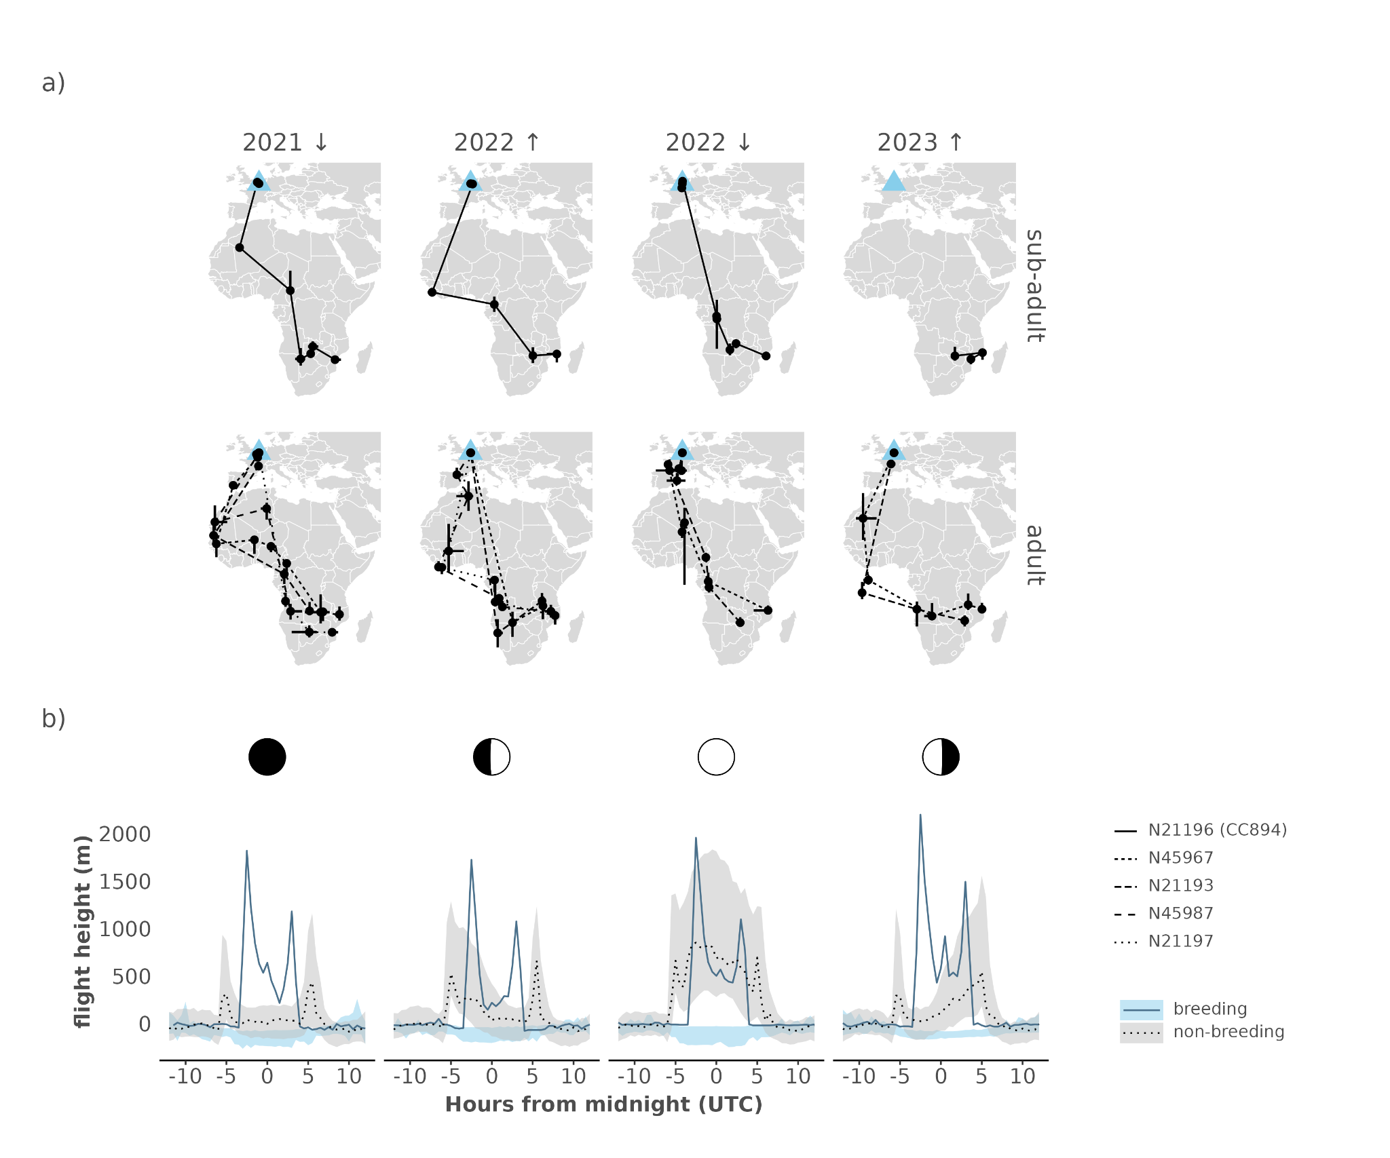
Figure 1. Overview panel plot showing: a) the flight path of the common swifts (Apus apus) from Ghent Voorhaven including the sub-adult CC894 (N21196, top panels) and four adult swifts (top panels) as derived from MDL geolocator data during two consecutive seasons (2021 - 2022 and 2022 - 2023). The general movement of the flight path is indicated by arrows (↑↓) Geolocator based locations were clustered using a breakpoint analysis dividing migration and stationary periods, and only stationary periods were retained and shown as full circles ( ). Error bars showing quantiles around the median position for every cluster. The originating colony at the Ghent Voorhaven site is marked with a large light blue triangle. Locations outside the mapping domain around the equinoxes were removed. b) The diurnal flight height (normalized altitudes in m, relative to daytime mean values) dynamics, centered on midnight, for both sub-adult and adults swifts according to moon phases (from left to right: new moon, first quarter, full moon and last quarter as indicated by icons). Adult flight dynamics are shown as ribbon plots bounded by the 25th and 75th quantile of the flight height across all individuals. Median flight responses for the sub-adult CC894 are shown as a single full or dotted line, for the breeding and non-breeding season, respectively. Note the overlap between moonlight-driven flight height responses during the non-breeding season for both adults and the sub-adult (see Hufkens et al. 2022). During the breeding season this correspondence in adult swifts is lacking, as well as the typical asymmetrical flight height patterns in response to moon phases.

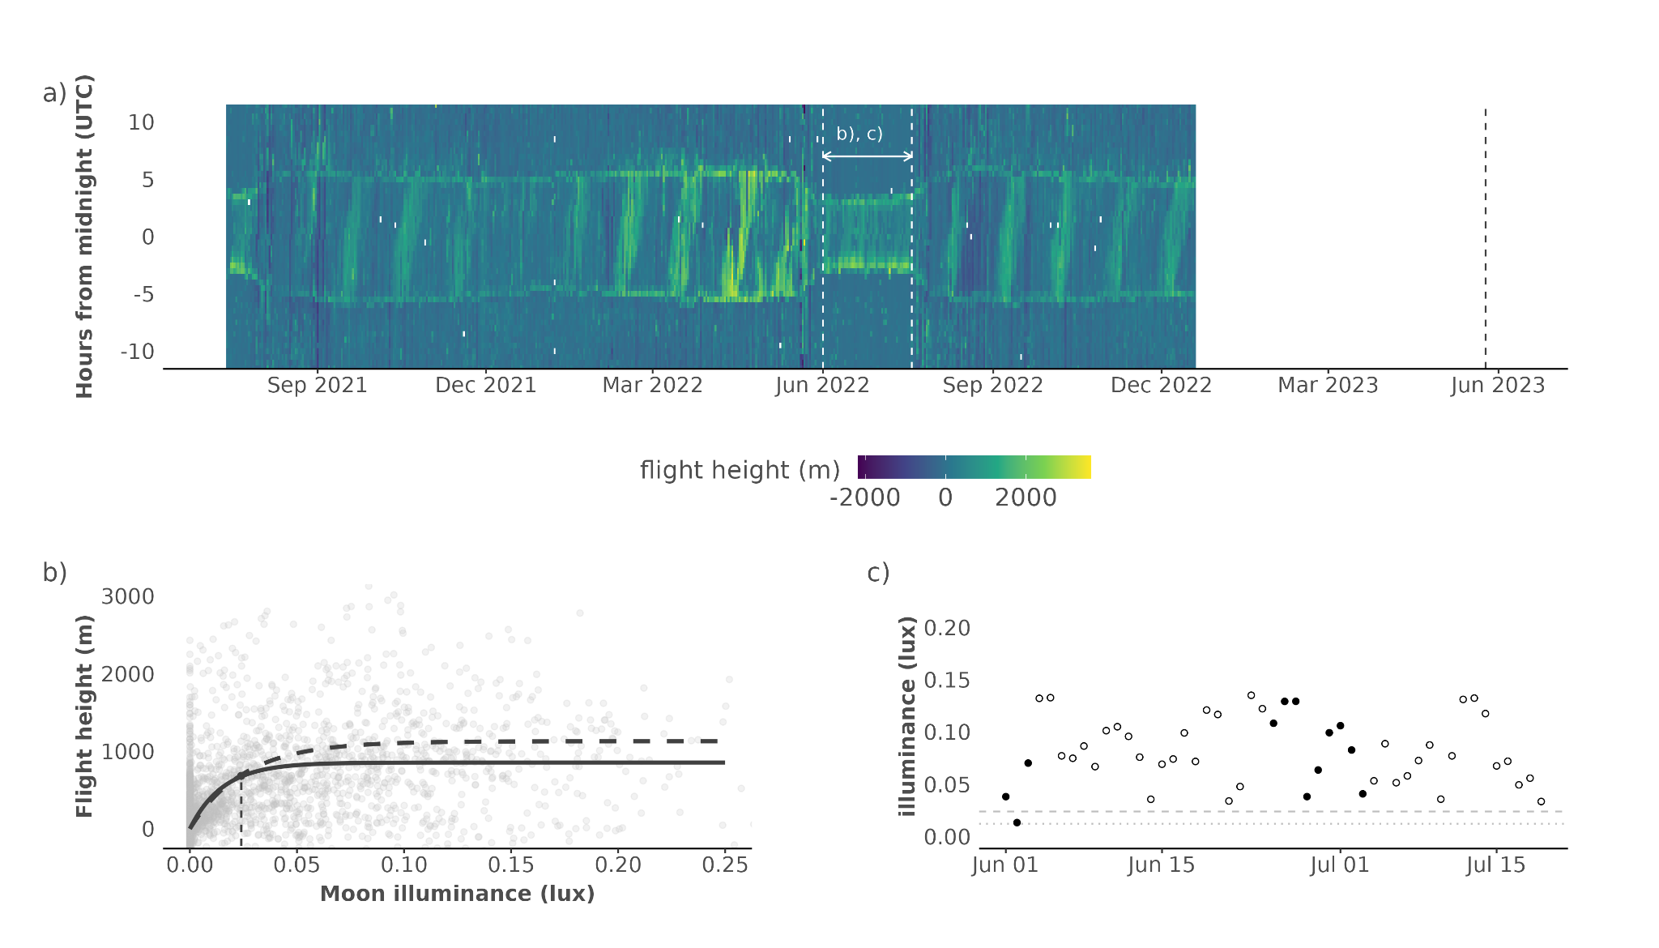
Figure 2. Overview plot of the flight dynamics during the 25 month journey of sub-adult common swift (Apus apus) CC894 (ring N21196). We show a) the raw actogram of flight height changes using normalized altitudes (m) relative to daytime mean values with a dashed vertical line marking the logger retrieval date, b) the non-breeding season moonlight driven flight height changes, c) and the changes in sky glow due to cloud cover, relative to a fixed site based light pollution baseline (dotted line) across the breeding season. Nighttime moonlight driven flight responses in (b), for adult swifts and sub-adult swift CC894, are fitted using an inverse exponential fit for months October to May and shown as dashed and full lines, respectively. The expected flight heights from model fits for a reference value of 80% of the asymptote (dashed vertical line), or maximum flight height, is highlighted with dotted vertical line. The sub-adult modelled 80% maximum flight height illuminance level is marked as a horizontal dashed line in (c), with new moon values marked as closed black circles ( ), linking exceeding this reference value with increased flight heights during the breeding season.

Tables
Table 1. Overview table of the Multisensor Data Logger (MDL) meta-data. We report the logger tag number, the sun angle used in geolocation calculations, the start and end date defining the maximum available data or the recapture date (whichever comes first). Adult birds which were logged twice are highlighted in bold text. Tag CC874 does not have activity data.
Age | Ring | Tag | Season(s) | Sun angle | Start  date | End  date
Adult | N45987 | CC893 | 2021 | -5 | 2021-07-30 | 2022-06-17
Adult | N21197 | CC895 | 2021 | -5 | 2021-07-10 | 2022-06-18
Adult | N45967 | CC896 | 2021 | -7 | 2021-06-25 | 2022-07-22
Adult | N21193 | CC874 | 2021 | -6 | 2021-07-10 | 2022-06-18
Adult | N45967 | CH767 | 2022 | -5.5 | 2022-07-22 | 2023-06-11
Adult | N21193 | CH766 | 2022 | -4 | 2022-07-22 | 2023-06-11
Sub-adult | N21196 | CC894 | 2021 - 2022 | -3 | 2021-07-10 | 2023-06-11

Appendix
We calculated the altitude (z) from pressure values using the international standard atmosphere (International Organizations for Standardization ISO 2533:1975) which is defined as:
Eq. 1
With T₀ the temperature at sea level (288.15 K), L the temperature lapse rate (-0.0065° K m⁻¹), P₀ the standard atmospheric pressure at sea level (1013.25 hPa), P the measured air pressure (hPa), g the gravitational acceleration (9.81 m s⁻¹) and R₀ the universal gas constant (287.053 J kg⁻¹ K⁻¹).

Light pollution processing
The returned values from Fachi et al. (2019) in candella (mcd/m²) are converted to approximate values in lux using the approximation of I = π * (L * 0.001), where I is illuminance in candella and L is zenith luminance following Kyba et al. (2017).
Data are further scaled to sky glow using a fixed ten-fold multiplier scaled by ERA5-land cloud cover fraction (0 - 1). To assess the influence of light pollution around the Belgian nesting colony we compare the maximum value in a 5 km radius around the colony with data collected in a region with lower light pollution levels. We used the location used in the assessment of nighttime sub-adult flight behaviour as described in the radar study of Nilsson et al. (2019) and extracted sky brightness values in a 5 km radius, corresponding to the radar footprint. In addition, we calculate the solar angle (per minute) for the six days on which radar data were recorded. Total nighttime per day was calculated as the time with sun elevations below -12 degrees.

Modelled illuminance responses
Flight height responses in relation to changing moon illuminance values were modelled using an ordinary nonlinear least-squares method and an asymptotic exponential model of the form, flight height = C * (1 - e^{k * illuminance}). Where C is the maximum (asymptotic) flight height and k modules an exponential response to illuminance (either natural or anthropogenic). Parameter values were constrained between -2000 and 4000 m for the maximum (asymptotic) flight height C and between -Inf and 0 for the exponential factor k. Only flight height values between October and May during nighttime (excluding all twilight phases), not marked as migratory movements, were considered.

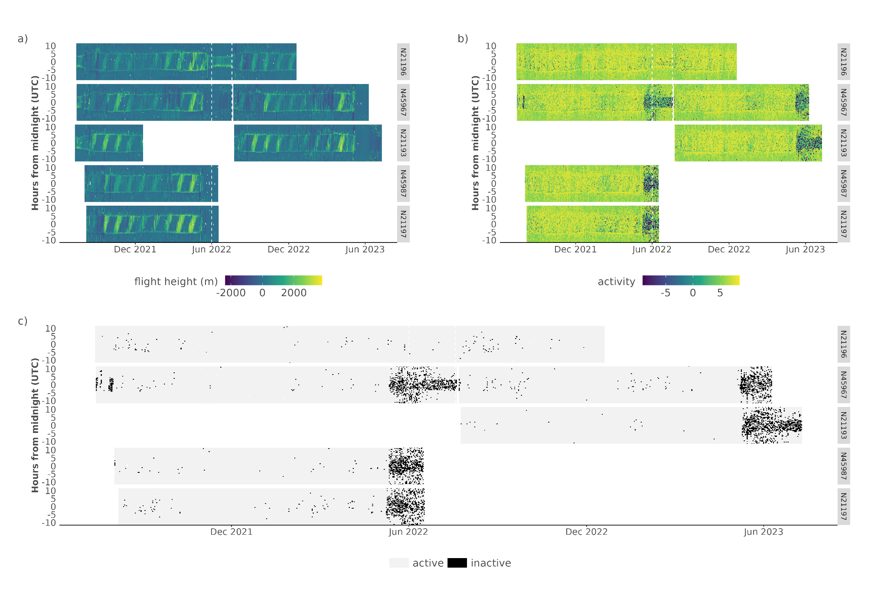
Figure S1. Actograms of all tagged swifts showing both flight height (normalized altitudes relative to daytime flights) a) and registered log transformed activity values b) and approximate indications of active or inactive behaviour for times where flight heights are negative (below the daytime mean) and activity is lower than 10 (on a scale of 0 to ~5000). Multiple birds have been logged with different tags (but the same ring number) are here plotted on the same time axis (see Table 1). The swift with tag CC894 (ring N21196) is shown in the top panel of each subplot. We note the differences in both the flight height dynamics and activity values between N21196 and more stationary breeding birds (as shown by darker activity values).

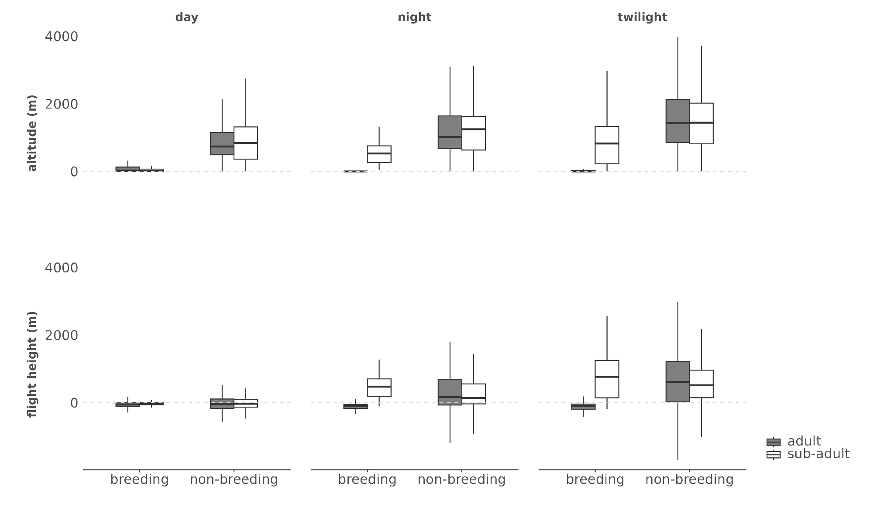
Figure S2. Boxplots of flight altitudes and flight heights according to day, night and twilight periods for both adult and sub-adults swifts. General correspondence between adults and sub-adults is seen during the non-breeding season in the altitude and flight heights. We note marked changes in nighttime patterns due to the roosting of adult swifts during the breeding season. We also note a decrease in flight altitudes relative to the non-breeding season, while flight heights for the sub-adults remain similar. In short, baseline flight altitude values (a reference to calculate flight heights) during daytime are higher as seen in the top left panel.

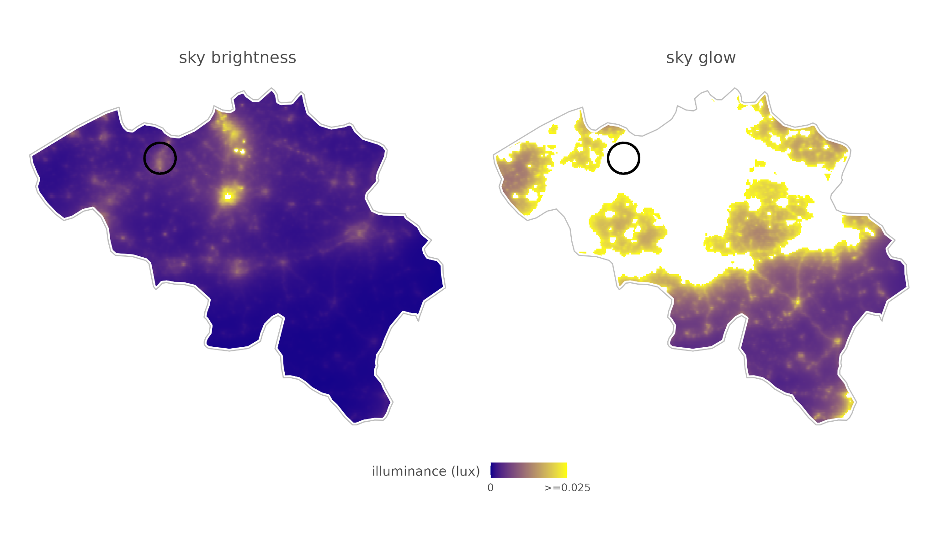
Figure S3. Sky brightness and sky glow values (10x sky brightness) under cloud cover for Belgium (in lux). The Ghent harbor colony and general surroundings is marked with an open round circle. Sky glow values in white exceed the threshold triggering an increased light driven flight response.

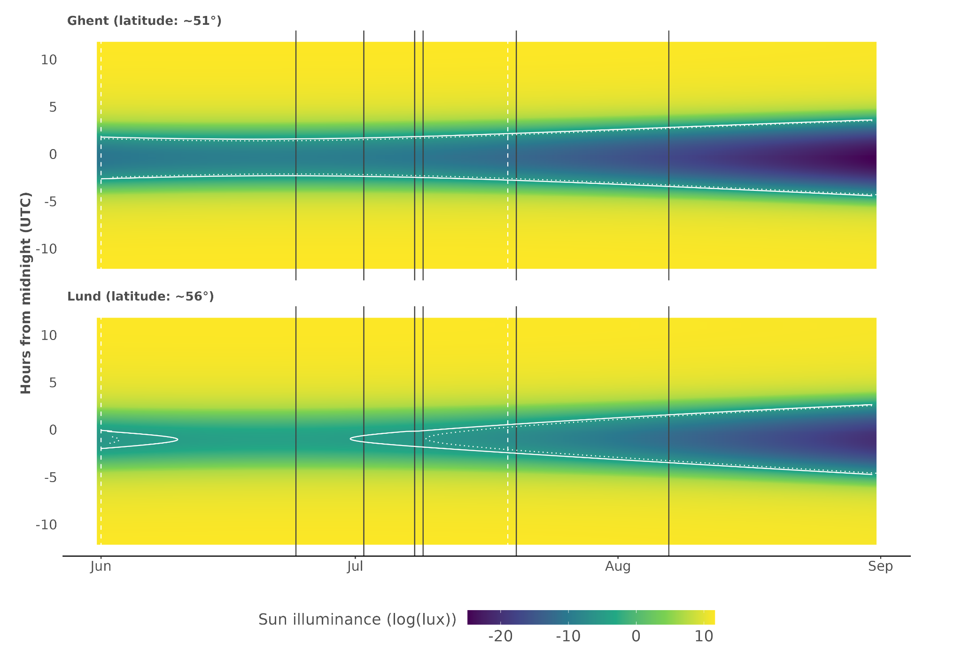
Figure S4. Sun (log) illuminance for the colony locations in Ghent harbor and at Lund, as described in Nilsson et al. (2019). Vertical grey lines indicate the data acquisition dates during the nights of 24 June, 2, 8, 9 and 20 July, and 7 August 2013 in Lund by Nilsson et al. (2019). Contours highlight the threshold value to elicit an 50% flight height increase (i.e. ~0.01 lux), nautical twilight, i.e. < -12 degrees sun angle, is shown as a dashed contour. Sampling dates of the Nilsson et al. (2019) radar study are shown as black vertical lines, the summer season of the sub-adult is outlined by two vertical white dashed lines. Note that due to “white nights” only later season acquisition days in Lund pass nautical twilight into astronomical twilight and true nighttime. The influence of the moon is not shown on this graph as variable over the years.

