Exercise 1
Question 1
Source IP:192.168.1.102
Source port:1161

Question 2
gaia.cs.umass.edu IP:128.119.245.12
Port:80

Question 3
The initiate sequence number:232129012
The Flags shows “SYN” to identifies SYNACK segment.

Question 4
Sequence number:8833061785
ACK:2322129013
The ACK number is determine by the client sequence number plus one since the SYN segment does not contain any data.
The Flags shows “SYN” and “ACK” to identifies SYNACK segment.

Question 5
Seq:232129013
ACK:883061786
This part is still not contain any data.
The Flags can still identifies it as a ACK segment.

Question 6
Seq：232129013

Question 7,8
Seq | Time | ACK receive time | RTT | EstimatedRTT | Length
232129013 | 0.026477 | 0.053937 | 0.027460 | 0.027460 | 619
232129578 | 0.041737 | 0.077294 | 0.035557 | 0.0284721 | 1514
232131038 | 0.054026 | 0.124085 | 0.070059 | 0.0336704 | 1514
232132498 | 0.054690 | 0.169118 | 0.114428 | 0.0437651 | 1514
232133958 | 0.077405 | 0.217299 | 0.139894 | 0.0557812 | 1514
232135418 | 0.078157 | 0.267802 | 0.189645 | 0.0725142 | 1514
Question 9
The minimum buffer space is 5840 bytes which is the “SYN,ACK” segment send back to the client.
No, it doesn’t. The buffer space always bigger than the segment size it send.

Question 10
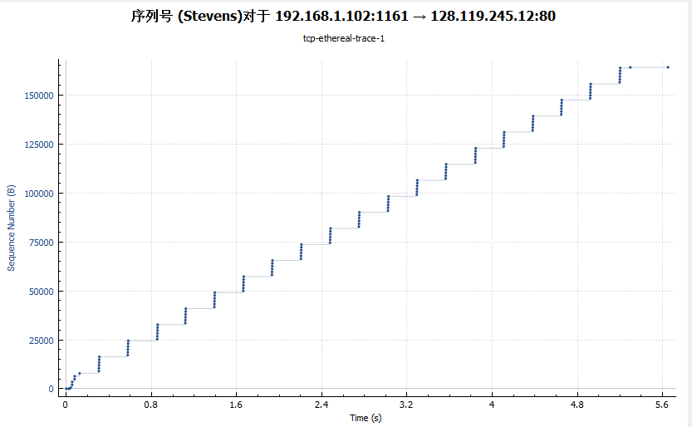
As to check the Time-Sequence-Graph we can get the sequence number is keep increasing. So there no retransmit segments.

Question 11
It is easy to see the receiver typically acknowledge data is 1460 bytes.
At the begin of the trace, each packet have their individual ACK and send back by receiver. But since no.59 segment, the responses are not equal to the amount of send at that period. We have know that there is no retransmit segments in the whole trace and the values of ACK are equal to sequence number plus two segment after that.

Question 12
First we should know the file size, it can be shown by the first file-sending sequence number and the last file-sending ACK. The first sequence number is 232129013, the last is 232293053. So the file size is 232293053-232129013 = 164040 byte. The transmission time should be the whole trace time. So the throughput is 164040/7.595557 = 21.596 Kbyte/s.

Question 13
The graph shows obviously that the slow star phase only about 0.1s in the beginning of the trace. During the trace, the TCP transmit window size is keeping at 5. It seems not have to use congestion avoidance to control the flow.

