Assignment 2 Report

This work is coded by Python 3.5

Base function
The whole work combine by several function. sendMessageFuntion() and receive() are two main function of this work. I use thread to make sure them work simultaneously, and update the shortest path.

The core idea of my work is to exchange the information of each nodes, and each node should record the path from the former node and transmit to the next node. It is important that the next node ID should not appear in the path to make sure it will not happen infinity reverse. Therefore, we can get the start node ID and it path cost to this node. So we just need to choose the smaller one and update to the record.

For example: let A send F. We do not need to care how A get F, no mater it choose ABCDEF or ADBECF, we just need to compare the smallest path cost and record the cost. When A start try to link to F, first it will choose B or D, and it will send AB or AD and the cost to them. B and D will record the path and then it will plus their cost to their adjacent nodes and send this message to the adjacent nodes.

Nodes fail
To check the one node(for example E) is alive or not, we just need to check the record in the adjacent node’s update time is over the live time or not, if message can be sent through E to get its adjacent node, it is alive. And it should be notice that for those not adjacent nodes, it should check the record update time of E is over the live time or not. If the node think there have the node is fail, it will clear all the record contain that code and recalculate the shortest path to the rest nodes. If the node is revive after fail, the update time will be refresh and the node will recalculate the shortest path again.

Poisoned reverse
In poisoned reverse, when the length of input is 4 and the 4th is ‘ -p‘ it will start in Poisoned mode. To make sure it have get the shortest path in first status, I let the node should run after 10 time to receive message for the adjacent nodes, the record is not change in 10s and it should print stable result 3 times. After that it will start the Poisoned Reverse. It will check which adjacent cost is changed and reverse those cost has been changed record and recalculate it.

Extension
To start up extension mode, you should input command form like “A 2000 configA2.txt -p -e”. The test files are just modify from the original assignment test file. Just to notice that I choose infinity represent by “ - ”, so you can modify the test file you like just make sure the infinity is “ - ”.
The method to test the extension version is similar to the Poisoned Reverse. The core idea of it is also similar to the Poisoned Reverse version, but I assume when infinity happen between “A” and “B”, “A” and “B” will not have any communication between each other. So when infinity start, i remove the send port “B” from “A”, same as “B”. So when other nodes found that the shortest path cross “A-B” does not response for a while, it will think the “A-B” link is fail and refresh the path of the record target nodes which through “A-B” link. Since “A”, “B” do not have each other port it will have path “A-B” be sent to rest nodes. So the new shortest will be refresh to the nodes.
In my test files I only modify the link between “A-D” for a simple test, you can modify it if you like. The link graph is same as the assignment graph shows like:
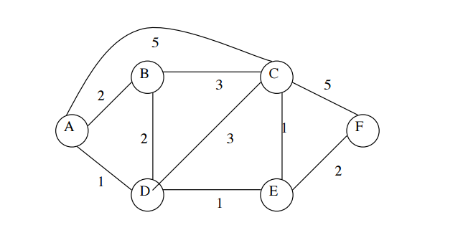
You can just copy the command from the test.txt if you want.

