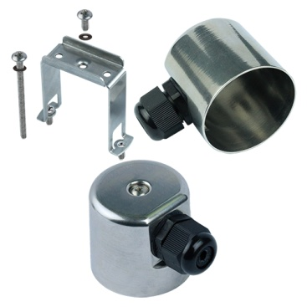

**Type Y3K1**

**Round miniature simplified immersion heater enclosure**

Deep drawn enclosure formoderately corrosive media,in stainless steelAISI 304 or AISI 316, these enclosures provide a good compromise between impact resistance, weather resistance and chemicals, they are non-flammable and have a maximum IP69K degree of ingress protection,Size(mm): Dia. 54 x 50, Volume(cm3): 105.