**BlueInno2 User’s Guide for Linux User**

2016-8-23

Ver 0.1

This guide explains how to setup the development environment of BlueInno for linux users.

# Prerequisites

First, you need to prepare followings,

* Virtual Machine Tool : VirtualBox(4.3 or above)
* OS image : ubuntu-14.04.3-desktop-amd64.iso
* Arduino IDE : Sketch 1.6.9 or above
* BlueInno2 library : v1.0.3

Then, you will install VitualBox and Ubuntu OS according to the distributed install guide. Please refer to the home pages for your reference.

* VirtualBox : [https://www.**virtualbox**.org/](https://www.virtualbox.org/)
* Ubuntu : <http://www.ubuntu.com>
* Arduino IDE : <https://www.arduino.cc/>

Now, you’ll have the Ubuntu running on VirtualBox like the image below.

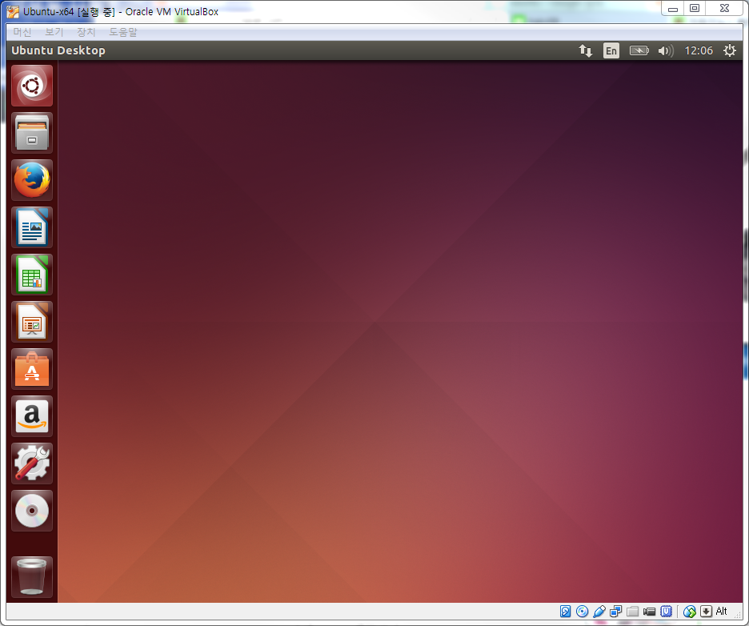

# Setup arduino dev. environment

## Install OpenJDK Java 7 Runtime

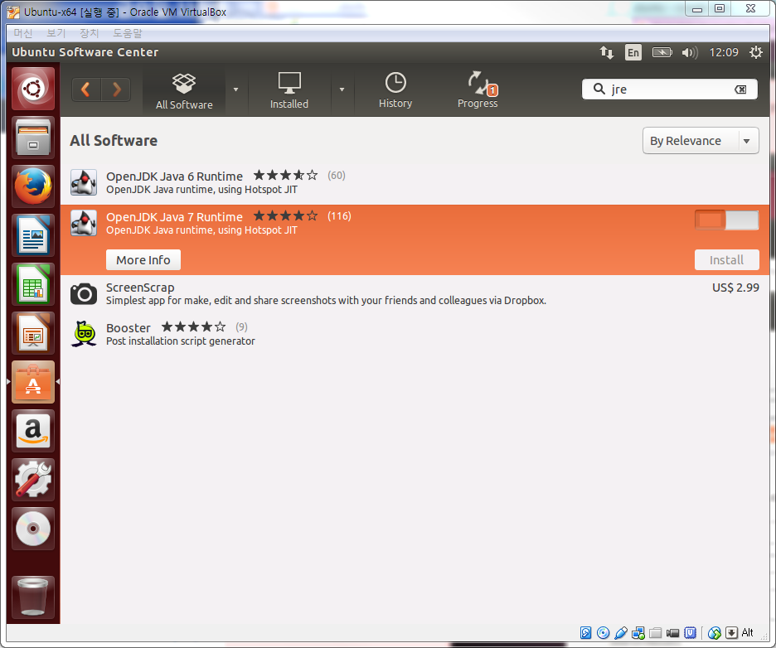

## Install Arduino IDE(Sketch)

* Download arduino ide(arduino-1.6.11-linux64.tar.xz) from arduino web site(www.arduino.cc.)

* Open terminal and decompress the file.

$ xz -d arduino-1.6.11-linux64.tar.xz

$ tar –xf arduino-1.6.11-linux64.tar

## Setup BlueInno2 USB Device

Before setup BlueInno2 USB Device on Ubuntu guest OS, you need to setup the driver on Host OS(Windows) first. After plug in the BlueInno2 into USB port, please check if the driver is well installed and work from device manager as following picture on Windows OS. (If the driver is not installed, please refer to the our café, <http://cafe.naver.com/arduinoplusble>). Before going to the further steps, the driver should be properly installed.

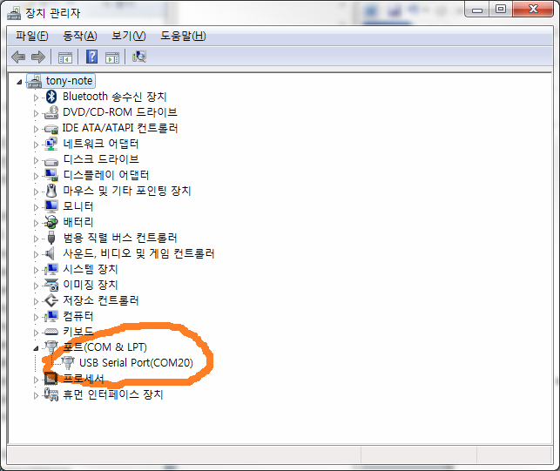

Next, you will setup the device from VirtualBox device manager like the following picture.

$dmesg

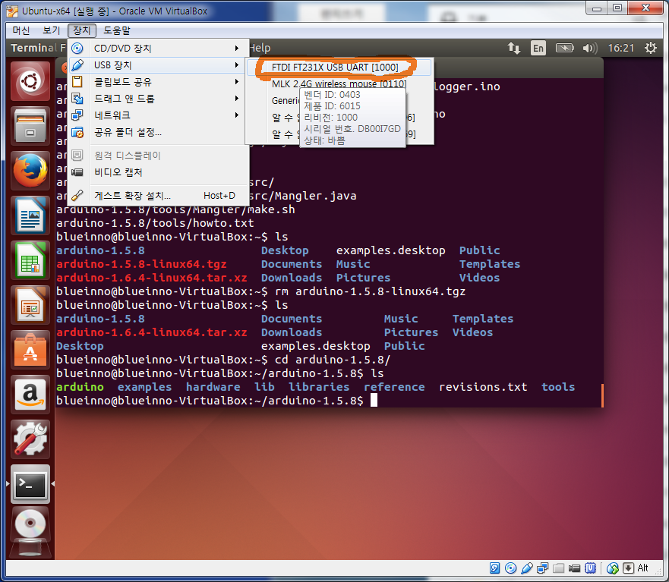

After selecting the FTDI FT231X USB UART device on VirtualBox, you should check if the device is well working with the following command in the terminal.

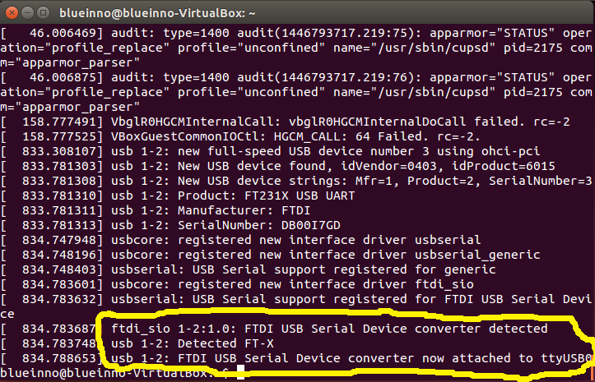

## Setup intelhex tool

Open terminal and install python-pip and intelhex.

$sudo apt-get install python-pip

$sudo pip install intelhex

## Setup USB Device mode and Reboot

$ sudo usermod -a -G dialout $USER

$ sudo reboot

## Install BlueInno2 library

First, execute arduino ide and setup for installing BlueInno2 library.

$cd arduino-1.6.11

$./arduino

Edit Preferences(File->Preferences) and add “<https://github.com/blueinno/blueinno2.archive/raw/master/package_blueinno2_103_index.json>” to Additional Board Manager URLs and save.

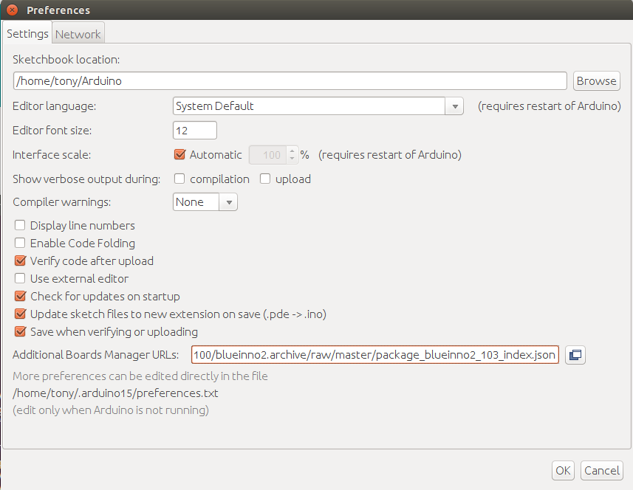

Install BlueInno2 Board in Boards Manager(Tools->Board Manager->BlueInno2 Boards).

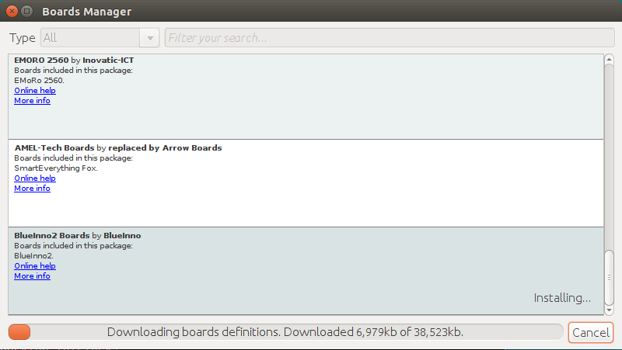

## Edit boards.txt

After install BlueInno2 library, you must modify upload tool for Linux OS.

$cd /home/tony/.arduino15/packages/BlueInno2/hardware/BlueInno2/1.0.3

$gedit boards.txt

---

# for Windows OS series

#BlueInno2.upload.tool=AppLoader 🡸 Comment out

# for Linux or Mac OS series

**BlueInno2.upload.tool=Pyloader**

---

# Compile & Upload

Before launching Sketch, you need to login as root in the terminal.

$cd arduino-1.6.11

$./arduino

After executing Sketch, select BlueInno2 as Board and choose /dev/ttyUSB0 as Port.

Select an example source.(File->Examples->BlueinnoNonBLE->01.Basics->Blink)

Compile and Upload.

