**BlueInno2 User’s Guide for OSX User**

2016-8-24

Ver 0.1

This guide explains how to setup the development environment of BlueInno2 for OSX(Mac OS) users.

# Prerequisites

First, you need to prepare followings,

* Mac Machine : OS X 10.10 Yosemite
* Arduino IDE : Sketch 1.6.9 or above for Mac(<https://www.arduino.cc/>)

From now on, we assume that you have Mac machine.

# Setup arduino dev. environment

## Install Java for OS X

* Download and install Java for OS X using Safari web browser. (https://support.apple.com/kb/DL1572?locale=ko_KR).

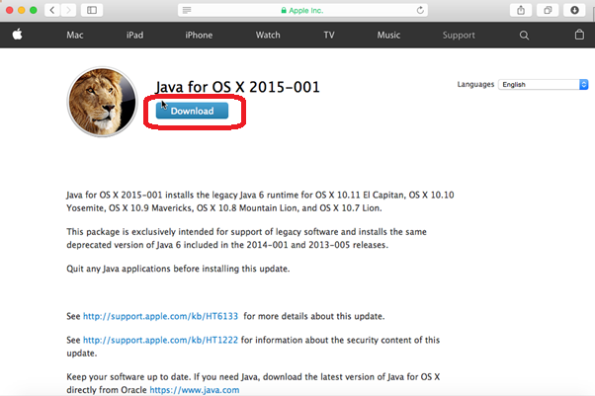

## Install Arduino IDE

* Download and install arduino ide(1.6.9 or above) from Arduino home page(www.arduino.cc).

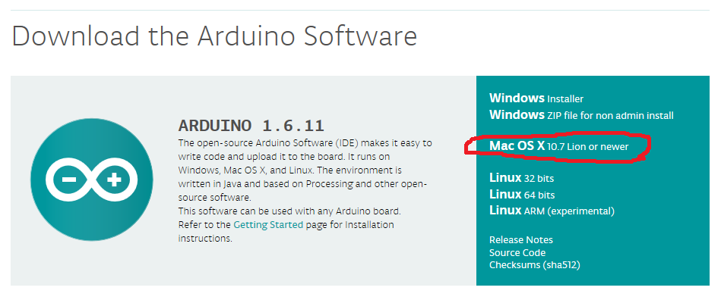

After downloading arduino ide, move into Applications folder.

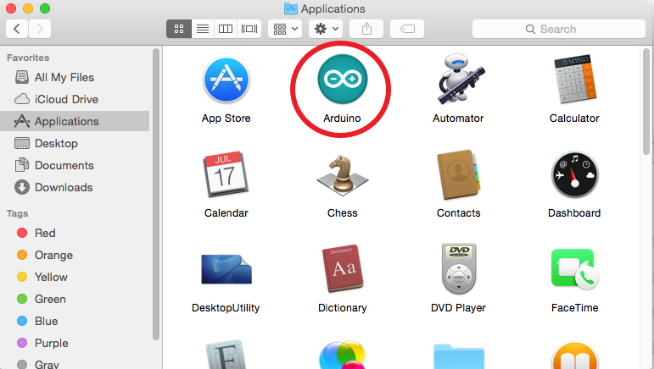

## Install BlueInno2 library

First, execute arduino ide and setup for installing BlueInno2 library.

Edit Preferences(Arduino->Preferences) and add “<https://github.com/blueinno/blueinno2.archive/raw/master/package_blueinno2_103_index.json>” to Additional Board Manager URLs and save.

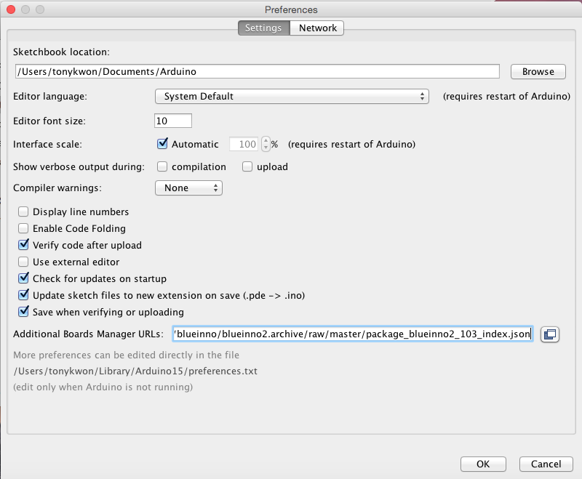

Install BlueInno2 Board in Boards Manager(Tools->Board Manager->BlueInno2 Boards).

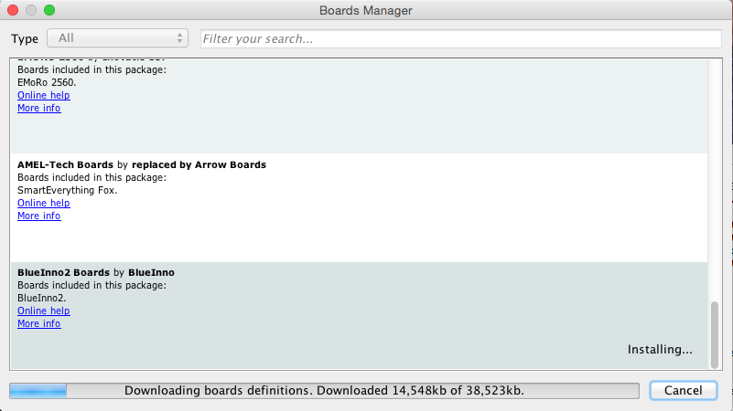

You can find installed blueinno2 library under /Users/username/Arduino15/packages/BlueInno2/hardware/BlueInno2

## Change uploader tool

Open boards.txt file under the folder(/Users/username/Library/Arduino15/packages/BlueInno2/hardware/BlueInno2/1.0.3) and choose Pyloader for Mac OS.

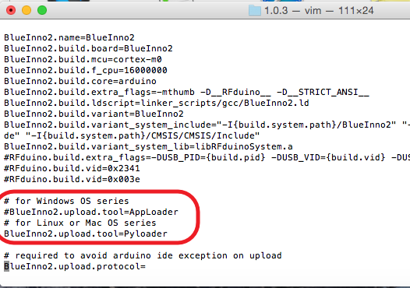

## Install USB Driver

* Visit the following link : <http://www.ftdichip.com/Drivers/VCP.htm>
* Download and Install the drivers for your system.
* Reboot the computer.

## Setup intelhex and pyserial tool

Open terminal(Go>Applications>Utilities>Terminal) and install python-pip and intelhex. You can find the terminal in Utilites.

$sudo easy_install pip

$sudo pip install intelhex

$sudo pip install pyserial

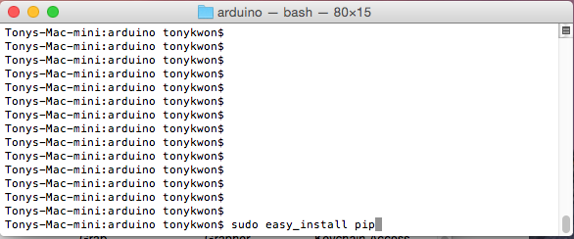

# Compile & Upload

After executing Arduino IDE, select BlueInno2 as Board and choose /dev/tty.usbserial-D80017GD as Port(Tools->Board, Tools->Port->/dev/tty.usbserial-DB0017GD).

Select an example source.(File->Examples->BlueInno2NonBLE->01.Basics->Blink)

Compile and Upload.

