Some Quick Notes on Installation
- We will be distributing the contents of this tutorial on an Ettus Research LiveUSB Drive.

- Even if you have a LiveUSB drive, you may still want to build with the latest:

cd src/gr-dt
git pull
cd build
sudo make install

- We may not have enough LiveUSB drives to go around. If you do not receive a LiveUSB drive you will also need to install the latest master branch of UHD, GNU Radio, gr-extras, and pre-cog before installing the gr-dt library. You can find installation instructions for both of these here:

https://github.com/buoyboy/pre-cog/wiki/Installation
- Once you have the dependencies installed, you can pull the code for this tutorial.
git clone https://github.com/buoyboy/gr-dt.git
- Use this process to build gr-dt.
cd [gr-dt directory]/
mkdir build
cd build
cmake ../
sudo make install
sudo ldconfig

- Whenever you modify the code and want to re-install, return to the [gr-dt]/build directory and:
sudo make install
- You may have to configure your Ethernet adapter for the USRP N210/NI 2920.

Python Blocks Cheat Sheet

This is a truncation of the material available here:
gr-extras Block Coding Guide

What functions do we need? (bare minimums)
- an __init__ function
- a work function

Example init function
def __init__(self, args):
gr.block.__init__(self,
name="another_adder_block",
in_sig=[...],
out_sig=[...])
self.set_auto_consume(False)

Example work function
def work(self, input_items, output_items):
#buffer references
in0 = input_items[0]
in1 = input_items[1]
out = output_items[0]

#process data
out[:] = in0 + in1

//consume the inputs
self.consume(0, len(in0)) //consume port 0 input
self.consume(1, len(in1)) //consume port 1 input
#self.consume_each(len(out)) //or shortcut to consume on all inputs

#return produced
return len(out)

Python Blocks Cheat Sheet (cont'd)

More on gr.block.init

A typical exampl of I/O signature in pre_cog
gr.block.__init__(
self,
name = "tdma_engine",
in_sig = [numpy.complex64],
out_sig = None,
num_msg_inputs = 3,
num_msg_outputs = 2,
)

arguments of gr.block.__init__()
name = name, not sure what this is used for at the moment
in_sig = stream-based input signal
out_sig = stream-based output signal
num_msg_inputs = how many msg inputs
num_msg_outputs = how many msg outputs

more examples for init
# A block with 2 inputs and 1 output --
gr.block.__init__(self, name="my adder",
in_sig=[numpy.float32, numpy.float32],
out_sig=[numpy.float32])

# A block with no inputs and 1 output --
gr.block.__init__(self, name="my source",
in_sig=None,
out_sig=[numpy.float32])

# A block with 2 inputs (float and double) and 1 output --
gr.block.__init__(self, name="my block",
in_sig=[numpy.float32, numpy.float64],
out_sig=[numpy.float32])

PMT – Blob Cheat Sheet

Block call to pull msg from queue
try: msg = self.pop_msg_queue()
except: return -1

What's in the message?
value = msg.value #PMT type - could be blob, string, dictionary or other types
offset = msg.offset #which port the message arrived on
key = msg.key #string designating the key [arbitrary]
source = msg.src #string, where did this come from?

Check type - for example, checking to make sure msg is a blob
if not pmt.pmt_is_blob(msg.value): print "not a blob!"

Getting numpy array from blob
data = pmt.pmt_blob_data(msg.value)

Getting key string
key_string = pmt.pmt_symbol_to_string(msg.key)

Converting a numpy array to a blob
blob = self.mgr.acquire(True) #block
pmt.pmt_blob_resize(blob, len(payload))
pmt.pmt_blob_rw_data(blob)[:] = payload

Converting a string to a blob
blob = self.mgr.acquire(True) #block
pmt.pmt_blob_resize(blob, len(my_string)) pmt.pmt_blob_rw_data(blob)[:] =
numpy.fromstring(my_string, dtype='uint8')

Sending a blob to a msg output
self.post_msg(0, pmt.pmt_string_to_symbol('U'), blob)

post_msg arguments
--peudo code--
post_msg(int port_num, pmt key, pmt value, pmt source (optional))

PMT - Tags Cheat Sheet

Reading Tags

Searching for tags in a buffer of samples
tags = self.get_tags_in_range(0, nread, nread+ninput_items)

Processing tags by key
Note: It is possible to search for keys with specific tags. This is a more generic example.
for tag in tags:
key_string = pmt.pmt_symbol_to_string(tag.key)
if key_string == "rx_time":
self.samples_since_last_rx_time = 0
self.current_integer,self.current_fractional = pmt.to_python(tag.value)
elif key_string == "rx_rate":
self.rate = pmt.to_python(tag.value)
self.sample_period = 1/self.rate

Reading values
Example: reading tag with key = “rx_time”
self.current_integer,self.current_fractional = pmt.to_python(tag.value)

Writing Tags

Assigning values
key = pmt.pmt_string_to_symbol("tx_sob")
source = pmt.pmt_string_to_symbol("framer")
value = pmt.PMT_T #PMT_T in this example, can be other types...

Sending tag out of port
self.add_item_tag(0, self.nitems_written(0), key, value, source)

add_item_tag arguments
self.add_item_tag(int port offset, long sample_offset_to_tag, pmt key, pmt value, pmt source -optional-)

Set 1 – Exercise 1

Exercise:

Create your own Python block. You can choose any I/O type you'd like, but it may be a little easier if the group standardized on [numpy.float32]. Do some basic math operation(s) in this block. In GRC, use this block with constant sources to test the functionality.

Objective:

This exercise will show Python block basics: I/O signatures, initialization, how to write a work function, etc.

Resources:

For brevity, the Python files and XML files have been generated for you. You should only modify the work function of “my_first_python_block.py” and rebuild the project.

Hints:

None for this exercise.

Cheat:

The complete python file for a simple floating point adder block can be found in the cheat/python folder. The corresponding example is my_first_python_block_fg.grc, which can be found in the cheat/examples folder.

Set 1 – Exercise 2

Exercise:

Modify my_first_msg_block.py. Create your own Python block that uses the gr-extras extensions for msg passing. This block should accept msg's on two ports, 'data_in' and 'ctrl_in'. Write the work function to print the key and value of the incoming msg's from the 'data_in' port. When a msg is received on the 'ctrl_in' port, pass the key and value on as a new message on the 'data_out' port. In GRC, build a flowgraph that drives the two inputs with a heart_beat block, and a msg_to_stdout block on “data_out” port.

Objective:

This exercise will show you how to use the gr-extras extensions and pass msg's between blocks.

Resources:

For brevity, the Python files and XML files have been generated for you. You should modify the work function of “my_first_msg_block.py” and rebuild the project. You will have to build the GRC flowgraph from scratch.

Hints:

See Blob and PMT cheat sheets.

Cheat:

The complete python file for this exercise can be found in the cheat/python folder. The corresponding example is my_first_msg_block_fg.grc.

Set 1 – Exercise 3

Exercise:

Build on the previous exercise. Modify my_second_msg_block.py

This block will accept a string of comma-delimited frequencies and will store these as a list of floats upon initialization. When a msg is received on the “ctrl_in” port the block should issue a properly formatted msg to “ctrl_out” port, which will be fed to a PMT_RPC block in a GRC flowgraph. The GRC flowgraph will also contain a USRP/UHD source, and a WX GUI FFT. The outgoing msg's on the “ctrl_out” port will set the frequency of the USRP. In effect, this will create a event based system that steps through a set of frequencies and shows the resulting spectrum on the FFT whenever a msg is received on the “ctrl_in” port of your block. The msg will be generated from a heart_beat block.

Objective:

This exercise will show you how to use the gr-extras features for control plane functionality.

Resources:

For brevity, the Python files and XML files have been generated for you. You should modify the _init_ and work functions of “my_second_msg_block.py”. Then you can rebuild the project. You will have to build the GRC flowgraph from scratch.

Hints:

See Blob and PMT cheat sheets.

Cheat:

The complete python file for this exercise can be found in the cheat/python folder. The corresponding example is my_second_msg_block_fg.grc.

Set 1 – Exercise 4

Exercise:

Modify usrp_time.py. Build a block that will receive the stream tags of a complex stream from a USRP/UHD source and determine the time of the USRP.

Objective:

This exercise will show you how to read stream tags.

Resources:

For brevity, the Python files and XML files have been generated for you. You should modify the work functions of “usrp_time.py” and rebuild the project. You will have to build the GRC flowgraph from scratch.

Hints:

See Tags and PMT cheat sheets.

Note: This block has been written with a msg output. You will not do anything with the msg output in this exercise.

Cheat:

The complete python file for this exercise can be found in the cheat/python. The corresponding example is get_time.grc.

Set 1 – Exercise 5

Exercise:

Build msg passing block from scratch. Make your own xml files, modify the CmakeLists.txt, etc.

Objective:

This exercise will show you how add your own, custom block to a library.

Resources:

You must create every file from scratch. We recommend that you use existing python and xml files in the project.

Hints:

- Copy the code from my_first_msg_block.py into a new Python file for templating.
- Add your new python file to python/CMakeLists.txt
- Add your block to __init__.py, following the same pattern of other blocks in this library.
- Copy the code from my_first_msg_block.py into your new xml file for templating. Modify as needed.
- Add the new .xml file to grc/CMakeLists.txt
- Add the block to block_tree.xml
- Rebuild/re-install the project

Cheat:

The complete python file, xml file, and corresponding CmakeLists.txt files can be found in the cheat folder. It is called “my_cognitive_radio” block.
Set 2 – Exercise 1

Exercise:

Build a simple radio with “radio_hier” that uses a gr-extras “socket_msg” block to communicate via a TCP/IP port. Using netcat as a simple text chat program, talked to your fellow radio developers on the local radio network.

Objective:

This exercise will show you how to build basic radios in GRC with pre-installed blocks. You should note the poor MAC functionality of this example.

Resources:

None. You must create the flowgraph from scratch. [or copy it from cheat/examples folder]

Hints:

- If your radio is very close to other radios you are communicating with, you may need to set the tx and rx gain low (i.e. 3-5 dB each)
- It should look like this when you're done:

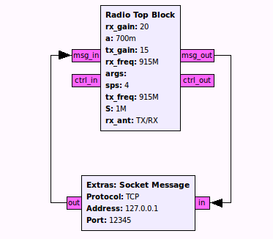

Cheat:

The complete example file can be found in the cheat/examples folder - simple_trx_1.grc.
Set 2 – Exercise 2

Exercise:

Build a simple radio with “radio_hier” that uses a gr-extras “socket_msg” block to communicate via a TCP/IP port. Insert a simple_mac block between the two to provide addressing and arq functionality. Using netcat as a simple text chat program, talked to your fellow radio developers on the local radio network.

Objective:

This exercise will show you how add protocol layers in a modular way with GRC.

Resources:

None. You must create the flowgraph from scratch. [or copy it from cheat/examples folder]

Hints:

- If your radio is very close to other radios you are communicating with, you may need to set the tx and rx gain low (i.e. 3-5 dB each)
- You will have to assign an address to your radio (on the simple_mac) block. This will give your radio a unique ID so it can cooperate with other radios on the same frequency. You must also set the destination address of your virtual_channel_formatter to talk to use the address of the neighbor you are trying to talk to.
- It should look like this when you're done:

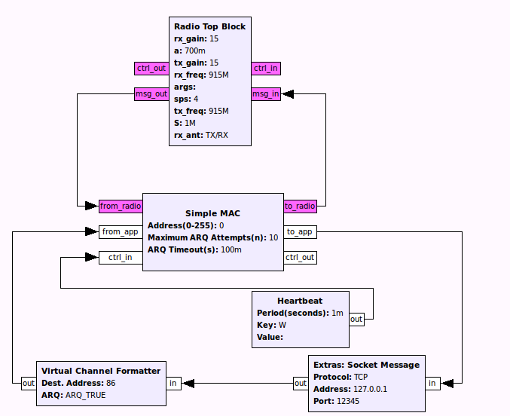

Cheat:

The complete example file can be found in the cheat/examples folder - simple_trx_2.grc.

Set 2 – Exercise 3

Exercise:

This exercise will not use any USRPs. Instead, you will build a flow graph that uses a virtual_channel_mux and virtual_channel_demux. There is no specific passing criteria for this exercise, just gain an understanding of the concept of virtual channel and multiplexing.

Objective:

Learn how to use channel mux and demux blocks to interleave multiple data streams into one.

Resources:

None. You must create the flowgraph from scratch. [or copy it from cheat/examples folder]

Hints:

- The virtual_channel_mux will add a one-byte header, which is used to determine which port the msgs to be routed to by the virtual_channel_demux.
- It should look like this when you're done:

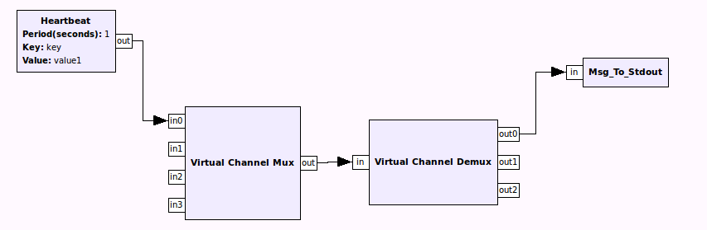

Cheat:

The complete example file can be found in the cheat/examples folder - mux_work.grc.

Set 2 – Exercise 4

Exercise:

Build from Exercise 2. Use channel multiplexers and de-multiplexers to communicate with multiple radios. Create a separate TCP/IP socket to interact with each of the radios.

Objective:

This exercise will show you how to use virtual channel mux/demux and formatters to implemented multiple data endpoints which can be used to interact with multiple radios.

Resources:

None. You must create the flowgraph from scratch. [or copy it from cheat/examples folder]

Hints:

- If your radio is very close to other radios you are communicating with, you may need to set the tx and rx gain low (i.e. 3-5 dB each)
- You will have to assign an address to your radio (on the simple_mac) block. This will give your radio a unique ID so it can cooperate with other radios on the same frequency.
- It should look like this when you're done:

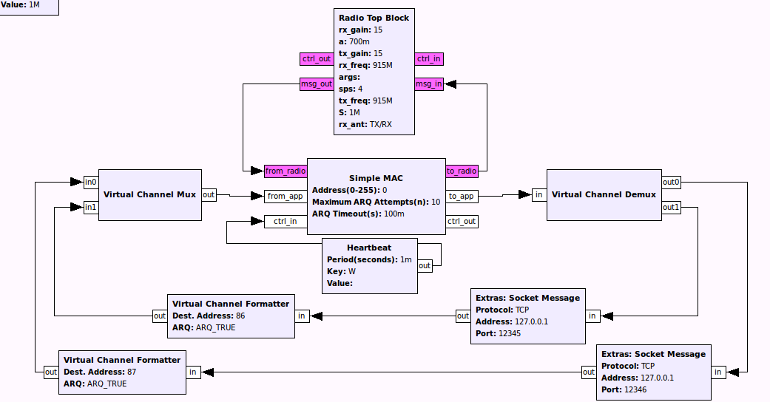

Cheat:

The complete example file can be found in the cheat/examples folder - simple_trx_3.grc.
Set 2 – Exercise 5
Exercise:

Build from Exercise 2. Use channel multiplexers and de-multiplexers to interleave data from multiple, asynchronous streams onto a single PHY. Use a heart_beat block to send a periodic beacon msg, which will be printed out by the addressed radio. Maintain the TCP/IP msg functionality of exercise 2. Use virtual_channel_mux and virtual_channel_demux for this exercise.

Objective:

This exercise will show you how to use virtual channel mux/demux and formatters to implemented multiple data endpoints on a two-radio network.

Resources:

None. You must create the flowgraph from scratch. [or copy it from cheat/examples folder]

Hints:
- If your radio is very close to other radios you are communicating with, you may need to set the tx and rx gain low (i.e. 3-5 dB each)
- You will have to assign an address to your radio (on the simple_mac) block. This will give your radio a unique ID so it can cooperate with other radios on the same frequency.

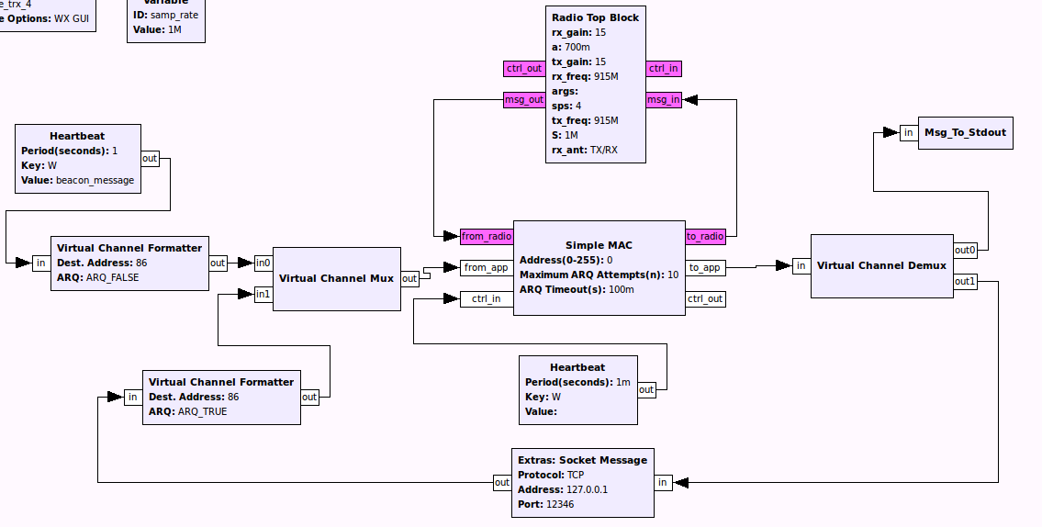

Cheat:

The complete example file can be found in the cheat/examples folder - simple_trx_4.grc.

