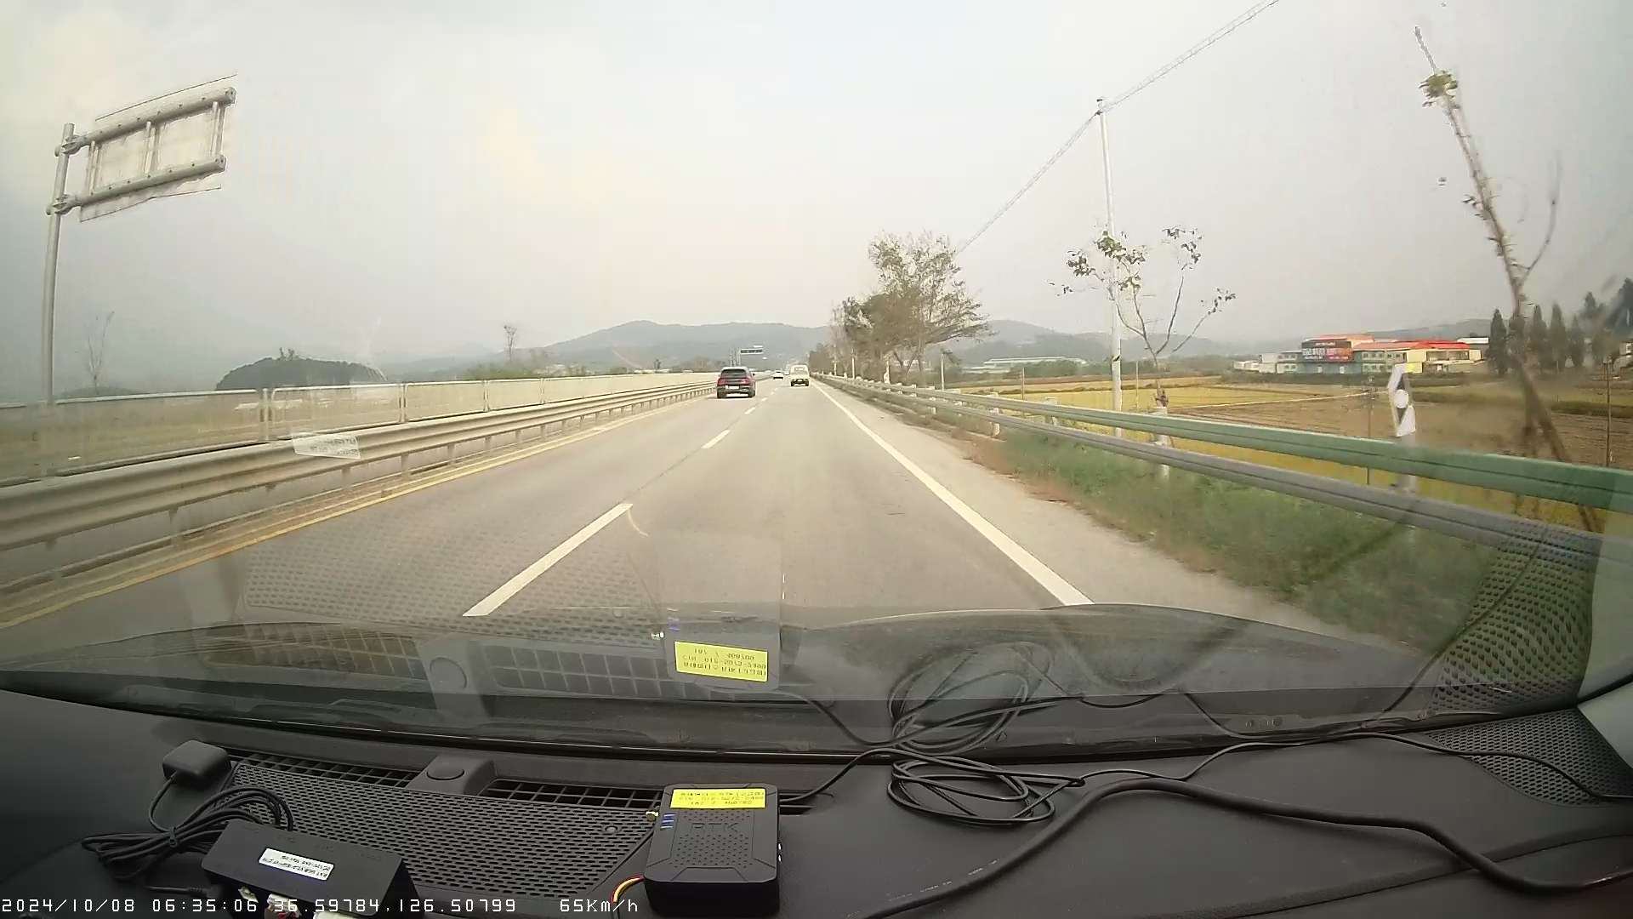
2024/10/08 06:35:06
59784 126.50799
65km/h
10540000
CAR 01 0-3 san
ITE

