

Face Emotion Detection Guideline

# Computer Graphics

## TRAN DUY BAO – ITITIU15076

# 

1. You need to have your python enviroment in your PC, to install it : <https://www.python.org/downloads/> and choose the version that support . After downloading , install it.

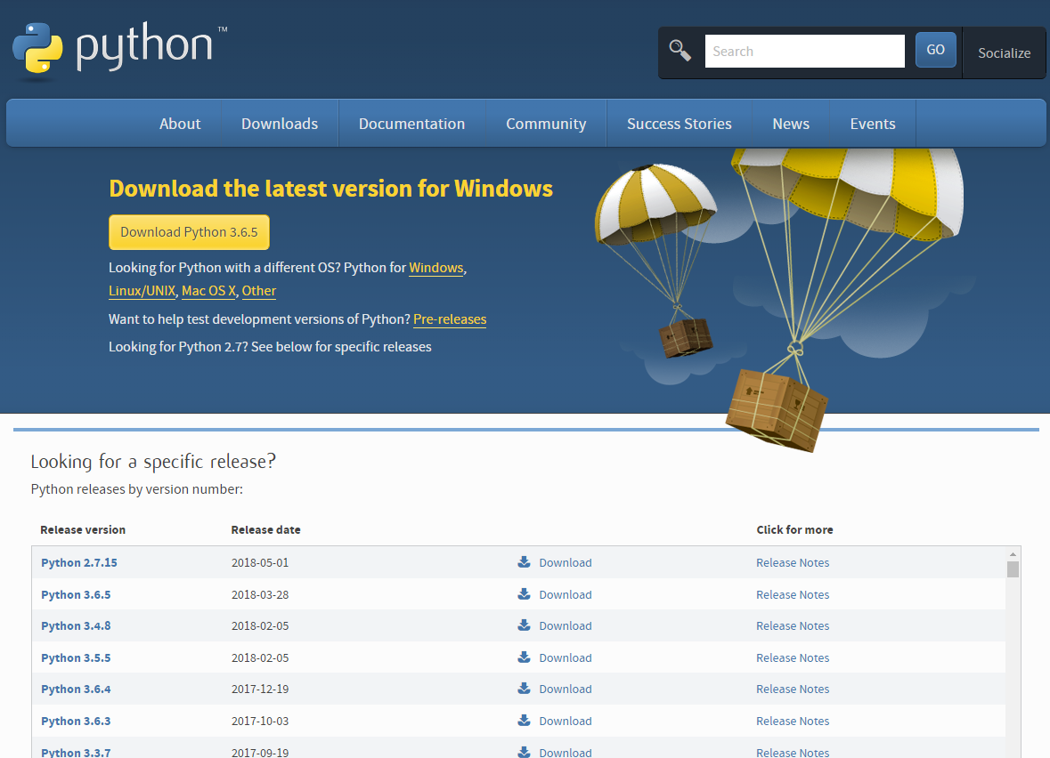

1. You can use directly the python file on the command prompt, but in order to set up a separate enviroment to use, we recommend use Anaconda ( an IDE support Python ). Link download : <https://www.anaconda.com/download/>



1. Create a new Enviroment for Emotion Detection System :

+ Open Anaconda Prompt, on screen type :

conda create emotion pip python=3.6

+ It create an enviroment name emotion, 3.6 is the version of python you use , after having the enviroment, you can setup and work on it , type :

activate emotion

1. Setup some library that need for the project :

+ In the emotion detection system, there are some library that required such as : OpenCV, Tensorflow , Tflearn, to install it, on the prompt type :

conda install –c menpo opencv

pip install –ignore-installed –upgrade tensorflow

pip install tflearn

+ There are some version of tensorflow which is work with nongpu and gpu device, for more details : <https://www.tensorflow.org/install/install_windows>

<http://tflearn.org/installation/#tflearn-installation>

1. So it is finished for the setup , then we will work with the code, download the full project on the link : <https://drive.google.com/open?id=1c5QVMZFyS_DtCYyAv7Io6rB-ivCEFqEH>

+ Extract and put the folder in a directory to use , such as : C:\Users\ADMIN\Desktop\emo for using

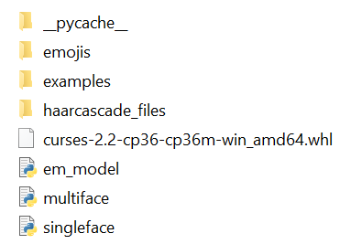

1. Download the training data and put in the data in that folder : <https://drive.google.com/open?id=1knMKd7jztySLS5pKLtaEhdwcoldPSggR>
2. On the anaconda prompt , activate your environment then change directory to your project folder :

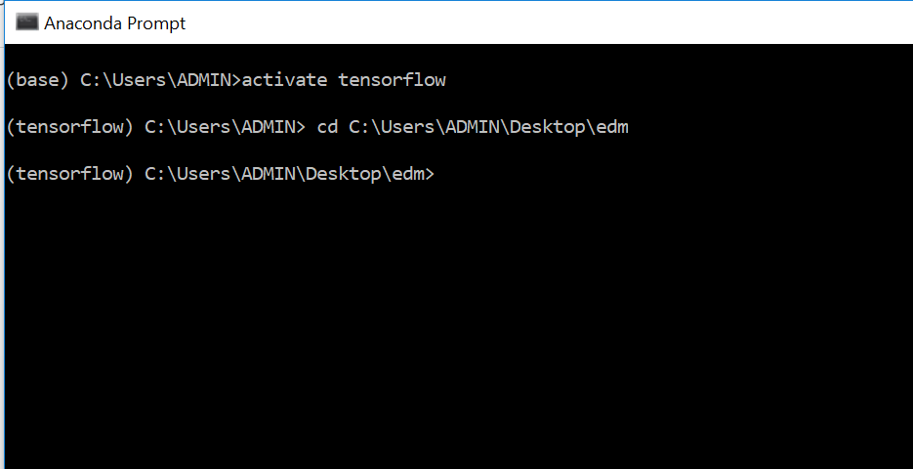

Then run your app by typing : python singleface.py

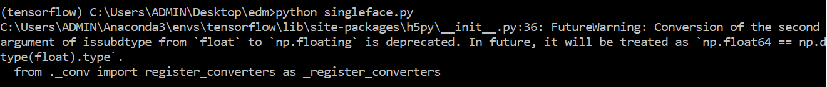

It takes a second to load the model , then it run the application :

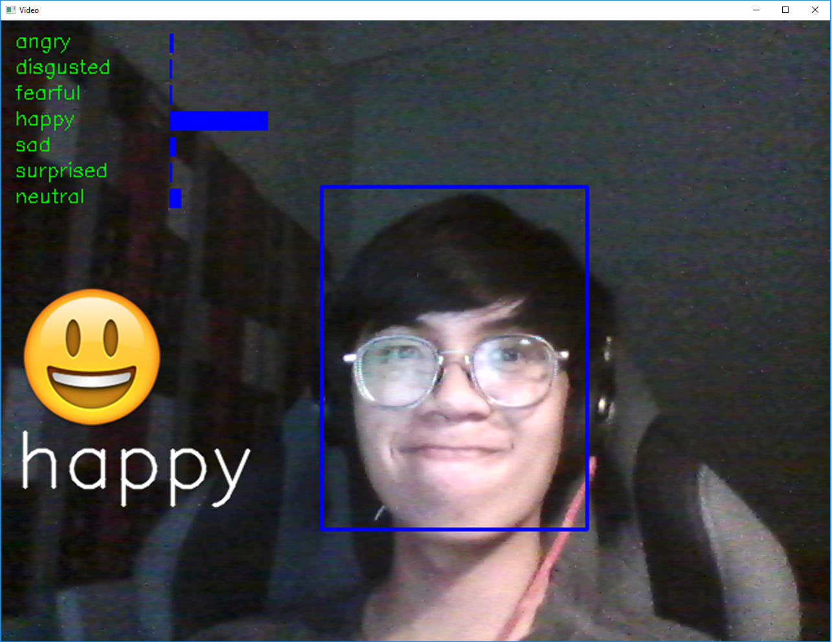

So it worked. You can use the app with multiple face by typing on the prompt : python multiface.py