

Computer Architechture

Laboratory Report

Mini Project : Read Analog Voltage by MSP430

Tran Duy Bao | ITITIU15076 | May 24th , 2017

# Device

* MSP430G2223 Launchpad

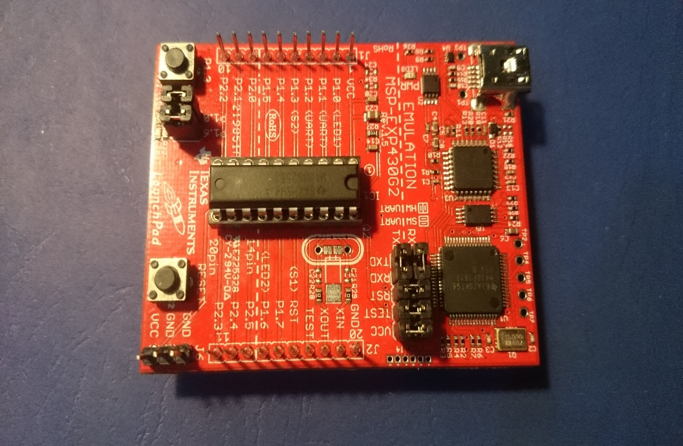

* 10k Potentiometer

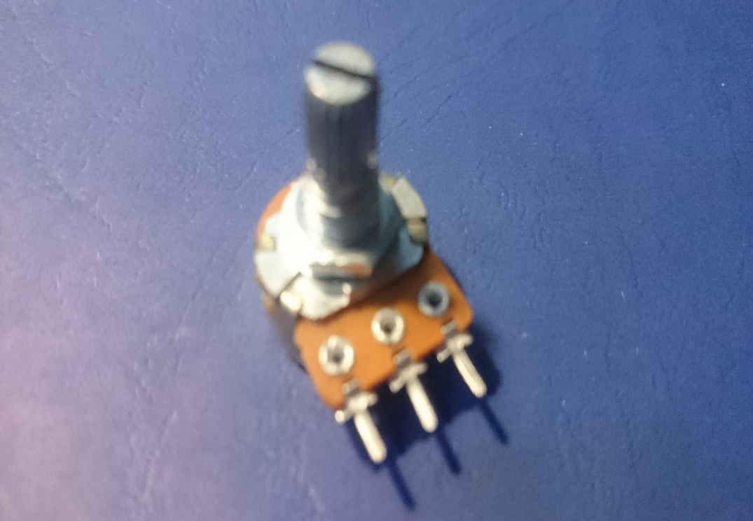

* Testboard, Wire

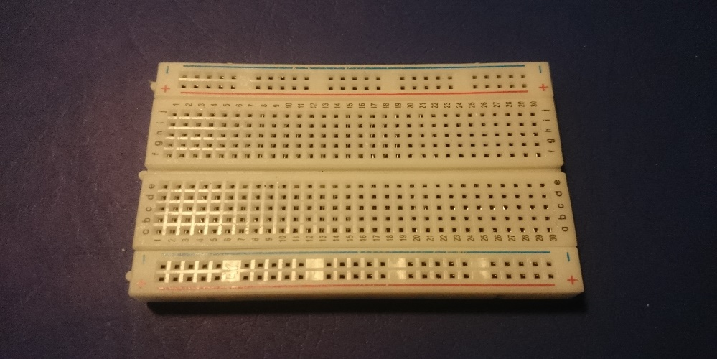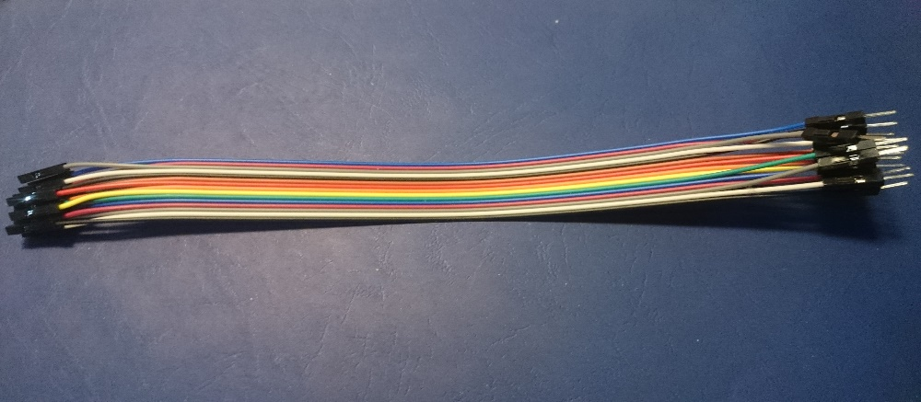

### Application

* Energia andCode Composer Studio

### Schematic

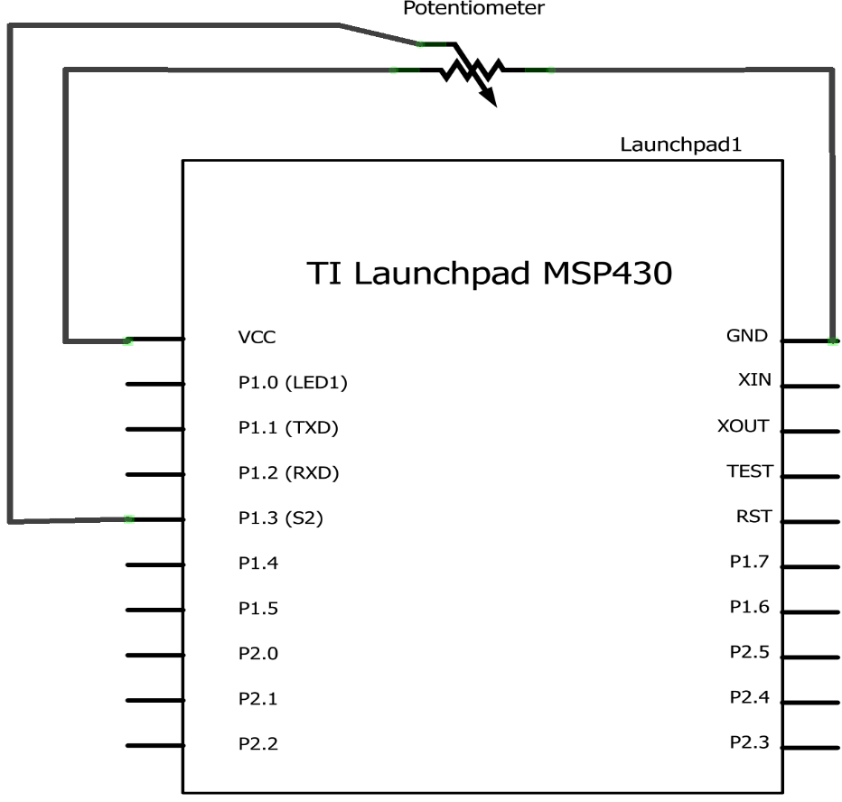

Project’s schematic

### Function

void setup() {

Serial.begin(9600); // initialize serial communication at 9600 bits per second:

}

void loop() {

int sensorValue = analogRead(A3);

// Convert the analog reading of ADC10 (which goes from 0 - 1023) to a voltage (0 - 3V):

// Can either use type int or float to store voltage, int takes up less memory and is recommend

// In fact , use int save much memory, but less accuracy

float voltage = sensorValue * (3.0 / 1023.0);

// ADC10 is 10 bit , so the value we get should be devided to 2^10 - 1 and multiply by 3

//float voltage = sensorValue * (3.0 / 1023.0);

Serial.println(voltage); // print out the value you read:

}

### Assembly Code

Sketch the Energia program on CCS ,on the diassembly you will see :

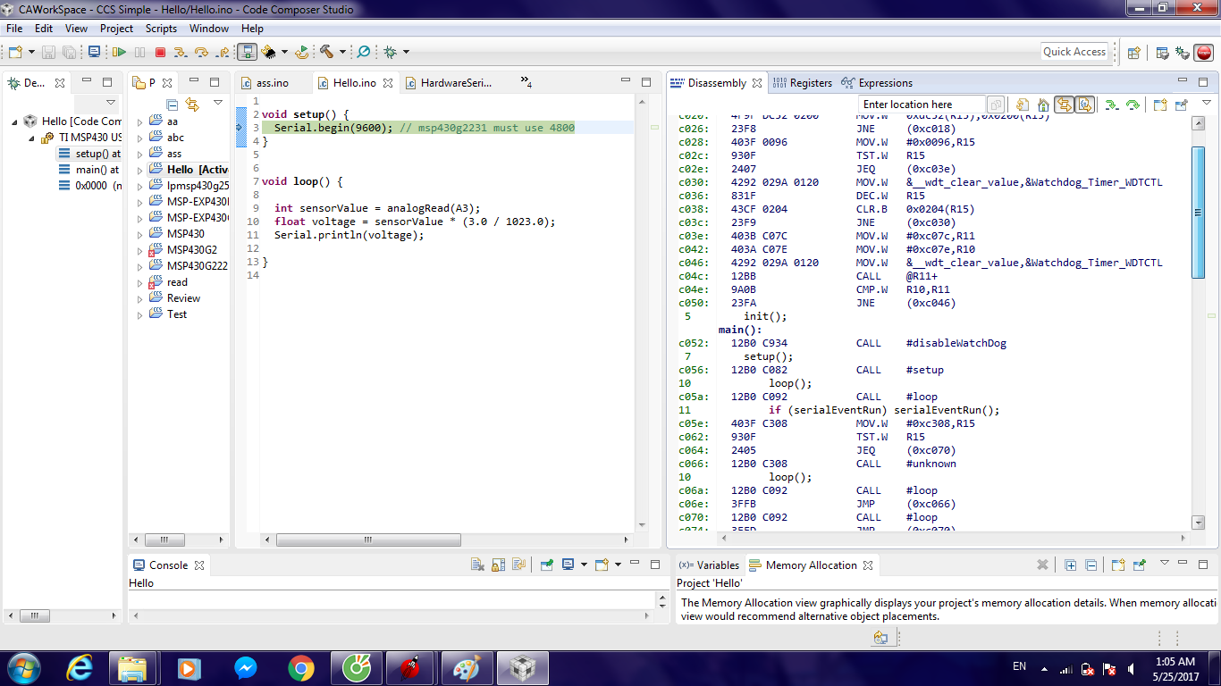

The code has been converted to assembly

### Result

After press Run , on the Serial Monitor of Energia, the Voltage is printed continuely :

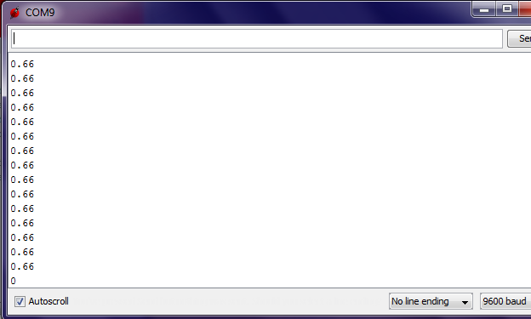

Rotate the Potentiometer , the Voltage change :

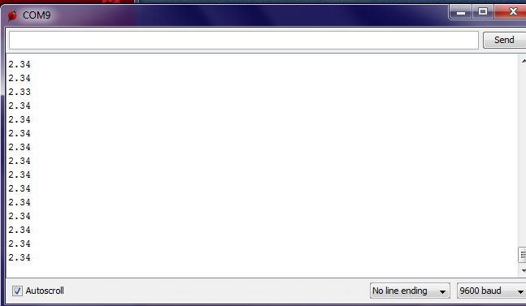

The maximum voltage can reached is 3 :

