

Computer Architechture

Laboratory Report

Mini Project : Display LCD with MSP430 Launchpad and LCD 1602

Tran Duy Bao | ITITIU15076 | May 24th , 2017

# Device

* MSP430G2223 Launchpad

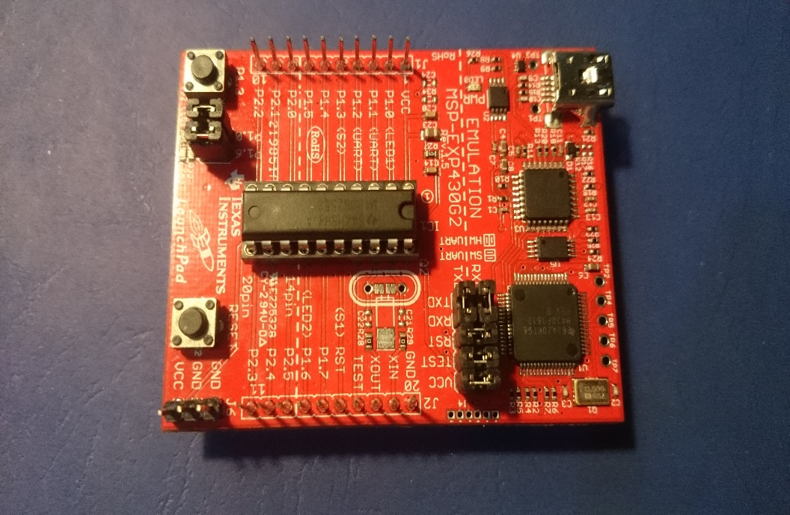

* LCD 1602 Display

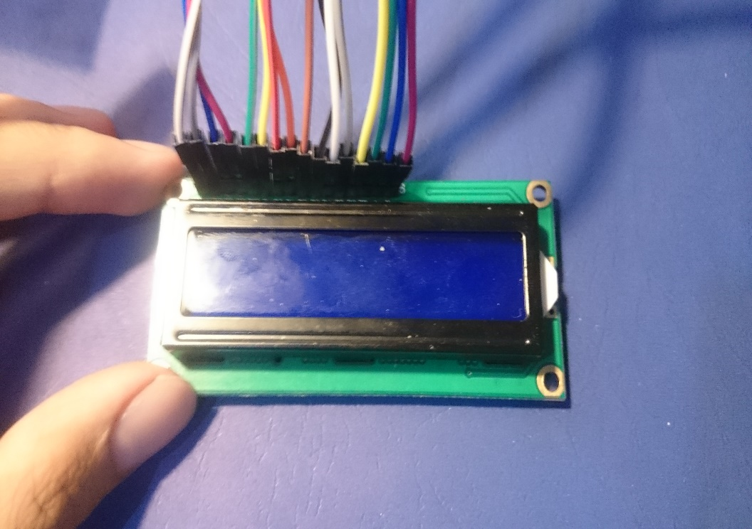

* 10k Potentiometer

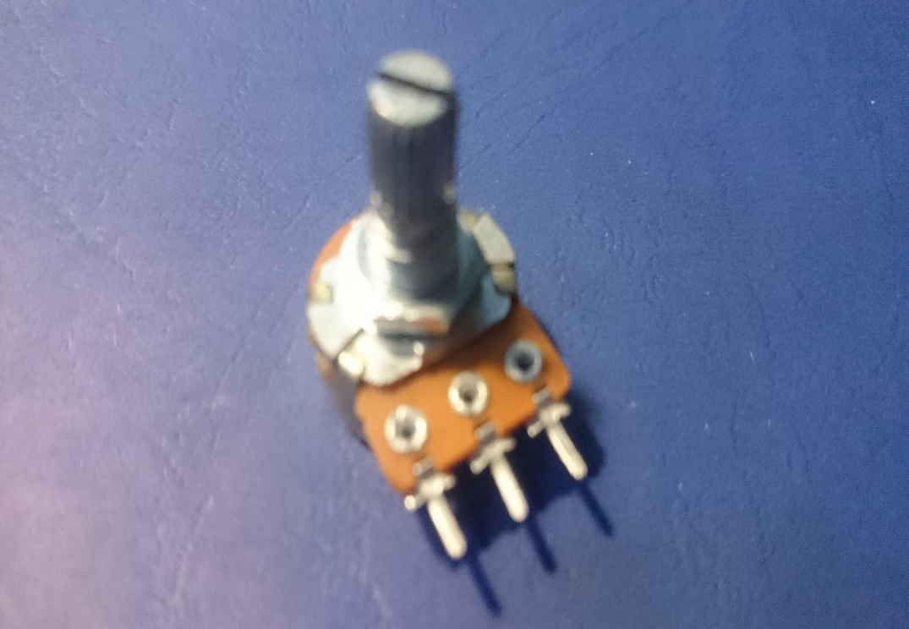

* Testboard, Wire

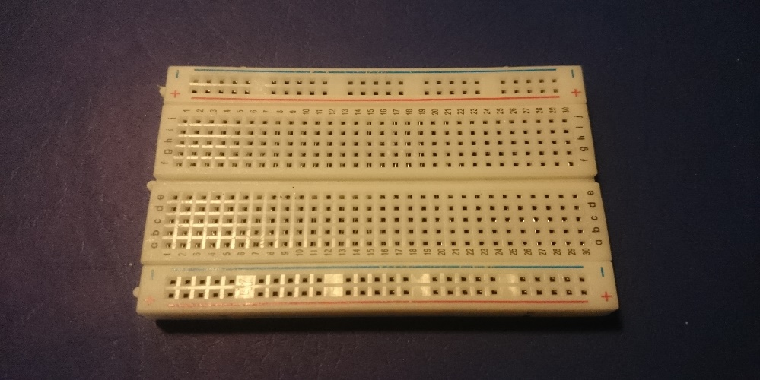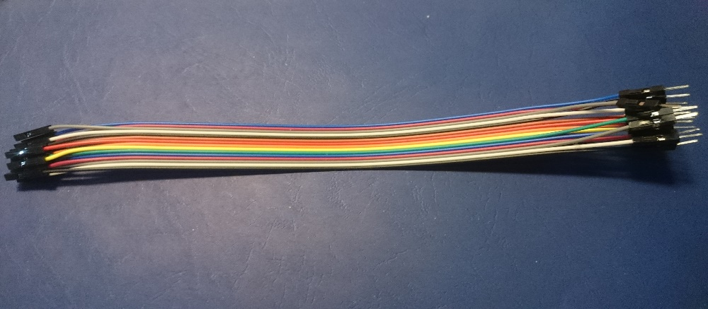

### Application

* Energia andCode Composer Studio

### Schematic

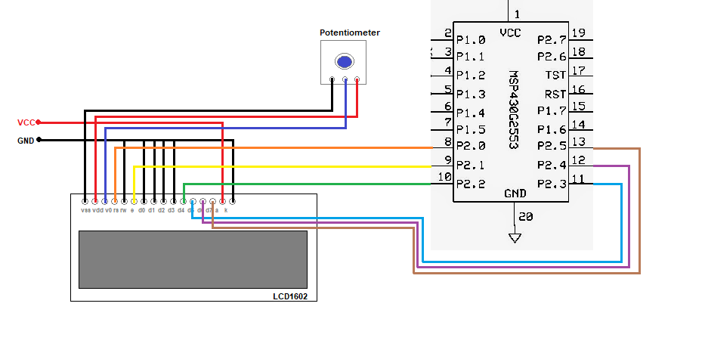

LCD display Schema

### Function

#include <LiquidCrystal.h> //include the LCD library

LiquidCrystal lcd(P2_0, P2_1, P2_2, P2_3, P2_4, P2_5); // use the port 2.0 -> 2.5 of Launchpad to read/write in 4 bits mode

void setup() {

lcd.begin(16, 2); // set up the LCD's number of columns and rows

lcd.setCursor(0,0); //set the cursor to the 1st column and line 1

lcd.print("Mini Project: "); // Print a message to the LCD.

lcd.setCursor(0,1); //set the text begin at the 2nd column and line 2

lcd.print("Time: ");

}

void loop() {

lcd.setCursor(9, 1); // set the cursor to column 0, line 1

lcd.print(millis()/1000); // print the number of seconds since reset

}

### Assembly Code

Sketch the Energia program on CCS ,on the diassembly you will see :

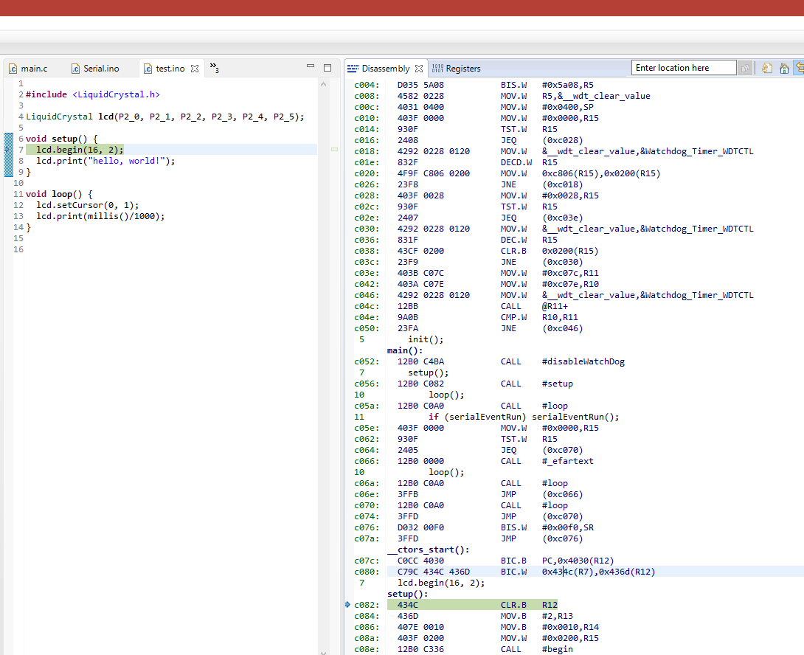

The code has been converted to assembly

### Result

After press Run , the Program worked :

