DATA SCIENCE PROJECT REPORT

MENTAL HEALTH ANALYZER
Comprehensive Analysis and Implementation

Submitted by:
- Mansha Mehboob Ali 26140 (EDA)
- Hamood ur Rehman 23890 (Feature engineering, report)
- Saad Yousef 22639 (preprocessing, model trainning)
- Laiba Parveen 22718 (css, ppt)
Date: 10 September 2025
Institution: Iqra University
Course: Data Science

Contents
1. INTRODUCTION 3
1.1 Project Overview 3
1.2 Problem Statement 3
1.3 Project Objectives 3
1.4 Key Features 3
2. DATASET DESCRIPTION 3
2.1 Data Source 3
2.2 Characteristics 4
2.3 Feature Categories 4
2.4 Target Variable 4
2.5 Data Distribution 4
3. METHODOLOGY 4
3.1 Data Processing 4
3.2 Feature Selection 4
3.3 Machine Learning Models 5
3.4 Model Selection 5
3.5 Prediction Pipeline 5
3.6 Web Application 5
4. ENVIRONMENTAL SETUP 5
5. RESULTS AND EVALUATION 6
5.1 Performance 6
5.2 Feature Selection Impact 6
5.3 Class Imbalance 6
5.4 Web App & Deployment 6
6. FUTURE WORK 7
7. ARCHITECTURAL DIAGRAM 7
8. CONCLUSION 7

1. INTRODUCTION

1.1 Project Overview
The Mental Health Analyzer is a machine learning-based system designed to predict whether a student requires counseling.
It integrates psychological, academic, and lifestyle indicators to provide early detection of students in need of support

1.2 Problem Statement
- Student mental health challenges such as depression, anxiety, and stress are rising.
- Traditional detection is often late, resulting in academic decline and dropout.
- Early intervention systems are limited in most institutions.

1.3 Project Objectives
- Predict counseling needs from student survey data.
- Provide a user-friendly web interface for counselors.
- Build a robust ML pipeline optimized for real-world deployment.
- Handle class imbalance effectively while maintaining interpretability.

1.4 Key Features
- Advanced feature selection.
- Rule-based target creation for “IsCounselingNeeded.”
- End-to-end ML pipeline with input validation.
- Flask web application with Docker deployment (later).

2. DATASET DESCRIPTION

2.1 Data Source
- 1,000 anonymized student survey responses.
- Covers demographics, academics, and mental health.
- Data collected ethically and anonymized.

2.2 Characteristics
- Samples: 1,000
- Features: 15 predictors + 1 target
- Data Quality: Clean, no missing values

2.3 Feature Categories
- Demographics: Gender, Age
- Academic: CGPA, StudyHoursPerWeek, StudyStressLevel, AcademicEngagement
- Mental Health: Depression, Anxiety, PanicAttack, SpecialistTreatment
- Support: SymptomFrequency_Last7Days, HasMentalHealthSupport, SleepQuality

2.4 Target Variable
- IsCounselingNeeded (0 = No, 1 = Yes)
- Defined using rule-based logic combining academic, stress, and mental health indicators.

2.5 Data Distribution
- Highly imbalanced (≈99.7% positive cases).
- Strong correlation between CGPA & StudyHours (0.93).
- Perfect correlation between SpecialistTreatment & HasMentalHealthSupport (1.0).

3. METHODOLOGY

3.1 Data Processing
- Target variable creation from survey logic.
- Removal of irrelevant columns (Timestamp, Course, etc.).
- Stratified 70–30 train-test split.

3.2 Feature Selection
- Statistical (Chi-Square, ANOVA, Mutual Info).
- Model-based (LASSO, Random Forest, RFE).
- Final: 8 optimal features selected (38% reduction, 99% performance retained).
- Performance Comparison
Method | Features | F1 Score | Accuracy
All Features | 13 | 0.979 ± 0.013 | 0.960 ± 0.024
Chi-Square | 8 | 0.977 ± 0.015 | 0.956 ± 0.029
F-Classify | 8 | 0.977 ± 0.015 | 0.956 ± 0.029
Ensemble | 8 | 0.977 ± 0.015 | 0.956 ± 0.029
RFE | 8 | 0.976 ± 0.015 | 0.954 ± 0.029

3.3 Machine Learning Models
- Algorithms tested: Random Forest, Decision Tree, Gradient Boosting, Logistic Regression, XGBoost, CatBoost, AdaBoost.
- Hyperparameter tuning via GridSearchCV optimizing F1-score.

3.4 Model Selection
- Metric: F1-score due to severe imbalance.
- Achieved F1 > 0.95 and Accuracy > 0.90 consistently.

3.5 Prediction Pipeline
- Input validation, preprocessing, prediction, and error handling.

3.6 Web Application
- Flask-based web app with user-friendly input form.
- Dockerized for deployment, scalable and reliable.

4. ENVIRONMENTAL SETUP
- Python: 3.8+
- Libraries: scikit-learn, pandas, numpy, xgboost, catboost, Flask, matplotlib, seaborn.
- Monitoring: Logging with error tracking.

5. RESULTS AND EVALUATION

5.1 Performance
- F1-Score: >0.95
- Accuracy: >0.90
- Balanced precision & recall across validation folds

5.2 Feature Selection Impact
- Reduced features from 16 → 8 with minimal drop (~0.2%).
- Top features:

- SymptomFrequency_Last7Days
- StudyStressLevel
- Depression
- PanicAttack
- Gender
- CGPA
- Anxiety
- StudyHoursPerWeek

5.3 Class Imbalance
Managed using stratified sampling, class weighting, and F1 optimization.

5.4 Web App & Deployment
- Sub-second response time
- Edge case handling validated
- Scalable via Docker containerization
- User-friendly for counselors and administrators

6. FUTURE WORK
- Expand dataset to 10,000+ students across institutions.
- Apply SMOTE and other methods for class balancing.
- Explore deep learning models and ensemble stacking.
- Add interpretability tools (SHAP, LIME).
- Enhance UI with dashboards and mobile app support.
- Deploy at scale (microservices).

7. ARCHITECTURAL DIAGRAM
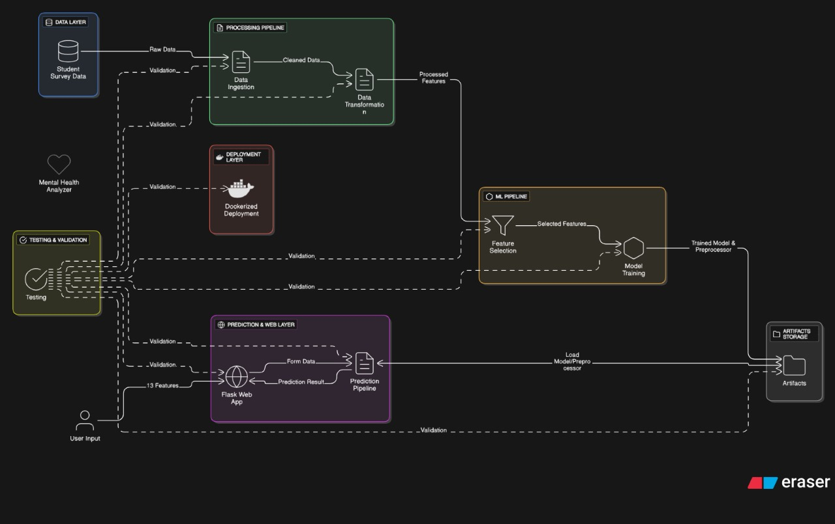

8. CONCLUSION
The Mental Health Analyzer demonstrates how machine learning can provide early detection of student mental health risks.
Key achievements include:
- A robust ML pipeline with F1 > 95%.
- Optimized feature selection reducing input complexity.
- A production-ready web application deployed in Docker.
This system has significant potential to improve student well-being by enabling timely interventions, reducing dropout risk, and supporting counselors in educational institutions.

