Project charter : Le clou doré

Project Objectives:

First objective is to have a functional API: it has to be included within the current website, so that it delivers static page and also handles CRUD operation. By the end a user should be able to create read update and delete his profile and read products. The admin should be able to Create Read Update and Delete product.
Timeline : One week

Second objective is to have a functional front end. The front end should include the already existing content, correct some aspect of the website such as the footer and add more pages in order to create a shop and a student profile
Timeline : One week

Stakeholders and Roles:
This project would be a “one man team” although there should be some input to gather from external sources.

The client → Atelier le clou doré
the shop owner input would be gathered at early stages and throughout the development

the current web agency → visicode
When taking over their website I will have to meet with them for exchanging on their work and discuss the handover.

Potential risk:
The time limit : On top of this project I also have some extra work on the side and therefore time would very valuable.
The team size: some choices would be made in order to avoid too much experimentation although the decisions process would be fast, it is also expected that some will be mistakes.

High-Level Plan: Timeline or phases of the project.

To try and focus the effort on one area at a time and keep complexity at a minimum 3 areas of work have been detected and 1 week of effort is dedicated to each

- The back end
- The Front end
- Problem solving

Here is a basic timeline.

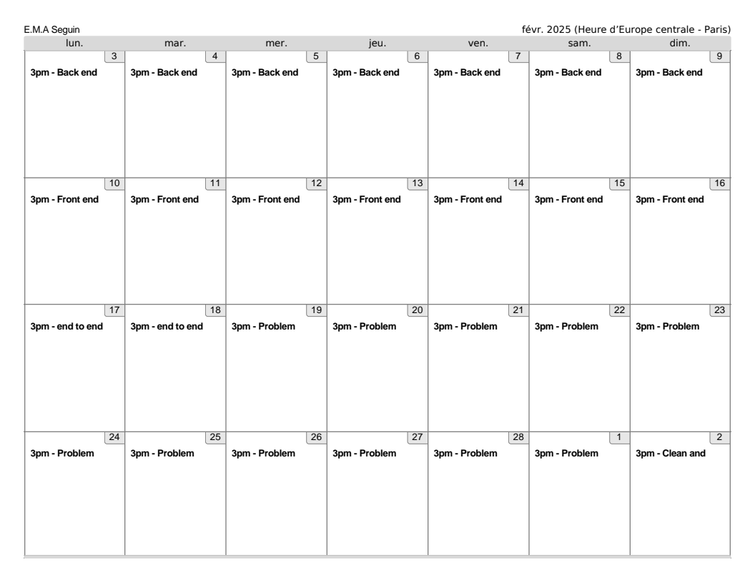
The volume available is 3hours per day including week end although it is mainly meant to be a guideline it is very much subject to unexpected event.

