Technical documentation: le clou doré

User stories and wire-frame

In this context the client is the end user who is a client to the shop owner and the shop owner is referred to as admin

As a client I want to buy a product online because I want them

As a client I want to offer lessons to a family member because it will make a good gift

As an admin I want to advert my shop and sell courses online because I want to diversify revenue sources

Below are two wire-frame highlighting the addition to make to the website.

SHOP PAGE

The shop page would present the available product and allow user either logged in or not to purchase them.

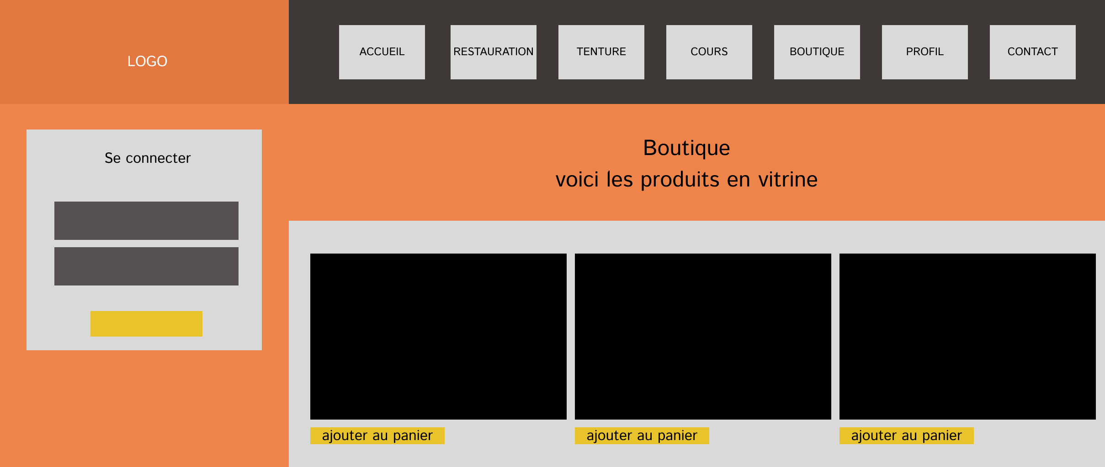

HOMEPAGE
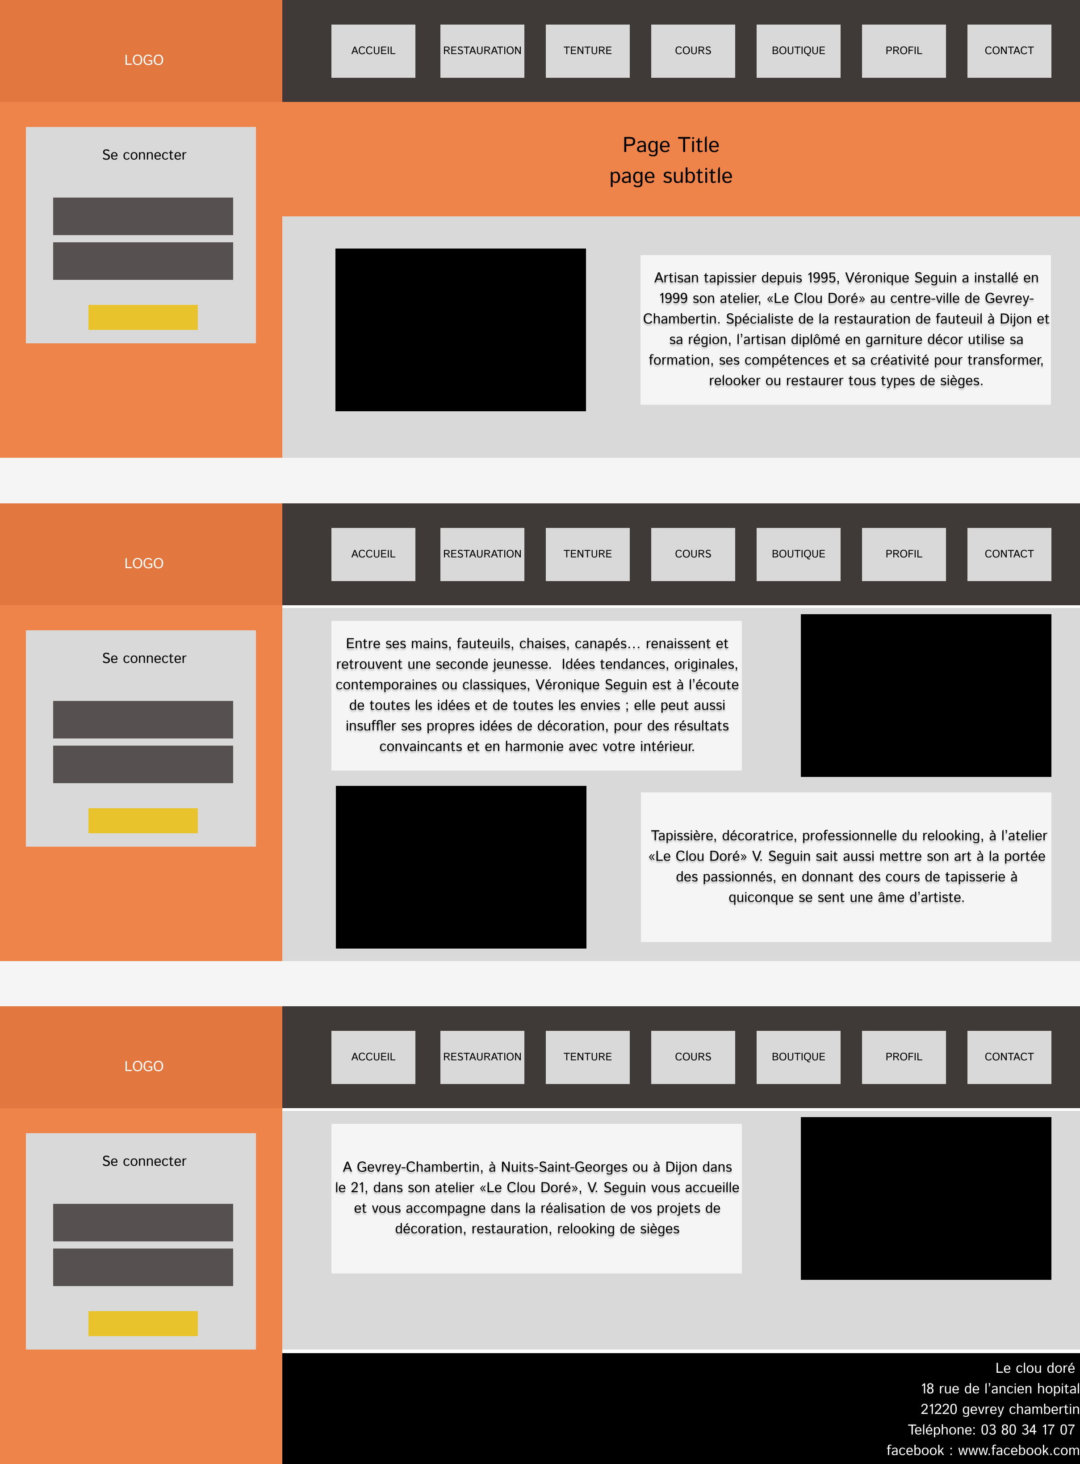
The homepage with added sections and a sticky navigation bar as well as a footer updated. Also on the side it is possible for students to log in.

System architecture

The system architecture is a simple monolith, for couple of reason:

Project scale :
The size of the project for the moment does not need to be overly-complex it is a trade off between simplicity of the overall architecture versus the advantages of highly specific tools

Framework mileage:
Because it is a framework I have already used there is a some benefits in diving further in the framework features.
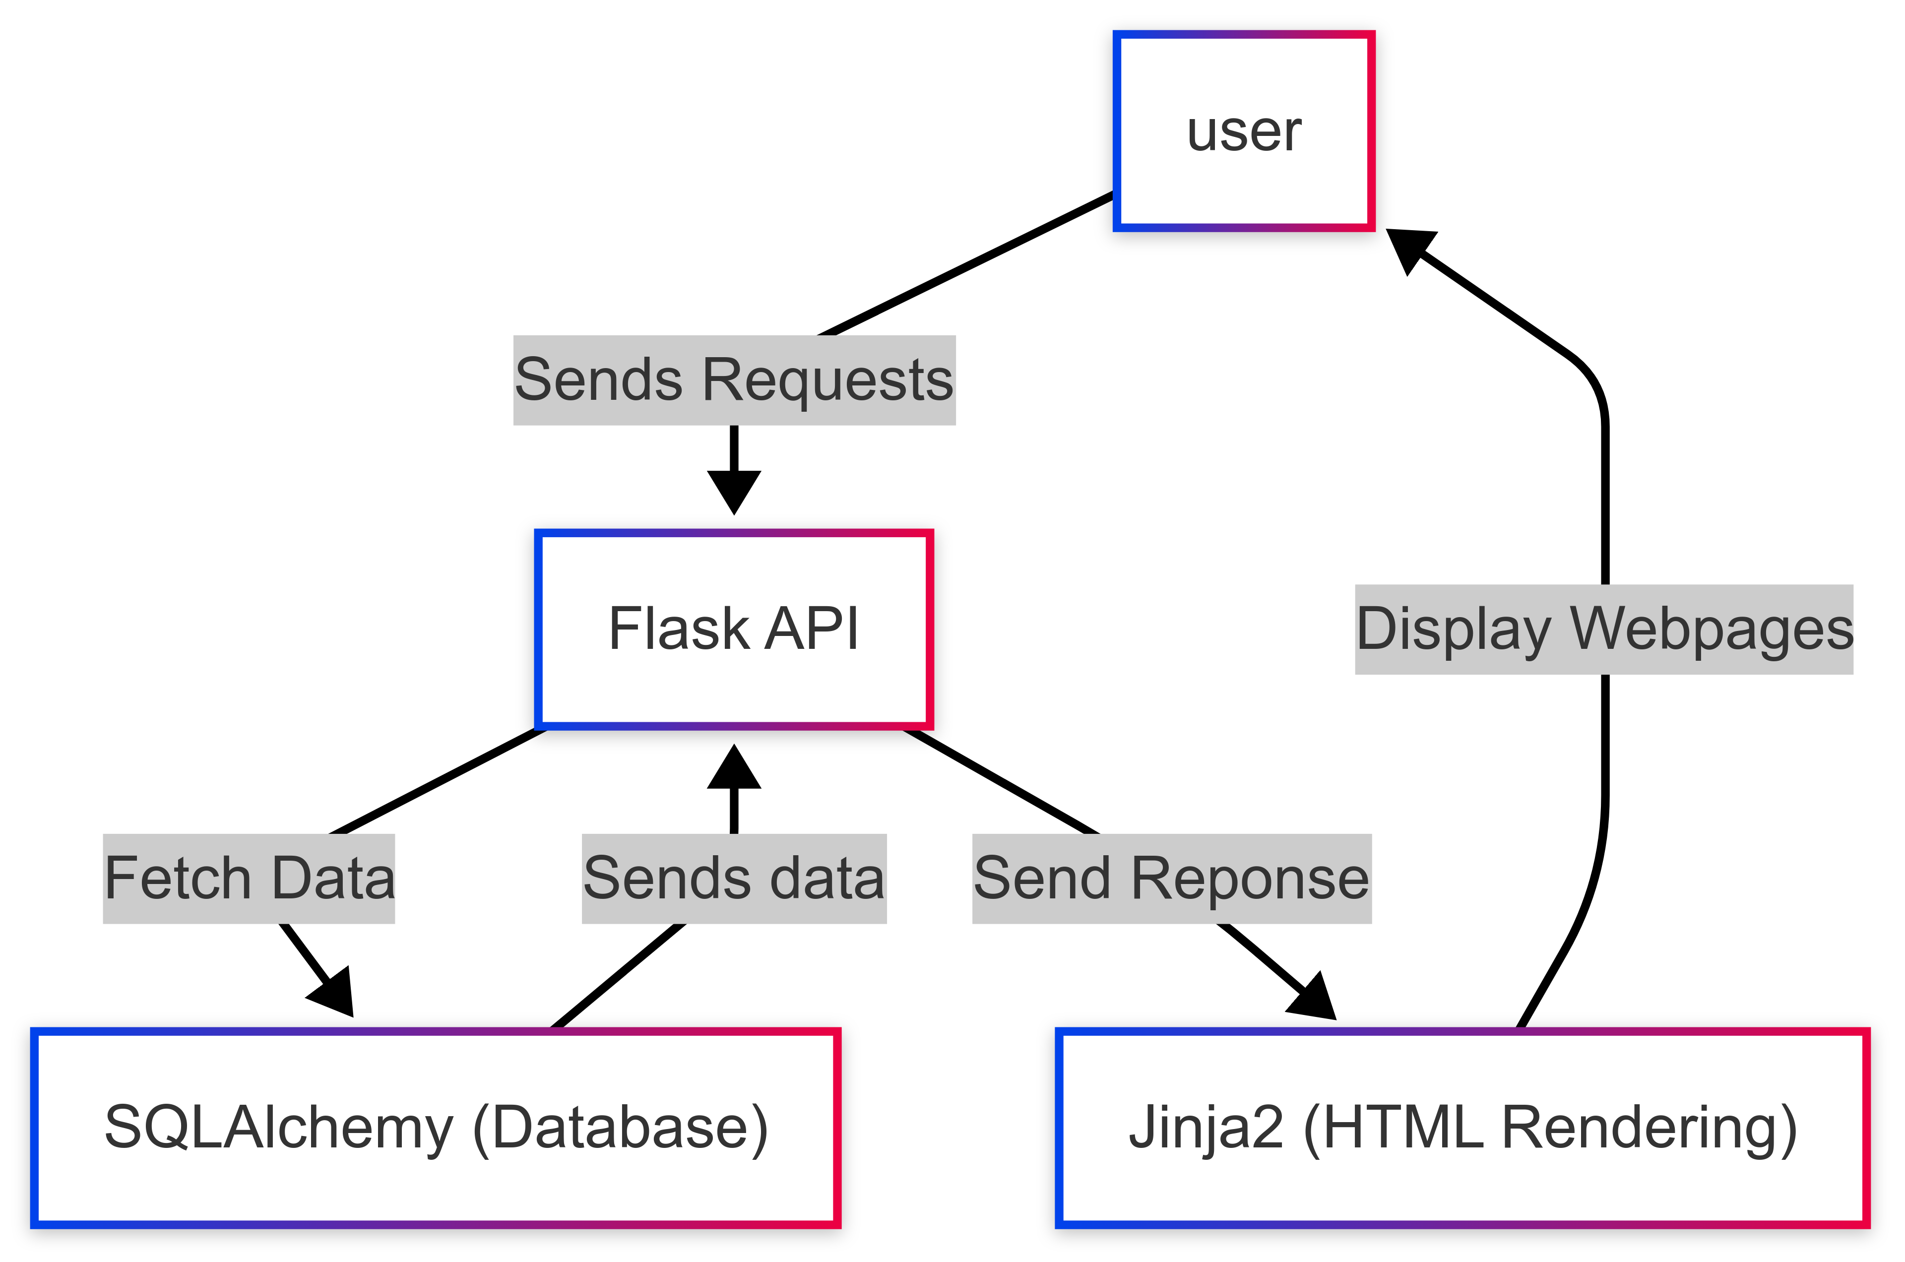

Component Classes and Database Design
Here are the classes diagram for the user, the product and the session class
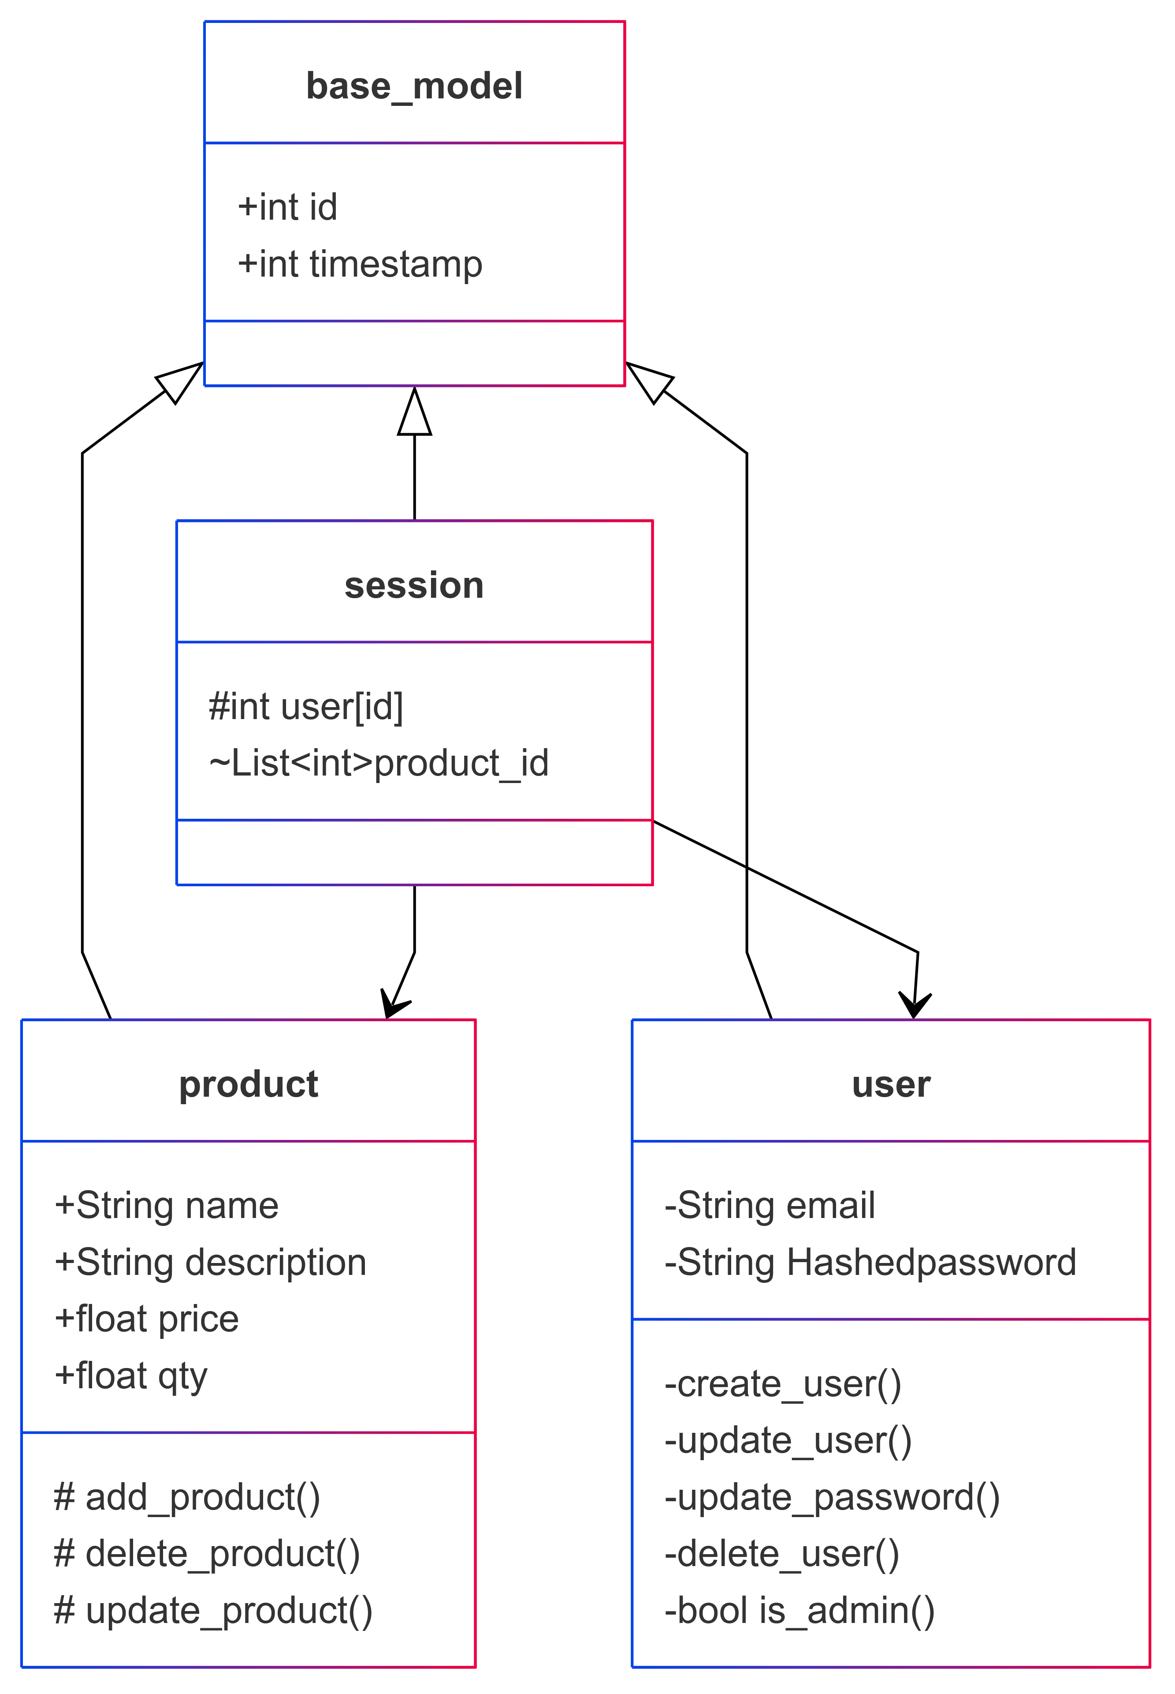

Sequences diagram:
We will now look at 2 sequences, the user login and the user purchase:
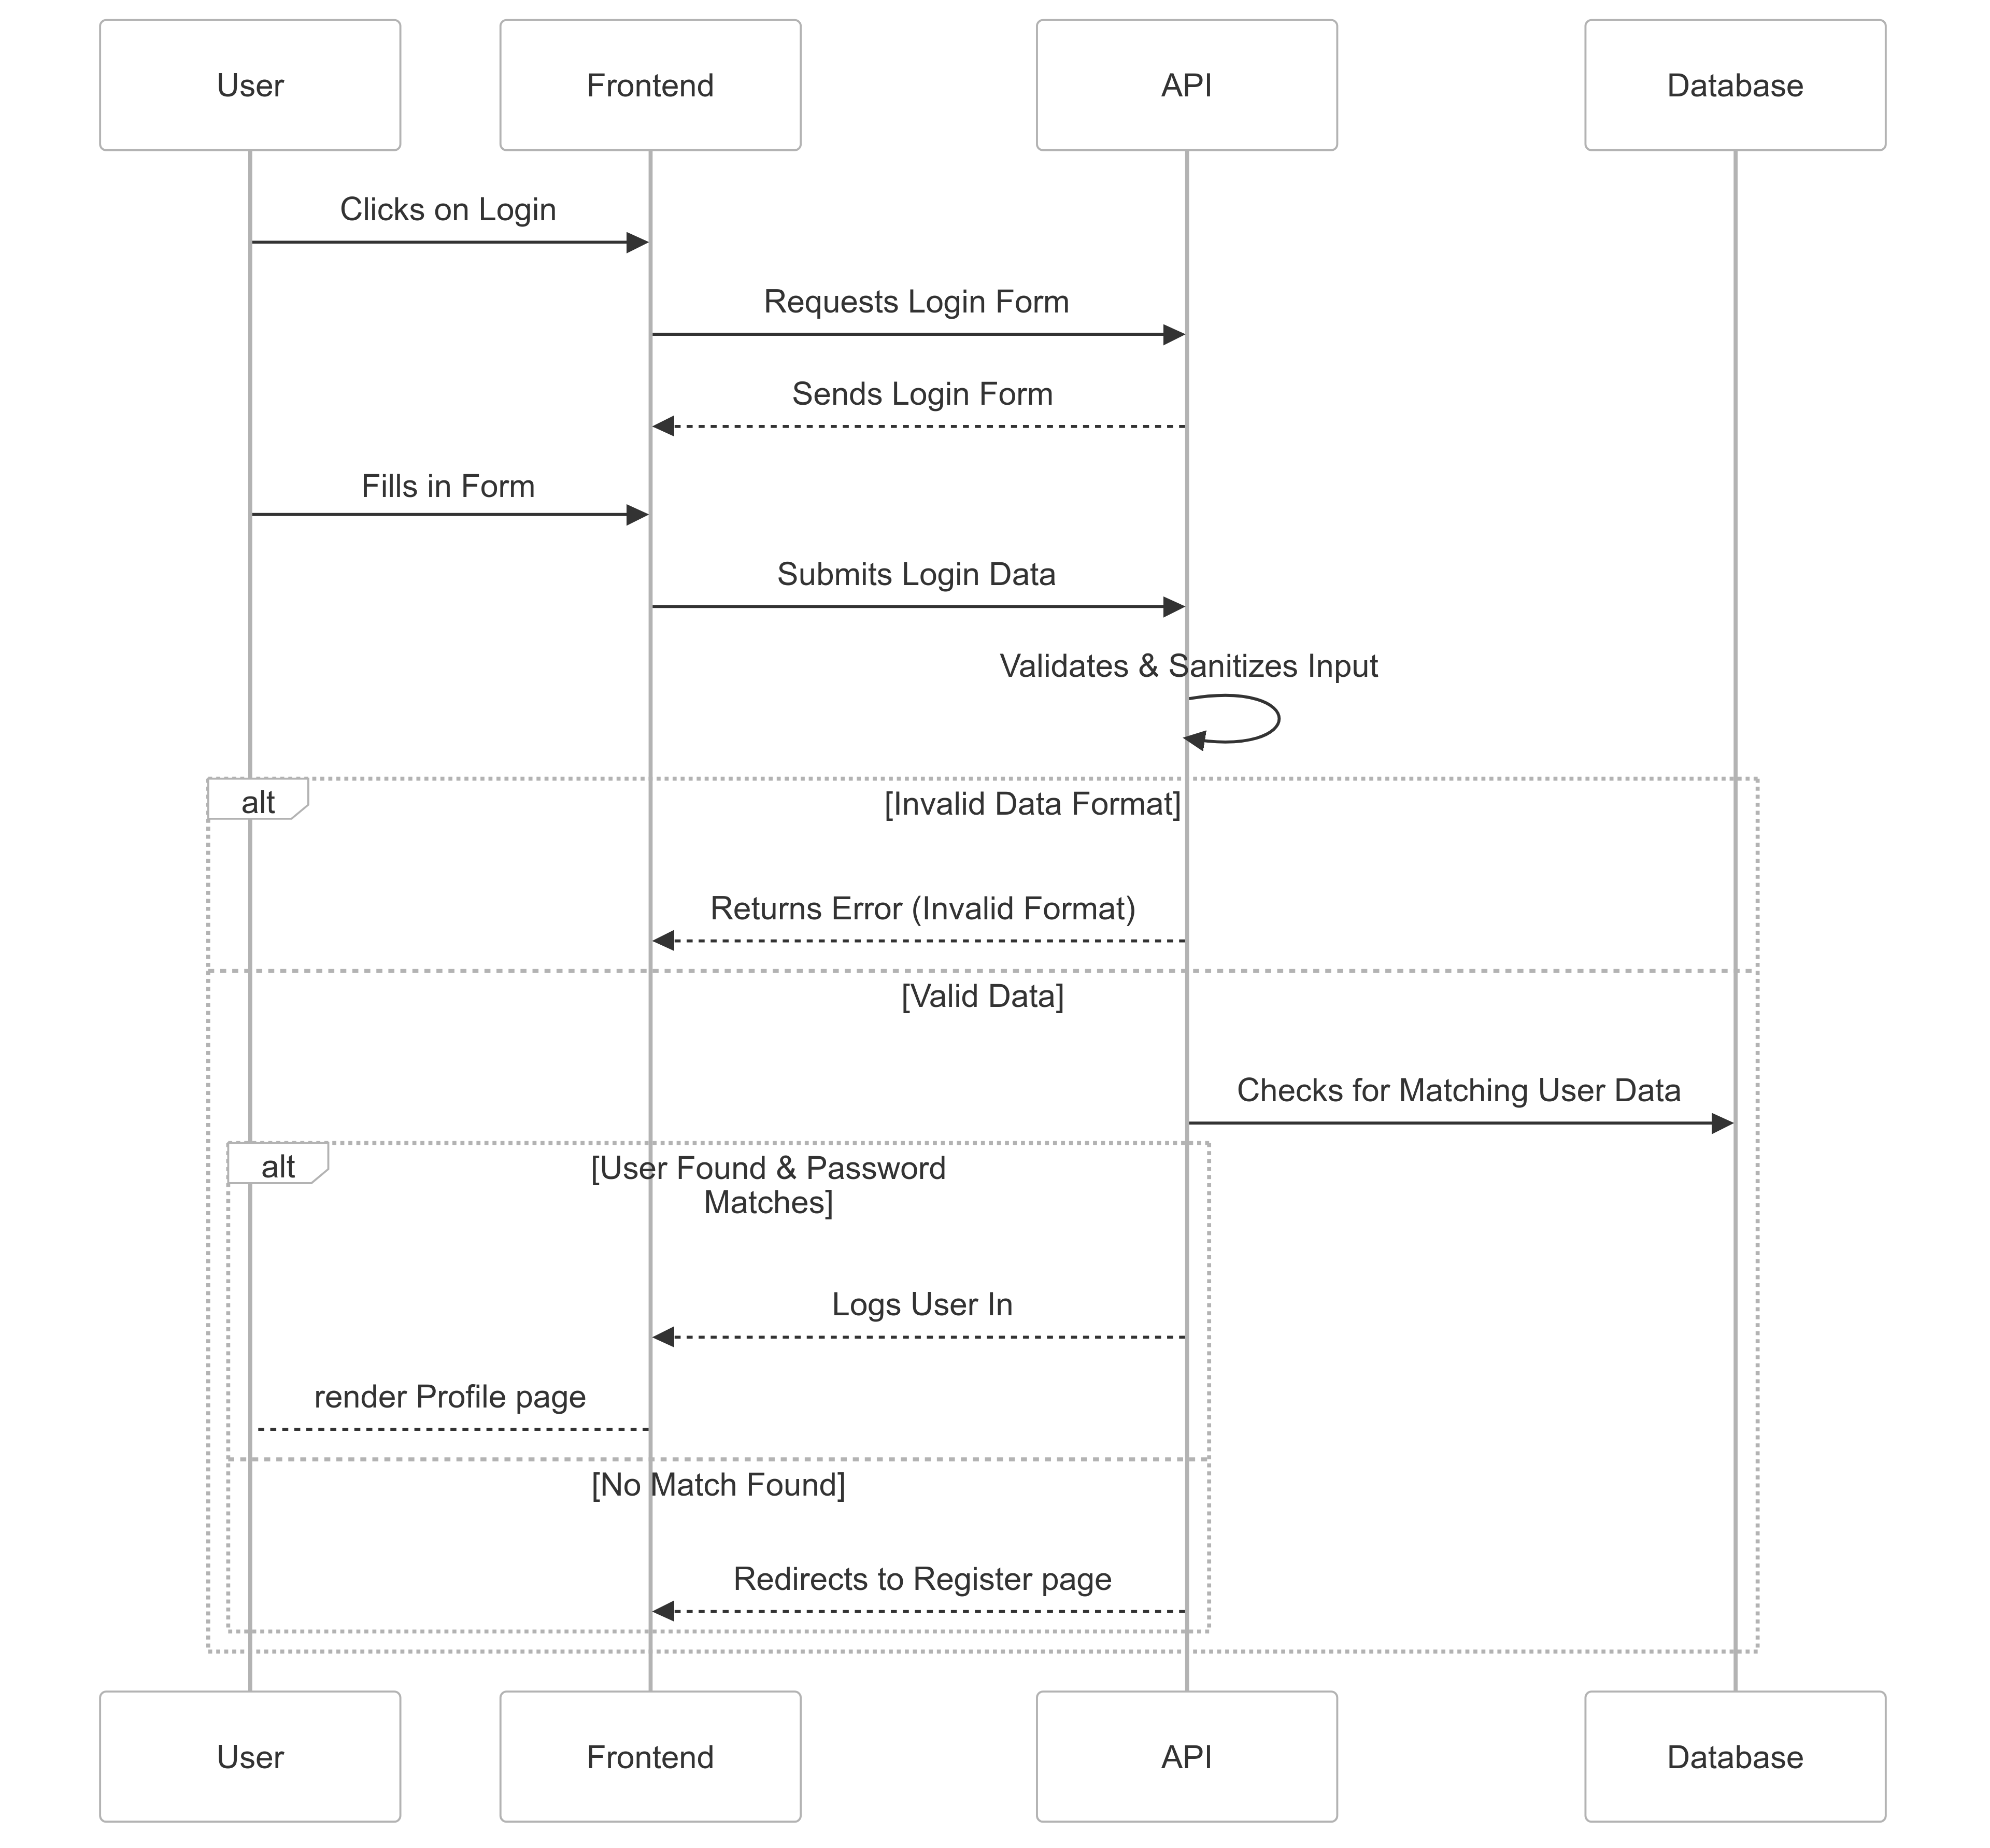

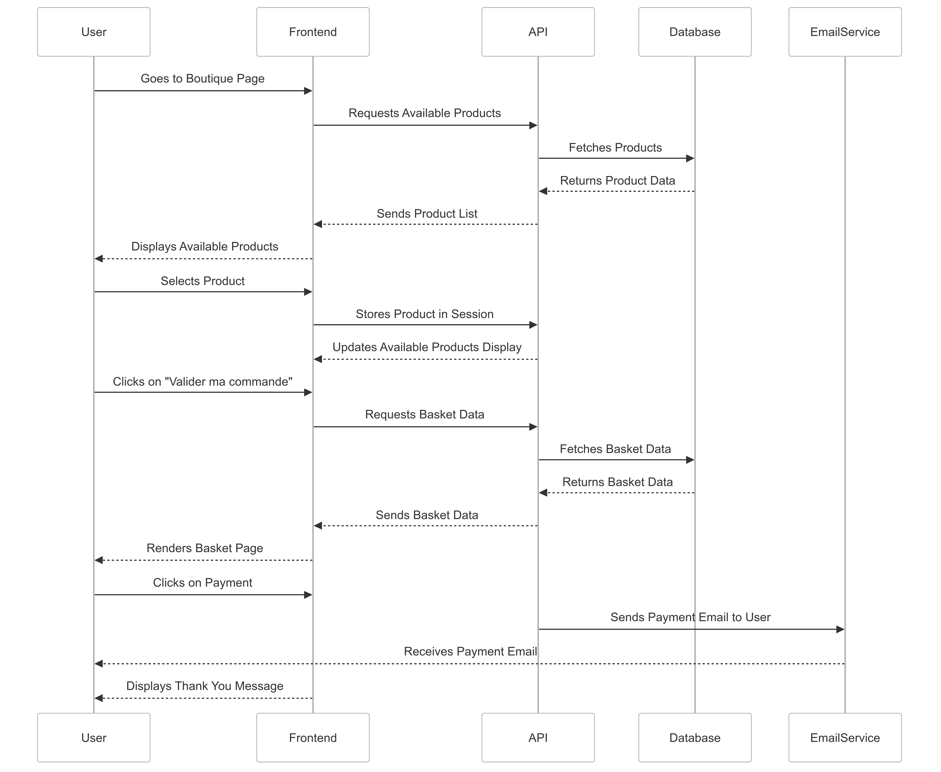

Databases tables
The current application is using a relational database, mainly for practicing sql and also the size of the project allows it. Although a document oriented database is said to be favored at the moment making sql request vs writing json is both more appealing and does not really matter.

Users table
- user_id prim.key
-email
-name
-lastname
-passwordhash
-is_admin
Product table:
-Product_id prim.key
-name
-description
-price
-qty

Session table:
-user_id
-product_id []

API

One main point of focus is to manage payment seamlessly for the user. Here is a list of external api considered to handle the payment system

STRIPE
A know solution in order to handle payment is stripe. Which is considered inexpensive and well featured. The current challenge would be to set up a good testing environment for payment solution
BPBFC
There is also an alternative which implies the bank provider, there is an advantage in the fact that it is a partner to the company they also provide support with a french speaking advisor.

At the moment none has been chosen as it is too early to decide, also other solution might be handy.

At the moment it is very early to decide what would be worth implementing. Although the BPBFC seems to be easier to implement because of the support provided.

