Ho Yu College and Primary School (Sponsored by Sik Sik Yuen)
First Term Examination (2025– 2026)
Secondary 5 | Name
Physics | Class
Paper 1 Section A | Class number
Time Allowed：2 hours 30 minutes
____________________________________________________________
Stationery : Rough-work sheet (1) Multiple-choice answer sheet (1)
GENERAL INSTRUCTIONS
(1) There are TWO sections, A and B, in this Paper. Section A consists of 33 questions (35% of Paper 1); Section B consists of 11 questions, 83marks (65% of Paper 1). You are advised to finish Section A in about 60 minutes.
(2) Section A consists of multiple-choice questions in this question paper, while Section B contains conventional questions printed separately in Question-Answer Book.
(3) Answers to Section A should be marked on the Multiple-choice Answer Sheet while answers to Section B should be written in the spaces provided in Question-Answer Book. The Answer Sheet for Section A and the Question-Answer Book for Section B will be collected separately at the end of the test.
(4) The diagrams in this paper are NOT necessarily drawn to scale.
(5) The last two pages of this question paper contain a list of data, formulae and relationships which you may find useful.

INSTRUCTIONS FOR SECTION A (MULTIPLE-CHOICE QUESTIONS)
(1) Read carefully the instructions on the Answer Sheet. After the announcement of the start of the test, you should first write down your Name, Class and Class Number in the spaces provided. No extra time will be given after the ‘Time is up’ announcement.
(2) When told to open this book, you should check that all the questions are there. This Section consists of 14 pages. Look for the words ‘END OF SECTION A’ after the last question.
(3) All questions carry equal marks.
(4) ANSWER ALL QUESTIONS. You are advised to use an HB pencil to mark all the answers on the Answer Sheet, so that wrong marks can be completely erased with a rubber. You must mark the answers clearly; otherwise you will lose marks if the answers cannot be captured.
(5) You should mark only ONE answer for each question. If you mark more than one answer, you will receive NO MARKS for that question.
(6) No marks will be deducted for wrong answers.
Section A
There are 33 questions. Questions marked with * involve knowledge of the extension component.
1. A student wants to find out the temperature of the flame from a Bunsen burner. She heats a metal block with the flame for some time and transfers it quickly to a beaker of water. She obtains the following data:
Heat capacity of metal block = 50 J °C⁻¹
Heat capacity of water in beaker = 650 J °C⁻¹
Heat capacity of beaker = 70 J °C⁻¹
Initial temperature of water = 18 °C
Final temperature of water = 42 °C
The temperature of the flame is about
A. 330 °C B. 352 °C C. 388 °C D. 450 °C

2. A cup of water at 20 °C is heated by an immersion heater of constant power. Its temperature is
32 °C after it is heated for 1 minute. What is its temperature if it is heated for 3 minutes from
20 °C? The energy loss to the surroundings is negligible.
A. 40 °C B. 50 °C C. 56 °C D. 48 °C

3. Two beakers contain equal mass of water at different temperatures. Which of the following statements is correct?
A. They have the same mass, so they have the same internal energy.
B. They have the same average molecular KE, so they have the same internal energy.
C. They have the same molecular KE but the hot water has more molecular PE, so the hot water has more internal energy.
D. They have the same molecular PE but the hot water has more molecular KE, so the hot water has more internal energy.

4. Which of the following statements is/are correct?
(1) Conduction can take place in any medium except a vacuum.
(2) Convection can take place in any medium except a vacuum.
(3) Radiation can only take place in a vacuum.
A. (1) only B. (2) only
C. (1) and (2) only D. (2) and (3) only

5. A ball is thrown vertically upwards and then returns to its starting position as shown.
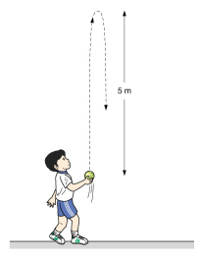
5 m
What is the total displacement of the ball in the whole journey?
A. 0 B. 5 m upwards
C. 5 m upwards then 5 m downwards D. 10 m downwards

6. A 3-kg box is pushed by a horizontal force of 21 N. The box moves horizontally with an acceleration of 4 m s^{–2}.
3 kg
4 m s⁻²
21 N
What is the frictional force acting on the box?
A. 6 N B. 8 N C. 9 N D. 12 N

7. The displacement–time graph below shows the motion of an object moving along a straight line. Find the average velocity of the object from t = 0 to t = 10 s.
0
5
10
15
20
time / s
displacement / m
2
4
6
8
10
A. 1.5 m s^{–1} B. 2 m s^{–1} C. 2.5 m s^{–1} D. 11 m s^{–1}

8. A hawk is flying with an initial speed of 30 m s⁻¹ along a straight line in the sky. Its acceleration−time graph is shown below.
a / m s⁻²
t / s
50
100
0
−0.3
What is the displacement of the hawk from 0−100 s?
A. 1125 m B. 1500 m C. 2625 m D. 3375 m

9. Two boxes X and Y are pushed to move on a rough horizontal surface by a force of 45 N as shown in figure below. The masses of X and Y are respectively 2 kg and 4 kg. Both boxes move with constant velocity. The friction acting of Y is twice that acting on X.
X
Y
45 N
What is the magnitude of the force acting on X by Y?
A. 15 N B. 22.5 N C. 30 N D. 45 N

10. Three forces act on a particle P as shown below. A fourth force F acts on P to keep it in equilibrium. Find the magnitude of F.
P
4 N
2 N
1 N
50°
A. 2.87 N B. 4.58 N C. 5.02 N D. 5.30 N

11. In which of the following cases is the net moment about point O the largest?
A. | 10 N  3 cm  4 cm  O  10 N | B. | 10 N  3 cm  4 cm  O  10 N
C. | 10 N  3 cm  4 cm  O  10 N | D. | 10 N  3 cm  4 cm  O  10 N
12. Bonnie pushes a handcart on a horizontal ground in a supermarket. The horizontal force exerted by Bonnie is 3 N and the speed of the handcart is 0.3 m s⁻¹. What is Bonnie’s output power on the handcart?
A. 0.9 W B. 2.7 W C. 3.3 W D. 10 W

13. Berry of mass 60 kg goes bungee jumping. He rebounds after reaching the lowest position X, which is 50 m below the starting point O. When he reaches position Y, which is 40 m below O, he moves upwards at 5 m s⁻¹. He moves along a straight line through the jump. Neglect air resistance and Berry’s size.
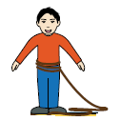
O
X
Y
50 m
40 m
Find the change in the elastic potential energy stored in the string when Berry moves from X to Y.
A. −6640 J B. −5140 J C. 5140 J D. 6640 J

14. Two objects of different masses fall from the same height in a vacuum. Which of the following statements is/are correct?
(1) The heavier object falls faster.
(2) The power input to the heavier object is larger.
(3) The heavier object loses more potential energy.
A. (3) only B. (1) and (2) only
C. (2) and (3) only D. (1), (2) and (3)
15. On a smooth horizontal surface, two moving objects X and Y collide head on. Which of the following quantities is/are conserved if the collision is inelastic?
(1) Total kinetic energy of X and Y
(2) Total momentum of X and Y
(3) Momentum of X
A. (1) only B. (2) only C. (1) and (2) only D. (1), (2) and (3)

16. Trolley X of mass 2 kg moves at constant velocity of 3 m s⁻¹ towards the right and trolley Y of mass 1.5 kg moves at a constant velocity v towards the left on a smooth horizontal track. The trolleys stop after colliding with each other. Find v.
A. 0.857 m s⁻¹ B. 2.25 m s⁻¹ C. 3 m s⁻¹ D. 4 m s⁻¹

17. A wooden block of mass 300 g is at rest on the smooth horizontal ground. A horizontal force of
20 N is then applied on it as shown below. If the force lasts for 5 s, what is the magnitude of the final momentum of the wooden block?
20 N
A. 20 kg m s⁻¹ B. 100 kg m s⁻¹ C. 150 kg m s⁻¹ D. 333 kg m s⁻¹

*18. A ball is projected horizontally from the top of a building at 20 m s⁻¹. Assume that there is no air resistance. What is its horizontal speed 5 s later?
A. 10 m s^{–1} B. 20 m s^{–1} C. 29 m s^{–1} D. 69 m s^{–1}

*19. Two balls A and B are held at the same height. The mass of B is twice that of A. At the same instant, A is released from rest while B is projected horizontally with speed u. Which of the following statements are correct? Neglect air resistance.
(1) A and B reach the ground at the same time.
(2) A and B have the same acceleration.
(3) A and B have the same vertical speed on reaching the ground.
A. (1) and (2) only B. (1) and (3) only
C. (2) and (3) only D. (1), (2) and (3)

*20. When an object moves in uniform circular motion,
(1) its speed varies with its position.
(2) its acceleration varies with its position.
(3) the direction of its velocity changes all the time.
A. (1) and (2) only B. (1) and (3) only
C. (2) and (3) only D. (1), (2) and (3)

*21. As shown in the figure below, a particle of mass 10 g is rolling at a constant speed along a horizontal circular path on a cone-shaped frictionless surface.
Find the angular speed of the particle.
A. 17.2 rad s^{–1} B. 18.4 rad s^{–1}
C. 19.8 rad s^{–1} D. Cannot be determined

*22. The planet Uranus has a radius about 4 times that of the Earth. The mass of Uranus is about 15 times that of the Earth. Estimate the acceleration due to gravity near Uranus’s surface. Take the acceleration due to gravity near the Earth’s surface as 9.81 m s⁻².
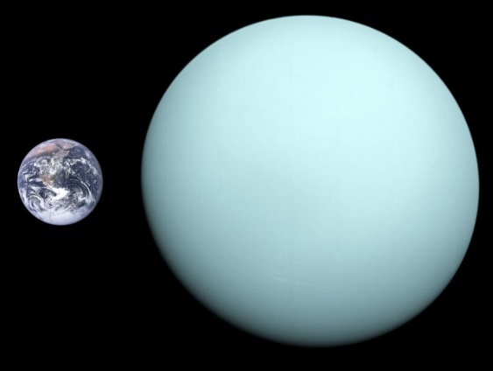
Earth
Uranus
A. 9.0 m s⁻² B. 9.2 m s⁻² C. 9.6 m s⁻² D. 9.9 m s⁻²

23. Ivan of height 1.8 m checks his appearance from a plane mirror before he leaves home for school. His eyes are 10 cm below the top of his head. The ray diagram below shows that he can just see his whole body in the mirror.
Ivan
Ivan’s image
Which of the following statements is/are correct?
(1) The length of the mirror is 0.9 m.
(2) His image will be larger if he walks towards the mirror.
(3) He can only see part of his image if he walks towards the mirror.
A. (1) only B. (1) and (3) only
C. (2) and (3) only D. (1), (2) and (3)

24. Three light rays enter an air bubble in water. C is the centre of the bubble. Which of the paths shown below is/are correct?
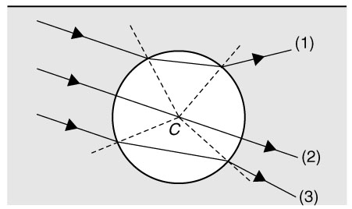
water
air
A. (2) only B. (1) and (2) only
C. (1) and (3) only D. (1), (2) and (3)

25. According to the figure, which of the following descriptions of the image I is correct?
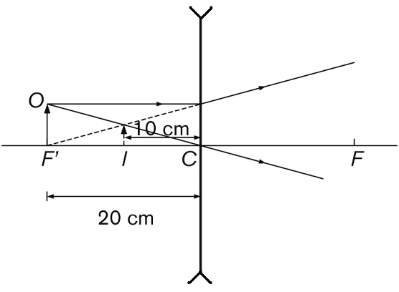
 | Magnification | Image nature
A. | 0.5 | real
B. | 0.5 | virtual
C. | 2 | real
D. | 2 | virtual

26. A convex lens of focal length 20 cm is 35 cm away from the letter ‘F’ shown below. The image formed is captured by a screen.
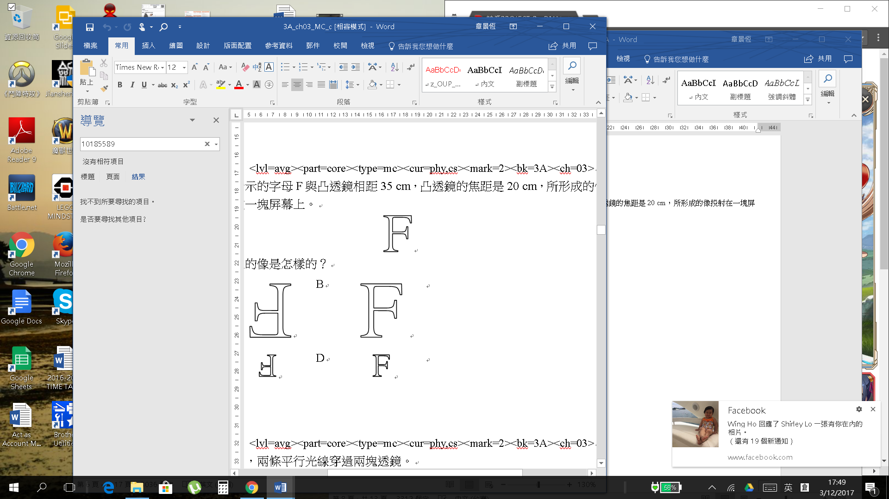
Which of the following best shows the image on the screen? 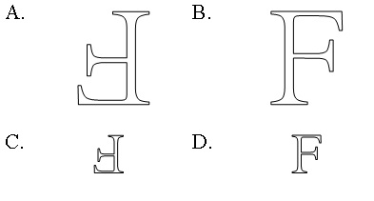

27. A sinusoidal wave is travelling at speed 1.5 m s^{–1} with frequency 2 Hz and amplitude 5 cm in a medium.
Which of the following is a /are possible speed of a particle in the medium?
(1) 0
(2) 0.4 m s^{–1}
(3) 1.5 m s^{–1}
A. (1) only B. (1) and (2) only
C. (2) and (3) only D. (1), (2) and (3)

28. The figure below shows a longitudinal wave travelling through some particles.
What is the amplitude of the wave?
A. 2 cm B. 3 cm C. 4 cm D. 5 cm

29. A boy sees a lightning at the sky and hears the sound of thunder 3 s later. It is given that the speed of sound in the air is 340 m s⁻¹, how far is he from the thunderstorm?
A. 510 m B. 1020 m C. 2040 m D. 2550 m

30. The figure shows an electric field line.
X
Y
Which of the following statements is correct?
A. The electric field strength at X must be stronger than that at Y.
B. The electric field strength at X must be weaker than that at Y.
C. The electric field strength at X must be equal to that at Y.
D. It is impossible to determine which point has a stronger electric field strength from the information given.

31. Three light plastic strips are used in an experiment on electrostatics. It is found that P and Q attract each other but there is no force between Q and R.
Which of the following statements must be correct?
A. P and Q are of the same charge. B. P and Q are of opposite charges.
C. Q and R are of opposite charges. D. R is uncharged.

*32. Four point charges W (−2Q), X (+Q), Y (–3Q) and Z (+Q) are placed at the vertices of a square of side length d as shown.
Find the electric field strength at the centre of the square.
A. (towards W) B. (towards Y)
C. (towards W) D. (towards Y)

33. Which of the following method(s) can make a neutral metal sphere to carry a positive charge?
(1) Put it beside a negatively charged object and touch it with a finger momentarily.
(2) Touch it using a positively charged metal sphere.
(3) Connect it to a positively charged metal sphere with a conducting wire and touch it with a finger momentarily.
A. (2) only B. (1) and (2) only
C. (1) and (3) only D. (1), (2) and (3)

END OF SECTION A

Blank Page
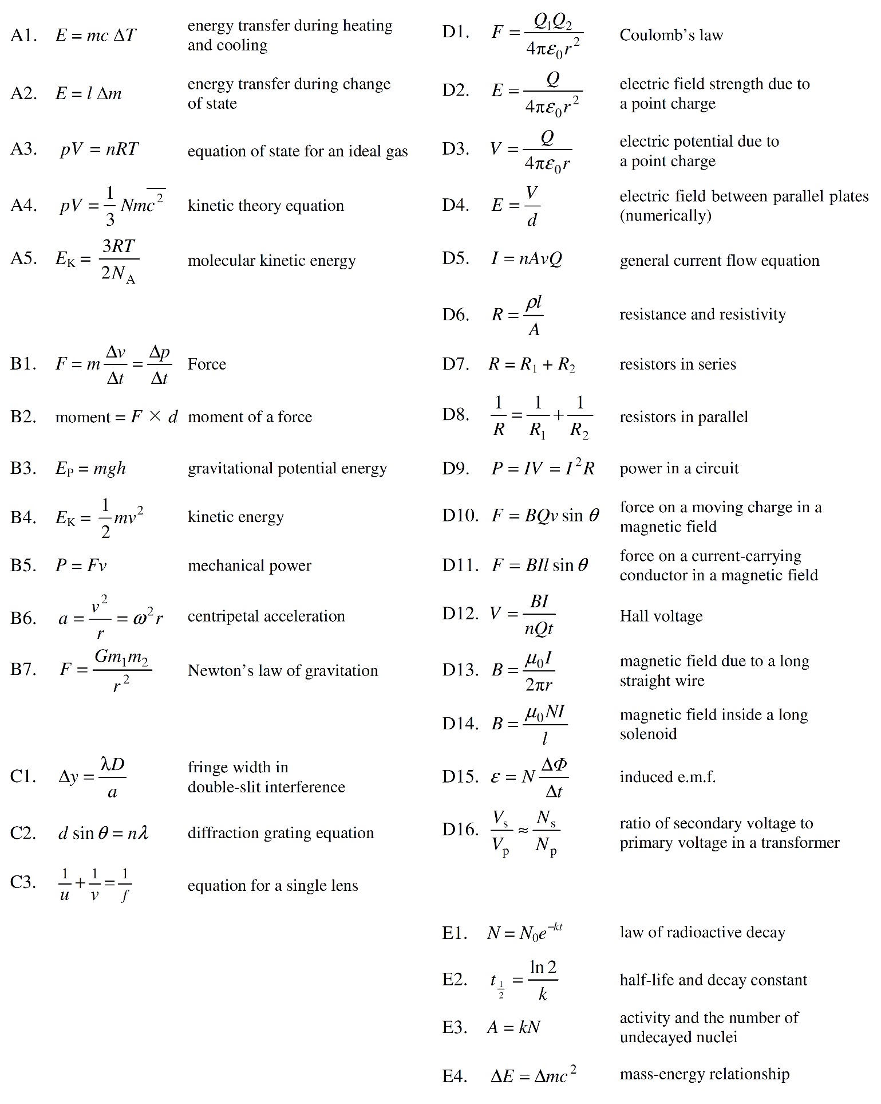

1 C 21 A
2 B 22 B
3 C 23 A
4 A 24 B
5 A 25 B

6 C 26 A
7 A 27 B
8 C 28 C
9 C 29 B
10 C 30 D

11 B 31 D
12 A 32 D
13 A 33 B
14 C
15 B

16 D
17 B
18 B
19 D
20 C

