Ho Yu College and Primary School (Sponsored by Sik Sik Yuen)
First Term Examination (2025 – 2026)

Secondary 5 | Name
Physics | Class
Paper 1 Section B | Class number

Question-Answer Book
____________________________________________________________

INSTRUCTIONS FOR SECTION B

(1) After the announcement of the start of the test, you should first write your Name, Class and Class Number in the spaces provided on Page 1.

(2) Refer to the general instructions on the cover of the Question Paper for Section A.

(3) This paper consists of 11 pages. Answer ALL questions.

(4) Write your answers in the spaces provided in this Question-Answer Book. Do not write in the margins. Answers written in the margins will not be marked.

(5) Graph paper and supplementary answer sheets will be provided on request. Write your information, mark the question number box on each sheet, and fasten them with string INSIDE this Question-Answer Book.

(6) No extra time will be given to candidates for writing their information after the ‘Time is up’ announcement.

Section B: Answer ALL questions. Parts marked with * involve knowledge of the extension component. Write your answers in the spaces provided.
Question | 1 | 2 | 3 | 4 | 5 | 6 | 7 | 8 | 9 | 10 | 11
Marks | 12 | 5 | 7 | 10 | 4 | 8 | 4 | 10 | 6 | 7 | 10
1. Bonny is an athlete of the sports team and has a mass of 55 kg. At the beginning of the practice, her body temperature increases at a rate of 2.5 × 10⁻³ °C s⁻¹.
(a) What is the rate of generating internal energy in her body if she loses energy through various processes at a rate of 280 W? Take the average specific heat capacity of the human body as 4100 J kg⁻¹ °C⁻¹. (2 marks)

(b) Explain, in terms of molecular motion, how she loses energy to the surroundings through sweating. (4 marks)

(c) After practicing for a while, her rate of losing energy through sweating increases to 300 W.
(i) Suggest a reason why the rate of losing energy through sweating increases after practising for a while. (1 mark)

(ii) Estimate the amount of sweat that evaporates in 10 s. The latent heat of vaporization of sweat is 2.26 × 10⁶ J kg⁻¹. (3 marks)

(d) Suggest two other ways that she loses energy to the surroundings. (2 marks)

2. A student stands on a weighing scale in a lift. The scale reading is 70 kg when the lift is stationary.
(a) If the lift travels downwards with a constant speed of 1.5 m s^{–1}, what is the scale reading? (1 mark)

(b) If the lift slows down at 1.5 m s^{–2} during the upward journey, what is the scale reading?
(3 marks)

(c) If an accident happened and the lift fell freely, what would be the scale reading? (1 mark)

3. A car of mass 1600 kg stops on a rough horizontal road due to an engine problem. A man pushes the car with a force of 900 N to restart it. The force makes an angle of 25° to the horizontal. The car moves along a straight line and accelerates uniformly from rest to 0.8 m s^{–1} in 4 s.
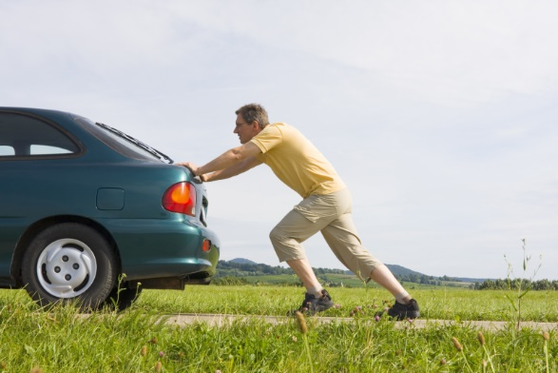Figure 3
25°
900 N
(a) Draw the free-body diagram for the car. Represent the car by a point. (2 marks)

(b) Find the magnitude of the friction acting on the car. (3 marks)

(c) Find the normal force acting on the car by the road. (2 marks)

4. In a routine physical training, Ivan, an athlete of mass 60 kg, runs up a flight of stairs of vertical height 4.5 m in 4 s at a constant velocity.
(a) How much potential energy does Ivan gain? (2 marks)

(b) Find Ivan’s average power. (2 marks)

(c) One way of comparing athletes of different sizes is to compare their power-to-weight ratios, which are equal to the power divided by the weight.
(i) Show that the power-to-weight ratio of Ivan is equal to his average vertical velocity.
(1 mark)

(ii) Tommy of mass 70 kg generates power of 700 W in the said training. Who, Ivan or Tommy, finishes the training in a shorter time? (3 marks)

(iii) Instead of running up the stairs, Alfred of mass 65 kg runs along the inclined runway as shown at a constant velocity of 6 m s⁻¹. Find Alfred’s power. (2 marks)
Figure 4
4.5 m
10°

5. In a snooker game, the white ball moves at 1 m s⁻¹ and collides head on with a stationary red ball. The white ball stops after the collision. The balls have the same mass. The friction between the balls and the table is negligible.
(a) Find the velocity of the red ball after the collision. (2 marks)

(b) What kind of collision is this? Explain briefly. (2 marks)

*6. A cannonball is shot from the ground towards a castle wall 220 m away. It is projected with an initial speed of 50 m s^{–1} at an angle of 40° above the horizontal. The height of the wall is 30 m. Assume that effects due to the air are negligible.
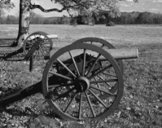Figure 6
(a) How long does it take for the cannonball to travel to the wall? (2 marks)

(b) Will the cannonball strike the wall? Show your calculation. (3 marks)

(c) Assume that the location of the cannon and the launching speed of the cannonball are fixed but the launching angle can vary. Can the cannonball fly over the wall? Show your calculation. (3 marks)

*7. A wooden block of mass 50 g on a uniformly rotating plate is 25 cm away from the rotational axis. The maximum friction between the block and the plate is 0.2 N. At most how many revolutions can the plate rotate in a second such that the block does not slide? (4 marks)
Figure 7

8. A light ray travels from a liquid to an air bubble with centre O as shown.
Figure 8
40°
60°
air
liquid
O
(a) (i) Find the refractive index of the liquid. (2 marks)

(ii) Find the critical angle for the interface between the liquid and the air. (2 marks)

(b) State two conditions for total internal reflection of light to occur. (2 marks)

(c) Complete the path of the light ray until it emerges from the air bubble to the liquid in Figure 8. Draw the normal(s) wherever the light ray meets an interface. Label all the angles that the light ray makes with the normal(s). (4 marks)

9. An object is placed in front of lens L. The following ray diagram shows that a light ray from the object is refracted by L.
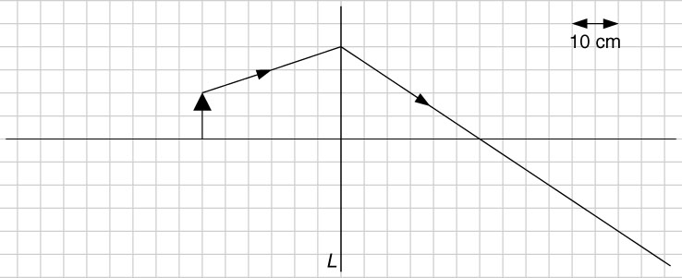Figure 9
(a) What type of lens is L? (1 mark)

(b) By adding suitable light rays to Figure 9, find the image distance, magnification of the image, and the focal length of the lens. (5 marks)

10. Figure 10 shows an experimental set-up to determine the wavelength of monochromatic light emitted from the vertical narrow slit of a discharge lamp. A, B are two mutually perpendicular metre rules on the bench with rule A pointing towards the lamp. A diffraction grating with vertical lines is placed at one end of rule A. A vertically mounted pin P is moved along rule B until the pin is in line with the diffracted image of the second-order to the observer. The corresponding distance x is measured for finding the diffraction angle θ.
B
A
P
θ
x
To supply
discharge lamp
observer
grating
illuminated slit
1 m

Figure 10

The grating has 300 lines per mm and x is found to be 0.38 m for the second-order image.
(a) (i) Calculate the diffraction angle θ. (1 mark)

*(ii) Hence, find the wavelength of the light from the lamp. (3 marks)

(iii) Give ONE advantage of measuring the position of the second-order image instead of the first-order one. (1 mark)

(b) In the experiment, the illuminated slit may not be well aligned along metre rule A. Suggest one way to reduce this error. (2 marks)

11. Two identical balls X and Y, each of mass 1 g and charge +48 nC, are suspended by insulating threads as shown. Each string is 1.38 cm long. The separation between the balls is 12 cm. Neglect the sizes of the balls. Take ε₀ = 8.85 × 10⁻¹² C² N⁻¹ m⁻² and g = 9.81 m s⁻².
Figure 11.1
θ
θ
s
12 cm
X
Y
(a) Find the magnitude of the electrostatic force between the balls. (2 marks)

(b) Find the tension T in each string and the angle θ between each string and the vertical.
(4 marks)

(c) The threads are suspended from two points separated by a distance s. Find s. (1 mark)

(d) Now another charged ball Z is put at the mid-point between X and Y as shown below. The threads become vertical.
Figure 11.2
s
Z
X
Y
(i) Does Z carry a positive or negative charge? (1 mark)

(ii) Find the charge of Z. (2 marks)

END OF PAPER
1.
-- ans --
Solutions | Marks
(a) Rate of generating internal energy =+ 250 | 1M
= 55 × 4100 × 2.5 × 10⁻³ + 280  = 844W | 1A
(b) When the sweat evaporates,  the fast molecules escape from the sweat, leaving the slow molecules behind,  so the sweat cools down.  Heat is then transferred from the human body to the sweat through conduction. | 1A  1A  1A  1A
(c) (i) Any one of the following:  Her body temperature increases.  She sweats more, so the sweat covers a larger area.  (ii) Energy lost by sweating in 10 s = 300 × 10 = 3000 J  By Q = ml_{v}, | 1A  1M  1M
m === 1.33 × 10⁻³ kg | 1A
1.33 × 10⁻³ kg of sweat evaporates in 10 s.  (d) Radiation  Conduction between the human body and air | 1A  1A
-- ans end --
2.
-- ans --
Solutions | Marks
(a) 70 kg | 1A
(b) Take downwards as positive. Let R be the normal force acting on the student by the scale.  By F = ma,  mg − R = ma  R = mg − ma  = 70 × 9.81 − 70 × 1.5  = 581.7 N | 1M  1M
Scale reading =$\frac{581.7}{9.81}$= 59.3 kg. | 1A
(c) 0 | 1A
-- ans end --

3.
-- ans --
Solutions |  | Marks
(a) | weight  800 N  friction  normal force  20°
(Each correct force with correct name) |  | 4 × 0.5A
(b) Acceleration of the car ==$\frac{0.8-0}{4}$= 0.2 m s^{–2} |  | 1M
Let f be the friction acting on the car.  The car moves in the horizontal direction. By F = ma,  900 cos 25° − f = 1600 × 0.2  f = 496 N  The magnitude of the friction acting on the car is 496 N.  (c) Consider the vertical direction.  N = W + 900 sin 25°  = 1600 × 9.81 + 900 sin 25°  = 1.61 × 10⁴ N  The normal force acting on the car by the road is 1.61 × 10⁴ N. |  | 1M  1A  1M  1A
-- ans end --

4.
-- ans --
Solutions | Marks
(a) Gain in PE = mgh  = 60 × 9.81 × 4.5  = 2649 J  ≈ 2650 J | 1M  1A
(b) Average power = | 1M
=
= 662 W | 1A
(c) (i) Power == mg ×= weight × average vertical velocity | 1A
⇒ = average vertical velocity
(ii) Ivan’s average vertical velocity === 1.13 m s⁻¹ | 1M
Tommy’s average vertical velocity
= power-to-weight ratio == 1.02 m s⁻¹ | 1M
∴ Ivan finishes the training in a shorter time. | 1A
(iii) Alfred’s power-to-weight ratio  = average vertical velocity = 6 sin 10° = 1.042 m s⁻¹  Alfred’s power = 1.042 × weight = 1.042 × 65 × 9.81 = 664 W | 1M  1A
-- ans end –

5.
-- ans --
Solutions | Marks
(a) Take the initial moving direction of the white ball as positive.
By conservation of momentum,
m_{W}u_{W} + m_{R}u_{R} = m_{W}v_{W} + m_{R}v_{R} | 1M
1 + 0 = 0 + v_{R}
v_{R} =1 m s⁻¹ | 1A
The red ball moves at1 m s⁻¹ along the initial moving direction of the white ball after the collision.
(b) Total KE before collision =m(1)² +m(0)² = 1m | 0.5M
Total KE after collision =m(0)² +m(1)² = 1m | 0.5M
∴ This is elastic collision. | 1A
-- ans end --

6.
-- ans --
Solutions | Marks
(a) Consider the horizontal direction.
Time needed = | 1M
=
= 5.744 s  ≈ 5.74 s | 1A
(b) Consider the vertical direction, taking the upward direction as positive.
s_{y} = u_{y} t + | 1M
= 50 sin 40° × 5.744 +
= 22.8 m | 1A
< 30 m
∴ The cannonball will strike the wall. | 1A
(c) Suppose the launching angle is 45°.
Consider the horizontal direction.
Time needed for the cannonball to reach the wall
=== 6.22 s | 1M
Consider the vertical direction, taking the upward direction as positive.
s_{y} = u_{y} t +
= 50 sin 45° × 6.22 +× (−9.81) × 6.22²
= 30.1 m | 1M
> 30 m
∴ The cannonball can fly over the wall. | 1A
-- ans end --

7.
-- ans --
Solutions | Marks
The block will not slide if the friction can provide the centripetal force.
Centripetal force ≤ maximum friction
mrω ² ≤ f_{max} | 1M
ω ≤== 4 rad s^{–1} | 1A
Maximum number of revolutions in a second = | 1M
== 0.637 | 1A
-- ans end --

8.
--- ans --
Solutions |  | Marks
(a) (i) Refractive index of the liquid =, |  | 1M
=
= 1.347
≈ 1.35 |  | 1A
(ii) Critical angle = |  | 1M
=
= 47.9° |  | 1A
(b) Light travels from an optically denser medium to an optically less dense medium. |  | 1A
The angle of incidence is larger than the critical angle. |  | 1A
(c) | 40°  60°  60°  40°  O
(Correct normal) |  | 1A
(Correct emergent ray) |  | 1A
(Correct angles) |  | 2 × 1A
-- ans end --

9.
-- ans --
Solutions | Marks
(a) Convex lens | 1A
(b)
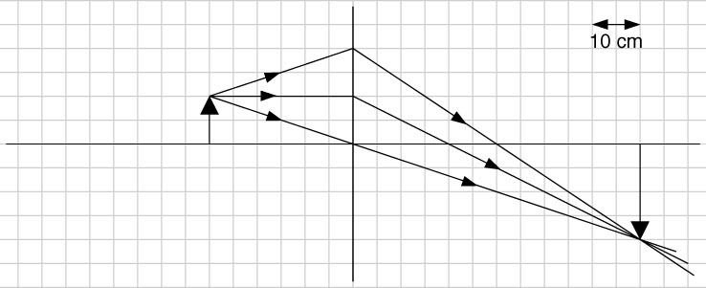
(Correct application of construction rules)  From the ray diagram,  Image distance = 60 cm | 2 × 1A  1A
Magnification of the image === 2 | 1A
Focal length = 20 cm | 1A
-- ans end --
10.
-- ans --
題 解 | 分 數
- (i)
tan θ = 0.38
θ = 20.8° | 1A
(ii) d sinθ = nλ | 1M
($\frac{1}{300} ×{10}^{-3}) ×sin20.8=2λ$ | 1M
λ = 5.92 $× {10}^{-7}m$ | 1A
(iii) 比較少的百分比誤差 | 1A
- 重覆以上步驟但把釘子放在尺子的另一端。  再利用兩端的ｘ值計算出其平均值，並用此來計算波長 | 1A
 | 1A

11.
-- ans --
Solutions | Marks
(a) Electrostatic force F = | 1M
=
= 1.4387 × 10⁻³ N  ≈ 1.44 × 10⁻³ N | 1A
(b) Consider X.
tension T
weight mg
electrostatic force F
X
θ
Along the vertical direction:  T cos θ = mg (1)  Along the horizontal direction:  T sin θ = F (2)  (2) ÷ (1): | 1M  1M
tan θ ==
⇒ θ = 8.34°  From (1), | 1A
T === 9.91 × 10⁻³ N | 1A
(c) s + 2 × 1.38 sin 8.34° = 12  s = 11.6 cm | 1A
(d) (i) A negative charge  (ii) Consider X. The electrostatic force acting on it due to Y balances that due to Z. | 1A
F_{XY} = −F_{XZ}
= − | 1M
Q_{Z} = −× Q_{Y}
= −× 48
= −12 nC  The charge of Z is −12 nC. | 1A
-- ans end --

