Turning Triangles into Rectangles
Name: ______________________ Date: ____________
Cut out each triangle. Cut it again along the grid line halfway up, then turn or slide the pieces to make a rectangle. Glue each rectangle into your book and write its area.
Every square stands for 1 cm.
1 Right-angled triangle — base 5 cm, height 4 cm
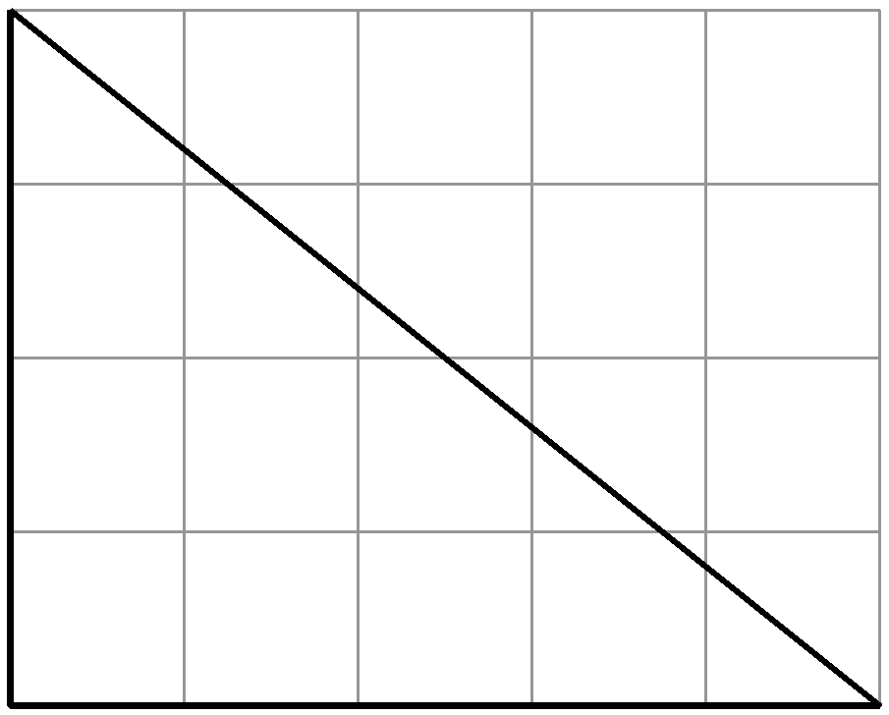
2 Acute triangle — base 5 cm, height 4 cm
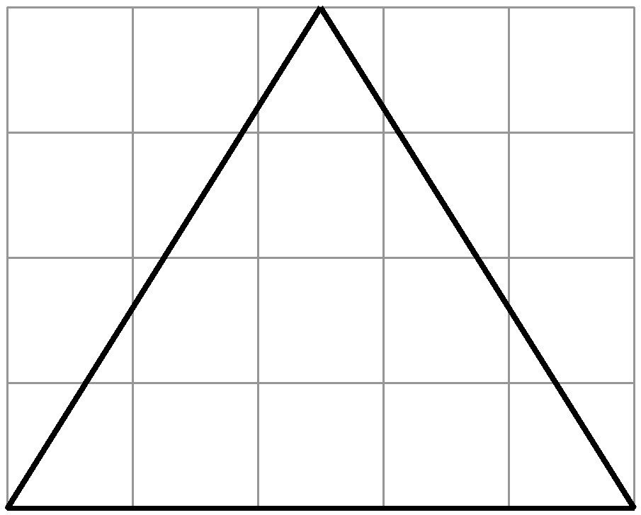
3 Obtuse triangle — base 5 cm, height 4 cm
