Turning a Parallelogram into a Rectangle
Name: ______________________ Date: ____________
Cut out the parallelogram. Cut along the dashed line, then slide the triangle across to the other side to make a rectangle. Glue it into your book and write down its area.
Every square stands for 1 cm.
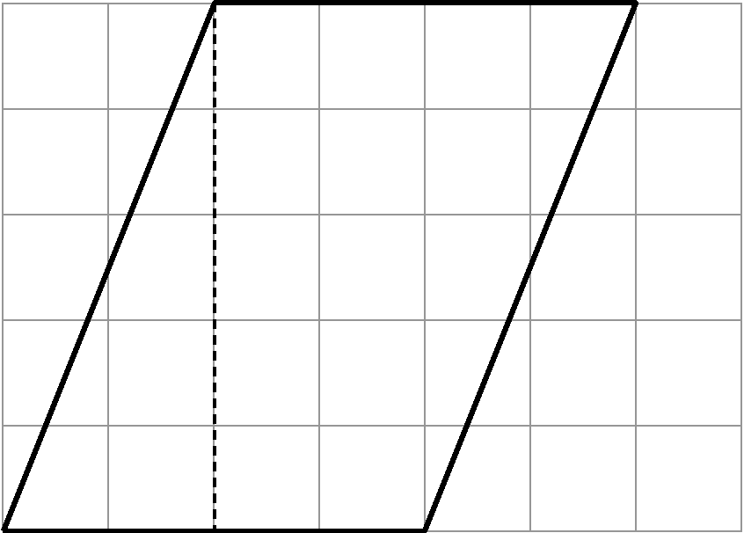
base = ________ cm height = ________ cm
Area of the rectangle = ________ cm² Area of the parallelogram = ________ cm²
What do you notice? Write one sentence about the base, the height and the area.

