Property Management CRM — Software Requirements Specification
Oct 15, 2026 · @Vyom Patel

1. Introduction
This SRS turns the BlueNova Gujarati project brief (sections 1–25) into buildable requirements for a web-based Property Management CRM: one platform to manage Properties, Units, Tenants, Agreements, Rent, Payments, Maintenance, Expenses and Reports. The presentation sections of the brief (20, 21) are out of scope here, as requested.

1.1 Purpose
- Give the intern team one reference for what to build, how modules connect, and in which order to build them.
- Answer every point in the brief with a concrete decision (what, how, with which tool).
- Serve as the basis for design, development, testing and the final demo.

1.2 Problem being solved (brief §2)
Small and mid-size property managers run on Excel, paper registers, WhatsApp and loose files. That causes eight concrete problems:
# | Problem today | How this CRM fixes it
P1 | Finding who lives in which unit takes time | Unit grid with live status + tenant; global search by unit/tenant/mobile
P2 | Pending rent is checked manually | Auto-generated monthly rent invoices with Paid / Pending / Overdue status
P3 | Agreement expiry is missed | Daily job flags leases expiring in 30 days; dashboard + notification
P4 | Maintenance complaints are hard to track | Ticket system with priority, assignee, status and cost
P5 | No clear property-wise income vs expense | Payments and Expenses both linked to Property; Income vs Expense report
P6 | 100–500 units are unmanageable manually | Bulk unit creation, filters, pagination, indexed database
P7 | Tenant history is scattered | Tenant profile shows leases, payments, dues, documents, tickets in one page
P8 | No real-time dashboard or reports | Dashboard with 16 KPIs/widgets + 10 standard reports

1.3 Scope
In scope (MVP, brief §16): Login & role management, Property, Unit, Tenant, Lease, Rent & Payment, Maintenance, Dashboard, Basic Reports, Search/Filter, Activity Log.
Phase 2: Documents (full), Notifications & automated reminders, Owner portal, Expenses (full), advanced analytics, tenant portal.
Phase 3 / Future (brief §17): Mobile apps, online rent payment, auto invoices/receipts, WhatsApp/SMS/Email, AI insights, vendor management, accounting integration, multi-company (SaaS), forecasting, e-sign.

1.4 Definitions
Term | Meaning
Property | A building or site (e.g. Sunrise Residency) that contains units
Unit | One rentable space inside a property — flat, shop, office, warehouse bay
Tenant / Customer | Person or company occupying a unit under a lease
Owner | Person who owns one or more properties
Lease / Agreement | Contract linking one tenant to one unit for a period, rent and deposit
Rent invoice (charge) | A monthly amount due generated from an active lease
Payment | Money received against one or more rent invoices
Ticket | A maintenance request
RBAC | Role-Based Access Control
MVP | Minimum Viable Product — first working version
Soft delete | Record hidden with a deleted_at timestamp instead of being erased

1.5 References
- Property_Management_CRM_Project_Brief_Gujarati.docx (BlueNova) — source of all business requirements.
- IEEE 830 / ISO/IEC/IEEE 29148 — structure followed for this SRS.

1.6 Guiding rule from the brief (§25)
Do not implement blindly. Lock the MVP scope first, then follow this order: UI/UX → Database → Backend/API → Frontend → Testing → Deployment. Where a requirement is unclear, ask the project owner instead of assuming — open questions are listed in section 10.

2. Overall Description
The CRM is a new, standalone, browser-based system with a REST API backend and a relational database; Owner and Tenant portals reuse the same API later.

2.1 Product perspective
Modules are separate but linked by the chain from brief §3: Property → Units → Tenants → Lease → Payments → Maintenance → Expenses → Reports. Opening Unit 101 must show its current tenant, rent, deposit, agreement, payment status and maintenance history on one page.

2.2 User roles and permissions (brief §4, §13)
Role | Main responsibility | Scope of data
Super Admin | Manage the whole system, users, settings | All data
Property Manager | Properties, units, tenants, leases, daily operations | Properties assigned to them
Account / Finance | Rent, payments, dues, expenses, financial reports | Financial modules only, assigned properties
Maintenance Staff | Work on maintenance tickets | Only tickets assigned to them
Owner | View performance of own properties | Only properties they own (read-only)
Tenant / Customer | View own lease, dues, raise requests | Only own records (Phase 2 portal)
Permission matrix — C = create, R = read, U = update, D = delete (soft), — = no access:
Module | Super Admin | Property Manager | Finance | Maint. Staff | Owner | Tenant
Users & Settings | CRUD | — | — | — | — | —
Properties | CRUD | CRU | R | — | R (own) | —
Units | CRUD | CRUD | R | R (ticket unit) | R (own) | R (own)
Owners | CRUD | CRU | R | — | R (self) | —
Tenants | CRUD | CRUD | R | R (name, phone) | — | R/U (self, limited)
Leases | CRUD | CRUD | R | — | R (own) | R (own)
Rent invoices & Payments | CRUD | CR | CRUD | — | R (own) | R (own)
Maintenance tickets | CRUD | CRUD | R | R/U (assigned) | R (own) | C/R (own)
Expenses | CRUD | CR | CRUD | C (ticket cost) | R (own) | —
Documents | CRUD | CRUD | CR (receipts) | C (ticket photos) | R (own, non-KYC) | R (own)
Reports & Dashboard | All | Operational | Financial | — | Owner statement | —
Activity log | R | R (own properties) | — | — | — | —

2.3 Operating environment
- Client: latest Chrome, Edge, Firefox, Safari; responsive from 360 px (phone) to 1920 px (desktop).
- Server: Linux container or managed platform (Render, Railway, AWS, etc.), Node.js 20+ LTS.
- Database: PostgreSQL 15+.
- File storage: S3-compatible object storage (Cloudflare R2 / AWS S3 / Supabase Storage).

2.4 Design and implementation constraints
- Currency INR (₹), dates DD-MM-YYYY in the UI, ISO in the API, timezone Asia/Kolkata.
- UI language English first; labels kept in a translation file so Gujarati/Hindi can be added.
- Must handle at least 1,000 units per property and 10,000 units total without redesign (brief §10, §23).
- Soft delete for business records; no hard delete of financial data.
- Every important create/update/delete is written to the activity log.

2.5 Assumptions and dependencies
- One lease links exactly one tenant to one unit; a unit has at most one active lease at a time.
- Rent is monthly; due day is set per lease (default the 5th).
- One property has one owner in the MVP (joint ownership is Phase 2).
- Partial payments are in scope (a payment can be smaller than the invoice; remainder stays outstanding).
- Internet connection is available; no offline mode in the MVP.
- Email/SMS/WhatsApp require third-party providers (Phase 2).

3. Functional Requirements
Each requirement has an ID (FR-module-number), the brief section it comes from, and its release (MVP / P2 / P3). Every bullet in brief §5–§15 maps to at least one requirement below.

3.1 Authentication & Role Management (§4, §13) — MVP
ID | Requirement | How
FR-AUTH-1 | Users log in with email + password | bcrypt-hashed password; JWT access token (15 min) + refresh token (7 days) in httpOnly cookie
FR-AUTH-2 | Super Admin creates users, assigns a role and properties | users, roles, user_property_access tables
FR-AUTH-3 | Account status Active / Disabled; disabled users cannot log in | users.status checked at login and on refresh
FR-AUTH-4 | Forgot / reset password by email link | One-time token valid 30 min (P2 if email not ready; admin reset in MVP)
FR-AUTH-5 | Every API call checks role permission and property scope | Middleware authorize('payments:create') + row filter by allowed property IDs
FR-AUTH-6 | Lock account for 15 min after 5 failed logins | Counter on users
FR-AUTH-7 | Logout and “logout all devices” | Revoke refresh tokens table

3.2 Property Management (§5.1) — MVP
ID | Requirement
FR-PROP-1 | Add, edit, view, archive a property (archive = soft delete, blocked while active leases exist)
FR-PROP-2 | Fields: name, unique code (e.g. SUN-RES), type (Residential, Commercial, Office, Shop, Warehouse, Mixed)
FR-PROP-3 | Address: line 1, line 2, area, city, state, PIN, optional latitude/longitude
FR-PROP-4 | Linked owner (select existing or create new)
FR-PROP-5 | Total, occupied and vacant unit counts are computed from units, never typed
FR-PROP-6 | Status: Active / Inactive / Under Maintenance
FR-PROP-7 | Attach documents and free-text notes (notes MVP; documents P2)
FR-PROP-8 | Property detail page with tabs: Overview, Units, Tenants, Payments, Maintenance, Expenses, Documents, Activity

3.3 Unit Management (§5.2, §8, §9) — MVP
ID | Requirement
FR-UNIT-1 | Create a single unit or bulk-create a range (e.g. 001–100 or 101–110 on floors 1–10) with a shared template
FR-UNIT-2 | Fields: unit number, floor, block/wing, unit type (1BHK, 2BHK, Shop, Office, …), area (sq ft), expected rent, security deposit
FR-UNIT-3 | Status: Vacant / Occupied / Reserved / Maintenance. Occupied is set automatically when a lease activates and cleared when it ends
FR-UNIT-4 | Unit shows its current tenant via the active lease
FR-UNIT-5 | Unit grid view per property (colour by status, §8 example) and table view
FR-UNIT-6 | Unit detail page (§9): basic info, status, current tenant, rent, deposit, agreement dates, payment summary, pending amount, maintenance history, documents, notes, activity timeline
FR-UNIT-7 | Import units from CSV/Excel template (P2)
FR-UNIT-8 | Unit number unique within a property

3.4 Tenant / Customer Management (§5.3) — MVP
ID | Requirement
FR-TEN-1 | Tenant profile: type (Individual/Company), full name, mobile (unique, 10 digits), alternate mobile, email, address, emergency contact, ID type + number
FR-TEN-2 | Shows assigned property and unit via active lease(s)
FR-TEN-3 | Shows lease details, rent, deposit, payment history, pending dues, documents, maintenance history on one page (fixes P7)
FR-TEN-4 | Status: Active (has active lease) / Inactive (no lease yet) / Previous (lease ended) — computed
FR-TEN-5 | Duplicate check on mobile number before save
FR-TEN-6 | Mask ID number (e.g. XXXX-XXXX-1234) for roles other than Admin/Manager

3.5 Lease / Agreement Management (§5.4) — MVP
ID | Requirement
FR-LEASE-1 | Create lease: unit (must be Vacant or Reserved), tenant, start date, end date, monthly rent, security deposit, rent due day (1–28), maintenance charge (optional), escalation % on renewal, notice period, renewal terms text
FR-LEASE-2 | Status lifecycle: Draft → Active → Expiring Soon (≤30 days) → Expired / Renewed / Terminated
FR-LEASE-3 | Activating a lease sets unit to Occupied and tenant to Active; ending it sets unit to Vacant and tenant to Previous
FR-LEASE-4 | Upload signed agreement PDF (MVP: single file; P2: full document module)
FR-LEASE-5 | Renew: creates a new lease linked by previous_lease_id, applies escalation % to rent
FR-LEASE-6 | Terminate early with date and reason; future unpaid invoices cancelled
FR-LEASE-7 | Full history of previous agreements per unit and per tenant
FR-LEASE-8 | Deposit tracking: received, refunded, deductions with reason
FR-LEASE-9 | Expiry and renewal reminders at 60/30/7 days (dashboard in MVP; notifications P2)

3.6 Rent & Payment Management (§5.5) — MVP
ID | Requirement
FR-PAY-1 | Monthly rent invoices auto-generated on the 1st of each month for every active lease (scheduled job), plus manual “Generate now”
FR-PAY-2 | Invoice status: Pending (not yet due or unpaid) → Partially Paid → Paid; Overdue when unpaid after due date (+ optional grace days)
FR-PAY-3 | Record payment: date, amount, mode (Cash, UPI, Bank Transfer, Cheque, Card), reference/receipt no., received by, notes
FR-PAY-4 | Partial payments: one payment can be allocated across invoices, oldest first
FR-PAY-5 | Outstanding amount per tenant, unit, property = sum of unpaid invoice balances
FR-PAY-6 | Tenant-wise and property-wise payment history with filters
FR-PAY-7 | Auto receipt number (e.g. RCPT-2026-000123) and PDF receipt (P2; MVP shows printable page)
FR-PAY-8 | Optional late fee rule (flat or % per month) configurable per property (P2)
FR-PAY-9 | Payments cannot be deleted; only reversed with a reason (audit)

3.7 Maintenance Management (§5.6) — MVP
ID | Requirement
FR-MNT-1 | Manager (MVP) or tenant (P2 portal) creates a ticket for a unit or common area of a property
FR-MNT-2 | Fields: category (Plumbing, Electrical, Carpentry, Painting, Cleaning, Appliance, Lift, Security, Other), title, description, priority (Low/Medium/High/Urgent)
FR-MNT-3 | Assign to staff user or external vendor
FR-MNT-4 | Status: Open → In Progress → Resolved → Closed (+ Reopened, Cancelled) with comment on each change
FR-MNT-5 | Estimated cost, actual cost; on close, actual cost can create an Expense automatically
FR-MNT-6 | Before/after photos (P2 with storage)
FR-MNT-7 | Resolution date auto-filled when status becomes Resolved
FR-MNT-8 | Full history per unit, tenant, property; staff see only assigned tickets
FR-MNT-9 | SLA target by priority (Urgent 24 h, High 48 h, Medium 5 d, Low 10 d) highlighted when breached

3.8 Owner Management (§5.7) — MVP basic, portal P2
ID | Requirement
FR-OWN-1 | Owner profile: name, mobile, email, address, PAN, bank details (masked)
FR-OWN-2 | List of all properties of an owner
FR-OWN-3 | Property-wise income (payments received), expenses, net income
FR-OWN-4 | Owner statement for a date range, exportable to PDF/Excel
FR-OWN-5 | Owner login with read-only access to own properties (P2)

3.9 Expense Management (§5.8) — MVP basic
ID | Requirement
FR-EXP-1 | Record expense: property (required), unit (optional), category (Maintenance, Utility, Vendor Payment, Salary, Tax, Insurance, Administrative, Other), amount, date, paid to, mode, notes
FR-EXP-2 | Link to maintenance ticket where relevant
FR-EXP-3 | Attach bill (P2)
FR-EXP-4 | Property-wise expense report by category and month

3.10 Document Management (§5.9) — P2 (lease PDF only in MVP)
ID | Requirement
FR-DOC-1 | Upload PDF/JPG/PNG up to 10 MB; stored in object storage, metadata in DB
FR-DOC-2 | Category: Lease, KYC/ID, Property, Receipt, Maintenance Bill, Other
FR-DOC-3 | Linked entity (property, unit, tenant, lease, ticket, expense) via entity_type + entity_id
FR-DOC-4 | Upload date, uploaded by, optional expiry date (for document-expiry reminder)
FR-DOC-5 | Access control: KYC visible to Admin/Manager only; downloads via short-lived signed URL (5 min)

3.11 Notifications & Reminders (§5.10, §14) — dashboard alerts MVP, delivery P2
Event (§14) | Trigger | Recipient | Channel
Rent due | 3 days before due date | Tenant, Manager | In-app (MVP), Email/SMS/WhatsApp (P2)
Rent overdue | Day after due date, then weekly | Tenant, Manager, Finance | In-app + dashboard badge
Agreement expiring | 60, 30, 7 days before end | Manager, Tenant, Owner | In-app + Email
Renewal reminder | 30 days before end if not renewed | Manager | In-app
Ticket created | On create | Manager, assigned staff | In-app + Email
Ticket resolved | On status change | Tenant, Manager | In-app + SMS
Document expiry | 30 days before expiry_date | Uploader, Manager | In-app
FR-NOT-1: All alerts stored in notifications with status Unread/Read/Sent/Failed. FR-NOT-2: Bell icon with unread count. FR-NOT-3: Users can choose channels in settings (P2).

3.12 Dashboard (§6) — MVP
FR-DASH-1: The manager must understand the business in 10–15 seconds. The dashboard shows, filtered by property and month:
- KPI cards: Total Properties, Total Units, Occupied, Vacant, Reserved, Active Tenants, This Month Collection, Pending Rent, Overdue Rent, Open Maintenance, Upcoming Expiry (30 days), Total Expenses, Net Income.
- Charts: property-wise occupancy (stacked bar), collection vs due (last 6 months).
- Lists: recent payments (10), recent maintenance requests (10), action list (overdue tenants, expiring leases).
- FR-DASH-2: Each card is clickable and opens the filtered list behind it (“actionable”, §22).
- FR-DASH-3: Loads in under 2 seconds for 10,000 units (see aggregation approach in section 8).

3.13 Reports & Analytics (§5.11, §15) — basic MVP
Report | Answers the §15 question | Release
Unit occupancy | How many units occupied / vacant? | MVP
Rent collection | How much rent collected this month? | MVP
Pending / overdue | How much pending? Which tenants overdue? | MVP
Agreement expiry | Which agreements expire soon? | MVP
Maintenance | Which property has most requests? | MVP
Income vs expense | Property-wise income and expense? | MVP
Long-vacant units | Which units vacant for a long time? (days since last lease) | MVP
Owner statement / performance | Owner-wise performance? | MVP basic
Property-wise summary | All KPIs per property | MVP
Tenant report | Tenant list with status, dues | MVP
FR-REP-1: Every report has date range + property filters. FR-REP-2: Export to CSV/Excel (MVP) and PDF (P2).

3.14 Search, Filter, Sorting (§10) — MVP
- FR-SRCH-1: Global search bar — tenant name, mobile, unit number, property code.
- FR-SRCH-2: Filters: property, unit status, rent status (Paid/Pending/Overdue), agreement expiry date range, maintenance status, owner, property type.
- FR-SRCH-3: Sort any list column; server-side pagination (25/50/100 rows).
- FR-SRCH-4: Filters kept in the URL so a filtered view can be bookmarked or shared.

3.15 Activity Log & Data Safety (§13) — MVP
- FR-LOG-1: Record who, what entity, action (create/update/delete/login), old vs new values (JSON), time, IP.
- FR-LOG-2: Timeline shown on unit, tenant, lease, property pages.
- FR-LOG-3: Confirmation dialog before any delete/archive; soft delete with restore by Admin.

4. Non-Functional Requirements
The system must be secure by role, fast at 10,000 units, and simple enough that a manager understands the dashboard in 15 seconds.
ID | Category | Requirement | How it is met
NFR-1 | Performance | List pages and dashboard respond in < 2 s at 10,000 units, 50,000 invoices | DB indexes on foreign keys + status + dates; server pagination; aggregate SQL views
NFR-2 | Performance | API p95 latency < 500 ms for CRUD | Prisma/SQL with selective columns; no N+1 queries
NFR-3 | Scalability | Grow from 10 to 10,000+ units and multiple companies without redesign | company_id on every table from day 1 (multi-tenant ready); stateless API for horizontal scaling
NFR-4 | Security | Passwords hashed (bcrypt, cost 12); HTTPS only; JWT in httpOnly secure cookies | Helmet, CORS allow-list, rate limit 100 req/min/IP on auth
NFR-5 | Security | Role + property-scope check on every endpoint | Central RBAC middleware + automated tests per role
NFR-6 | Security | Input validation on client and server | Zod schemas shared by frontend and backend
NFR-7 | Security | OWASP Top 10 covered (SQL injection, XSS, CSRF, IDOR) | ORM parameterised queries, React escaping, SameSite cookies, ownership checks
NFR-8 | Privacy | KYC/ID documents and bank details restricted and masked | Signed URLs, field masking, access logged
NFR-9 | Availability | 99.5% uptime target in production | Managed hosting + health check endpoint + uptime monitor
NFR-10 | Backup | Daily automatic DB backup, 7–30 day retention; weekly restore test | Managed Postgres backups + pg_dump to object storage
NFR-11 | Auditability | All critical changes logged; financial records never hard-deleted | Activity log + soft delete + payment reversal
NFR-12 | Usability | Responsive (mobile, tablet, desktop); max 3 clicks to any unit from dashboard | Tailwind responsive layout; global search
NFR-13 | Usability | Clear empty states, inline validation messages, toast confirmations | shadcn/ui components
NFR-14 | Accessibility | WCAG 2.1 AA basics: labels, contrast, keyboard navigation | Radix-based components
NFR-15 | Maintainability | TypeScript end-to-end; lint + format; 60%+ backend test coverage on services | ESLint, Prettier, Vitest/Jest, PR reviews
NFR-16 | Reliability | Consistent error format; no silent failures | Global error handler {code, message, details}; logging with request ID
NFR-17 | Portability | Runs locally with one command | Docker Compose (app + Postgres)
NFR-18 | Localisation | INR formatting (₹1,20,000), Indian date format, translatable labels | Intl.NumberFormat('en-IN'), i18n file

5. Diagrams
Six diagrams cover the deliverables in brief §19: architecture, use cases, ER, end-to-end workflow, state machines and the payment sequence. Dashed boxes are later phases.

5.1 System architecture
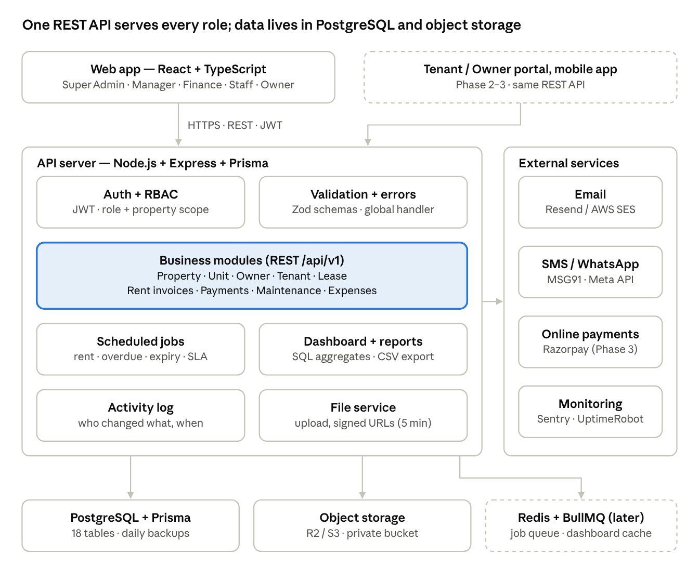
System architecture · 3 tiers + external services
The browser talks only to the API over HTTPS; every request passes Auth + RBAC before reaching a business module, and files go to object storage while their metadata stays in PostgreSQL.

5.2 Use case diagram
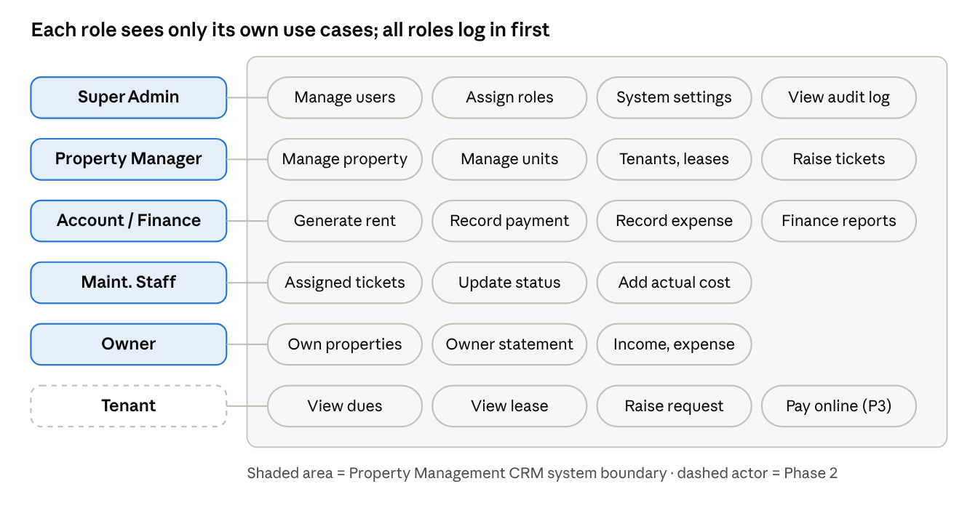
Use case diagram · 6 actors
Every actor authenticates first; the permission matrix in section 2.2 decides which of these use cases each role can reach.

5.3 ER diagram
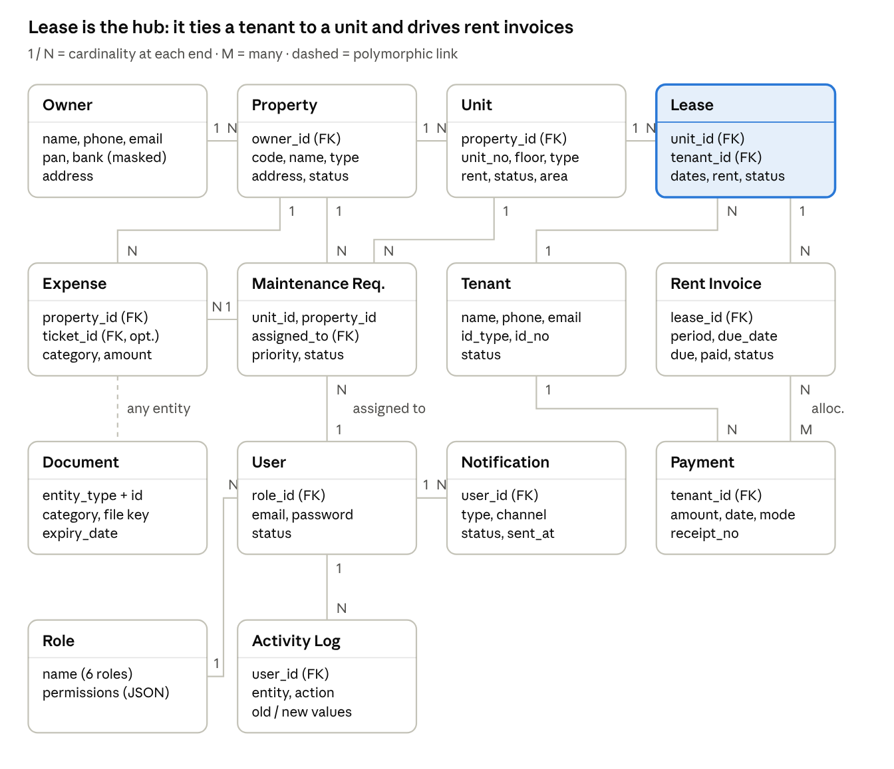
ER diagram · 14 core entities
The chain from brief §12 (Owner → Property → Unit → Lease ← Tenant, Lease → Rent Invoice ↔ Payment) runs along the top; Rent Invoice and Payment are many-to-many through payment_allocations, which is what makes partial payments work. Full columns are in section 6.

5.4 End-to-end business workflow
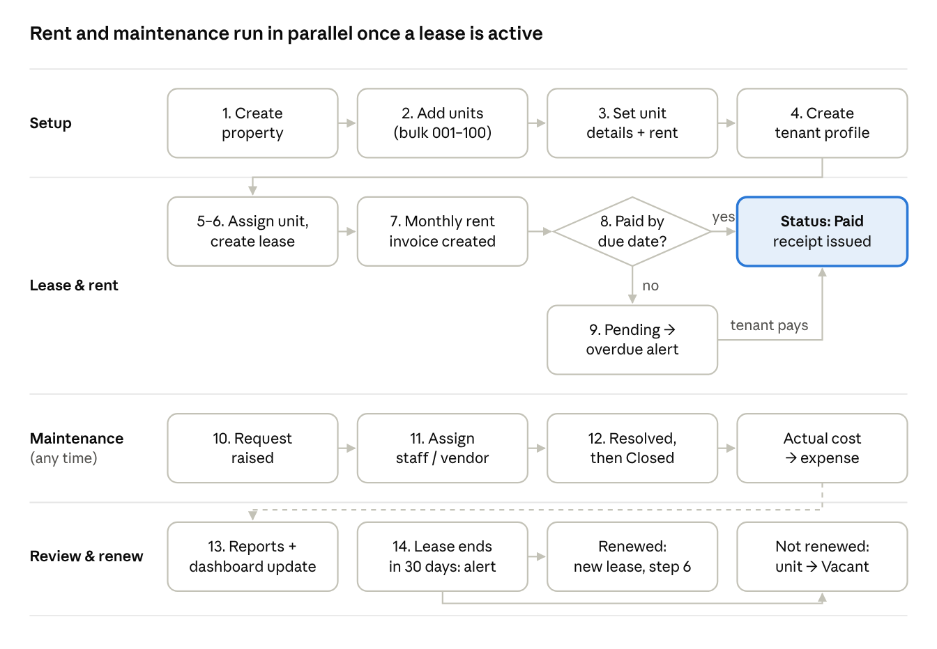
End-to-end business workflow · brief §7, 14 steps
Steps 1–8 are sequential; maintenance (10–12) can start any time a unit exists, and every payment, expense and status change feeds the reports in step 13. The dashed line shows ticket costs flowing into the expense reports.

5.5 State diagrams
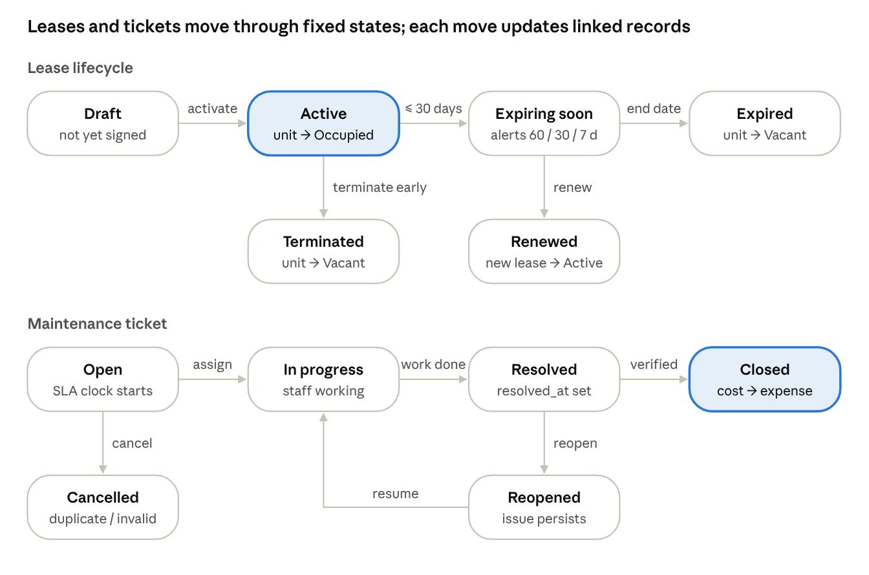
State diagrams · lease and maintenance ticket
Only these transitions are allowed; the API rejects any other status change with 409. The daily job moves leases to Expiring soon and Expired; people trigger every other move. Rent invoices follow a simpler path: Pending → Partially paid → Paid, or Pending → Overdue → Paid.

5.6 Sequence: recording a payment
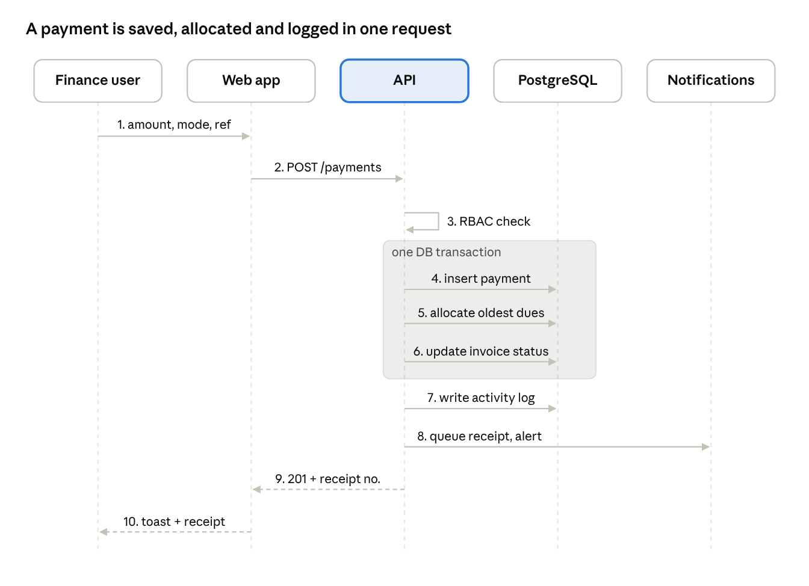
Sequence diagram · record a payment
Steps 4–6 run in one transaction, so a failure leaves no half-paid invoice; dashed arrows are responses. The same pattern (validate → authorise → transaction → log → notify) applies to lease activation and ticket status changes.

6. Data Dictionary
18 tables cover the 12 entities in brief §11 plus 6 supporting tables (companies, roles, property access, rent invoices, payment allocations, ticket comments). Every table also has id (UUID, PK), company_id (FK, for future multi-company), created_at, updated_at, created_by, and business tables have deleted_at (soft delete). These common columns are not repeated below.
Table | Key columns (type) | Constraints / indexes
companies | name, gstin, address, logo_url, settings (JSONB) | Future SaaS; one row in MVP
roles | name (SUPER_ADMIN, MANAGER, FINANCE, STAFF, OWNER, TENANT), permissions (JSONB) | name unique
users | name, email, phone, password_hash, role_id FK, status (ACTIVE/DISABLED), failed_logins, last_login_at, owner_id FK null, tenant_id FK null | email unique
user_property_access | user_id FK, property_id FK | PK (user_id, property_id)
owners | name, phone, email, address, pan, bank_account (encrypted), ifsc | phone index
properties | code, name, type (enum), address_line1, address_line2, area, city, state, pincode, lat, lng, owner_id FK, status (ACTIVE/INACTIVE/UNDER_MAINTENANCE), notes | code unique per company; index owner_id, type
units | property_id FK, unit_no, floor, block, unit_type, area_sqft (numeric), expected_rent (numeric 12,2), security_deposit, status (VACANT/OCCUPIED/RESERVED/MAINTENANCE), vacant_since (date), notes | unique (property_id, unit_no); index status
tenants | type (INDIVIDUAL/COMPANY), full_name, phone, alt_phone, email, address, id_type, id_number (encrypted), emergency_name, emergency_phone, status (ACTIVE/INACTIVE/PREVIOUS) | phone unique; trigram index on full_name
leases | unit_id FK, tenant_id FK, start_date, end_date, monthly_rent, security_deposit, deposit_status, due_day (1–28), grace_days, escalation_pct, notice_days, renewal_terms, status (DRAFT/ACTIVE/EXPIRED/RENEWED/TERMINATED), previous_lease_id FK self, terminated_on, termination_reason | partial unique index: one ACTIVE lease per unit; index end_date
rent_invoices | lease_id FK, unit_id FK, tenant_id FK, period (YYYY-MM), amount_due, late_fee, amount_paid, due_date, status (PENDING/PARTIAL/PAID/OVERDUE/CANCELLED) | unique (lease_id, period); index status, due_date
payments | tenant_id FK, lease_id FK, amount, payment_date, mode (CASH/UPI/BANK/CHEQUE/CARD), reference_no, receipt_no, received_by FK users, status (SUCCESS/REVERSED), reversal_reason, notes | receipt_no unique; index payment_date
payment_allocations | payment_id FK, invoice_id FK, amount | Supports partial payments across invoices
maintenance_requests | ticket_no, property_id FK, unit_id FK null, tenant_id FK null, category, title, description, priority (LOW/MEDIUM/HIGH/URGENT), status (OPEN/IN_PROGRESS/RESOLVED/CLOSED/REOPENED/CANCELLED), assigned_to FK users null, vendor_name, estimated_cost, actual_cost, sla_due_at, resolved_at, closed_at | index status, assigned_to, property_id
maintenance_comments | request_id FK, user_id FK, comment, old_status, new_status | Status history
expenses | property_id FK, unit_id FK null, maintenance_request_id FK null, category, amount, expense_date, paid_to, mode, notes | index (property_id, expense_date)
documents | entity_type (PROPERTY/UNIT/TENANT/LEASE/TICKET/EXPENSE/PAYMENT), entity_id, category, file_name, storage_key, mime_type, size_bytes, expiry_date, is_sensitive | index (entity_type, entity_id)
notifications | user_id FK, type, title, message, link, channel (IN_APP/EMAIL/SMS/WHATSAPP), status (UNREAD/READ/SENT/FAILED), scheduled_for, sent_at, dedupe_key | index (user_id, status); dedupe_key unique
activity_logs | user_id FK, entity_type, entity_id, action, old_values (JSONB), new_values (JSONB), ip_address | index (entity_type, entity_id, created_at); append-only
Key business rules enforced in the database or service layer
- A unit can have only one ACTIVE lease (partial unique index).
- rent_invoices.amount_paid = sum of its allocations; status recalculated after every payment.
- Property unit counts are computed with COUNT(*) FILTER (WHERE status = …) — never stored manually.
- Money columns use NUMERIC(12,2), never float.
- Payments and activity logs are never deleted.

7. Wireframes
18 screens cover the MVP; the five that carry the most logic are drawn below as low-fidelity wireframes, and the rest follow the same layout (left sidebar, top search bar, filter row, table or detail tabs). Rebuild these in Figma before coding.
# | Screen | Used by | Key elements
1 | Login | All | Email, password, forgot password, error message, lockout notice
2 | Dashboard | Admin, Manager, Finance | 13 KPI cards, occupancy + collection charts, recent payments/tickets, quick actions (7.1)
3 | Properties list | Admin, Manager | Table: code, name, type, owner, units, occupancy %, status; filters by type/owner/status; + Add
4 | Property form | Admin, Manager | Name, code, type, address, owner select, status, notes
5 | Property detail + unit grid | Manager | Header KPIs, tabs, colour-coded unit grid, bulk add units (7.2)
6 | Unit detail | Manager, Finance | All 12 items from brief §9 (7.3)
7 | Tenants list | Manager, Finance | Search by name/mobile, filters by status/property, dues column
8 | Tenant profile | Manager, Finance | Contact, current unit, leases, ledger, dues, documents, tickets, timeline
9 | Lease wizard | Manager | Step 1 unit + tenant → Step 2 dates, rent, deposit, due day → Step 3 terms + PDF → Review & activate
10 | Rent & Payments | Finance, Manager | Invoices table with Paid/Pending/Overdue tabs, Generate rent, Record payment modal (7.4)
11 | Maintenance board | Manager, Staff | Kanban by status, priority chips, SLA badge, filters (7.5)
12 | Ticket detail | Manager, Staff | Details, assignee, status buttons, comments, costs, photos
13 | Expenses | Finance | Table + add form: property, unit, category, amount, date, linked ticket
14 | Owners + statement | Manager, Owner | Owner profile, properties, income/expense/net by property, export
15 | Reports | All except Staff | Report list, filters (date range, property), table + chart, CSV/PDF export
16 | Notifications | All | List with unread/read, link to record, mark all read
17 | Users & roles | Super Admin | Users table, role select, property access, enable/disable
18 | Activity log | Admin, Manager | Who, what, when, old → new values, filters

7.1 Dashboard
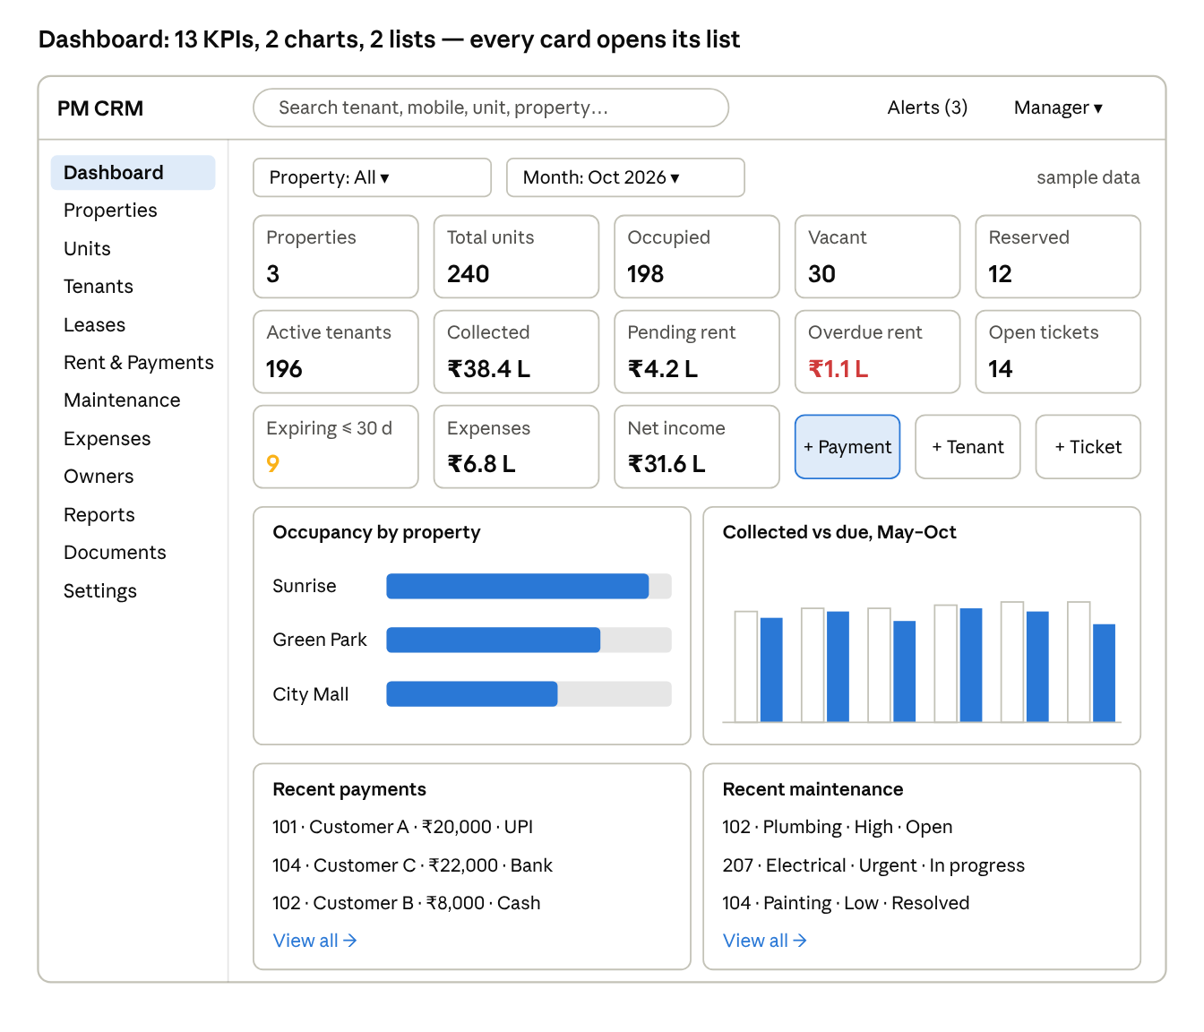
Wireframe · Dashboard (desktop)
Overdue and expiring figures use warning colours so they are seen first; every card links to its filtered list (FR-DASH-2). On a phone, cards stack two per row and the sidebar becomes a bottom menu.

7.2 Property detail and unit grid
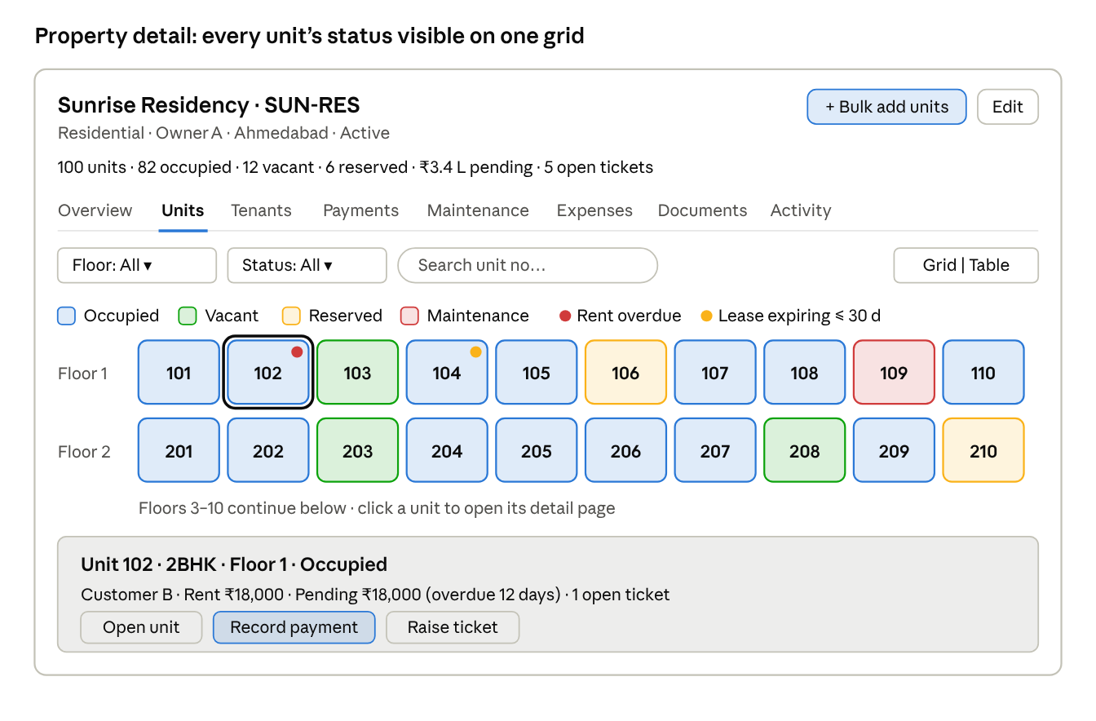
Wireframe · Property detail and unit grid
This is the brief’s §8 Sunrise Residency example as a screen: colour shows status, dots flag overdue rent and expiring leases, and clicking a unit opens a quick view with the next action. The Grid | Table toggle switches to a sortable table with the §8 columns (Unit, Status, Tenant, Rent, Agreement, Payment, Maintenance).

7.3 Unit detail
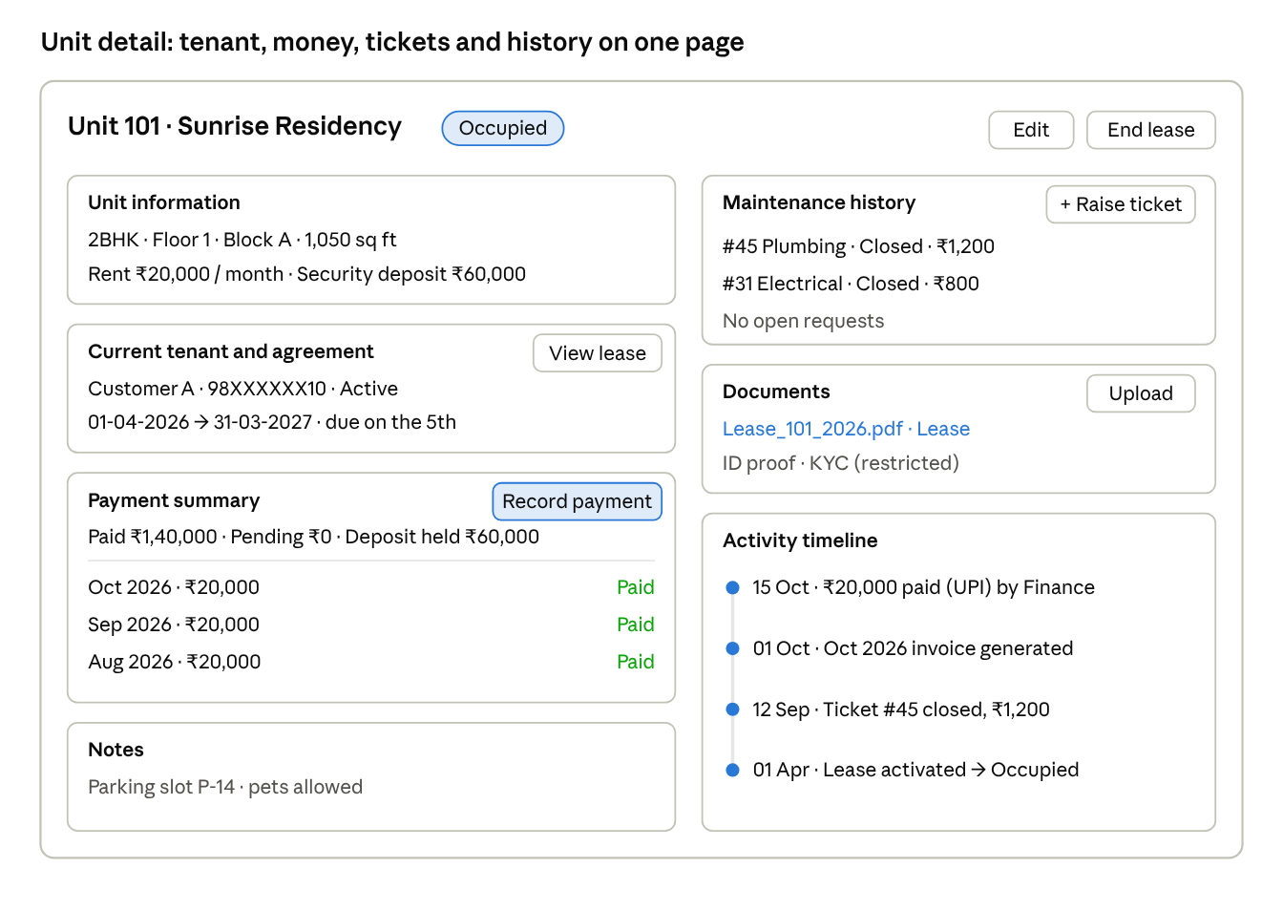
Wireframe · Unit detail
All 12 items in brief §9 are on one page: basic info, status, tenant, rent, deposit, agreement dates, payment summary, pending amount, maintenance history, documents, notes and the activity timeline (read from activity_logs).

7.4 Rent & Payments
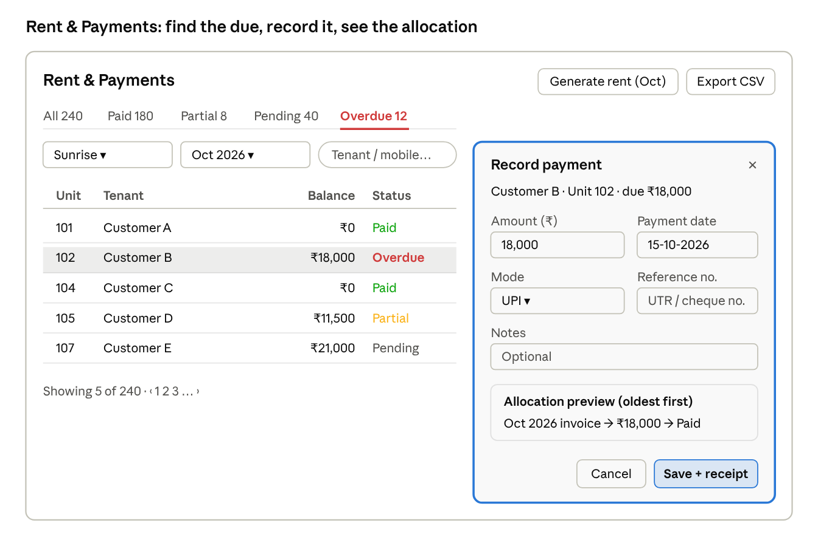
Wireframe · Rent & Payments with Record payment form
Status tabs give the brief’s Paid / Pending / Overdue view in one click; the form shows how the amount will be split across open invoices before saving, so partial payments are never a surprise.

7.5 Maintenance board
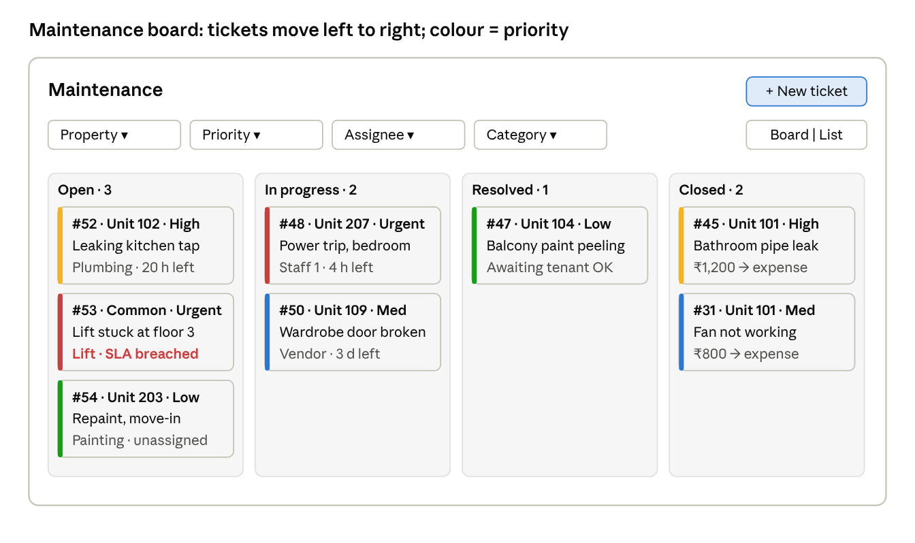
Wireframe · Maintenance board
Managers drag cards between columns (each move calls the status API and asks for a comment); staff see the same board filtered to their own tickets. The left stripe is priority: red Urgent, amber High, blue Medium, green Low.

8. Tools & Technology Stack
Recommended stack: React + TypeScript frontend, Node.js (Express) + Prisma backend, PostgreSQL database — free to build, cheap to host, and it scales to the SaaS future. Prices below are approximate list prices as of October 2026 from general knowledge, not looked up live; confirm on each vendor’s pricing page before buying.

8.1 Answers to brief §18 — technical decisions
§18 question | Decision | Why
Frontend technology? | React 18 + Vite + TypeScript, Tailwind CSS, shadcn/ui, TanStack Query + TanStack Table, React Hook Form + Zod, Recharts, React Router | Most job-relevant; huge component ecosystem; tables with 1,000 rows handled by TanStack Table
Backend technology? | Node.js 20 LTS + Express (or NestJS if the team wants structure) + TypeScript | Same language as frontend; one intern can work both sides
Database? | PostgreSQL 15+ with Prisma ORM | Data is highly relational (owner → property → unit → lease → payment); needs transactions for payments; MongoDB is a poor fit
Authentication? | Email + password, bcrypt, JWT access (15 min) + refresh (7 d) in httpOnly cookies | Standard, free, no vendor lock-in. Alternative: Supabase Auth / Clerk
Role-based access? | roles.permissions list like units:create; middleware authorize() + property-scope filter in every query | Covers both “what action” and “which data” (§13)
API architecture? | REST, versioned /api/v1, resource-based, JSON, OpenAPI (Swagger) docs, layered: route → controller → service → Prisma | Simple, testable, easy for future mobile app
File/document storage? | S3-compatible object storage (Cloudflare R2 / Supabase Storage / AWS S3); DB stores metadata; private bucket + signed URLs | Files never in DB or on server disk
Notifications? | notifications table + scheduled jobs (node-cron in MVP → BullMQ + Redis later); channels: in-app first, then email (Resend/SES), SMS (MSG91), WhatsApp (Meta Cloud API / Interakt) | Start free, add paid channels later
Dashboard aggregation? | Live SQL aggregate queries with indexes for MVP; materialised views refreshed every 5–15 min or Redis cache when > 10,000 units | Fast enough without extra infra
Deployment? | Frontend on Vercel/Netlify; API on Render/Railway; DB on Neon/Supabase. Production: AWS (EC2/ECS + RDS + S3) or DigitalOcean | Free for MVP, clear upgrade path
Backup & security? | Managed daily backups + weekly pg_dump to R2; HTTPS, Helmet, rate limit, CORS, secrets in env vars, least-privilege DB user | Covers NFR-4 to NFR-10
Testing & error handling? | Vitest/Jest unit tests, Supertest API tests, Playwright E2E, Postman collections; global error handler, Zod validation, Sentry error tracking | See section 9 testing plan

8.2 Tool-by-tool: budget vs premium
Purpose | Budget / free choice (now) | Price | Premium choice (expansion) | Approx. price
Wireframes / UI design | Figma Starter, Penpot, Excalidraw | Free
Low-fi wireframes | Excalidraw, Balsamiq trial | Free | Balsamiq Cloud | ~$9–$12/month
Diagrams (ER, flow, architecture) | draw.io (diagrams.net), Mermaid, dbdiagram.io free | Free
Project management | Trello, Jira Free (≤10 users), GitHub Projects | Free
Code editor + AI | VS Code, GitHub Copilot Free | Free | Copilot Pro, Claude Code (Claude Pro plan) | ~$10 / ~$20 per month
Source control & CI | GitHub Free + GitHub Actions (2,000 min) | Free
API testing / docs | Postman Free, Swagger UI, Thunder Client | Free
Frontend hosting | Vercel Hobby, Netlify Free, Cloudflare Pages | Free | Vercel Pro | ~$20 per user/month
Backend hosting | Render Free (sleeps), Railway trial | Free | Render Starter/Standard, Railway Hobby/Pro, AWS EC2 t3.small, DigitalOcean Droplet | ~$7–$25 / ~$5–$20 / ~$15 / ~$6–$12 per month
PostgreSQL | Neon Free, Supabase Free (500 MB) | Free | Supabase Pro, Neon paid, AWS RDS db.t3.micro–small | ~$25 / ~$19 / ~$15–$30 per month
File storage | Cloudflare R2 (10 GB free), Supabase Storage (1 GB) | Free | R2 / S3 pay-as-you-go | ~$0.015 / ~$0.023 per GB-month
Email | Resend Free (3,000/month), Brevo Free (300/day) | Free
SMS (India, needs DLT registration) | — | — | MSG91, Twilio | ~₹0.20–₹0.30 per SMS
WhatsApp | Meta WhatsApp Cloud API (free service window) | Per-template fee
Online rent payment | — | — | Razorpay, Cashfree, PhonePe PG | ~2% per transaction, no setup fee
E-sign agreements | — | — | Leegality, Digio, DocuSign | ~₹25–₹100 per sign / DocuSign ~$10+/month
Error monitoring | Sentry Developer | Free | Sentry Team | ~$26/month
Uptime monitoring | UptimeRobot (50 monitors) | Free | Better Stack | ~$25+/month
Reports / BI | Built-in Recharts + CSV export, Metabase open source | Free | Metabase Cloud, Power BI Pro | ~$85+/month / ~$14 per user/month
Accounting integration | CSV export to Tally | Free
Mobile app (future) | React Native + Expo (Expo free tier) | Free | Expo EAS Production; Apple Developer; Google Play | ~$99/month / $99/year / $25 one-time
AI insights (future) | — | — | Claude API (usage-based) | Check current pricing at build time
Domain + SSL | Free subdomain (*.vercel.app) + free SSL | Free | .in / .com domain | ~₹700–₹1,200 per year

8.3 Monthly cost by stage
Stage | Setup | Approx. cost
Internship MVP / demo | Vercel + Render Free + Neon/Supabase Free + R2 Free + GitHub | ₹0
Pilot (1 client, ~500 units) | Render Starter + Supabase Pro + domain + Resend Free | ~₹3,000–₹4,000/month
Production (10–20 clients) | AWS/DO + managed Postgres + Redis + Sentry Team + SMS/WhatsApp | ~₹15,000–₹40,000/month + per-message
SaaS scale (multi-company) | AWS ECS/EKS + RDS Multi-AZ + CDN + BI + support tools | ₹1,00,000+/month

8.4 Alternative stacks (if the team prefers)
- Next.js full-stack (App Router) + Prisma + Postgres — one codebase; good if the team is small.
- Django + Django REST Framework + Postgres — built-in admin panel saves time; good for Python teams.
- Laravel + MySQL — very common in Indian agencies; fast CRUD with Filament admin.
- Supabase (Auth + DB + Storage) + React — least backend code; less control over complex business rules.

9. Implementation Plan (What I will do, and how)
The MVP is built in 12 weeks in the order the brief mandates (§25): scope lock → UI/UX → Database → Backend/API → Frontend → Testing → Deployment. The 12-week length is an assumption; compress or stretch the phases to the actual internship length.

9.1 Phase plan
Week | Phase | What I will do | How I will do it | Output (deliverable from §19)
1 | Requirement & scope lock | Read brief, list modules, confirm MVP, get open questions answered | This SRS; review meeting with project owner; sign-off | Requirement understanding, module list, roles & permissions document
2 | UI/UX | Wireframes for 12 key screens, navigation map, style guide | Excalidraw/Figma low-fi → Figma clickable prototype; shadcn/ui as design base | UI/UX wireframes, user flow diagram
3 | Database & architecture | ER diagram, Prisma schema, seed data (Sunrise Residency, 100 units) | dbdiagram.io/draw.io → schema.prisma → prisma migrate dev → seed script with Faker | ER diagram, DB design, architecture diagram
3 | Project setup | Monorepo, lint, CI, Docker Postgres, env config | apps/web, apps/api, packages/shared; GitHub Actions running lint + tests | Repo + README
4 | Backend: auth & RBAC | Login, refresh, users, roles, permission middleware, activity log hook | Express + Zod + bcrypt + jsonwebtoken; Prisma middleware writes activity_logs | Auth API + tests per role
5 | Backend: Property, Unit, Owner, Tenant | CRUD, bulk unit create, search/filter/pagination | Service layer per module; query builder for filters; Swagger docs | API/module plan executed
6 | Backend: Lease, Rent, Payments | Lease lifecycle, invoice generation job, payment allocation, overdue job | Prisma transactions; node-cron daily 00:30 IST jobs | Core business logic + unit tests
7 | Backend: Maintenance, Expenses, Dashboard, Reports | Ticket workflow, SLA, expense link, aggregate queries, CSV export | SQL GROUP BY + FILTER; json2csv/exceljs | Dashboard + report APIs
8 | Frontend: shell & masters | Login, layout, sidebar by role, Property/Unit/Owner/Tenant screens | React Router, TanStack Query, TanStack Table, React Hook Form + Zod | Working screens
9 | Frontend: operations | Lease wizard, rent & payments, maintenance board, expenses | Multi-step form, Kanban columns for tickets | Working screens
10 | Frontend: dashboard, reports, search, detail pages | KPI cards, Recharts charts, unit detail timeline, global search | Recharts; debounced search; URL query filters | Full MVP UI
11 | Testing & fixing | Unit, API, E2E, role-access, 1,000-unit load test, UAT with manager | Vitest, Supertest, Playwright, k6; bug tracker | Testing plan + test report
12 | Deployment & demo | Deploy, seed demo data, run end-to-end demo scenario, write handover docs | Vercel + Render + Neon; backups on; Sentry; UptimeRobot | Final demo, future scope document

9.2 Folder structure
property-crm/
apps/
api/ Express + Prisma
src/modules/{auth,users,properties,units,owners,tenants,leases,
invoices,payments,maintenance,expenses,documents,
notifications,dashboard,reports,activity}
<module>.routes.ts <module>.controller.ts
<module>.service.ts <module>.schema.ts (Zod)
src/middleware/{auth,authorize,error,rateLimit}.ts
src/jobs/{generateInvoices,markOverdue,leaseExpiry,reminders}.ts
prisma/schema.prisma prisma/seed.ts
web/ React + Vite
src/pages/ src/components/ src/features/<module>/
src/lib/api.ts src/hooks/ src/routes.tsx
packages/shared/ Zod schemas, enums, types shared by api and web
docker-compose.yml .github/workflows/ci.yml

9.3 REST API endpoints (MVP)
Module | Endpoints
Auth | POST /auth/login, POST /auth/refresh, POST /auth/logout, GET /auth/me, POST /auth/change-password
Users | GET/POST /users, GET/PATCH/DELETE /users/:id, PUT /users/:id/properties
Owners | GET/POST /owners, GET/PATCH/DELETE /owners/:id, GET /owners/:id/statement?from&to
Properties | GET/POST /properties, GET/PATCH/DELETE /properties/:id, GET /properties/:id/summary
Units | GET /properties/:id/units, POST /properties/:id/units, POST /properties/:id/units/bulk, GET/PATCH/DELETE /units/:id, GET /units/:id/timeline
Tenants | GET/POST /tenants, GET/PATCH/DELETE /tenants/:id, GET /tenants/:id/ledger
Leases | GET/POST /leases, GET/PATCH /leases/:id, POST /leases/:id/activate, /renew, /terminate
Invoices | GET /invoices?status&property&month, POST /invoices/generate?month
Payments | GET/POST /payments, GET /payments/:id/receipt, POST /payments/:id/reverse
Maintenance | GET/POST /maintenance, GET/PATCH /maintenance/:id, POST /maintenance/:id/status, POST /maintenance/:id/comments
Expenses | GET/POST /expenses, GET/PATCH/DELETE /expenses/:id
Documents (P2) | POST /documents (multipart), GET /documents?entityType&entityId, GET /documents/:id/url, DELETE /documents/:id
Notifications | GET /notifications, PATCH /notifications/:id/read, POST /notifications/read-all
Dashboard | GET /dashboard/summary?propertyId&month, GET /dashboard/occupancy, GET /dashboard/recent
Reports | GET /reports/{occupancy,collection,overdue,expiry,maintenance,income-expense,vacancy,owner,tenants}?format=json|csv
Search | GET /search?q= (tenants, units, properties)
All list endpoints accept page, limit, sort, order and module filters; responses are { data, meta: { page, limit, total } }; errors are { error: { code, message, details } }.

9.4 Core business logic (how the key parts work)
A. Monthly rent generation (job at 00:30 on the 1st, also manual):
for each lease where status = ACTIVE and start_date <= last day of month:
if no invoice exists for (lease_id, period):
amount = monthly_rent (pro-rata for first/last partial month)
due_date = date(period, lease.due_day)
insert rent_invoice(status = PENDING)
B. Record payment with partial allocation (one DB transaction):
insert payment(amount, mode, receipt_no = next sequence)
remaining = amount
for invoice in tenant's unpaid invoices ordered by due_date:
apply = min(remaining, invoice.amount_due + late_fee - amount_paid)
insert payment_allocation(payment, invoice, apply)
invoice.amount_paid += apply; recompute status (PAID / PARTIAL)
remaining -= apply; stop when remaining = 0
if remaining > 0: store as tenant advance credit
write activity_log; create notification for tenant/manager
C. Daily status job (00:30 IST): mark invoices OVERDUE when due_date + grace_days < today and not paid; flag leases ending in ≤ 60/30/7 days and create notifications (deduplicated by dedupe_key); expire leases past end_date and set unit VACANT; mark tickets past sla_due_at.
D. Lease activation (transaction): check unit has no other ACTIVE lease → lease ACTIVE → unit OCCUPIED, vacant_since = null → tenant ACTIVE → generate current month invoice → log.
E. Permission check (every request): verify JWT → load user role permissions → authorize('payments:create') → services add WHERE property_id IN (user's allowed ids); staff queries add assigned_to = user.id; owners add owner_id = user.owner_id.

9.5 Testing plan
Level | Tool | What is tested | Target
Unit | Vitest / Jest | Rent generation, pro-rata, allocation, status rules, permission helper | All business rules; 60%+ service coverage
API / integration | Supertest + test Postgres | Every endpoint: success, validation error, 401, 403 per role | Each role × each module
Frontend component | React Testing Library | Forms, validation messages, tables | Key forms
End-to-end | Playwright | Workflow §7 steps 1–14 in one script (create property → … → expiry reminder) | Passes on every deploy
Performance | k6 + seed of 10,000 units | Dashboard, unit list, search | p95 < 2 s
Security | OWASP ZAP baseline, npm audit | Headers, injection, auth bypass, IDOR | No high findings
UAT | Manual checklist with project owner | Real scenario: Sunrise Residency, 100 units | Sign-off
Error handling: Zod validation returns 400 with field errors; known business errors (e.g. UNIT_ALREADY_OCCUPIED) return 409; unknown errors return 500 with a request ID, logged to Sentry; the frontend shows a toast and keeps form data.

9.6 Deployment steps
- Create Neon/Supabase Postgres; set DATABASE_URL; run prisma migrate deploy.
- Deploy API to Render (build npm run build, start node dist/server.js); set env vars (JWT secrets, DB URL, R2 keys, CORS origin).
- Deploy web to Vercel with VITE_API_URL.
- Run the seed script for demo data; create the Super Admin account.
- Turn on daily backups; schedule weekly pg_dump via GitHub Actions to R2.
- Add Sentry DSN and an UptimeRobot monitor on /health.
- Use GitHub flow: main protected, feature branches, PR review, CI must pass before merge.

9.7 Demo scenario for the final demo (§22)
- Log in as Manager → create Sunrise Residency → bulk-create units 001–100.
- Add Customer A → lease on Unit 101 at ₹20,000 → unit turns Occupied.
- Generate rent → record full payment for A, partial for B → dashboard updates.
- Run the overdue job → B shows Overdue with an alert.
- Raise a plumbing ticket on 102 → log in as Staff → resolve it → cost becomes an expense.
- Show Lease 104 “Expiring Soon” and the reminder.
- Log in as Finance and Owner to prove role limits; open reports and export CSV.

10. Point-by-Point Answers to the Brief
Every section of the brief has an answer below; §20–21 (presentation) are excluded as requested.
Brief § | What the brief asks | My answer / solution | Where in this SRS
1 Core idea | Manage all properties and every unit (e.g. 100 units) in one system | Property → Unit hierarchy, bulk unit creation, unit detail page linking tenant, rent, deposit, lease, payments, maintenance | 3.2, 3.3
2 Problem | 8 problems with Excel/WhatsApp/registers | Each problem mapped to a feature (P1–P8) | 1.2
3 Solution | Interconnected modules Property → … → Reports | Relational schema with FKs; Unit 101 page shows everything | 2.1, 5, 6
4 Roles | 6 roles with responsibilities | 6 roles + CRUD permission matrix | 2.2
5.1 Property | 9 fields/features | FR-PROP-1 to 8 | 3.2
5.2 Unit | 9 fields/features | FR-UNIT-1 to 8 | 3.3
5.3 Tenant | 10 items | FR-TEN-1 to 6 | 3.4
5.4 Lease | 9 items | FR-LEASE-1 to 9 + lifecycle diagram | 3.5, 5
5.5 Rent & Payment | 10 items incl. partial payment, receipt | FR-PAY-1 to 9; allocation algorithm | 3.6, 9.4
5.6 Maintenance | 10 items | FR-MNT-1 to 9 + ticket state diagram | 3.7, 5
5.7 Owner | 7 items | FR-OWN-1 to 5 | 3.8
5.8 Expense | 7 items | FR-EXP-1 to 4 | 3.9
5.9 Documents | 7 items + access control | FR-DOC-1 to 5; private bucket + signed URLs | 3.10
5.10 Notifications | 7 reminder types | Trigger/recipient/channel table; daily job | 3.11, 9.4 C
5.11 Reports | 9 reports | 10 reports, CSV/PDF export | 3.13
6 Dashboard | 16 items, understandable in 10–15 s | 13 KPI cards + 2 charts + 3 lists, all clickable | 3.12, 7
7 Workflow | 14-step end-to-end flow | Workflow diagram + demo script | 5, 9.7
8 100-unit example | Sunrise Residency unit table | Unit grid/table view with status colours; seed data replicates it | 3.3, 7, 9.1
9 Unit detail page | 12 items incl. activity timeline | Wireframe with all 12 items | 3.3, 7
10 Search/filter | 8 filters | Global search + 7 filters + sorting + pagination | 3.14
11 Entities | 12 entities | 18 tables with fields | 6
12 Relationships | Owner → Property → Unit → Tenant → Lease → Payment, etc. | ER diagram with cardinalities | 5
13 Security | 8 rules | RBAC middleware, scope filters, masking, activity log, soft delete, confirm dialogs | 2.2, 3.15, 4
14 Notification scenarios | 6 events | Same 6 events + renewal, with channel per release | 3.11
15 Report questions | 10 questions | Each question → one report | 3.13
16 MVP | 9 modules | MVP scope locked; Documents/Notifications/Owner portal in Phase 2 | 1.3, 9.1
17 Future scope | 13 items | Phase 3 roadmap below | 10.1
18 Technical questions | 12 questions | One decision per question | 8.1
19 Deliverables | 14 deliverables | Mapped below | 10.2
22 Success criteria | 7 criteria | How each will be proven in the demo | 10.3
23–24 Vision & summary | Scalable single platform | company_id multi-tenant design, stateless API, indexes | 4 (NFR-3)
25 Note for interns | Don’t implement blindly; lock MVP; ask when unclear | Build order followed; open questions listed | 1.6, 10.4

10.1 Future scope (brief §17) — how each would be built
Feature | Approach | Tools
Tenant portal / app | Same API with TENANT role; view dues, pay, raise tickets | React (web), React Native + Expo (mobile)
Owner portal / app | OWNER role, read-only dashboards and statements | Same as above
Online rent payment | Payment link per invoice; webhook marks payment SUCCESS and allocates | Razorpay / Cashfree, UPI AutoPay for recurring rent
Auto invoice/receipt | PDF from HTML template; emailed on payment | Puppeteer or @react-pdf/renderer
WhatsApp/SMS/Email | Notification worker picks pending rows and sends by channel | Meta WhatsApp Cloud API / Interakt, MSG91, Resend/SES, BullMQ + Redis
AI insights | Monthly summaries of overdue risk, vacancy trends, rent suggestions from historical data | Claude API on aggregated (non-personal) data
Vendor management | vendors table, vendor ratings, work orders, vendor payments | Extends maintenance + expenses
Accounting integration | Export ledger entries / sync invoices and payments | Tally Prime XML export, Zoho Books API
Multi-property, multi-company | company_id already on every table; add company signup, billing, Postgres row-level security | Stripe/Razorpay Subscriptions
Advanced analytics & forecasting | Collection forecast, occupancy trend, churn prediction | Metabase / Power BI, Python service
Cloud deployment | Containers, managed DB, CDN, autoscaling | AWS ECS + RDS + S3 + CloudFront, or DigitalOcean App Platform
Digital agreement / e-sign | Generate lease PDF from template → send for Aadhaar e-sign → store signed copy | Leegality / Digio / DocuSign

10.2 Deliverables checklist (brief §19)
- ☐ Project requirement understanding — sections 1–3
- ☐ User roles and permissions document — section 2.2
- ☐ Complete module list — section 3
- ☐ User flow / workflow diagram — section 5
- ☐ ER diagram / database design — sections 5 and 6
- ☐ System architecture diagram — section 5
- ☐ UI/UX wireframes — section 7 (then Figma)
- ☐ Technology stack suggestion — section 8
- ☐ API/module development plan — sections 9.1–9.4
- ☐ MVP development — weeks 3–10
- ☐ Testing plan — section 9.5
- ☐ Final demo — section 9.7
- ☐ Future scope and improvement suggestions — section 10.1

10.3 Success criteria (brief §22) — how I will prove each
Criterion | Proof in the demo
Information is centralised | One login shows property, units, tenants, leases, rent, tickets, reports
Data relationships work between modules | Activating a lease changes unit status, tenant status and creates an invoice automatically
End-to-end workflows work | Playwright script and live demo run all 14 steps of §7
Dashboard is actionable | Clicking “Overdue Rent” opens the filtered overdue list with Record Payment buttons
Search/filter is practical | Find a tenant by mobile among 1,000 units in under 1 second
Roles and permissions work | Finance cannot open Maintenance; Staff sees only own tickets; Owner sees only own property
Real-world scenario | Sunrise Residency seed data with 100 units, mixed statuses as in §8

10.4 Open questions for the project owner
- Internship length and team size (plan assumes 12 weeks, 1–3 interns)?
- Is partial payment in MVP scope? (assumed yes)
- Should rent be generated automatically or entered manually each month? (assumed automatic + manual override)
- Can a property have multiple owners with share %? (assumed one owner in MVP)
- Are late fees and GST on commercial rent required?
- Which notification channel matters first: email, SMS or WhatsApp?
- Is a tenant portal needed in MVP or Phase 2? (assumed Phase 2, as brief §4 says optional)
- Preferred hosting / budget for the pilot?

