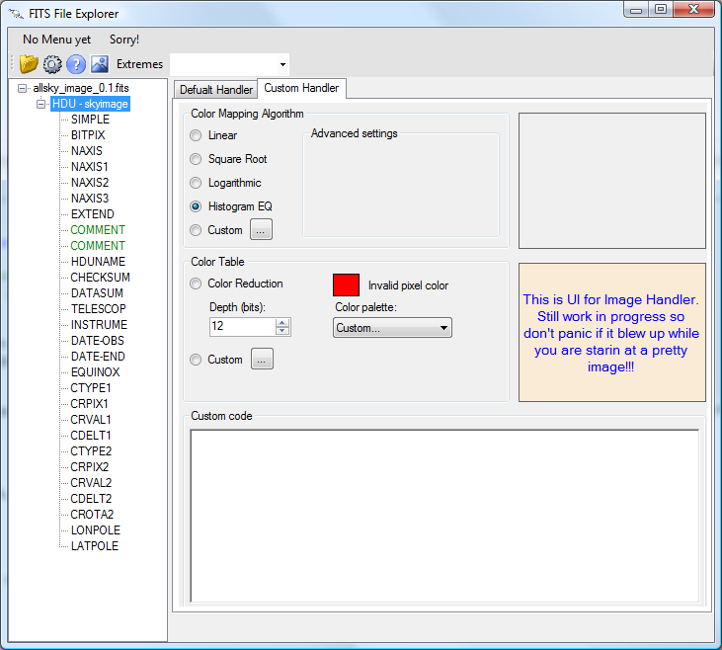

**How to use**: Follow the steps as shown in red:

1. Click to open the fits file.
2. Select the Image (primary or extension) HDU.
3. Click the button indicated to open the image window (shown below) – this will activate the custom handler tab and fill it with image controls.
4. Optional: select one of the available color stretch functions.
5. Optional: select one of the available Color palettes. Custom will ask you to browse for the palette file. It’s a text file with line for each color formatted as: R, G, B

Notes:

* Still under construction and many things are hardcoded.
* Designed to be a frame work – so color handler can be plugged, but this piece is not implemented yet.

5

4

3

2

1

**Image Window:**

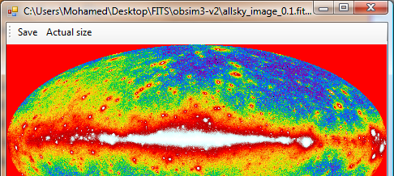

Click to save