Section 2: Art

Since we’re making a 2D game, art is relatively easy. We’ll start with the easiest bit: things that aren’t moving.

For the tile art, we’re using a standard 64x64 pixel size – there are some templates that you can use on GitHub, in the Assets folder: artTemplate.png is 64x64 pixels, while artTemplateBig.png is bigger, with a 64x64 pixel square marked in the middle.

There are loads of programs for doing this sort of thing – if you want to do fancy things, there’s programs like GIMP and Paint.NET (both free) that you can use to do all sorts of things, or you can just use whatever more basic thing you’ve got to hand: the standard Paint program that’s included with Windows works fine, though some things will be a little bit harder to do.

For tiles, the tricky bit is making them match up – we want tiles to be able to sit next to each other while looking good. How easy that is depends on what sort of art style you’re going for (and you should pick one and stick with it, at least within a level): if you’re going for something very flat, like Thomas Was Alone:
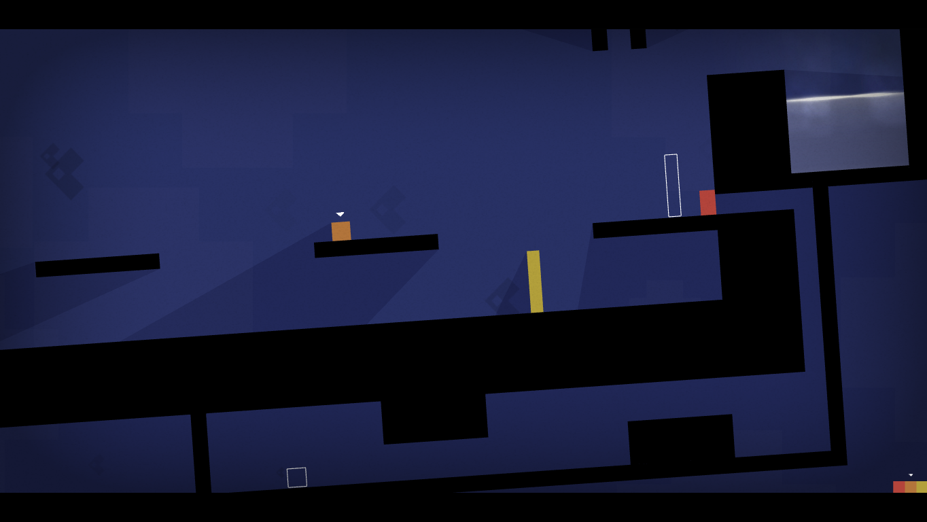
it’s really easy: those solid colour blocks fit together really easily. Similarly, if you’re going for something set indoors, you can do things like making your tiles match up to things like bricks, so that there’s supposed to be an obvious line around the edge, like this:
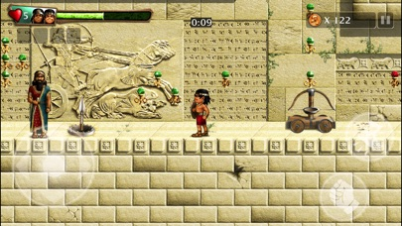

Other environments are harder – you need to make sure the sides (and top/bottom, if you’re going to be stacking them vertically) of your tiles match up properly. For an example, I’m going to make some generic soil tiles. I’m going to use Paint.NET for this, because it’s probably easier to use than GIMP, but lets me do some tricks to make getting things looking right easier that I can’t do in Microsoft Paint.

First off, I’m going to open artTemplateBig.png, and delete the white bits, so I’ve just got the guide square (S for the magic wand tool, click on each white bit and hit delete to remove it. I’m then going to make a new layer, and put it at the bottom, and right click on the “background” layer and set the opacity to 128 so that we can see through it.
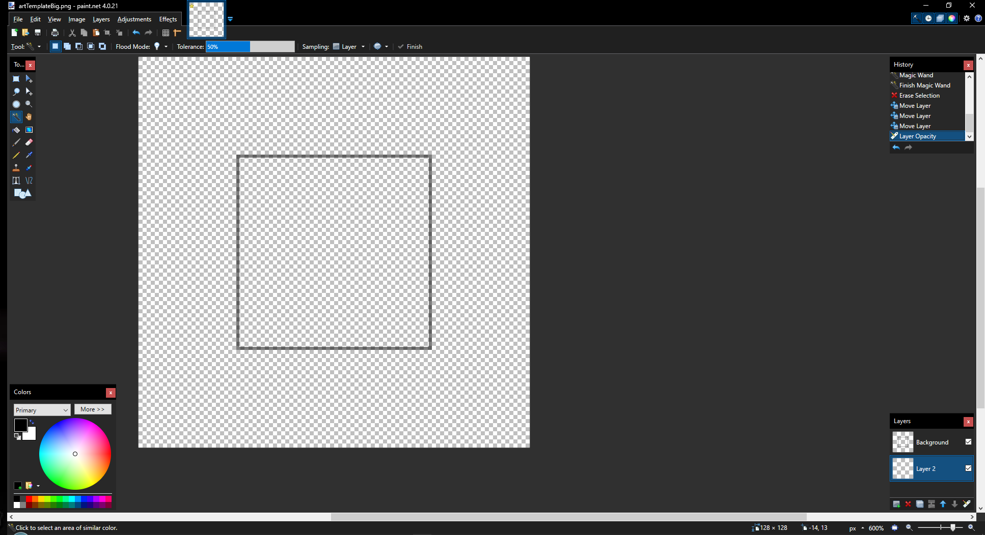
Now, select Layer 2, which is where we’re going to draw the actual art. I’ll start with a medium brown and just fill everything in (F for fill tool, pick brown using the colour wheel, click anywhere):
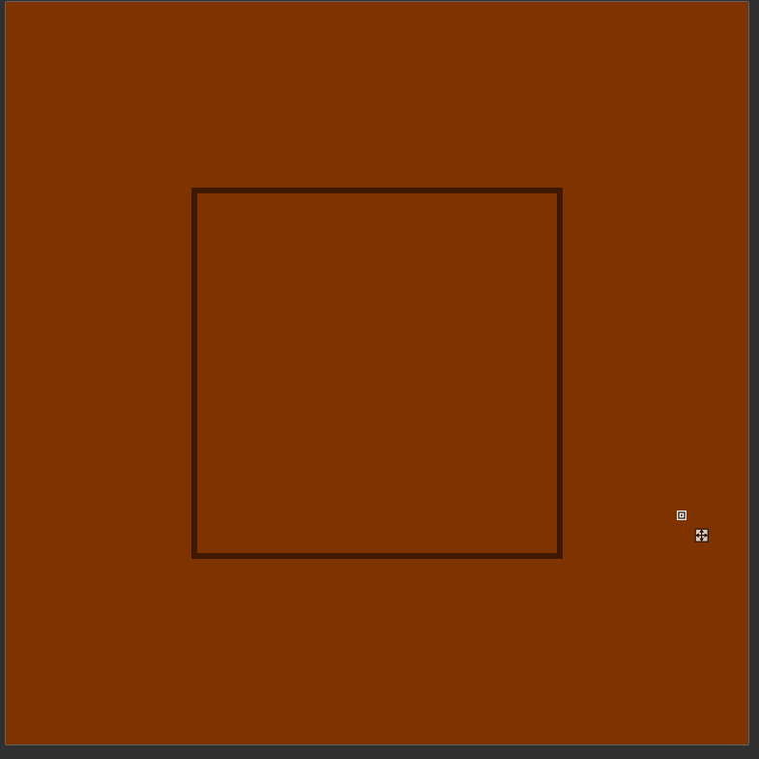

Now, that’s a bit light (and boring), so we’re going to add some blobs of a darker brown. Pick a darker brown (click “more” on the colours menu, drag “V” to the left:
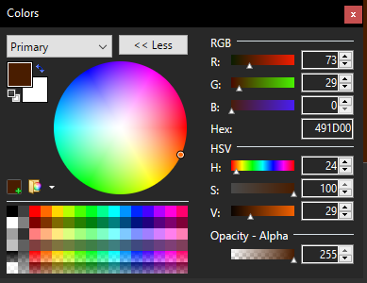

Now, make another new layer, and put it at the top.

And we’re going to draw some random blobs without going too close to the right or bottom sides of the square (press P and do the outlines with the pencil tool, then F and fill them with the fill tool – drag “Tolerance” down to zero at the top so that you don’t accidentally fill in the whole screen):
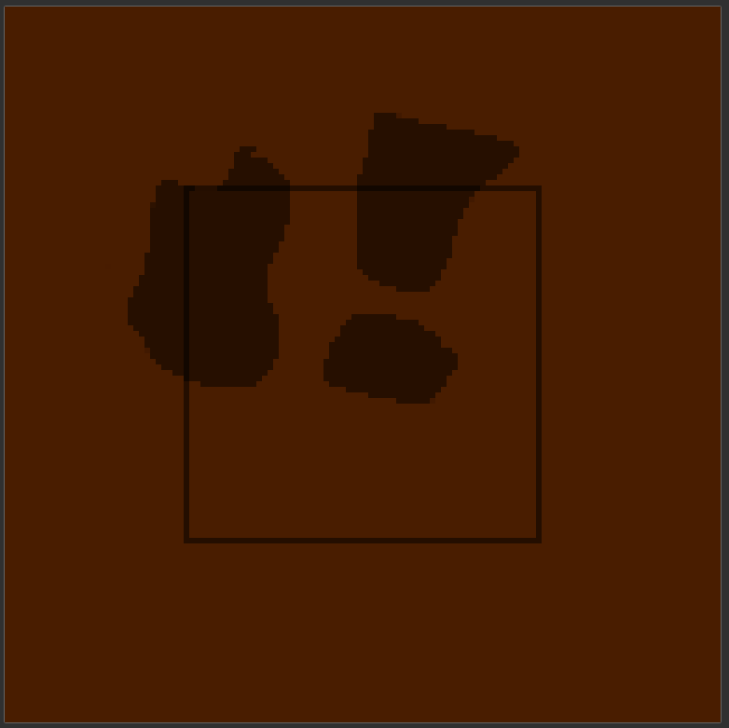

Now, we’re going to copy and paste what we’ve got sideways to fill in the gaps. To do this, press S for Rectangle select, click somewhere above the top and to the left of the picture, and drag down until the bottom-left says “Bounding rectangle size: 64 x 128”. Make sure those numbers are right – they’re important.
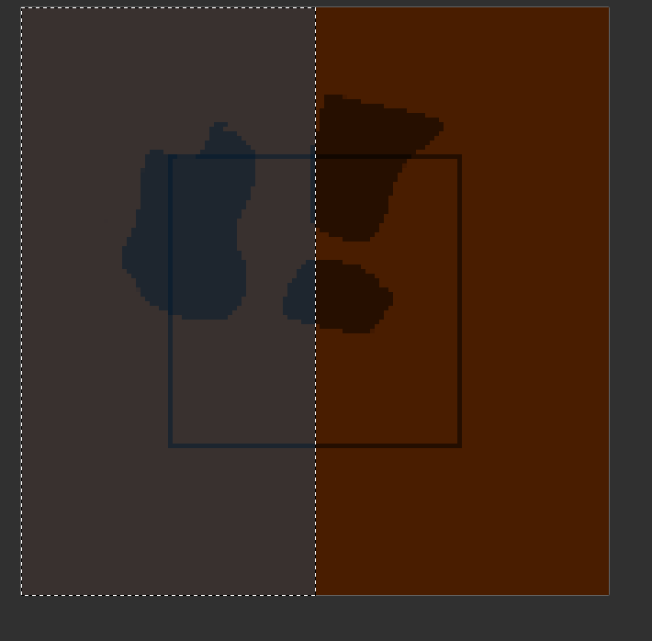

Make another new layer, and hide the plain layer.
Select your layer with blobs, press Ctrl+C to copy the square that you’ve got selected, click onto the new layer, and press Ctrl+V to paste it there, then drag it across until it’s lined up with the top-right corner of the image.
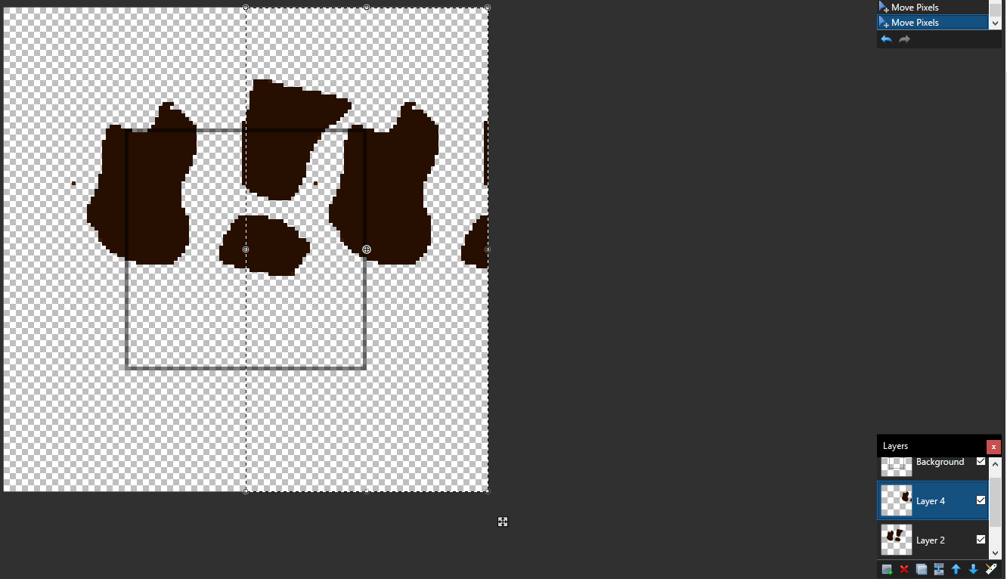

Press Escape to unselect everything, select your highest blob layer, and click “Merge Layer Down” in the layers menu.
Now, do the same thing again, but this time, we’re going to select a 128 x 64 pixel rectangle, and drag it down:
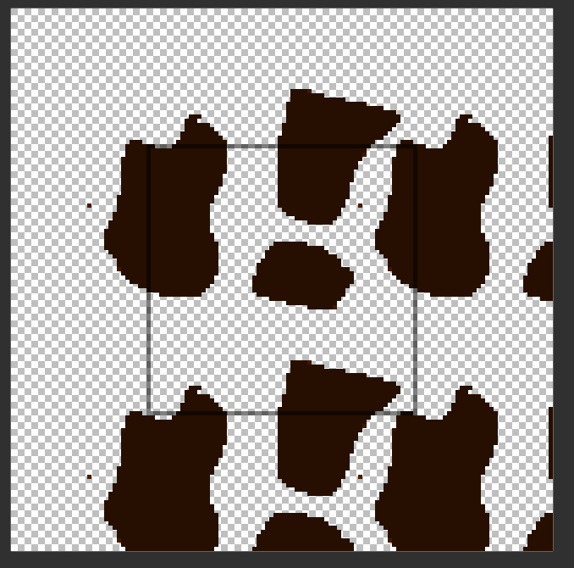
Finally, turn the solid colour layer that we deleted back on.

If you want to do more than one layer of things that you’re overlaying, do each one separately, hiding the ones that you aren’t using while you do the copy/pasting.

Now, we can edit anything inside the box as much as we like, so long as we don’t go near the edges. I like how this one looks, so I’ll leave it. For the next step, we’re going to delete everything outside the box – the lazy way to do this is to go to the Background layer, use the magic wand tool to select the outside, click to another layer, press delete on your keyboard, and repeat until you’ve done all of the layers:
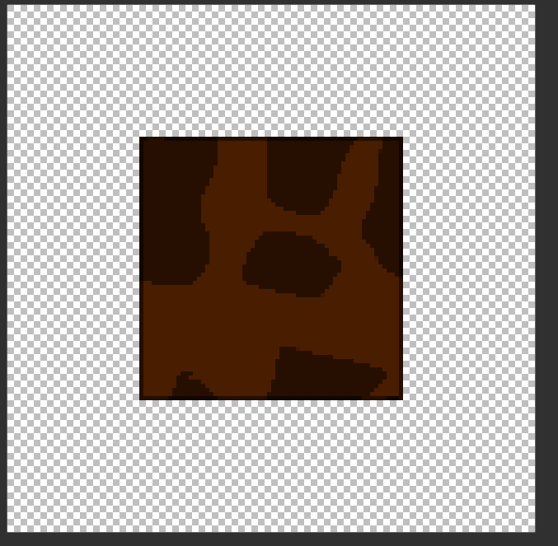

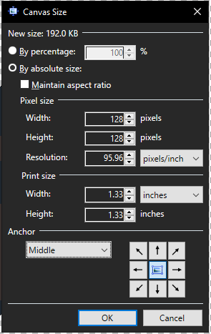
Now, if you hide the “background” layer, you’ll be left with a 64x64 pixel tile that will stack nicely with other tiles of the same type, so we just need to get rid of all of the blank space around the edges. Press Ctrl+Shift+R to open the Canvas Size menu, set (the first) “width” and “height” to 64 pixels each, change the Anchor to “Middle”, and hit OK.

Finally, press Ctrl+Shift+S to save it, and save it as something new, inside the “Assets/Resources/Art” folder (don’t overwrite the template image – you’ll still need that later).
Do that twice – save the first one as .pdn (the default), so you’ve got one with all of the layers in for editing later, and one as .png (which is the image format that we’ll actually use).

If you want to make a variant of a tile – for example, if you want a version of the soil with grass on top to use if there’s no soil above this tile, edit your .pdn file, then save it as a new one – I made a soilTop.png with some grass on for an example.
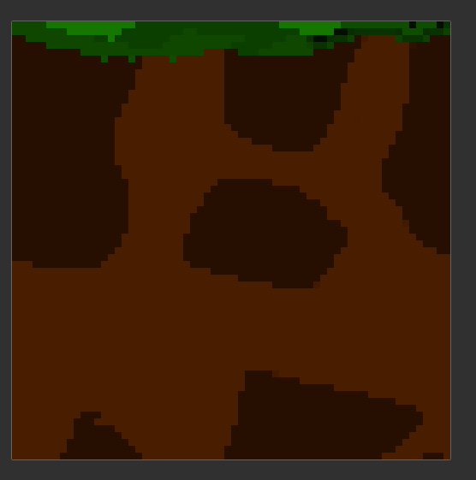

For things that we’re going to animate (probably not much, thankfully), you need to do everything that we’re animating separately, like on the right of this image:
