Section 3: Level Editor
There are two things that make up a level:
1. An image file that tells us what’s in any given space.
2. A text file that tells us what the colours in the image file mean.
These have to have the same name (so if your image is called level1.png, the text file has to be called level1.txt).

The text file starts off looking like this:
(255,255,255)Ground
(0,255,0)Platform
(255,0,0)TrapTile
(0,0,255)BreakableWall
(255,0,255)TriggerTile
(255,255,0)Enemy
(0,255,255)Character

Each line there has two things: first, a colour, then then a name. The colour is the RGB code for the colour – the numbers in the bottom-right here:
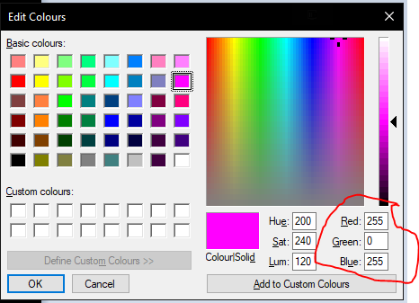

That image is from Microsoft Paint, but all image editing programs have something similar – what we can see here is that (255,0,255) is pink. If we look at the text file, we can see that “pink” means “TriggerTile” (which at the moment, just means that when you walk into it, it gives you a point, but we can change that later). The names are something called Prefabs – you can see the ones that exist in Assets/Resources/Prefabs. If you’ve got Unity installed, you can edit them and make more, but that’ll be in another tutorial.

To test your levels, save a copy as “map.png” and “map.txt” in Assets/Resources/maps, overwriting whatever’s in there, and run the levelTest.exe program. There’s no way to quit out of it yet, so press Alt+F4 when you’re done testing it.

