Section 1: GitHub
GitHub is a website that lets lots of people work on one thing without all breaking everything each other does.

The easiest way to use it is to install the desktop version (from here), but you can do it from the command line or through the website if you prefer. You’ll also need to make an account (here). Usual rules apply – no personal information, pick a sensible password, etc.

Now, tell me (Sam) what your username is, and I’ll give you access to the repository.
Once I’ve done that, go to this page, which should look something like this:
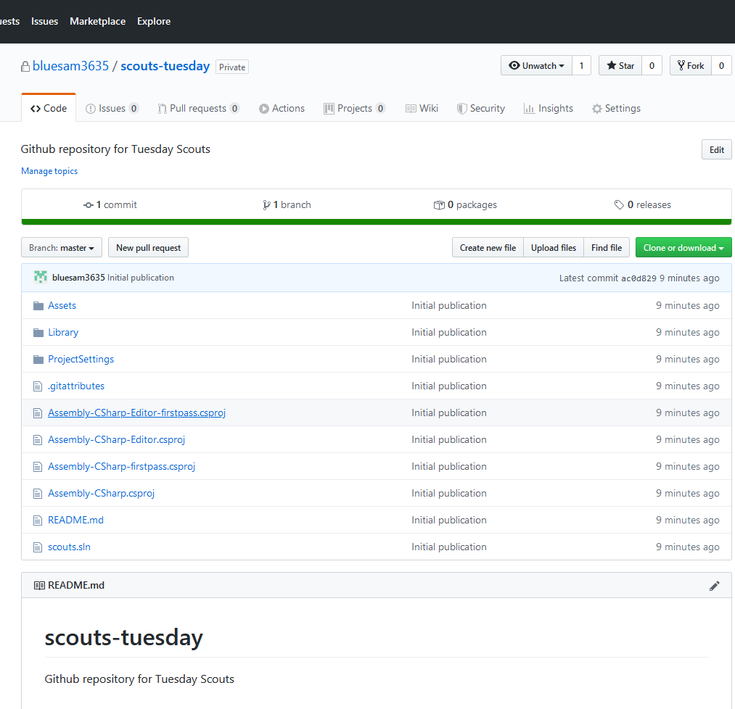
The only thing that’s of any relevance is that big green “Clone or download” button on the right. If you click it, you’ll get a few options: you’ll have the option to do it on the command line (if you know what that means, you don’t need my help to do it), “Open in Desktop” or “Download ZIP”. If you’ve installed the desktop version, click “open in desktop”. If not, click “Download ZIP”.
Desktop Version
If you’re using the desktop version, you’ll now get a screen that looks like this:
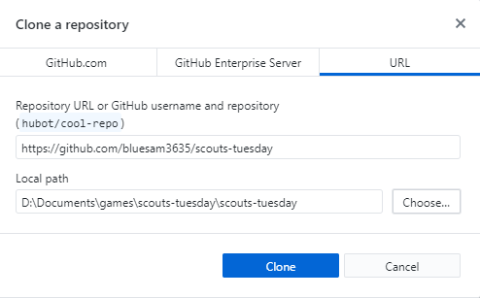
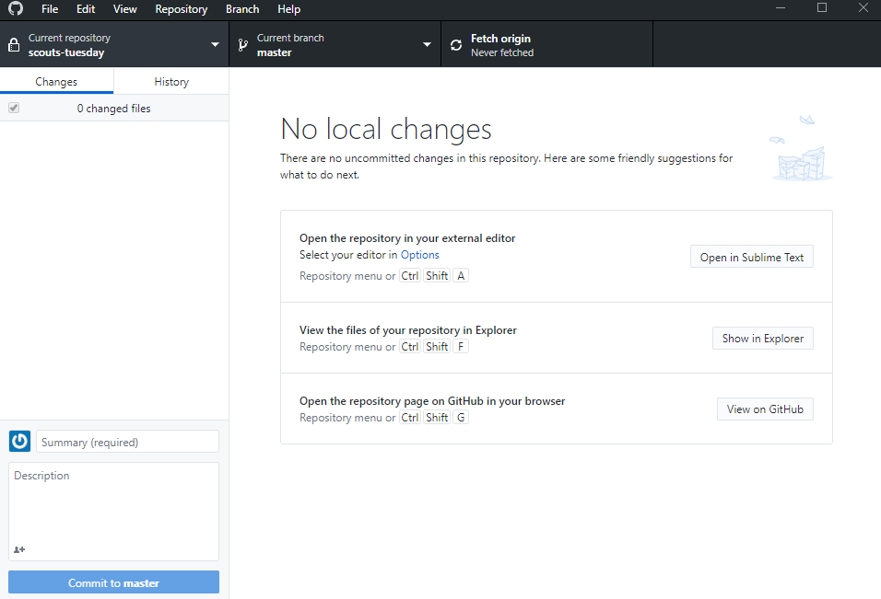
Put in where you want to install it in “local path”, and click “Clone”, which will give you a screen that looks something like this:
Click “Fetch origin” at the top.

You’ve now got a copy of the code on your computer. To make changes to it:

MAKE A NEW BRANCH FIRST

That bit’s important. A branch is basically a bunch of changes that you’re working on, which we can then merge back into the master branch at the end. To do this, click where it says “Current branch: master” at the top, click “new branch”, put in a sensible name for what you’re doing, and click “Create branch”.

Now, click “Show in Explorer” to open up the file repository, make whatever changes you like, then come back to GitHub. It’ll now look something like this:
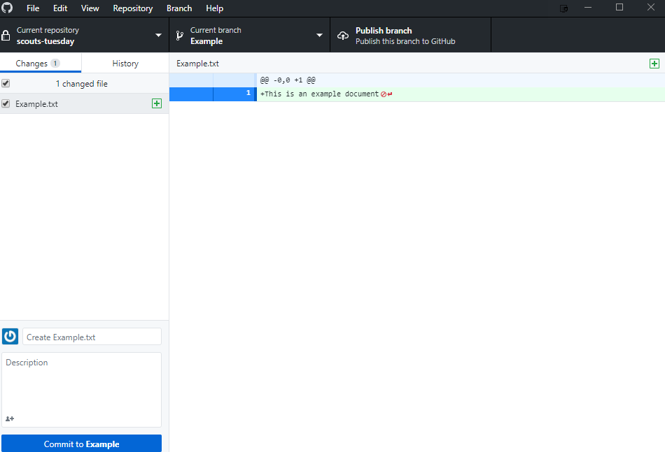
with a list of the files that you’ve changed on the left, and the actual changes for the selected file on the right. Put something sensible in the summary box (where it says “Create Example.txt” for me), and maybe a description if you think it needs more explanation for what it’s for, then click “Commit to Example” (it’ll have the name of your branch there instead of “Example”), which will give you this screen:
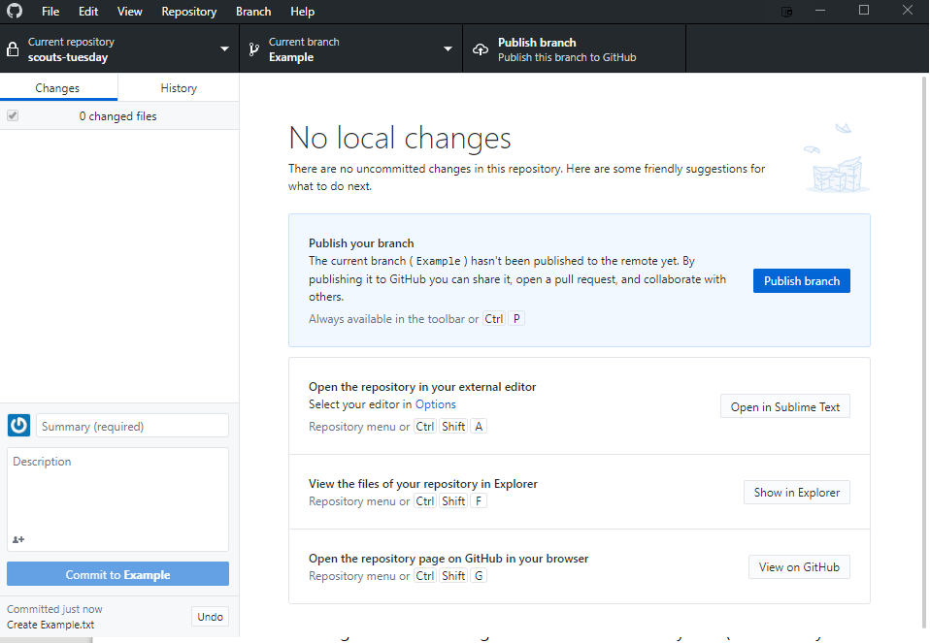
Click “publish branch” and wait a bit, and now everybody can see your new branch. Once you’ve tested it works and you’re happy with it, click “Create Pull Request” in the desktop version (or on the website), and you’ll get a web page that looks like this:
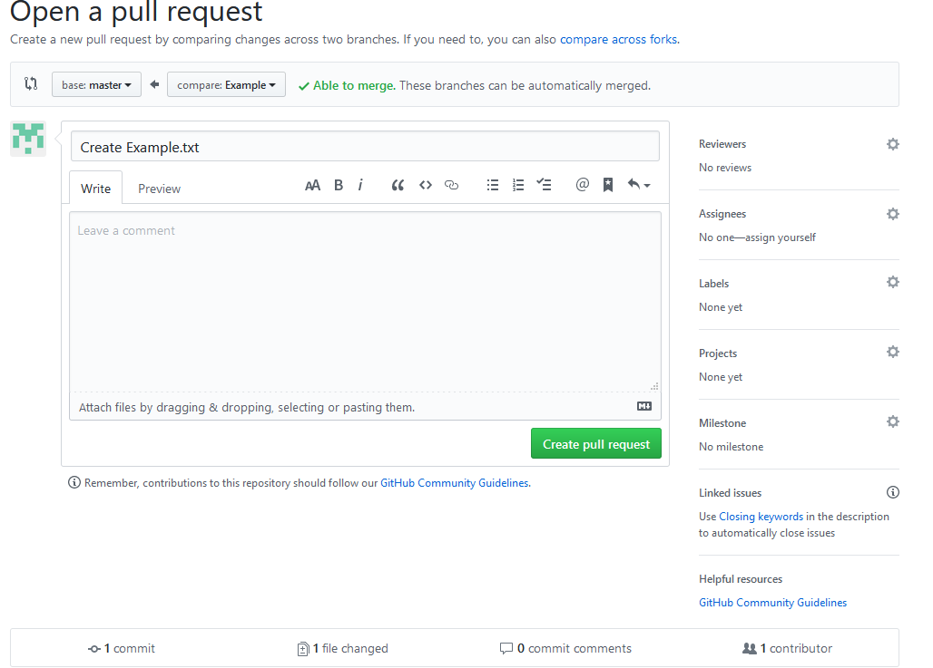
The important thing to look for is the green “Able to merge” tick – that means that there’s nothing weird going on, and you can just hit “Create pull request”. If that isn’t there, just leave it and let me know, and I’ll sort it out. If it is there, you’ll get a page like this:
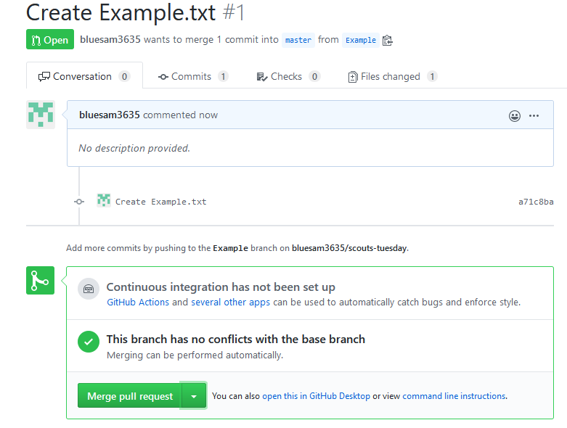
Again, look for the green tick – if that’s there, it means that nobody’s made any incompatible changes while you’ve been working, so just press “Merge pull request” and you’re done. If it isn’t, it means that two people have worked on the same thing at once. You can either go through and manually combine them, or just leave it and I’ll do it. Otherwise, click “Merge pull request” and “Confirm merge”, then click “Delete branch”, since we don’t need that branch any more (unless you’ve got more changes to make there, in which case you can keep it around).

Without using the desktop version
If you aren’t using the desktop version, you can do everything through the website:

Again,

CREATE A NEW BRANCH BEFORE CHANGING ANYTHING

That’s still important. To do it, go here and click “Branch: master” to get something like this:
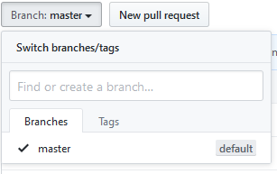

Type in the name of your branch in the “find or create a branch” box, and click “create branch: [name] from master” when it appears. To make changes, the easiest option is probably to download a ZIP of everything, make your changes, then upload the files that you want with the “Clone or download” and “Upload files” buttons, but you can also find the individual files and edit them on the website, as long as you’re only changing text files. For example, if you click on “Example.txt”, you’ll get this:
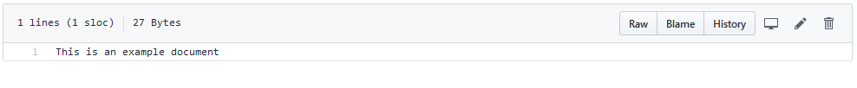
And you can edit it by clicking that pencil icon on the right, which will give you a basic text editor that you can use to make your changes.

Once you’ve made your changes in that editor, scroll to the bottom, where you’ll have this:
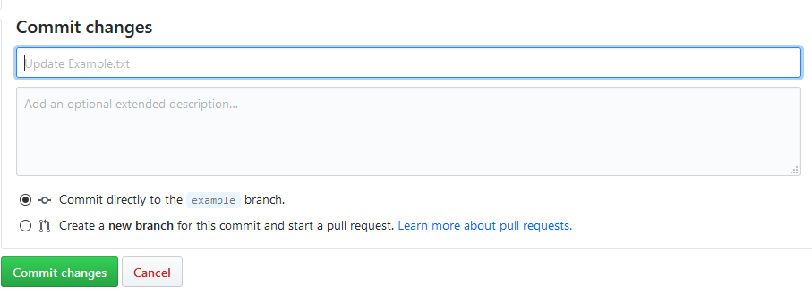
Type in a sensible summary where it says “Update Example.txt” on mine, add a description if you think it’s needed, make sure that it doesn’t say “Commit directly to the master branch” (if it does, tick the “create a new branch” box), and click “Commit changes”. Go back to here and click “Compare & pull request”. From there on, everything’s exactly the same as above, so do the same as we did there (Create pull request/Merge pull request/Confirm merge/Delete branch).

