## Create

CREATETABLE **COURSE (  
COURSE_ID INT** NOTNULL**,   
COURSE_NAME VARCHAR (100),** PRIMARYKEY **(COURSE_ID));**

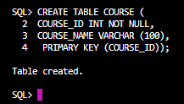

CREATETABLE **STUDENT (  
STUDENT_ID INT** NOTNULL**,  
STUDENT_NAME VARCHAR (100)** NOTNULL**,   
DOB DATE,  
GENDER CHAR (5)** CHECK **(GENDER** IN**('M', 'F', '0')),  
CITY VARCHAR (100)** NOTNULL**,  
STATE VARCHAR (100),  
COURSE_ID INT,**FOREIGNKEY **(COURSE_ID)** REFERENCES **COURSE(COURSE_ID),**PRIMARYKEY **(STUDENT_ID) );**

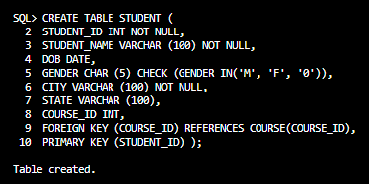

# DDL, DML Commands

## Insert

INSERTALLINTO **COURSE (COURSE_ID, COURSE_NAME)** VALUES **(1, 'Introduction to Programming')** INTO **COURSE (COURSE_ID, COURSE_NAME)** VALUES **(2, 'Database Management Systems')** INTO **COURSE (COURSE_ID, COURSE_NAME)** VALUES **(3, 'Web Development')** INTO **COURSE (COURSE_ID, COURSE_NAME)** VALUES **(4, 'Machine Learning Fundamentals')** INTO **COURSE (COURSE_ID, COURSE_NAME)** VALUES **(5, 'Data Structures and Algorithms')**SELECT **1** FROM **DUAL;**

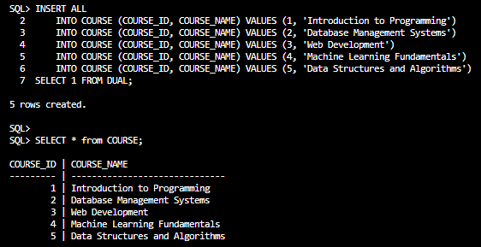INSERTALLINTO **STUDENT (STUDENT_ID, STUDENT_NAME, DOB, GENDER, CITY, STATE, COURSE_ID)** VALUES **(1, 'John Doe', DATE '1995-05-15', 'M', 'Kathmandu', 'Bagmati', 1)** INTO **STUDENT (STUDENT_ID, STUDENT_NAME, DOB, GENDER, CITY, STATE, COURSE_ID)** VALUES **(2, 'Jane Smith', DATE '1998-02-28', 'F', 'Pokhara', 'Gandaki', 3)** INTO **STUDENT (STUDENT_ID, STUDENT_NAME, DOB, GENDER, CITY, STATE, COURSE_ID)** VALUES **(3, 'Bob Johnson', DATE '1997-09-10', 'M', 'Biratnagar', 'Koshi', 2)** INTO **STUDENT (STUDENT_ID, STUDENT_NAME, DOB, GENDER, CITY, STATE, COURSE_ID)** VALUES **(4, 'Alice Williams', DATE '1996-11-20', 'F', 'Lalitpur', 'Bagmati', 4)** INTO **STUDENT (STUDENT_ID, STUDENT_NAME, DOB, GENDER, CITY, STATE, COURSE_ID)** VALUES **(5, 'Charlie Brown', DATE '1999-07-05', 'M', 'Bharatpur', 'Bagmati', 5)** INTO **STUDENT (STUDENT_ID, STUDENT_NAME, DOB, GENDER, CITY, STATE, COURSE_ID)** VALUES **(6, 'Eva Davis', DATE '1994-03-12', 'F', 'Hetauda', 'Bagmati', 1)** INTO **STUDENT (STUDENT_ID, STUDENT_NAME, DOB, GENDER, CITY, STATE, COURSE_ID)** VALUES **(7, 'Michael Clark', DATE '1998-08-25', 'M', 'Butwal', 'Lumbini', 3)** INTO **STUDENT (STUDENT_ID, STUDENT_NAME, DOB, GENDER, CITY, STATE, COURSE_ID)** VALUES **(8, 'Sophia Turner', DATE '1997-01-18', 'F', 'Dharan', 'Koshi', 4)** INTO **STUDENT (STUDENT_ID, STUDENT_NAME, DOB, GENDER, CITY, STATE, COURSE_ID)** VALUES **(9, 'Daniel Lee', DATE '1996-06-30', 'M', 'Nepalgunj', 'Mid-Western', 2)** INTO **STUDENT (STUDENT_ID, STUDENT_NAME, DOB, GENDER, CITY, STATE, COURSE_ID)** VALUES **(10, 'Olivia White', DATE '1999-12-08', 'F', 'Janakpur', 'Janakpur', 5)**SELECT **1** FROM **DUAL;**

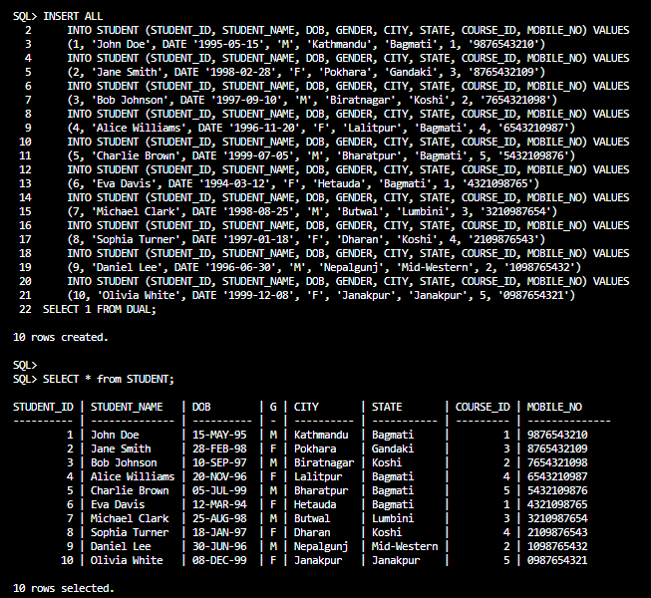

## Alter

ALTERTABLE **STUDENT** ADD **MOBILE_NO VARCHAR(100)** UNIQUE**;**



## Delete

Delete **student** withID **3** DELETEFROM **STUDENT** WHERE **STUDENT_ID = 3**



## Update

Updatethe **mobile number** of **student** withID **4** UPDATE **STUDENT** SET **MOBILE_NO = '9999999999'** WHERE **STUDENT_ID = 4;**



## Drop

Dropthe **MOBILE_NO** columnfromthe **STUDENT** tableALTERTABLE **STUDENT** DROPCOLUMN **MOBILE_NO;**



## Truncate

TRUNCATETABLE **STUDENT;**



# Data Control Language Commands

## Add User

CREATE **USER C##user1** IDENTIFIEDBYpassword**;**

## Grant

GRANTSELECT**,** INSERT**,** UPDATE**,** DELETEON **STUDENT** TO **C##user1;**



## Revoke

REVOKESELECT**,** INSERT**,** UPDATE**,** DELETEON **STUDENT** FROM **C##user1;**



# Transaction Control Language Commands

## Save-point

SAVEPOINT **point1;**



## Rollback

ROLLBACKTO **point1;**



# Aggregate Functions

## Avg()

SELECT **AVG(COURSE_ID)** AS **avg_course_id** FROM **STUDENT;**

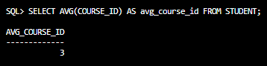

## COUNT ()

SELECT **COUNT(*)** AS **total_students** FROM **STUDENT;**

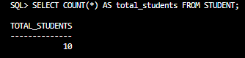

## MAX ()

SELECT **MAX(MOBILE_NO)** AS **MAX_mobile_no** from **student;**

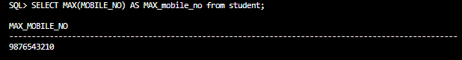

## MIN ()

SELECT **MIN(MOBILE_NO)** AS **MIN_mobile_no** from **student;**

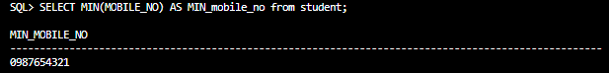

## SUM ()

SELECT **SUM(COURSE_ID)** AS **sum_course_id** FROM **STUDENT;**

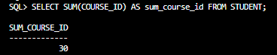

# Commands

## Use of OR

SELECT **\*** FROM **STUDENT** WHERE **COURSE_ID = 3** AND **GENDER = 'F';**

## Use of AND

SELECT **\*** FROM **STUDENT** WHERE **CITY** IN **('Kathmandu', 'Pokhara', 'Biratnagar');**

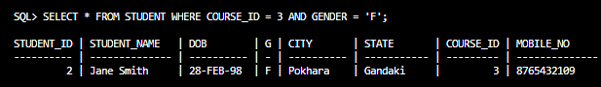

## Use of IN

SELECT **\*** FROM **STUDENT** WHERE **CITY** IN **('Kathmandu', 'Pokhara', 'Biratnagar');**

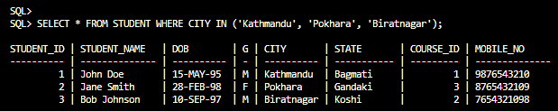

## Use of BETWEEN

SELECT **\*** FROM **STUDENT** WHERE **DOB** BETWEEN **DATE '1997-01-01'** AND **DATE '1998-12-31';**

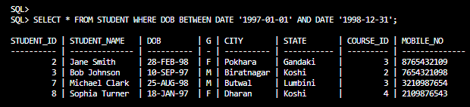

## Use of Order By

SELECT **\*** FROM **STUDENT** ORDERBY **COURSE_ID** DESC**, STUDENT_NAME** ASC**;**

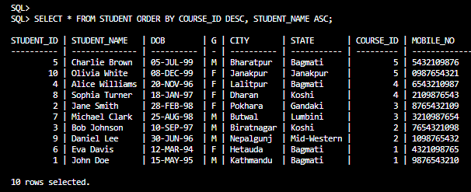

## Use of Group By

SELECT **COURSE_ID, COUNT(*)** AS **student_count** FROM **STUDENT** GROUPBY **COURSE_ID;**

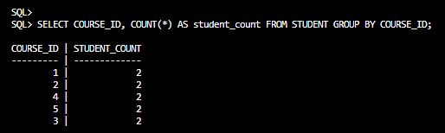

# 

# Types of Join

## Inner Join

SELECT **\*** FROM **STUDENT** INNERJOIN **COURSE** ON **STUDENT.COURSE_ID = COURSE.COURSE_ID;**

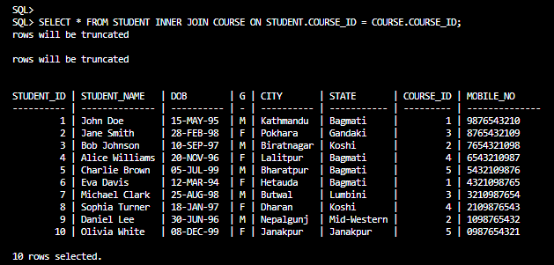

## Right Outer Join

SELECT **\*** FROM **STUDENT** RIGHTOUTERJOIN **COURSE** ON **STUDENT.COURSE_ID = COURSE.COURSE_ID;**

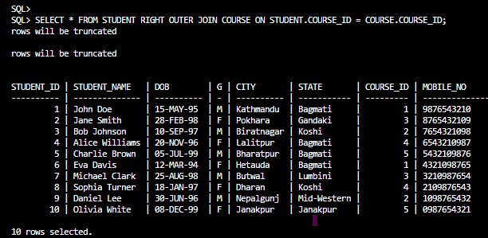

## Left Outer Join

SELECT **\*** FROM **STUDENT** LEFTOUTERJOIN **COURSE** ON **STUDENT.COURSE_ID = COURSE.COURSE_ID;**

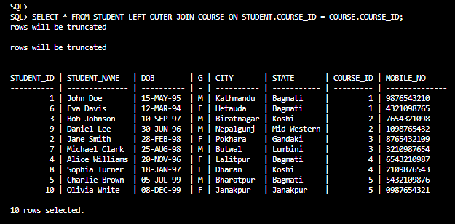

## Full Outer Join

SELECT **\*** FROM **STUDENT** FULLOUTERJOIN **COURSE** ON **STUDENT.COURSE_ID = COURSE.COURSE_ID;**

