BlueSeer Documentation

Version 4.2

Date: 2019-03-01


Table of Contents
1 Quick Installation Guide 1 4
2 Navigation Codes 2 5
3 Sales and Distribution 3 11
Customer Maintenance 3.1 11
Customer Maintenance Prerequisite Setup 3.1.1 11
Customer Master Record Entry (navcode: cusm) 3.1.2 11
State/Province Setup 3.1.3 12
Customer Master Field Definitions 3.1.4 14
Customer Ship-To Maintenance 3.1.5 15
Customer Contact Maintenance 3.1.6 15
Customer Cross Reference Maintenance (navcode: cupm) 3.2 18
Customer Item Price Maintenance (NavCode: cprm) 3.3 19
Carrier Maintenance (NavCode: carm) 3.4 21
Terms Maintenance (NavCode: term) 3.5 22
Order Maintenance (NavCode: ordm) 3.6 23
Spot (Discrete) Order 3.6.1 23
Searching Orders 3.6.2 24
Shipper Maintenance 3.7 26
Shipper From Sales Order(s) (NavCode: shpm) 3.7.1 26
Shipper From Non-Order (Service or Non-Inventory) 3.7.2 27
Warehouse Transfer Order 3.8 29
4 Purchasing 4 30
Vendor Maintenance 4.1 30
Vendor Item Cross Reference Maintenance 4.2 31
Vendor Item Price Maintenance 4.3 33
Purchase Order Maintenance 4.4 34
Purchase Order Creation 4.4.1 34
Purchase Order Search 4.4.2 36
Purchase Order Print 4.4.3 37
5 Quick Cash Management (Personal Finance) 5 38
Quick Cash Navigation (NavCode: cash) 5.1 38
Quick Cash (Buying Asset) 5.2 39
Quick Cash (Selling Asset) 5.3 41
Quick Cash (Expense Miscellaneous) 5.4 46
Quick Cash (Expense Recurring) 5.5 51
6 Finance 6 56
Chart of Accounts Maintenance 6.1 56
Ledger Calendar Maintenance 6.2 57
Department / Cost Center Maintenance 6.3 58
Bank Maintenance 6.4 59
Financial Transactions Overview 6.5 60
Financial Transactions Example Scenario 6.6 61
7 Inventory 7 65
Product Code Maintenance 7.1 65
Location Maintenance 7.2 67
Warehouse Maintenance 7.3 68
Item Master Maintenance (NavCode: item) 7.4 69
Work Cell Maintenance 7.5 71
Routing Maintenance 7.6 72
Bill Of Material Maintenance 7.7 74
Cost Maintenance 7.8 76
Production Entry (Generic) 7.9 78
Production Entry By Plan 7.10 79
Forecast Maintenance 7.11 81
Inventory Adjustments 7.12 83
MRP Maintenance 7.13 84
Scheduling Maintenance 7.14 85
8 Administration 8 86
Class (Panel) Maintenance 8.1 86
Menu Maintenance 8.2 87
Menu Tree Maintenance 8.3 88
Field Definitions: 8.3.1 90
Site Maintenance 8.4 92
User Maintenance 8.5 94
User Permissions Maintenance 8.6 95
Printer Maintenance 8.7 96
Label Maintenance 8.8 96
Label File Maintenance 8.9 96
Employee Maintenance 8.10 96
Shift Maintenance 8.11 98
TimeClock Management and Maintenance 8.12 98
TimeClock Accounting 8.12.1 101
AutoClock Maintenance and Procedure 8.12.2 101
TimeClock Code Maintenance 8.12.3 102
TimeClock Accounting Codes 8.12.4 102
9 EDI 9 104
Quick Guide Chronological Steps 9.1 104
Trading Partner Maintenance 9.2 105
TP/DOC Maintenance (Inbound specific) 9.3 106
Customer/TPDOC Maintenance (outbound specific) 9.4 108
EDI Control File 9.5 109
EDI Loader and Audit Log 9.6 110
EDI Maps 9.7 112
EDI Automation 9.8 115
EDI Command-Line Translator 9.9 116
10 Custom Application Guide 10 117
Customization Overview 10.1 117
Customization Example 10.2 118

Quick Installation Guide

Requirement: You need Java (JRE) installed on the target PC. If you do not have it already, you can download at http://www.oracle.com/technetwork/java/javase/downloads/index.html.

- Download (blueseer.sqlite.win.exe) from sourceforge.net to your local PC
- Run the package installer blueseer.sqlite.win.exe (you may need administrator rights)
- Accept the default options and click finish when complete.
- When finished, you should have a shortcut on your desktop and/or Start Menu to launch the blueseer application.
- The login and password are 'admin' and 'admin' respectively. Enjoy :)

- You can send feedback to services@blueseer.com for any comments, questions, or concerns.

Note: The sqlite version has all the functionality of the multi-user version (mysql), but it is intended for single-user use only. The sqlite version uses a file type SQL database called 'SQLite'. The usage of SQLite allows for a more convenient installation of the application without having to have a pre-existing database installed. For multi-user use, you will want to choose the MySQL version of BlueSeer.

ENJOY!

Navigation Codes

Each menu has a navigation code that allows you to quickly access any given menu without having to point and click through the menu hierarchies. For example, you can quickly navigate to the Item Master Maintenance screen by typing the navcode "item" in the navigation textbox on the menubar. The relevant navcodes for each menu can be viewed in the "NavCode List" report under the Help menu. The list is provided below. Not all menus will have navcodes (some are Menu Links), but all maintenance screens and relative browse/reports will have a unique code.

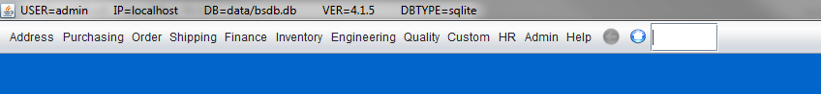

Figure 2.3 NavCode List

Menu | NavCode
About | about
AcctBalSumYTD | absy
AcctBrowse | accb
AcctMaint | accm
Address
AddrLabel | addl
Admin
APAgingView | apav
APControl | apcc
APMenu
ARAgingView | arav
ARControl | arcc
ARMemoMaint | armm
ARMenu
ARPaymentBrowse | arpb
ARPaymentMaint | arpm
ARTranRpt1 | artr
BankBrowse | bankb
BankMaint | bank
BOMMaint | bomm
BOMMenu
BOMTree | bomt
BrowseUtil
CalendarBrowse | calb
CarrierBrowse | carb
CarrierMaint | carm
CashTran | cash
CashTranBrowse | cashb
CashTransactionMenu
ClockApprovalMaint | clap
ClockAutoMaint | clam
ClockChartByCode | clor2
ClockChartByDept | clor1
ClockChartByEmp | clor3
ClockChartByWeek | clor4
ClockCode66Browse | cl66
ClockCodeBrowse | clcb
ClockCodeMaint | clcm
ClockControl | cloc
ClockDetailRpt | cldr
CostReports
CostRoll | roll
CurrencyMaint | curm
CustControl | cusc
CustEDIBrowse | edcmb
CustEDIMaint | edcm
CustMaint | cusm
Custom
CustomerMenu
CustomerReports
CustPriceMaint | cprm
CustPriceReport | cus3
CustReport1 | cus2
CustXrefBrowse | cuxb
CustXrefMaint | cupm
DefaultMaint | defm
DemdToPlan | dm2pl
DeptBrowse | depb
DeptMaint | depm
DiscreteOrderPerWeekDollars | orc2
DiscreteOrderPerWeekUnits | orc1
DOBrowse | domb
DOMaint | domm
DOMenu
ECNBrowse | ecnb
ECNMaint | ecnm
EDIControl | edic
EDILoad | edip
EDILog | ediz
EDIMenu
EDITPBrowse | edtb
EDITPDocMaint | edtdm
EDITPMaint | edtm
EDITransactionLog | edil
EmpBrowse | empb
EmployeeMaster | empm
Engineering
ExchangeMaint | excm
ExpenseMaint | expm
FcstToPlan | fc2pl
FileOrderLoad | orlo
Finance
FOBrowse | forb
FOMaint | form
forecast13weeks | fore13
ForecastBrowse | foreb
ForecastMaint | fore
FreightBrowse | frtb
FreightMaint | frtm
FTPMaint | ftpm
GenCodeBrowse | genb
GenericCodeMaint | genm
GLAcctBalSummaryByPeriod | acba
GLAcctBalSummaryByYear | acby
GLCalMaint | calm
GLControl | glcc
GLIncStmtDef | insd
GLTranMaint | gltr
GLTranRpt1 | gltrb
Help
HR
HRTrainingMenu
IncomeStatement1 | inst
IncomeStatementYear | insty
InvAdjustmentsMenu
Inventory
InventoryAdjustment | inva
InventoryCtrl | invc
InventoryReportsMenu
ItemBrowse | itemb
ItemLevelCalculate | mrpx
ItemMaint | item
ItemMenu
ItemRoutingRpt | itrr
ItemSearchMenu | itms
LabelBrowse | lblb
LabelFileBrowse | lblfb
LabelFileMaint | lblm
LabelMenu
LabelsContGeneric | lblg
LedgerBalanceExport | glbe
LedgerReportsMenu
LedgerSetupMenu
LocationBrowse | locb
LocationMaint | locm
LocationTransfer | loaj
MassLoad | load
MenuBrowse | menub
MenuMaint | menu
menuscreen | blank
MRPBrowse | mrpb
MRPMenu
NavCodeBrowse | navcodes
noStdCostBrowse | cosn
OEEEntry | oeee
Order
OrderBrowse | ordb
OrderControl | ordc
OrderMaint | ordm
OrderReports
OrderSource | orsc
OrderSourceBrowse | orsb
OrdLineBrowse | orlb
PanelBrowse | panelb
PanelMaint | panel
PaymentMaint | appm
piechart_custAR | sales2
piechart_salesbycust | sales1
PlanMiscMaint | plan
PlantDirectoryMenu | pdir
POBrowse | purb
POMaintMenu | purm
POSBrowse | posb
POSControlMaint | posc
POSMaint | posm
POSMenu
PostGLTrans | post
PrinterBrowse | prntb
PrinterMaint | prnt
ProdByWeekFGDollars | prdr3
ProdByWeekFGUnits | prdr2
ProdCodeBrowse | prcb
ProdCodeMaint | prcm
ProdEntryByPlan | prodp
ProdEntryMaint | prod
ProdRptDet | prdr1
ProdSchedMaint | schm
ProdSchedRpt1 | prscr
ProductionMenu
ProductionReports
Purchasing
QPRBrowse | qprb
QPRMaint | qprm
Quality
ReceiverMaintMenu | recm
RecvBrowse | recb
RecvByPOBrowse | recbp
ReqAmtByAcctChart | req3
ReqAmtByDeptChart | req1
ReqBrowseAll | reqb
ReqBrowseApproved | reqz
ReqChartsMenu
ReqControl | reqc
ReqFreqByUserChart | requ
ReqMaint | reqm
ReqPendingApproval | req2
ReqPendRpt1 | rqpr
RequisitionMenu
RoutingBrowse | roub
RoutingMaint | roum
RoutingMenu
SchedOrdBrowse | schb
ScheduleMenu
SchemaBrowse | schema
ScrapChartDolByCode | scrp1
ScrapChartDolByDept | scrp2
ScrapChartDolByPart | scrp3
ScrapChartQtyByCode | scrp4
ScrapChartQtyByDept | scrp5
ScrapChartQtyByPart | scrp6
ScrapEntry | scrp
ScrapMenu
ScrapPerWeek | scrpw
ScrapReports
ScrapRpt1 | scrr
ShiftBrowse | shfb
ShiftMaintenance | shfm
ShipConfirm | shcf
ShipMaint | shpm
ShipperBrowseDet | shpbd
ShipperControl | shpc
ShipperInvoiceBrowse | shpb
ShipPerWeekDollarsChart | shpr1
Shipping
ShipReports
ShipUnconfirm | uncf
SiteBrowse | siteb
SiteMaint | site
SystemControl | sysc
TaskBrowse | tasb
TaskMaint | tasm
TaxBrowse | taxb
TaxMaint | taxm
TCAdminMenu
TCReportsMenu
TermsBrowse | termb
TermsMaint | term
TimeClockAdjust | tima
TimeClockEntry | time
TimeClockMenu
TrainingMaint | tram
TrainingRpt1 | trnr
TransBrowse | tran
TransportationMenu
TreeMaint | tree
UnPostedTransRpt | ungl
UOMMaint | uomm
UserBrowse | usrb
UserMaint | usrm
UserPermsMaint | uspm
VendBrowse | venb
VendControl | venc
VendMaint | venm
VendorMenu
VendPriceMaint | vprm
VendPriceRpt1 | vprb
VendXrefMaint | vdxm
VendXrefRpt1 | vdxr
VoucherBrowse | vocb
VouchMaintPanel | vocm
WareHouseBrowse | wahb
WareHouseMaint | wahm
WhereUsedUtility | where
WorkCellBrowse | wkcm
WorkCellMaint | wkcb

Sales and Distribution

Customer Maintenance

The Customer Master is key to many of the subsequent operations within BlueSeer and is the cornerstone of most of the functionality of the Order-to-Cash life cycle. Setting up the Customer Master and it's dependent menus correctly will establish the necessary defaults in subsequent menus such as order entry, shipper creation, and invoicing. A well-constructed customer master will reduce data entry in many of these order-to-cash dependent menus that follow.

Customer Maintenance Prerequisite Setup

The following is a list of Maintenance screens that contain data that is used by the Customer Maintenance Menu in the form of drop down selection options. These drop-down lists are populated at start-up by selecting the appropriate master tables of each drop-down type. All of these drop-downs have a default value pre-installed with the initial install of BlueSeer, and while you can use these defaults, you will probably want to add or edit the existing values to match your needs.

- Account Maintenance
- Dept/Cost Center Maintenance
- Carrier Maintenance
- Terms Maintenance
- Bank Maintenance

Customer Master Record Entry (navcode: cusm)
To add a customer, Click on the Menu 'Customer Maintenance' under Address--> Customer Menu. The Customer Maintenance screen will appear. You can also enter 'cusm' in the navigation text box and you will be forwarded to the customer master menu screen. It is necessary to add a new customer code that represents the bill-to association of this customer record. Each customer code is unique. Therefore, only one customer code per bill-to record is allowed. An error will be generated if an attempt to enter the same code for two different bill-to customer records.
The default customer code is a sequential number automatically generated by the application upon clicking 'New'. Alternatively, you have the option of entering your own customer code as well. The customer control menu (navigation code "cusc") governs the automatic code creation. Unclick the auto-generate field in the customer control menu to stop the auto-generation of the code. You can then enter a custom code of your choice.
To add a new customer code, simply enter the code in the 'CustCode' field. The customer code can be any alphanumeric characters with a max character length of 10 characters. Enter all the associated data in the appropriate textboxes and/or dropdown lists. Once all the necessary fields have been entered, click 'Add' to commit the customer master record to the database. A dialogue box will appear indicated a successful addition or an error for any field validation issues. Note, it is not possible to enter any shipto code information or contact information until the customer master record has been committed. The ShipTo and Contact information is relative to the customer billto code and cannot be declared without association to a legitimate existing customer code.
Several fields are 'required' fields. Most of the required fields are drop-down lists, so it is necessary to choose the correct drop down option. You must enter a valid account in the 'Account' field. The Account field represents the AR Sales account you wish to associate this BillTo code with. This value will be validated against the accounts that were entered into Account Maintenance under Finance-->Ledger Setup. The Cost Center is another validated text-box. The CC must be a legitimate value found in Department/CC Maintenance under the Finance-->Ledger Setup Menu. A generic cost center of 9999 can be entered if multiple cost centers are not required by your site. Code '9999' should be available in Department/CC Maintenance as a result of the BlueSeer install. Figure 1.1 and 1.2 are screen shots of the customer maintenance screen before and after entering a new record.
Once you've entered a new Customer Master record, you can retrieve the record by one of two options. You can enter the code directly into the customer code field and press enter. If a legitimate code is entered, the record will be retrieved and the code field will become deactivated with a blue foreground color). If you enter an invalid code, the code field will show red foreground text. Alternatively, you can click on one of the search buttons “magnifying glass”. These buttons will take you to a search menu where you can enter a search string to find the exact record you are looking for. The string can be search by “Begins with”, “Ends With”, or “Matches”. If you simply click 'FindIt' with no string, it will return all records. Figure 1.3 shows a screen shot of the Search menu. Each record in the search criteria is returned with a select button (Flag icon). Clicking the Flag icon button will return you to the Maintenance screen from which it was called along with the relative record data you clicked on. You can then proceed to review, update, or delete (in some cases) the retrieved record. Note: Some maintenance screens will not allow you to delete the record from the Maintenance menu due to the associated nature of other tables that are related to this record. You will need to use a special delete utility to delete these type of records.

State/Province Setup
The State/Province drop down list on the customer master menu is controlled by generic codes that you can enter for various state or provinces of specific countries that you may do business within. The three character ISO standard code is recommended, and as a result, only the first 3 characters of the generic code you enter will be placed in the drop down list. The US states are provided by default. To enter other state/province values, go the the Generic Code Maintenance menu under the admin main menu or enter enter the appropriate navcode (navcode: genm). Enter the value 'state' in the field labeled 'code'. Enter the 2 or 3 character abbreviation in the 'key' field, and enter a description of the key in the 'value' field. Once this information is entered, click add to commit the record. This state/province record will now be visible in all the drop down lists of the various menus that have the 'state' drop down list. The below figure 1.4 shows the Generic Code Maintenance menu with a sample entry for Geneva, Switzerland.

Figure 1.1

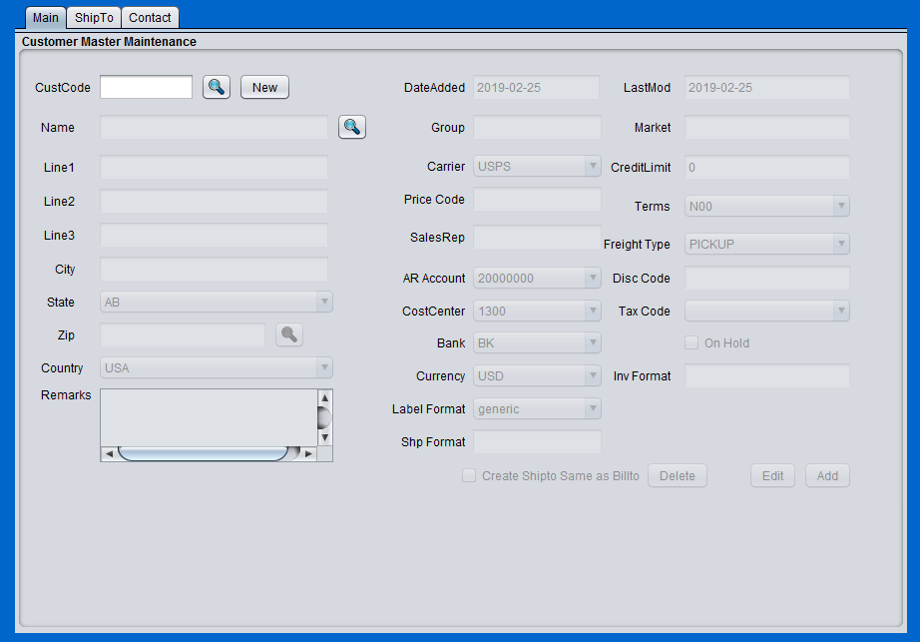
Figure 1.2

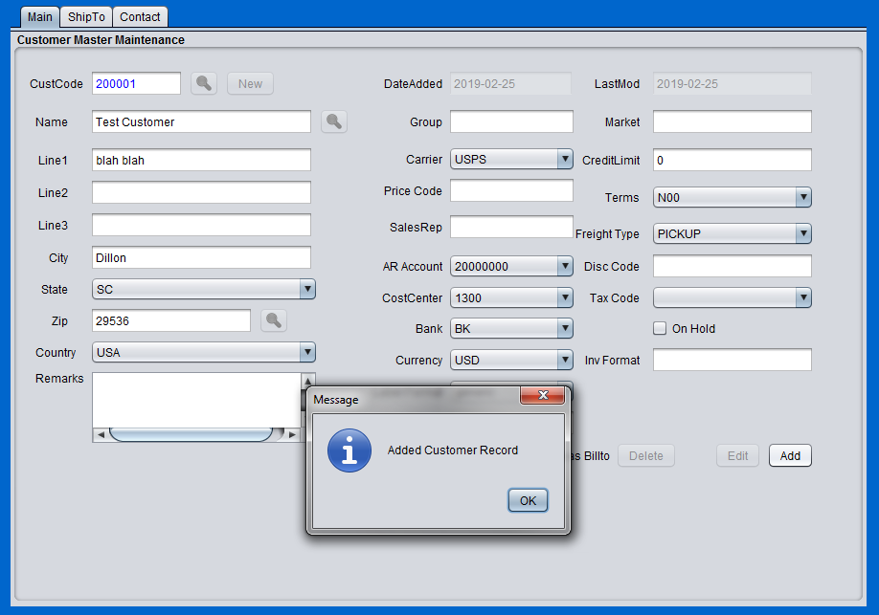

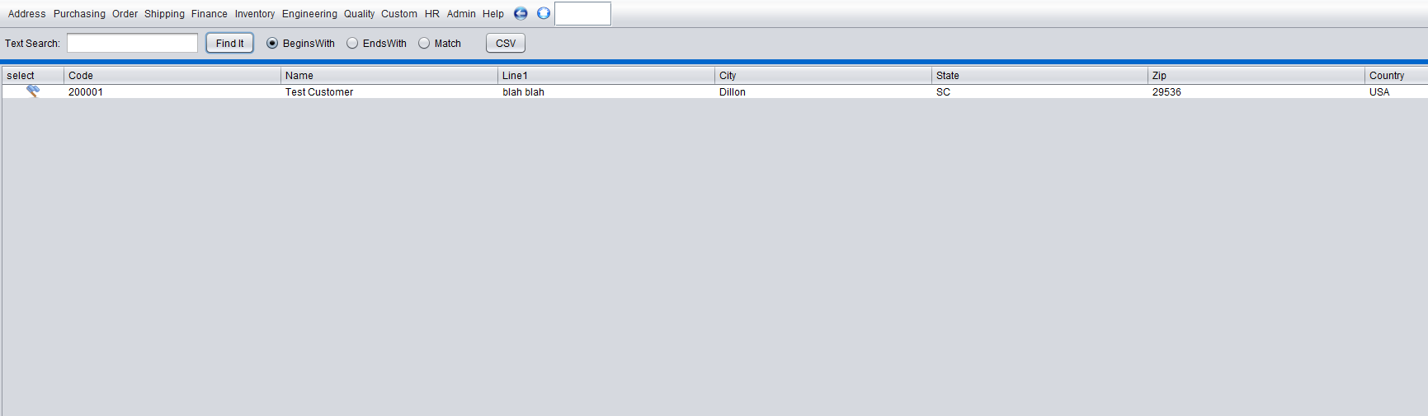
Figure 1.3

Figure 1.4.
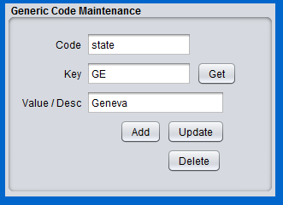

Customer Master Field Definitions

Customer Ship-To Maintenance
To add a customer shipto record, click on the menu 'Customer Master' under Address--> Customer Menu. The Customer Maintenance screen will appear. All shipto records are assigned to a particular billto record. Click one of the search buttons in the customer maintenance screen, and retrieve the customer billto record that is the parent of the shipto record you wish to add. Once you have the billto record in the customer maintenace screen, click on the 'New' button next to the 'ShipCode' text box in the shipto address panel of the customer maintenance menu. This will enable the shipto address fields for you to enter. Enter a unique code in the 'ShipCode' text box and then enter all relevant information in the appropriate address boxes within the shipto panel. Once complete, click 'Add' in the shipto panel to commit the new shipto record. You can then retrieve the newly added shipto record by clicking the search button next to the 'ShipCode' textbox and retrieving the record you just entered. Figure 1.4 shows the customer maintenance screen for adding a new shipto code 'TEST' for Customer 'ACME'.

Figure 1.4
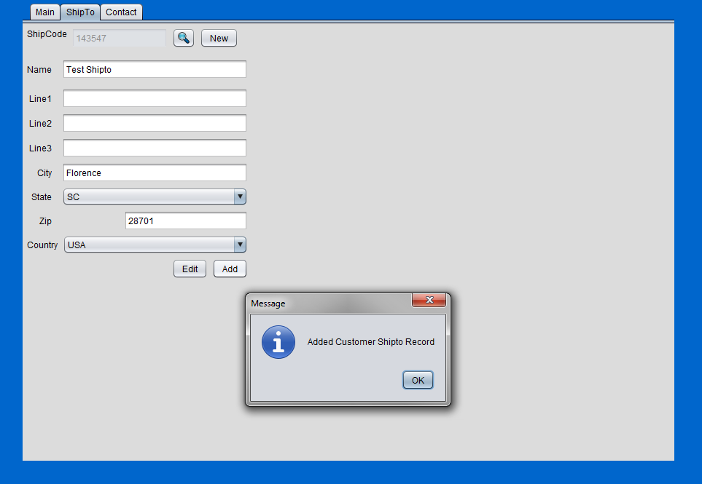

Customer Contact Maintenance
To add a customer contact record, click on the menu 'Customer Master' under Address--> Customer Menu. The Customer Maintenance screen will appear. All contact records are assigned to a particular billto record. Click one of the search buttons in the customer maintenance screen, and retrieve the customer billto record that is the parent of the contact record to be added. Once the appropriate billto record is selected, Enter the contact type, phone, contact name, fax, and email fields with the appropriate information and then click the 'AddContact' button in the Contact specific panel of the customer maintenance menu. A dialogue box indicating the addition of a new contact record will appear. The new record will also appear as a row in the table at the bottom of the Contact Panel. There is no limit on the number of contact that can be added. With each additional contact added, a new row will appear in the table. To edit a contact record, click on the row within the table. Upon clicking the row, the entry fields above will be occupied with the appropriate data. Edit the fields as necessary, and click 'EditContact'. This will commit the new data to the record and refresh the table. To delete a contact, the procedure is similar to the edit procedure. Click (highlight) the row within the table that is desired to be deleted, and click the 'DeleteContact' button. This will remove the record from the database and refresh the contact table. Figure 1.5 below shows the addition of a new contact record for the 'ACME' billto code.

Figure 1.5
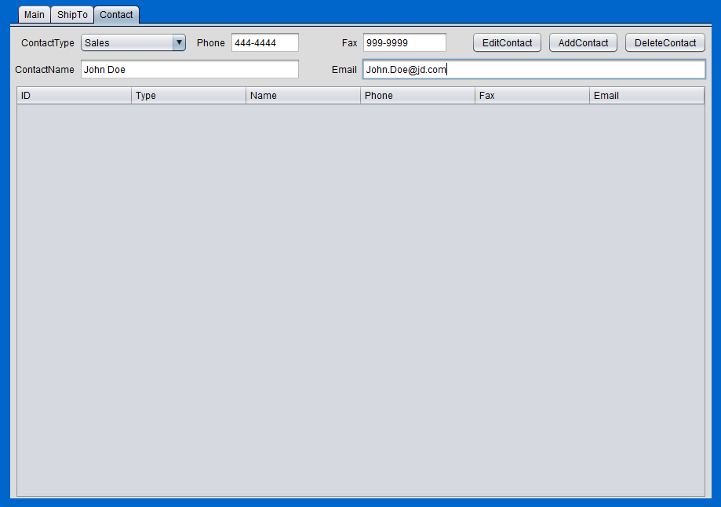

Customer Cross Reference Maintenance (navcode: cupm)
Customer part cross reference allows one to associate an internal item part number to a customer's part number. This association is important for many customer specific menus within BlueSeer. Creating customer cross references to the internal parts facilitates the automation of the order loading process by creating a list of customer specific part numbers (and customer specific prices ...see customer item price maintenance) when the sales order is created for a specific customer. This prevents the manual entry of customer part numbers and customer prices. Correct entries in the customer cross reference menu also facilitates loading orders automatically with the EDI module. Inbound EDI orders from any customer typically have the customer's part number within the document, and it is necessary to cross-reference this customer part number to the appropriate internal part number so that the order can load successfully.
To enter a customer cross reference record, enter 'cupm' in the navigation textbox or go to 'Address'-->'Customer Menu'-->'Customer Xref Maint'. Choose the appropriate customer code 'CustCode' in the drop down selection and then enter the customer item in 'cust item' textbox. Once the customer item is filled in, press the 'tab' key to move to the internal item drop down list. Note: if there is no cross reference previously established, a message will appear below the customer item field indicating 'Adding New Record'. However, if there is already a cross reference record for this customer code / customer part number combination, then there will be a message indicating 'Record Exists'. The other fields are optional to enter. Once the fields have been entered, click the 'Add' button, and the customer cross reference record will be committed. A screen shot of the enter a new record in the customer cross reference menu is provided below.

Figure 1.6
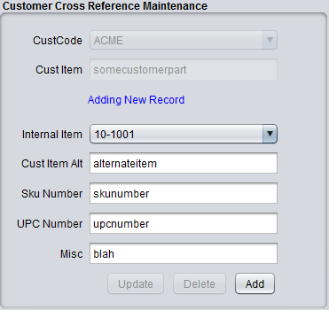

Customer Item Price Maintenance (NavCode: cprm)
Customer prices for customer specific items can be created and/or edited in the Customer Part Price Master under 'Address'-->'Customer Menu'-->'Customer Price Maintenance'. Once inside the Customer Price Maintenance menu, choose the appropriate CustCode from the drop down list. If there are any previously associated item/price records for this custcode, they will appear in the 'Applied' list. You can click on these records in the applied list to show the price for any item within the list. To enter a new record, choose the appropriate item in the drop down list and then 'tab' to the price field and enter the price. The price must be in decimal format "#.##". Each price list is specific to the uom and currency that is applicable. Choose the appropriate uom and currency for the item. Once you enter the required fields, click 'Add' to create the associated price record. It will appear in the Applied list.
Discounts can be created and/or edited in the same screen as the Part Price records. Discounts can be entered in Customer Part Price Master under 'Address'-->'Customer Menu'-->'Customer Price Maintenance'. Once inside the Customer Price Maintenance window, choose the appropriate CustCode from the dropdown list within the 'Discount Maintenance Window'. If there are any previously associated discounts, they will appear in the 'Applied' list. To enter a new record, enter a unique key in the 'key' text field. Then 'tab' to the percent field and enter the percent of the discount. This discount will be applied to all orders for this customer at the line item level. The discount percentage must be in decimal format "#.##". Once you enter the percent, then click 'Add' in the Discount Maintenance window to create the associated discount record. It will appear in the Applied list. Figure 1.7 provides a screen shot of the Customer Price Maintenance screen.
Figure 1.7
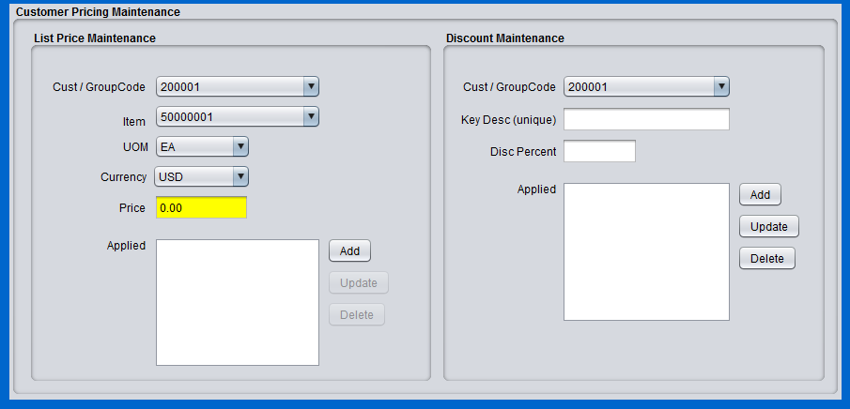

Note that once you click 'add', the application will immediately commit the price (in green background) and display the record in the 'Applied' listbox. The record will be a delimited value that includes the item, uom, and currency. See Figure 1.8.

Figure 1.8
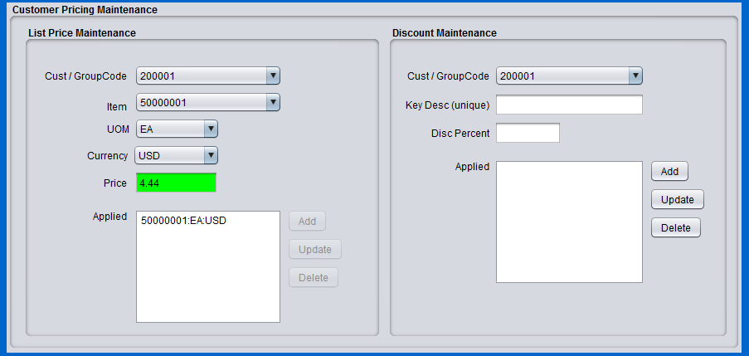

Carrier Maintenance (NavCode: carm)
Carriers (SCAC) codes can be created in Carrier Maintenance for any necessary carrier regardless of modal transport (truck, rail, ship, etc). The Carrier Maintenance menu provides a limited number of fields to maintain specific information about any given carrier. The associated fields to the carrier code are typically informational only. The 'scac' code, however, can appear in shipper, invoice, and bill of lading prints, and outbound EDI documents. These carrier records are available as drop down list values in a variety of customer and vendor specific menus (customer master, order entry, receiving, shipping, etc). To add carrier code, go to Carrier Maintenance under 'Address'-->'Customer Menu'-->'Carrier Maintenance'. The choice of carrier code is arbitrary and can be up to a maximum of 8 characters. The carrier code should not be confused with the scac code. The scac code is typically not arbitrary and is specific to the carrier. In many cases, creating your carrier code with the same value as your scac code is good practice. Most scac codes are between 4 and 6 characters however. You can add an additional description to the code to associate a name with the new record. After entering all the associated fields, click the 'Add' button, and the carrier record will be committed. Once the record is committed, it will be available in the various menus mentioned earlier that may have the 'carrier' drop down list.

Figure 1.8
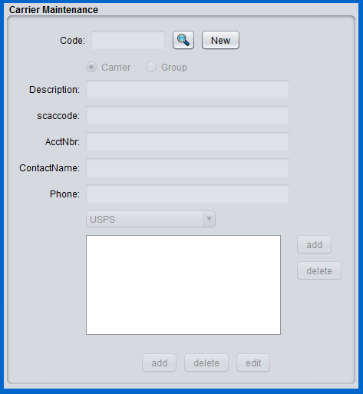

Terms Maintenance (NavCode: term)
Terms of payment for customer orders are maintained in Terms Maintenance under 'Address'-->'Customer Menu'-->'Terms Maintenance'. Each terms code created has an associated number of days before payment by your customer will be due. This due date is calculated from the invoice date of the invoice applied to the shipment. The terms code can be any 8 character code of your choice. Example codes are N30, N60 for net 30 days due and net 60 days due respectively. A descriptive field is provided for more detailed explanations of the respective term code. Enter the code, description, and number of due days applied to this code. For example, if the terms agreement is 30 days from day of invoice, Enter "N30" for the terms code (or Net30 depending on your preference), a description, and the integer 30 in the due days field.
Once the terms code is defined in Terms Maintenance, it can be chosen from a drop down selection box in the Customer Address Master record. Typically, each customer has a fixed terms length which is agreed upon before shipment(s). Choose the appropriate terms code for each of your customers and apply in the customer maintenance screen. Once set in the customer master, any sales orders or schedules for this specific customer will have the terms field automatically pulled from the customer master and applied to the order. You do have the option to change the terms code per individual sales order in the Order Maintenance screen. However, the default terms code for the initial order will be pulled from the customer master.
An optional Discount Due Days can be applied to the terms code in Terms Maintenance. You can offer a discount of whatever percentage you choose if the customer pays the invoice early. You can set the number of discount due days for each terms code that you wish to apply a discount. If you do not wish to apply a discount for early payment, then set discount due days to 0 and discount percentage to 0. As an example, if you wanted to offer the customer a 3% discount if they pay in 45 days instead of 60 days (which is their original due date terms), then set Due Days as 60, Discount Due Days as 45 and Discount Percentage as 3%. Note: Set the discount percentage as a legitimate percentage and not as the decimal equivalent. For example, enter '3' and not '.03' for the discount percentage. Do not enter the percent sign. Figure 1.9 below shows the Term Maintenance screen shot.
Figure 1.9
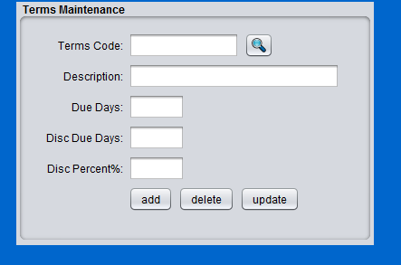

Order Maintenance (NavCode: ordm)
The Order Maintenance menu found directly under the 'Order' Menu contains the functionality to add, edit, and delete sales orders. It accommodates two types of orders: 1) Discrete(spot) type Sales orders and 2) Scheduled(blanket) type orders. A large number of fields within the order maintenance are pre-defined based on information entered for other Maintenance Screens (example: customer/shipto master, customer specific part numbers, customer specific part pricing, etc). The following section describes some of these pre-requisite data setups that are necessary for efficient operation of order entries.
There are several maintenance menus that need to be setup prior to creating a sales order. The minimum setup pre-requisite is the Customer Master bill-to and ship-to information. The procedure for entering your customer bill-to and ship-to info can be found in the Customer Maintenance section of the documentation. The customer item cross reference data and the customer item pricing data should also be setup prior to creating an order for a specific customer. This setup is necessary to ensure that customer part numbers and pricing (including relevant discounts) are applied in the drop down selection fields without having to manually look up each line item specific information. Choosing a part number in the drop down list should automatically establish the customer part number and the correct pricing and discounts to be applied once the customer cross reference and customer item prices have been established. Figure 1.9 shows the screen shot of the Order Maintenance Menu.

Spot (Discrete) Order

As mentioned previously, there are two types of orders accommodated by BlueSeer. The first is a spot order. A spot (discrete) order is generally defined as an order placed by your customer that has a unique PO, delivery date, and specific items and quantities that are to be shipped as a single order and shipped completely to the extent possible. To enter a spot order, go to the 'Order'-->'Order Maintenance' menu. Assuming you have previously set up your BillTo and ShipTo Codes, the drop-down list for Customer and Shipto will be populated with these codes to choose from. The first step is to click on 'New', which will assign a next-sequence number in the OrderNbr field. This will be your BlueSeer order number for this sales order. Choose the Customer Code for this order and subsequent ShipTo Code associated with the shipping address where these items are to be shipped. You have the options to enter in a PO (provided by your customer), ShipVia (the carrier you choose), and a DueDate that this order is expected to ship. There is a remarks field as well to enter any remarks necessary to support the order and is visible on subsequent documents such as packing slips and invoices.
Once the header information of the order has been established, you must now enter the detailed line items for this order. If you have previously set up Customer Xref records in the Customer Xref Maintenance menu then you will see a list of items in the Part Number drop-down list that are specific to this customer. Clicking on this list and selecting an item will populate the customer number field with the corresponding customer item number. Also, assuming you set up the customer price records for this customer / item in the Customer Item Price Maintenance menu , you will also see the list price, disc, and net price populated with the corresponding prices and discounts applicable to this customer's item. After entering your line items for this order, you then only have to click 'Save' to establish the order record.
If you did not enter the before mentioned xref and price files, then you can enter a non-stock item in the item drop-down list and tab to the qty field. The customer number will be shown in 'red' to alert you to the fact that this is a non-stocked item with unknown price. You will then have to enter the list, disc, and net price manually.

Searching Orders

To search for a specific order, there are several search buttons (magnifying glass) that will allow one to search for order records based on the field next to the search button. There is a search button for the order number, customer billto, order date, due date, and purchase order number. So, for example, to search by PO number, click on the search button next to the PO Number. This will send you to the browse screen. You can either enter a text string to search by or you can click 'Find It' without a search string. The latter will bring back all records. The former will bring back any records associated with the search string. You can choose the type of search to be 'begins with' , 'ends with', or 'match'. If records are returned, the browse screen will show each record with a select button beside the record. Clicking on the select button will return you to the order maintenance screen with the appropriate record selected. Another search option would be to search by due date of the order. For example, if you wanted to know all orders that are due in March of 2015, you would enter “2015-03” with the “begins with” option selected. This would return all orders regardless of customer with the duedate beginning with “2015-03”. Note: All order dates and due dates are of the format “YYYY-MM-DD” where the hyphen is mandatory.

Figure 1.9
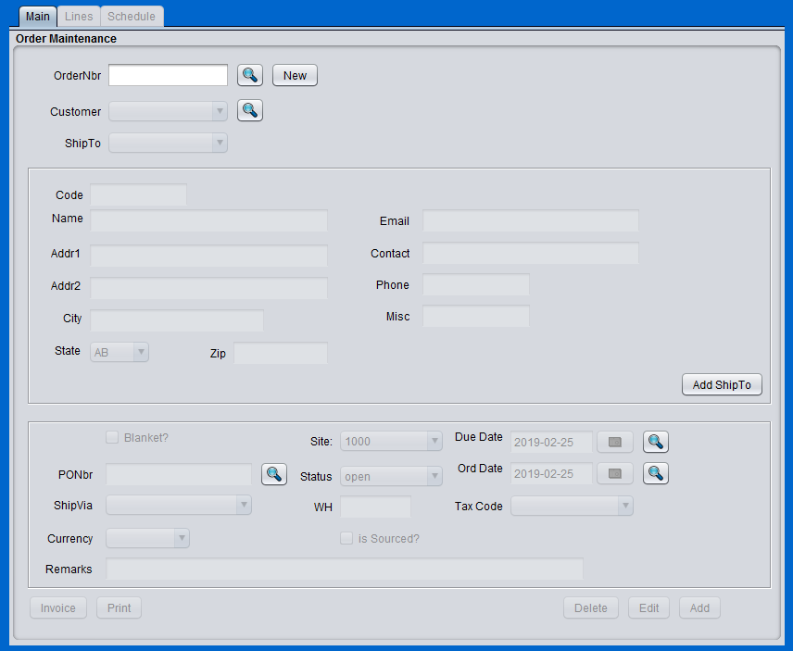

Shipper Maintenance
Shipper maintenance allows you to create a discrete shipper for one or more orders that you have previously created. The Shipper Maintenance menu offers two convenient methods for establishing the shipper. The most widely used method is to load the shipper from one or more sales orders or schedules. You can add as many orders are necessary with the only stipulation that the ShipTo (and therefore the BillTo) must be the same for all orders. The other method is to construct a non-stock shipper for items not in inventory or service related sales. Once the shipper is created, you can then print packing slips and/or pick tickets for pack staging or inventory movement. Once the shipment is physically complete and ready to be transported, the final action of confirming the shipper can be executed, which essentially commits the sales to the ledger and accounts receivable aging.

Shipper From Sales Order(s) (NavCode: shpm)

To add a shipper from a previously established customer sales order, go to the 'Shipping'-->'Shipper Maintenance' Menu. Click 'New' to initiate a new shipper. This will generate the next sequencial number and assign it to the shipper# textbox. You will then choose the 'order' toggle box which will enable the order drop down list while disabling the billto/shipto drop down option. See Figure 1.10 below for the 'order' selection option.

Figure 1.10
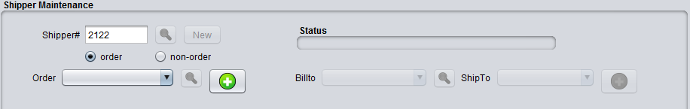
Next, choose the appropriate order number in the drop down list that you wish to ship and click the button with the green 'plus' icon next to the OrderNbr field. This action will load the order header and all open line item information into the shipper fields and shipper item table. If there are items in the 'Detail' window that you do not want, you can highlight that item (row) and click 'Del Item'. If necessary, you can go back up to the OrderNbr field, enter another Sales Order Number and click the 'plus' icon again. The additional sales order must have the same ShipTo Code as the previous order.
Once you have all your line items added to the Detail Item Table, you can then adjust the Header fields (ShipVia, Trailer, Remarks, etc) as necessary before adding the order. Once all Header and Detail fields are complete, click 'Add' at the botttom of the menu and your shipper will be complete. The entire menu will 'reload' with the newly created shipper, and the 'status' field will indicate that this shipper has not yet been confirmed (in red text). You can now proceed to create a packing slip by clicking 'Print Shipper' at the bottom of the menu. At this point, you have created a shipper, but you have not invoiced this shipper. Once the shipment is ready for transport go to the 'Shipper'-->'Shipper Confirm' Menu to commit your new shipper to the books. You can then return to the Shipper Maintenance screen where you can print an invoice as necessary. Once confirmed, the status will indicate that the shipper is already confirmed (in blue) and no further editing or adjusting of this shipper is allowed. Figure 1.10 gives the screen shot for the Shipper Maintenance menu.

Shipper From Non-Order (Service or Non-Inventory)

To create a shipper for a service or non-inventory item, click 'New' button. Then choose the 'non-order' toggle box which will enable the billto and shipto drop down fields while disabling the order
drop down field. See Figure 1.11 for a screen shot of the selection process.

Figure 1.11
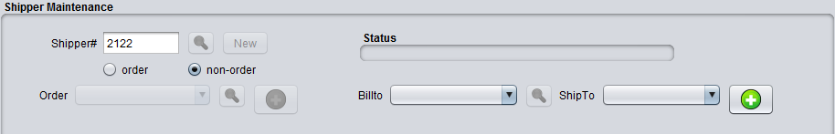
Once billto and shipto are enabled, choose the billto and shipto from the appropriate drop down selection lists. Then click the 'plus sign' button to the right of the shipto drop down list. This will enabled the header and detail fields for data entry.

You can then proceed to enter your header information and detail line item information. Note that since this shipper is constructed from a non-order, you will have to explicitly enter the item, ship qty, po nbr, and price. The item can be a service description such as 'service performed per work order' and provide an arbitrary price for the service. The ship qty in this case would be '1'. Once all the necessary information is entered, click add to commit the shipper.

Figure 1.10
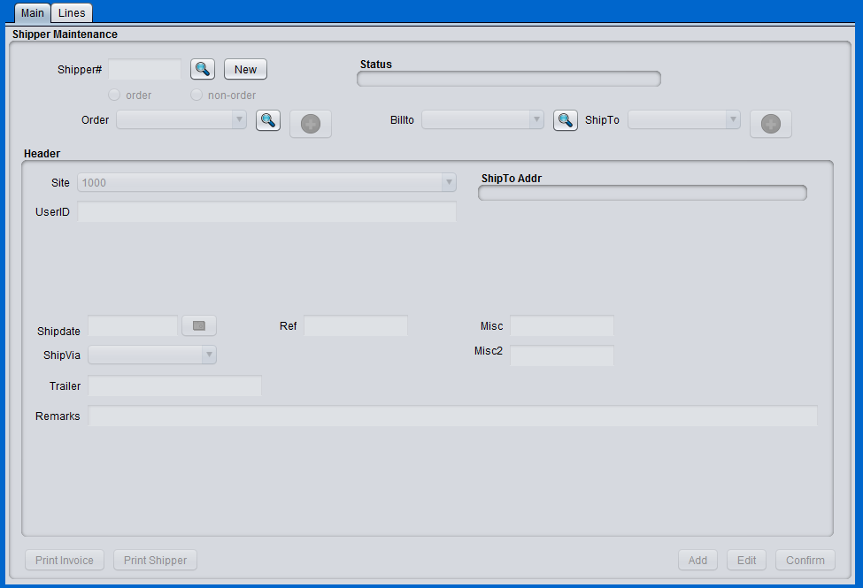

Warehouse Transfer Order

WH1
WH2
Production / Controller
Site
Customer
Stock Transfer
943
944
940
OrderType=DO
OrderType=SO
945
Shipment
940

Purchasing

Vendor Maintenance
To add a vendor, Click on the Menu 'Vendor Maintenance' under Address--> Vendor Menu. The Vendor Maintenance screen will appear. It is necessary to add a new vendor code that represents the remitto association of this vendor record. Each vendor code is unique. Therefore, only one vendor code per remitto record is allowed. An error will be generated if an attempt to enter the same code for two different remitto vendor records. To add a new vendor code, simply click the 'New' button and enter the code in the 'VendCode' field. The vendor code can be any alphanumeric characters with a max character length of 10 characters. Enter all the associated data in the appropriate text boxes and/or drop down lists. Once all the necessary fields have been entered, click 'Add' to commit the vendor master record to the database. A dialogue box will appear indicated a successful addition or an error for any field validation issues. See Figure 2.1 for a screen shot of the successful entry of adding a new vendor.
Figure 2.1
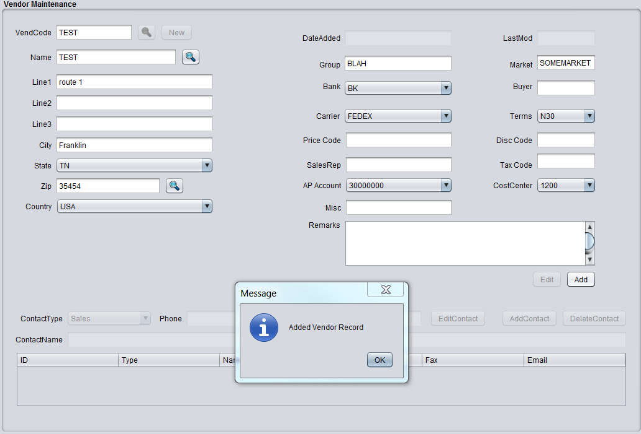

Note, it is not possible to enter any contact information until the vendor master record has been committed. The contact information is relative to the vendor remitto code and cannot be declared without association to a legitimate existing vendor code.
Several fields are 'required' fields. Most of the required fields are drop-down lists, so it is necessary to choose the correct drop down option. You must enter a valid account in the 'Account' field. The Account field represents the AP account you wish to associate this RemitTo code with. This value will be validated against the accounts that were entered into Account Maintenance under Finance-->Ledger Setup. The Cost Center is another validated text-box. The CC must be a legitimate value found in Department/CC Maintenance under the Finance-->Ledger Setup Menu. A generic cost center of 9999 can be entered if multiple cost centers are not required by your site. Code '9999' should be available in Department/CC Maintenance as a result of the BlueSeer install.
Once you've entered a new Vendor Master record, you can retrieve the record by clicking on one the search buttons “magnifying glass”. These buttons will take you to a search menu where you can enter a search string to find the exact record you are looking for. The string can be search by “Begins with”, “Ends With”, or “Matches”. If you simply click 'FindIt' with no string, it will return all records. Figure 1.3 shows a screen shot of the search menu. Each record in the search criteria is returned with a select button. Clicking the select button will return you to the Maintenance screen from which it was called along with the relative record data you clicked on. You can then proceed to review, update, or delete (in some cases) the retrieved record. Note: Some maintenance screens will not allow you to delete the record from the Maintenance menu due to the associated nature of other tables that are related to this record. You will need to use a special delete utility to delete these type of records.

Vendor Item Cross Reference Maintenance
You have the option to enter vendor specific part nomenclatures for you internal items. Most vendors have their own naming convention for any given part, and you have the option to create cross references of your vendor's part numbers to your internal part number naming scheme. For example, if you have an item named 'partA' and your vendor identifies the same part as 'partV' then you will want to create the necessary records in Vendor Item Cross Reference Maintenance. Each of these cross references that you add will be vendor specific. For example, you can have the above cross reference 'partA' to 'partV' for multiple vendors where each reference is associated to a specific vendor code.
To enter a vendor cross reference record, go to 'Address'-->'Vendor Menu'-->'Vendor Xref Maint'. Choose the appropriate vendor code 'VendCode' in the drop down selection and then enter the vendor item in 'vendor item' text box. Once the vendor item is filled in, press the tab key to move to the internal item drop down list. Note: if there is no cross reference previously established, a message will appear below the vendor item field indicating 'Adding New Record'. However, if there is already a cross reference record for this vendor code / vendor part number combination, then there will be a message indicating 'Record Exists'. The other fields are optional to enter. Once the fields have been entered, click the 'Add' button, and the vendor cross reference record will be committed.
The vendor item cross reference is useful throughout the purchasing process. When entering a purchase order, the vendor specific part number will be automatically applied to the po line and will be visible for ease of identification without having to manually enter it each time you enter a new line item on the PO. The cross reference will also be visible on various reports and receivers during the receiving process. See Figure 2.2 for a screen shot of the vendor cross reference maintenance menu.
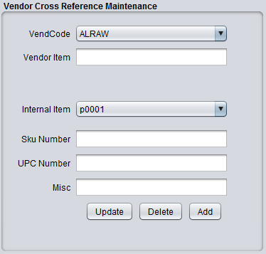
Figure 2.2

Vendor Item Price Maintenance
Vendor item price maintenance allows you to maintain a list of prices per item per vendor that can be used during the purchase order process. You have the option of entering a different price at the time of PO creation, or you can have the prices default from the vendor item price table for any item you enter on the purchase order.
Vendor prices for your items can be created and/or edited in the Vendor Item Price Master under 'Address'-->'Vendor Menu'-->'Vendor Item Price Maintenance'. Once you enter the Vendor Pricing Maintenance window, choose your VendCode from the dropdown list. If you have any previously associated item/price records, they will appear in the 'Applied' list. To enter a new record, enter the item in the item text field. Then 'tab' to the price field and enter the price. The price must be in decimal format "#.##". Once you enter the price, then click 'Add' to create the associated price record. It will appear in the Applied list. See Figure 2.3 for a screen shot of the Vendor Price Maintenance Menu.

Figure 2.3
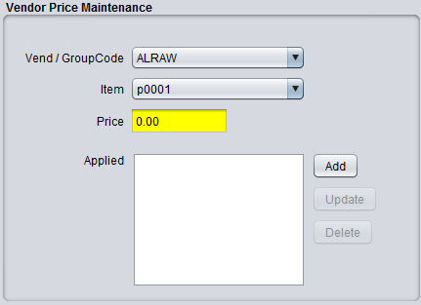

Purchase Order Maintenance
The purchasing module within BlueSeer is based on a simple discrete purchase order record. The PO record is the cornerstone of the purchasing module and it allows the receiving and vouchering of receipts from vendors against these records. The business use scenario for purchase orders is fairly straight forward. A purchase order is created for a vendor to deliver specific items and quantities of these items on a specific due date at an agreed upon price. The purchase order is referenced during receiving of the goods, vouchering of the receivers, and the subsequent payment of the voucher to the vendor.

Purchase Order Creation
To create a new Purchase Order, go to the 'Purchasing' parent menu and click 'Purchase Order Maintenance' to bring up the PO Maintenance panel. The OrderNbr field will be blank. Click the 'New' button to generate the next sequential PO Number that will be assigned to the OrderNbr text box. All the other fields will be enabled at this point. Then select the vendor associated with this PO and assign other header fields as necessary (Site, ShipVia, Remarks, etc). Once the header info has been entered, you can then choose an item from the PartNumber drop down list. Note: The Vendor Cross Reference Master and the Vendor Item Price Master must be set up prior to creating a Purchase Order. The PartNumber drop down list will be occupied with any items in the vendor cross reference table that associates items with specific vendors. Any items associated with the vendor chosen for this PO will be visible in the drop down list. (if there are no items, see Address->Vendor Menu->Vendor Xref Maintenance> and set up the appropriate records for this vendor). To continue, choose the part number in the drop down list. This action will assign the VendNumber field (per the Xref) and also assign the ListPrice, Disc%, and NetPrice fields accordingly with values pre assigned in the Vendor Price Maintenance menu. (If there is a 0.00 price, see see Address->Vendor Menu->Vendor Price Maintenance> and set up the appropriate price records for this vendor). The quantity field will initially be '0'. Enter the required QtyShip value expected for this PO for this item. Then, tab to the 'AddItem' button and click 'AddItem'. This will insert a record in to the detail table. (Note: To remove an item from the detail table, click (highlight) the desired row in the table and click the 'Del Item' button. This action will remove the row from the table and from the PO record). Once all the desired line items have been entered for this PO, click 'Save' to commit the PO. Figure 2.4 shows the screen shot for the example of creating a purchase order with pre-defined Vendor Item Xrefs and Vendor Item Prices. Note the blue text color of the VendorNumber field.
It is also possible to enter a purchase order for service or non-inventory items. The instructions are the same for entering these type of line items as it is for enter inventory items. You can manually enter a part number in the PartNumber drop down list. The VendorNumber part number will be occupied with this same PartNumber, but the text will be 'red'. Also, there will be no price generated, therefore, it will be necessary to manually enter the ListPrice, Disc% (if any) and then tab to the AddItem button and click. All other procedures are the same as for inventory items. Figure 2.5 below shows a screen shot of entering a non-inventory item in the purchase order.

Figure 2.4
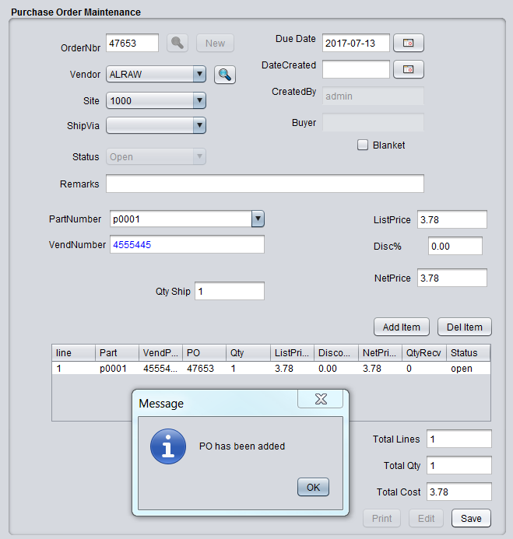

Figure 2.5
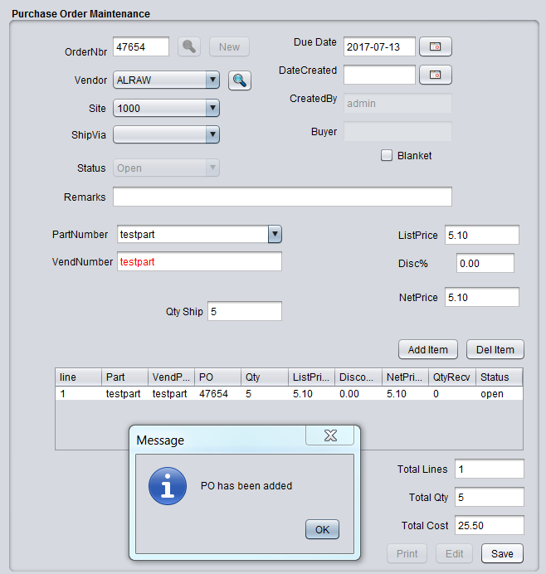

Purchase Order Search
To search for existing purchase orders, simply click one of the 'search buttons' associated with either OrderNbr or Vendor and the Browse Panel will appear. You have the option of searching based on text or you can click the 'Find It' button without text which will retrieve all POs. If the search button associated with the OrderNbr was clicked, the browse panel will do a search based on the text you entered for the Purchase Order number field. However, if you clicked the search button adjacent to the vendor drop down list, the search will be based on the vendor code. For example, if you enter 'ACME' in the text search box, the browse will return all POs associated with that PO. You can click the select button associated with the returned rows, and the browse panel will return to the PO Maintenance menu with the appropriately selected PO record.

Purchase Order Print
To print a PO, search for the desired PO and bring it up in the PO Maintenance Menu. Then, click the 'Print' button. If the appropriate PO is found, a new window will appear with the PO information to be printed. From this panel, you can either choose to print (which the printer dialog box will appear) or you can choose to save the document in PDF or other format. You must manually close the window when you have either saved or printed your document. The format of the PO print program is site specific and can be assigned and re-assigned in the Site Maintenance menu under the 'Admin' master menu.

Quick Cash Management (Personal Finance)

For small business or personal finance scenarios where in-depth financial mechanics are not necessary, Blueseer provides a trimmed down option of cash management transactions. Buying and selling simple assets, managing recurring and miscellaneous expenses are all possible within the Quick Cash Menu (NavCode: cash). This menu provides a stream-lined entry mechanism for expense recording and cash buy/sell transactions that do not require a lot of associative fields to support higher level cross functional business visibility. The Quick Cash menu is primarily for data entry. There is a browse/report menu for these transactions that can be viewed in Quick Cash Browse Menu (NavCode: cashb). The Browse menu consolidates all four types of entries in one browse screen and includes charting of the transations based on the date and type of transaction.

Quick Cash Navigation (NavCode: cash)

There are four functional sub-menus within the Quick Cash entry menu. The functional menus include 1) buying an asset, 2) selling an asset, 3 ) recording a miscellaneous expense, and 4) recording a recurring expense. You can enter 'cash' in the navigation text-box on the menu bar to bring up the Quick Cash entry screen. All four sub-menus are accessible within the main Quick Cash menu as shown below :
Figure 5.1. (Quick Cash Menu with sub-menus tabs)
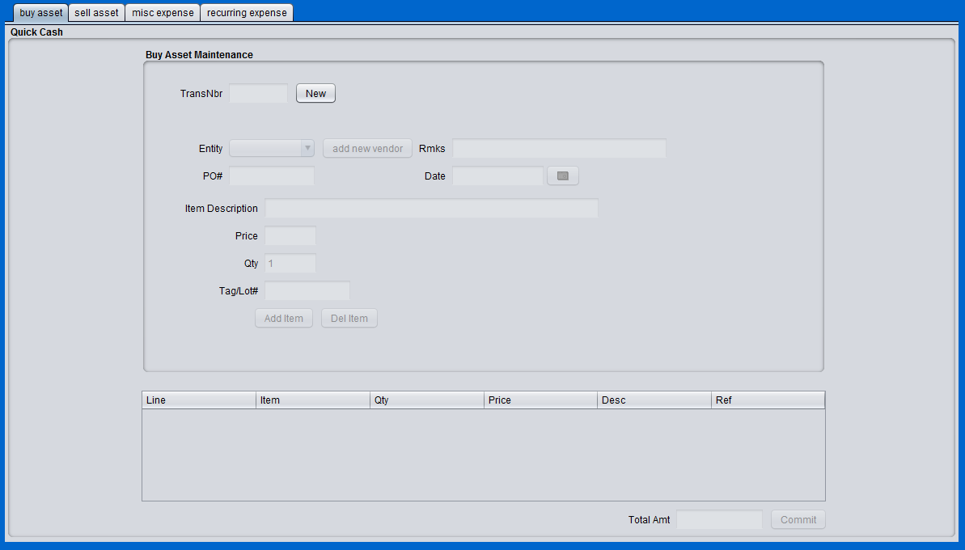

Quick Cash (Buying Asset)
To record the purchase of an asset/item, click the 'buy asset' tab in the Quick Cash Menu. To add a new purchase record, click the 'new' button. The 'buy' fields should become enabled. The Entity drop down list contains the Vendor Master codes for your vendors. If there are no records in the drop down list, click the 'add new vendor' button, and it will transfer you to the vendor master menu where you can enter a vendor record. Note, you do not have to maintain a separate vendor for each asset you buy. You can choose to create a generic vendor and apply all of your purchases to this 'generic' vendor code. However, you do have to have at least one record in the vendor master. Having legitimate vendors instead of a 'generic' vendor allows you to know more information about the vendor who you purchased the item from, but it is not absolutely required. A generic vendor will do the job.
Now that you have chosen a vendor from the drop down list, you can enter remarks and a PO# if you like (these are not mandatory). You can also change the date of the purchase by clicking on the date dialogue box. This allows you to track when you purchased the item. There are three 'mandatory' fields you must enter. You must enter an item description detailing the item you've purchased. This will be used as the description applied to the auto-creation of the item in the item master that occurs in the background. For example, entering 'black ball-point pen' will be captured in the item master for this item even though the item number generated will be the next incremental number. Note: once you've completed these steps and applied the purchase, an item in the item master (navcode: item) will be generated for you and marked as type = 'asset'.
The other two mandatory fields are the qty and price. The price field must be entered, and it must be a legitimate decimal number “no commas”. Once you've entered the price, you can tab to the qty field. Typically, the default '1' in the quantity field should suffice in most situations, so you can just tab to the 'tag/lot' field which is optional. Then click the 'add item' button. This will create a temporary record in the table below the fields. The cursor will go back to the item description field for situations where you have purchased more than one item, and you want to record all items on this one 'buy event'. If you have no further items, you can click the 'commit' button at the bottom, and your purchase will be complete.
Several transactions will occur behind the scenes upon committing. An item master record will have been recorded in the item master along with establishing an inventory record of this item. The appropriate financial ledger transactions will also occur, debiting you cash account and crediting the inventory account for this item. Note, if auto-posting is turned on (the default is on), you will not have to manually post these transactions to the ledger. The transactions will post automatically.
Once you have committed the transaction, the menu bar will indicate 'buy complete'. You can then view the transaction in the Quick Cash Browse (NavCode: cashb) menu. The images below show the progression of entering the information for the buy menu and adding the item to the temporary table. Note that in this example, we have created a 'generic vendor' entity to apply the purchase to.

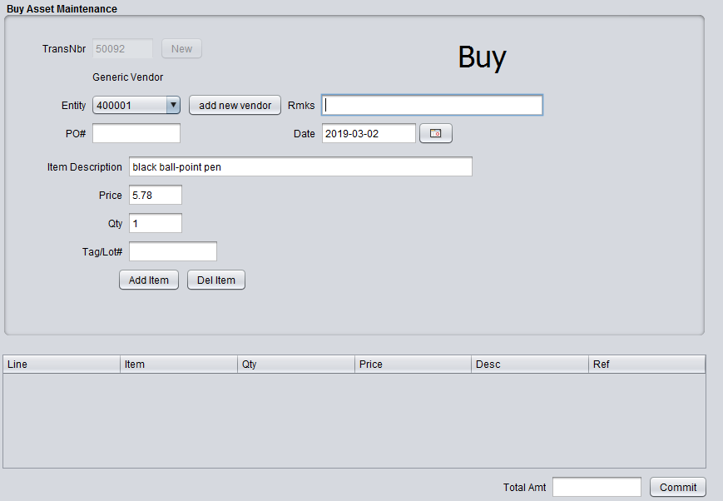
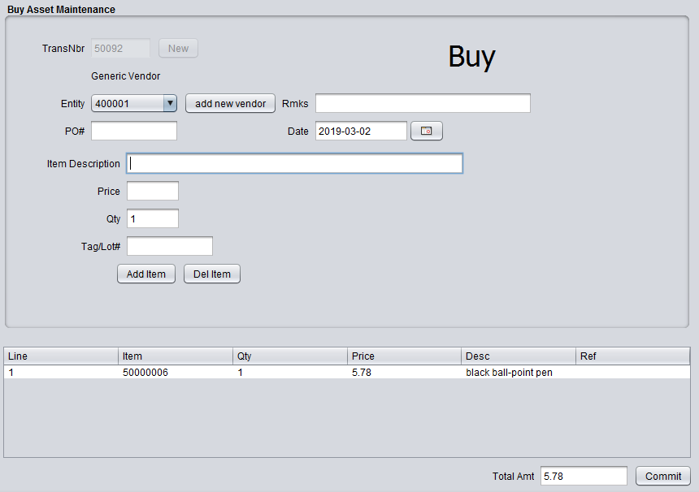

Quick Cash (Selling Asset)
To record the selling of an asset/item, click the 'sell asset' tab in the Quick Cash Menu. To add a new selling record, click the 'new' button. The 'sell' fields should become enabled. The Entity drop down list contains the Customer Master codes for the list of customers you have previously established. Unlike the 'buy asset' option where you do not explicitly have to have specific vendor codes for each purchase, it is advisable to establish specific customer master codes for each sell transaction. The 'sell' transaction will provide you with the option to print a receipt for the asset sold, and therefore the customer's information will be provided on the receipt of the specific addressing information is created for this customer in the customer master. If you have not previously set up the customer master records, click 'add new customer' and you will be forwarded to the customer master menu to enter the specifics of the customer you are selling the asset/item to.
The asset/item that is being sold must already exist in the item master, and the item must be an asset type (code = 'A'). The 'item nbr' drop down list in the Selling Asset tab will contain all items from the item master labeled as type 'A'. Choose from one of the items in this list and then tab to the next field. The price field and the qty field are mandatory. Enter a legitimate decimal price (no commas). Tab to the qty field and either choose the default value of '1' or enter a quantity. You are allowed to enter more than is in inventory under the assumption that the inventory values may be inaccurate. Press the tab to the tag/lot field (optional) and then click 'Add Item'. This will create a record in the table at the bottom. You then have the option of entering another item to sell, or if you are only selling the one item, you may click the 'commit' button to complete the transaction. Upon clicking the commit button, the description on the menu bar should indicate that the selling transaction is complete.
Several transactions will occur in the background upon committing. The inventory for this item will be reduced by the quantity entered in the qty field. Balanced financial transactions will occur at the ledger with crediting the cash account and debiting the inventory account. A receipt of the transaction may be provided to the customer purchasing the item. You can view the transaction and print the receipt, if desired, in the Quick Cash Browse menu (NavCode: cashb). The printer icon in the last column of the browse table will provide a PDF print of the receipt. Note, only the 'sell' option will allow the print icon to be shown in this column. The other three transaction types will show a lock icon. The following images show the progression of creating a 'selling asset' transaction.

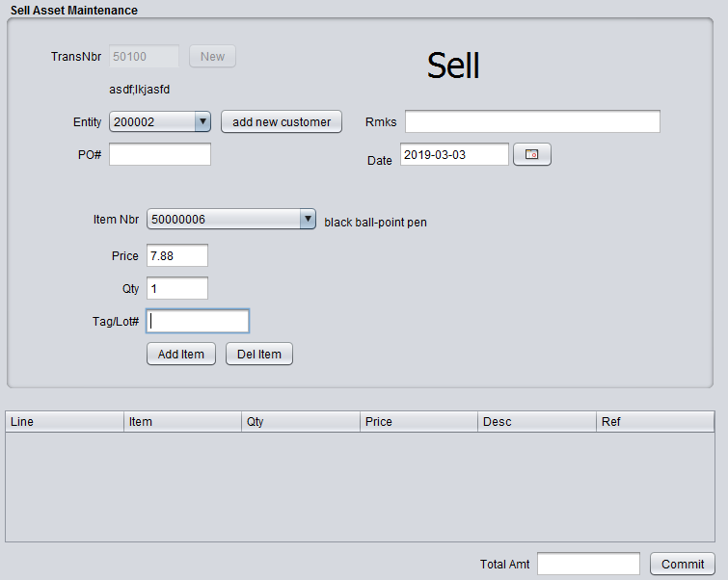
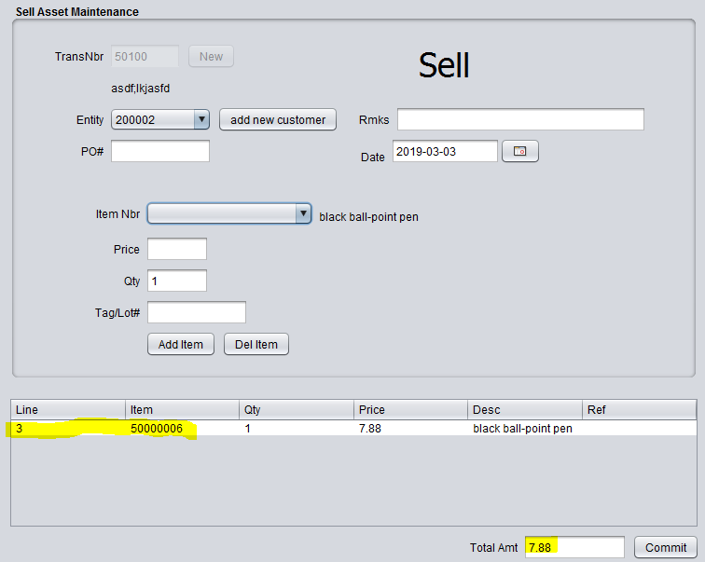

Figure: Clicking the commit button the complete the sell. Menu Bar indicating 'sell complete'.
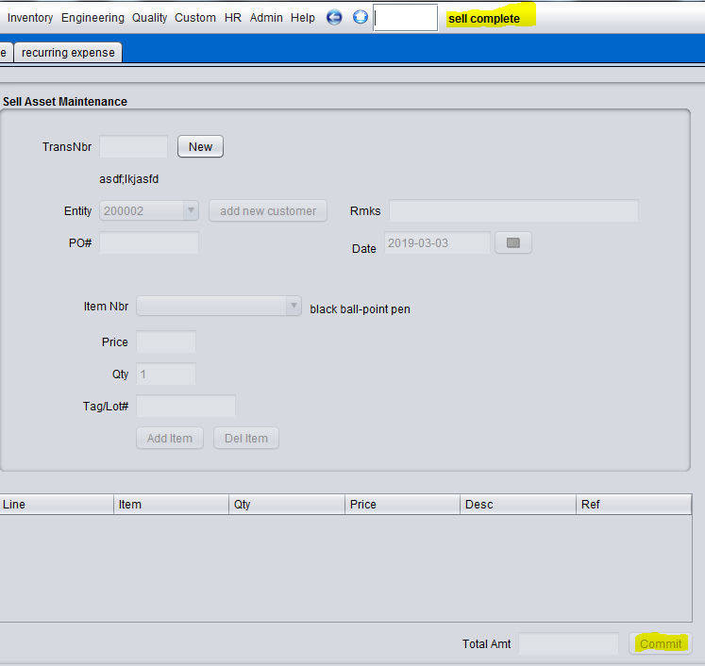

Figure: Quick Cash Browse (NavCode: cashb) showing the transactions. The 'sell' type transactions
will have a 'printer' icon in the last column that will allow a receipt to be printed or PDF file created.
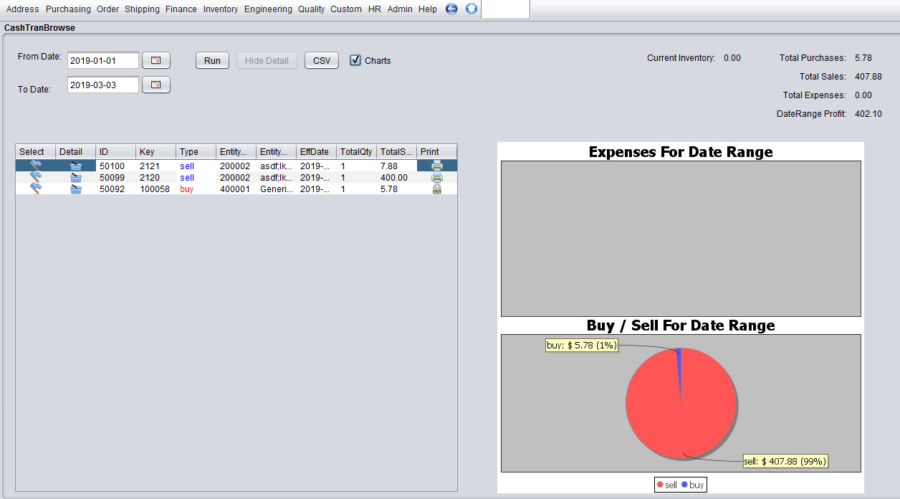

Figure : Receipt image of Sell Transaction. You can print and/or save as a PDF file.

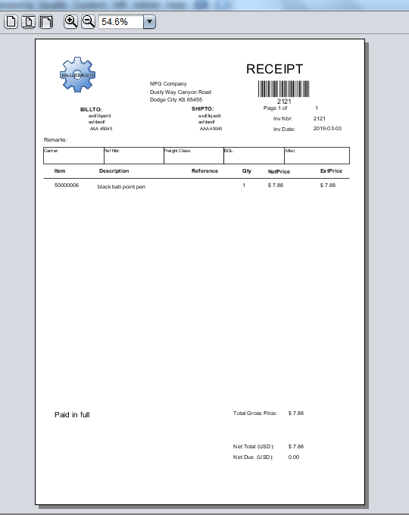

Quick Cash (Expense Miscellaneous)
Recording expenses is one of the more repetitive financial transactions that most people want to track. The Expense Miscellaneous tab allows you to capture those on the spot expenses that are not considered 'recurring'. The Expense Recurring tab is used for expenses that are recurring on a monthly or yearly basis.
To record a miscellaneous expense, click the 'misc expense' tab in the Quick Cash Menu. To add a new expense record, click the 'new' button. The 'misc expense' fields should become enabled. Much like the 'buy asset' tab, the expense miscellaneous menu allows you to track your expenses by vendor. You can alternatively choose to create a single 'generic' vendor, but you must have at least one vendor in the entity drop down list. The primary tracking method for expenses is determined by the expense account you place the transaction in. You can create as many expense accounts as necessary to distinguish and classify your expenses for reporting purposes. When you create a new expense account, it is automatically created in the Account Maintenance under the Finance menu as an incremental account number of type 'E' for expense with the description that you enter in the dialogue. To create a new expense account, click the 'add account' button, then enter a description (classification) for this account. As an example, you could enter 'office supplies' as the account description, and record any expense associated with office supplies (pens, paper, ink, etc) against this expense account. The more effort placed in creating appropriate account classifications, the more you will gain from tracking and reporting your expenses for audit or tax purposes. It is advised that you consider your accounting structure before recording your first entries. You can also go into account maintenance (NavCode: accm) and pre-enter your expected expense accounts. Expense electric, Expense water, Expense phone, Expense maintenance are all good examples of separating your account structure and classifying your expenses.
The Expense Description is a mandatory field. You must describe the nature of the expense in this field. You can then tab to the expense account drop down list and use your up/down arrow key to traverse the possible accounts. The description of the accounts are provided to the right as you key up or down. Once you select an account, press tab and enter the price of the miscellaneous expense. This must be a legitimate decimal value (no commas). Then, tab to the qty field and choose the default '1'. In most instances, the default quantity of 1 is sufficient. Then tab to the tag/lot field and enter a value (this field is optional). Click 'Add Item' to enter the transaction into the table at the bottom. You may choose to enter another expense to the transaction by entering another description and repeating the process. Once you have finished entering the expenses, click the commit button to record the set of expense transactions.
You can view the expense transactions that you entered in the Quick Cash Browse report (NavCode: cashb). This browse/report tool is a date specific report and defaults to the beginning of the year to the current date. You can change as necessary. All four types of transactions will be visible. You can also click the 'basket' icon to see details of transactions or click the 'chart' button to see pie charts of the total expenses for the date range (top chart) and total buy/sell transactions for the same date range (bottom chart). The below figures shows the steps of entering a miscellaneous expense through to reviewing in the Quick Cash Browse menu.

Figure: Entering a miscellaneous expense

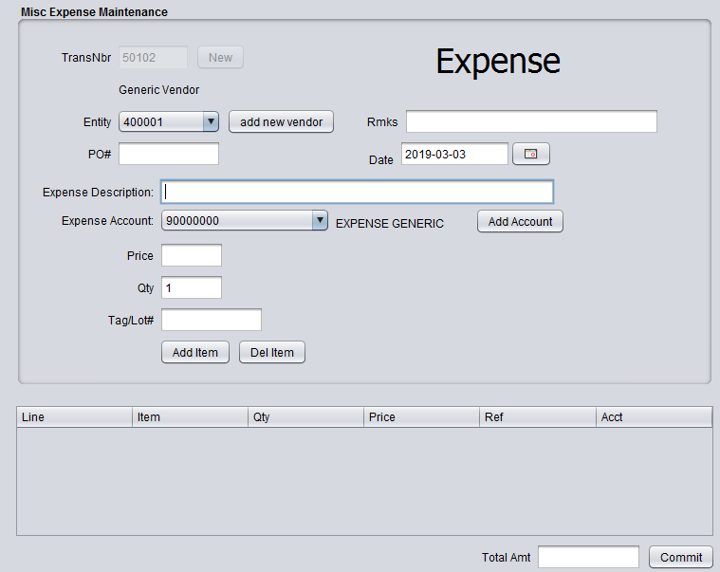

Figure: Adding a new Expense Account Description

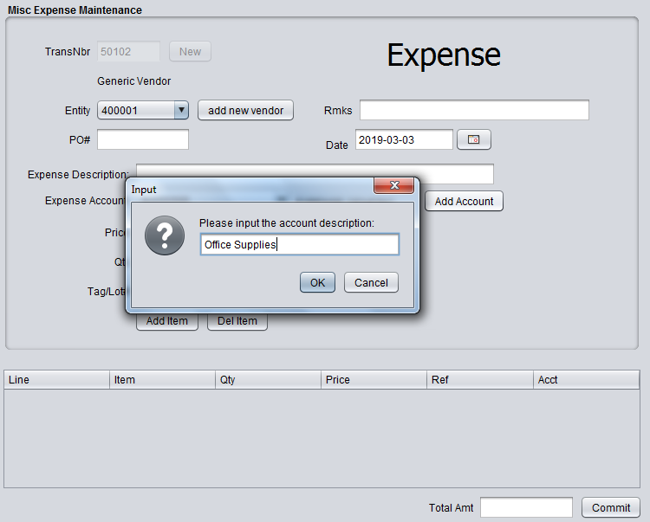

Figure: Adding expense items to the expense table before committing

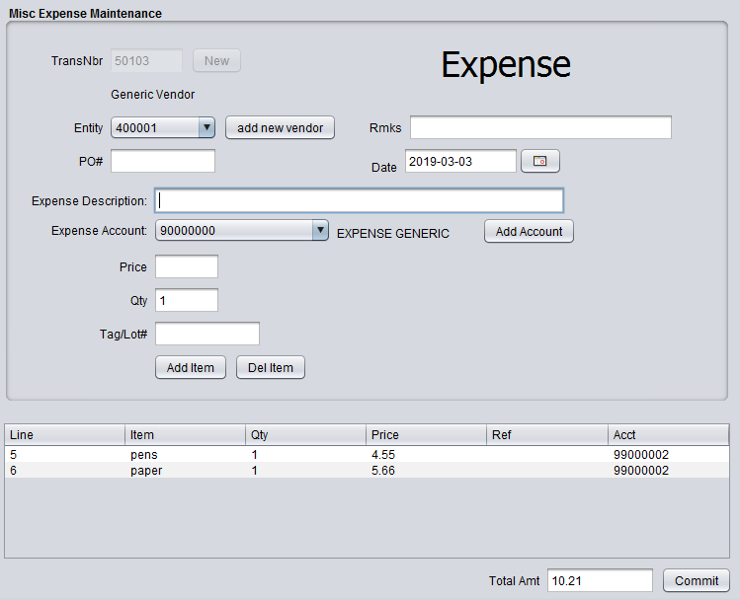

Figure: Committing the expense
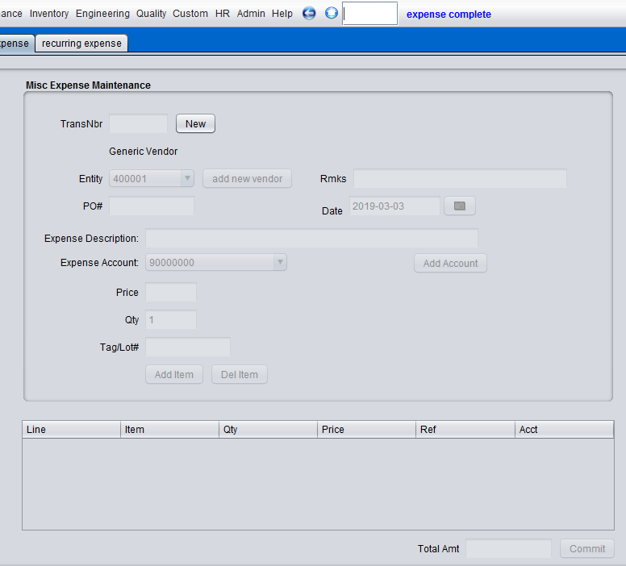

Quick Cash (Expense Recurring)
The Recurring Expense menu is very useful functionality for capturing and viewing monthly expenses are common among all business verticals. This menu allows you to designate monthly recurring expenses and to track whether or not you've paid those expenses on any given month. The Calendar month is used for paid/unpaid designation. For example, if you have established any recurring monthly expenses, at the beginning of each month, these expense records will be display as unpaid (visible x). Any time during the month, you can mark these expenses as paid, and they will remain paid (visible checkmark) until the first day of the next month. Along with the visibility cue, a history of each recurring expense is provided in a table at the bottom of the menu for convenience labeled 'History of Payment'.
To register a recurring expense, click the 'recurring expense' tab in the Quick Cash Menu. The entity drop down list should be set up with a list of the vendors for each of the recurring expense. You should create these before you register your recurring expense so that you can associate the appropriate expense with the appropriate vendor. You can go to the vendor master maintenance menu (NavCode: venm) to set up your vendor codes. Choose the appropriate vendor code and enter a value in the unique ID field. You can enter 'electric' as an example. Then enter a description of this expense in the description field. This is a mandatory field. You then choose the appropriate expense account to register this expense to. If you have not already created your expense accounts, you can click 'add account' and enter a description of the account. It will automatically be added to the list. Then enter a legitimate 'monthly' value in the price field of the expected expense. Click 'Add Item' and the item will be registered in the table at the right of the menu. The figure below is an example of registering the expense record.

Figure: registering recurring expense record.

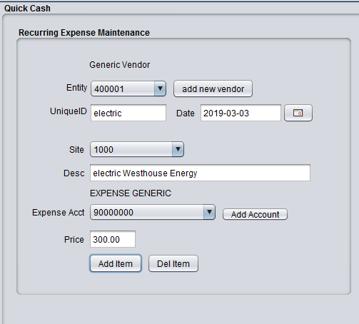

Figure: Table showing registered recurring expense after clicking 'add item'

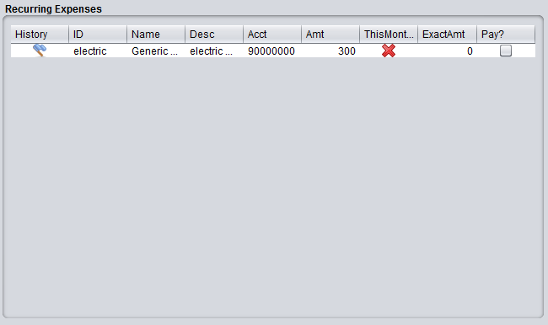

Notice from the above figure that the 'ThisMonth' column is marked with a red x. To pay this expense, simply place the dollar amount of the expense in the second to last column labeled 'ExamtAmt' and click on the checkbox in the last column. You can do multiple records in this same pattern at one time. Once you've clicked the expenses that you wish to pay and have entered the exact values of the expense, click the 'pay selected items' button at the bottom of the menu to commit these payments. The following figure shows the screen after paying the expense. Note: once the expense is paid for the month, you will not have the opportunity to pay this again until the first day of the following month as the last column will become disabled until then. You can also click on the first column (flag) to show the payment history of this expense in the table at the bottom of the menu.

Figure: Recurring expense after selecting to pay this expense for the month.
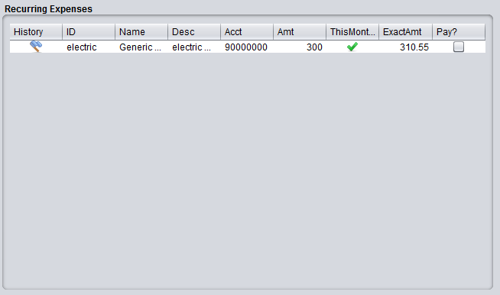

Once you have registered all of your recurring expenses, you can revisit this menu once a month to pay/track your monthly payments. A summed total of all recurring cost for the month is provided at the bottom of the menu as well as a placeholder for your monthly income. Simply add your expected monthly income in the income field, and click 'update income'. You can change this at any time. A difference field is provided for convenience between the monthly income and monthly expenses.
The below figure shows the payment history for this example as well as the total recurring amount, monthly income, and difference.

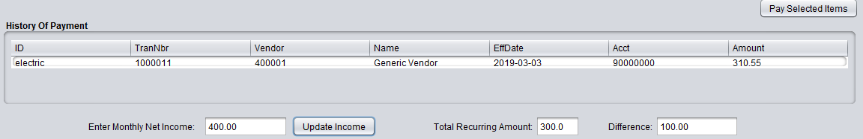

These expenses registered and paid on a monthly basis are visible in the Quick Cash Browse menu (NavCode: cashb). There is also charting functionality that provides a convenient visual cue of your expense breakdown, both recurring and miscellaneous. See example below.

Figure: Quick Cash Browse (NavCode: cashb).

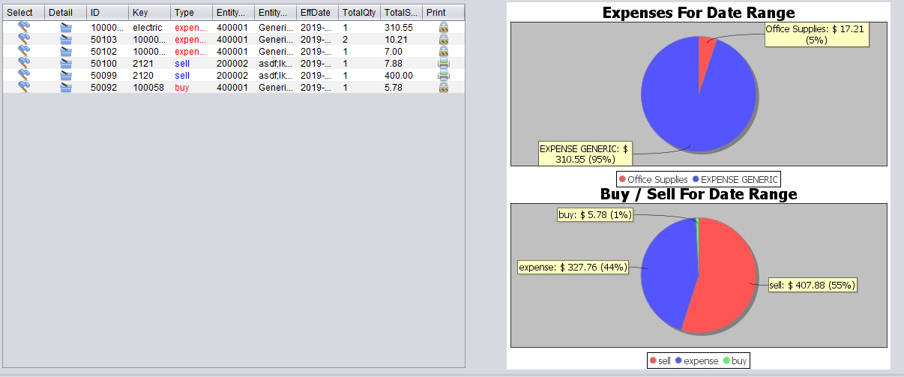

Finance

Chart of Accounts Maintenance
BlueSeer provides a sample chart of accounts for convenience. However, you will probably want to add your own or edit the given accounts to suit your needs. The account master maintenance menu is reasonably straight forward. There are only a few fields to consider in order to create an account record. The account 'ID' itself is the primary key to the account master table. This field is your account number and can be a max of 10 chars (no spaces). The account number is a unique field. You will need to assign a 'type' value to the account. There are four account types accomodated in BlueSeer. They are Asset (A), Liability (L), Income (I), and Expense (E). Each record must be assigned one of these four types. The Description field is arbitrary and should be as verbose as necessary (up to 50 chars). The only other field necessary to describe the account is the currency assignment. At this time, BlueSeer only accomodates US Currency (USD).
To add or edit an account, go to 'Finance'-->'Ledger Setup'-->Account Master Maintenance menu. Once inside the account maintenance window, enter your account ID, Description, Type, and Currency. Once the fields are entered, click 'Add' and a message box will appear indicating successfull entry of the account number. To Edit any account, click the search button beside the account id field. (Note: you can search by account or by description of account; depending on search button clicked). Clicking on one of the search buttons will bring up the browse panel where you can search by text or simply click 'Find It'. If you click 'Find It' without a search text, the browse panel will return all account records. Simply click on the account number that you want to edit/review, and it will return to the account maintenance screen with the appropriate record. Once you've edited your fields, click 'Edit' and a message box will appear indicating the success or failure of your edit. See Figure 3.1 for a screen shot of the Account Maintenance screen.

Figure 3.1
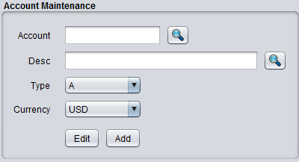

Ledger Calendar Maintenance
The General Ledger Calendar is maintained under the Finance main menu. Go to the Ledger Setup Menu and then choose the Ledger Calendar Maintenance menu. The ledger calendar allows you to assign beginning and ending dates to financial reporting periods within a given calendar year. You can span over years if your planning calendar requires so, or you can simply use the accepted months within a given year as your accounting periods. This example will illustrate. To assign period 1 in calendar year 2000, choose "2000" in the year drop down box, and then choose period 1 for your first period. Choose a beginning and ending date from the appropriate date icon box and then click the 'Add' button. You also have the option to close the accounting period by clicking the 'closed?' checkbox. It is a generally accepted practice to close all periods except the operating period to prevent transacations from being posted with erroneous dates. Closing the previous period and opening the new period is generally done at the end of the period by an appropriate controller. You can use Ledger Calendar Browse to see a list of all the periods and their assigned beginning and ending dates. To Edit a year / period, you simply choose the year and period and click 'Get'. If the record has been established previously, the beginning and ending dates will be populated. Edit the dates as you require, and then click Edit. Never edit a currently effective year/period record...(operating period). It could have undesirable consequences.

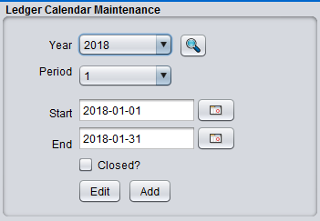

Department / Cost Center Maintenance
BlueSeer considers the Cost Center and Department to be the same in definition and is used interchangeably within the application. The Cost Center (department) is defined as an operational entity within a business that incurs a cost whether that cost be labor, burden or a combination of both.
One of the first steps in the implementation process of BlueSeer is to define one or more cost centers. The code used as the identity key for the department record can be up to 8 chars long (no spaces). When setting up a new department/cc, you will be asked to assign GL accounts to several fields associated with capturing labor, burden, and cost of operation costs. To add a new dept/cc, enter a code (up to 8 digits) for the dept/cc id and then occupy the account fields with the appropriate GL account. The accounts are validated, so these accounts must exist in the chart of accounts before continuing. Once the fields are completed, click 'Add' to enter a new dept/cc record. You can browse a list of the dept/cc records under the menu "Finance"-->"Ledger Setup"-->"Dept/CC Browse". The Browse will allow you to select any dept/cc for further info and editing.

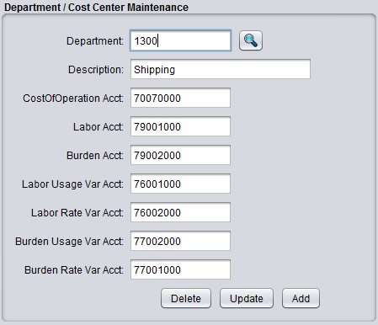

Bank Maintenance
Bank Maintenance allows the addition or updating of information related to banks and associated account information. These bank records are used a selection drop down boxes in several modules including the customer master and vendor master. Bank codes associated with various customers and/or vendors are used during shipping and receiving transactions as they pertain to GL account credits and debits. The bank record itself is simply an association of a GL account with a specific bank code. It can be used if you have more than one bank for specific customer payments or accounts payable check runs for vendors. At least one bank record must exist. A default bank record is provided with BlueSeer. You can delete, update, or add your own as necessary.
To add a bank record, go to 'Finance'-->'Ledger Setup'-->'Bank Maintenance' menu. Enter a 2 digit code (no spaces) for your bank code and provide a description of this bank (optional). Enter a valid GL account for this bank and choose the currency code. (Currently, only USD is allowed in this version). Check the 'Active' checkbox and click 'Add' to save the record. Note: You can inactivate bank records by unchecking the check box. This will prevent transactions from further using this bank code if unchecked without having to delete the record.
To update a bank record, you can either go through the Bank browse menu to access the target bank code or you can go directly to bank maintenance and enter the bank code then click 'get'. Once the record is retrieved, you can edit the fields within the menu and click 'update' to save the new info associated with this bank id.

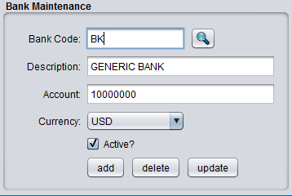

Financial Transactions Overview
In this section, you will receive a brief overview of the financial transactions that occur behind the scenes when various functional module events occur (shipping, invoicing, etc). The majority of the financial transactions hitting the ledger occur automatically upon the event of shipping, production, receiving, inventory adjustments etc. These transactions are written to the gl_tran table all throughout the production day, and the number of these transactions can be rather large depending on depth of bill of material, number of routing steps, and other variables. The GL Posting menu is used to post the GL transactions temporarily stored in the gl_tran table to the gl_hist table where they are committed indefinitely. This Posting procedure is typically ran once at night or (close of business). Posting also updates ledger account balances up to the point of posting.
There are a variety of transaction types. Most are used for manufacturing cost and inventory tracking and are committed automatically by the 'events' of inventory adjustments or production reporting. The only available costing method in BlueSeer is standard costing. All of the various transactions incorporated within the production menus are designed within the scope of the standard costing paradigm. The available transactions that are provided by BlueSeer are typical transactions generally found in a manufacturing environment where the financial worth of goods are issued and/or received into accounts based on operations in a workflow. The list of these types of transactions are provided below:
NOTE: These transaction types are also used in the tran_mstr table for inventory and miscellaneous transaction monitoring as well as Ledger transaction descriptions.

- RCT-PURCH (Receive Raw Material from Purchase)
- ISS-WIP (Issue Raw Material or SUB to Assembly)
- RCT-SUB (Production of SUB-Assembly)
- ISS-SUB (Issue of SUB to FG)
- RCT-WIPFG (Production of WIP (of FG) )
- RCT-FG (Production of FG final OP)
- ISS-SALES (Issue FG to Sales)
- ISS-MISC (Issue of Miscellaneous Material (RAW,SUB,FG) )
- RCT-MISC (Receipt of Miscellaneous Material (RAW,SUB,FG) )
- LOC-TRNF (Location Transfer of Material (RAW,SUB,FG) ) *

* NOTE: Location Transfer does not generate financial transactions. Only inventory movement.

An example of the mechanics of the above transactions would be helpful in understanding the nature of the above transaction codes. The example scenario provided below walks through most of the transactions mentioned above. The scenario includes a single item and an empty (zero-valued) ledger accounts. The items and accounts used in the scenario are already setup and present in the Demo Version of BlueSeer. The item, item cost, Bill of Material, and Routing/Work Center are all pre-defined, so you can walk through the scenario provided below with your own installation of the demo.

Financial Transactions Example Scenario

We are going to be using the data provided in the Demo Installation. All the necessary components to perform the below processes are provided in the demo instance. Below are the processes along with screen shots of the Unposted Ledger Report immediately after the process event occurred. You can access the Unposted Ledger Report under Finance → Ledger Reports → Unposted Transactions.
NOTE: By definition, all Credits are of (-) sign and all Debits are of (+) sign. Negatives are surrounded by parentheses.

- Receipt of Raw Material from a Purchase. Transaction type: RCT-PURCH
- For our first step, we are going to receive raw material for our inventory. This raw material is used as material in the BOM of the finished good product we will be posting and selling in subsequent transactions.
- The below receipt transaction was accomplished by creating a Purchase Order for item “p0001” at standard cost $0.10 / each for 100 pieces, and then receiving that item into inventory. (The event of receiving inventory into the system immediately triggers Ledger transactions. The creation of Purchase Orders do not).
- Notice the credit of the AP Trade account and the debit of the Raw Inventory account.

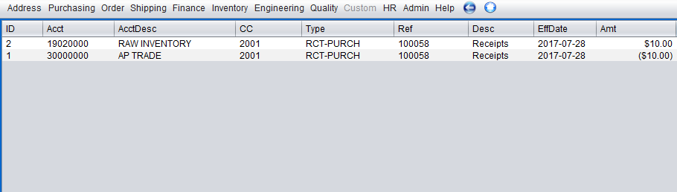
- Production posting of Finished Good Item. Transaction type:
- Now we are going to post production of a finished good item that consumes the raw material in the BOM and consumes labor and burden from each operation that is defined to manufacture the item.
- We will be posting production of item “10-1001” from the demo installation at standard cost $0.25 . A screen shot of the standard cost breakdown along with the operations to manufacture item 10-1001 is provided below.

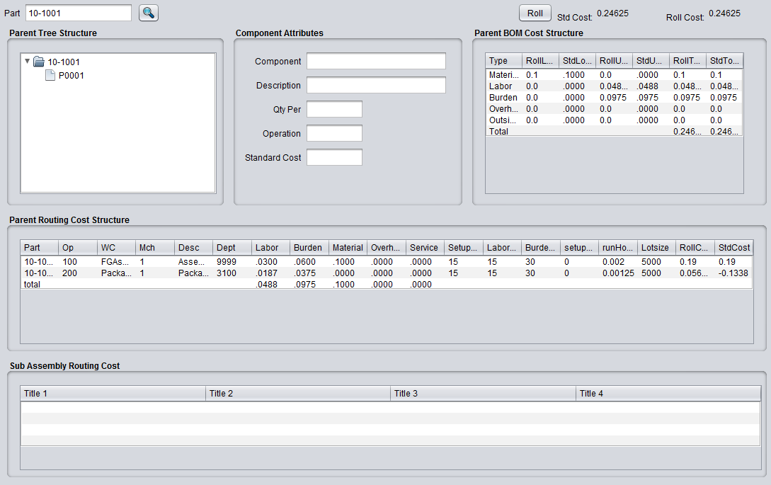
- Once we post production under Inventory → Production Menu → Production Entry, you will notice that there are multiple transactions occurring during the posting of a finished good. The raw material is issued to WIP, labor and burden costs are captured at each operation of the manufacturing steps of the finished good, and transfer of finished good from WIP to FG at the last operation signifying a complete state. All of these transactions occur at standard cost.
- There are two operations (Assembly (op 100) and Pack op (200) ). Each one of these operations have labor costs and burden costs which stem from the department fixed labor and burden rates where the operation occurred and the expected run rate (parts per hour) and setup costs. You can view these variables in both the Routing Maintenance and Work Center Maintenance screens respectively. The Routing ID for item 10-1001 can be viewed in Item Maintenance menu. With the Routing ID, you can also view the work center called in each operation of the routing.
- The below screen shot shows the labor, burden and material transfer of reporting production of item 10-1001 at 100 pieces. You will notice that the labor absorbed account was hit at each operation for ($.03 * 100) and ($.0188 * 100) respectively (op 100 and op 200). Similarly, the burden absorbed account was hit at each operation for ($.06 * 100) and ($.0375 * 100) respectively. In both occurrences, the labor/burden account was credited, and the WIP account was debited.

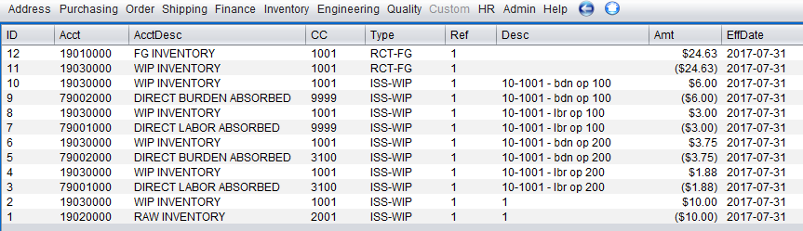

- Since production was posted at the last operation (200), this signals the system that the last operation of a product is completed, and a finished product has been produced. In the event of a last operation, a second transaction (RCT-FG) will occur which will credit WIP inventory and debit FG inventory, effectively moving the product to Finished Goods. The RCT-FG transaction will occur for both credit and debit at standard cost. The 'actual' cost is also captured, and any deviation from the standard cost will be reflected in the appropriate 'usage variance' account.
- Now that we have production of 100 pieces of item 10-1001, we will now show the transactions for shipping this item. The below screen shot shows all the transactions that occur by shipping 100 pieces of item 10-1001 to a customer at $.50 selling price / each. Notice that the income statement account 'generic sales income' has a credit of $50.00 and the balance sheet account 'A/R accounts receivable' has been debited at $50.00. Also, the Cost of Goods Sold (COGS) accounts (labor, burden, material) have been debited for their respective values, while the FG Inventory account has been credited for a similar amount.

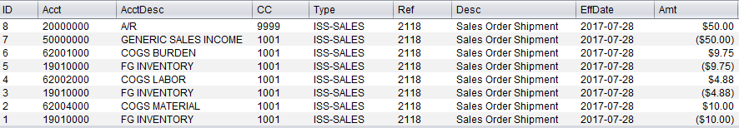
- Now that we have received raw material, posted production of finished goods, and shipped those goods, we can proceed to post the GL to the ledger via the GL Posting Menu. Once all the transactions have been posted, you can view the Ledger Balance Report to see all the summarized values of the accounts. You can also click the 'detail' button beside the account to see the itemized detail transactions that produced each account summary. The screen shot below shows the Account Balance Report for all non-zero valued accounts.

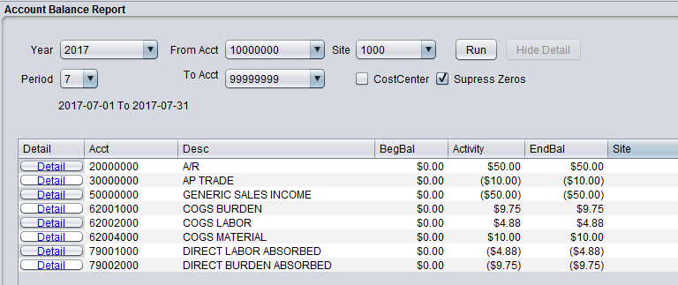
- Finally, you can view a generic Income Statement by clicking on the Finance → Ledger Reports → Income Statement menu. Clicking run will show the statement elements that add or subtract from the Standard Margin (Sales less Cost Of Goods). Since the above transactions were limited, the income statement is rather simple in this case, and is essentially the sales minus the cost of goods sold. Elements that reduce the standard margin...other than variance...are not directly involved in the production and therefore are elements captured outside the receipt, production, sales functions present in the previous automatic transactions. Elements such as engineering cost, marketing costs, G&A are all captured explicitly by the accounting team each period.

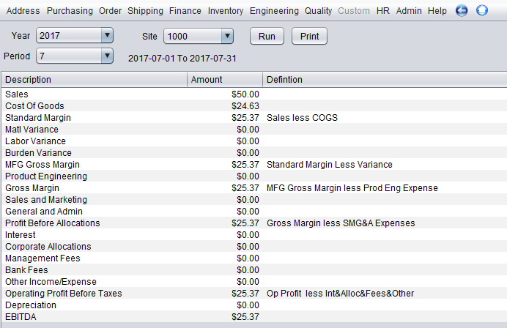

Inventory

Product Code Maintenance
The product code is a very important concept in blueseer because it controls the puts and takes of most of the financial accounting information collected within the application. All transactions essentially use the product code as a guide to control which GL accounts are targeted for any given transaction. As such, great care and forethought should be given to setting up the product codes for your products and the accounts that are associated with each product code. Product codes are typically controlled and maintained by the finance department. The finance department usually has the most to gain (or lose) with regards to proper (or improper) setup of the product codes.
There are 26 accounts that are associated with any given product code. These account types are labeled in the product code maintenance menu. Great care should be taken to ensure that the appropriate account is assigned to the correct field when adding or updating product codes. Inventory, Sales, Costs of Goods Sold (COGS), Purchasing, Variance are all accounting buckets that are controlled by the product code for each item that incurs a transaction. For example, any given item that is ordered, shipped, and invoiced to a customer will have the sales account and COGS account (as well as varous inventory accounts) adjusted per the product code of the item being sold. All items in the item master, whether FG, RAW, or WIP are assigned a product code. This allows financial accounting tracking of the items and materials as they are processed for any given transaction within the day to day activities of the business entity.
To add a new product code, go to 'Inventory'-->'Product Code Maintenance' and enter any 4 character code in the “prodcode” field. See Figure 5.1 for a screenshot of the Product Code Maintenance screen. The product codes are a maximum length of 4 characters (do not input spaces or tabs). Once you enter the code, you will need to enter all 26 account fields with 'valid' accounts. You can review your chart of accounts in Ledger Account Maintenance. You must enter a valid account for all accounting fields in the product code maintenance menu. Once you have completed all the fields, you can then click 'Add', and the product code and associated data will be committed. To edit a product code, you can simply go to the product code maintenance menu and enter the product code in question and click 'Get'. The fields will then be populated with the product code data. Once you've adjusted the fields you desire, click the 'Edit' button to save your changes.
There is a system default product code “9999” that is used by the system for 'default' behaviour when no product code is associated with various items. Do not delete this record code. However, you will have to adjust one or more account field values if you have entered a customer chart of accounts in the GL.

Figure 5.1
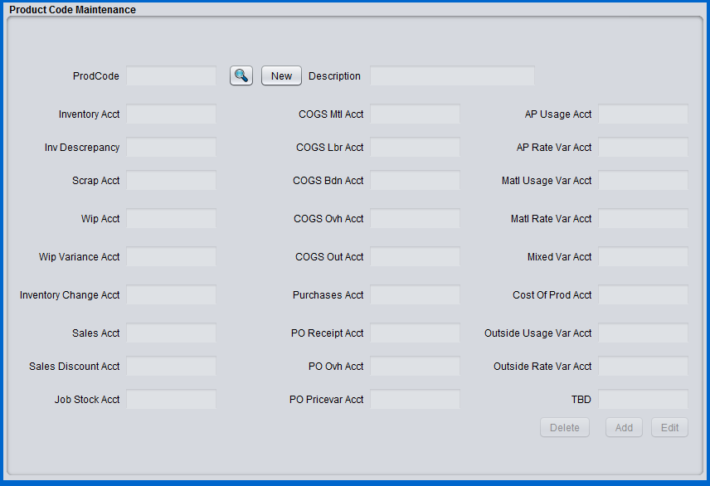

Location Maintenance
Location Maintenance provides a method to identify various physical locations within your business where inventory is maintained or transferred. These location records can identify 'actual' physical locations or represent a system holding category for inventory movement. The scheme for locations and their hierarchy within a site is the following: Each Site can have multiple warehouses and each warehouse can have multiple locations within it. So, defining a location in location maintenance requires the identification of a warehouse to associate it with. See figure 5.2 below for a screenshot of the Location Maintenance menu.
To add a new location ID, click 'New' in Location Maintenance. Then, enter a location code in the location field. You will then choose a site and a warehouse within a site and click Add. Note: both site records and warehouse records must be setup before you can enter a location.

Figure 5.2
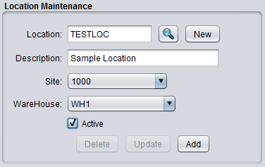

Warehouse Maintenance
Businesses that have a significant amount of distribution channels within their organization can establish warehouse entities within their sites. The warehouse maintenance menu allows you to create individual warehouse entities that are associated with each site. Each site can have multiple warehouses. These warehouse records are used predominantly with the Distribution functionality within BlueSeer which allows a business entity to maintain product levels at specific warehouses and move/ship product from warehouse to warehouse or warehouse to customer.
To add a new Warehouse, you will first need to ensure that you have the appropriate site record established. Each new warehouse created is assigned to a specific site. The available sites to associated are visible in the Site drop down selection box. If there are no values in the selection box or you wish to add another site, go to Site Maintenance menu and add as appropriate.
Once you have your site maintenance records established, click 'New' in the Warehouse Maintenance menu and enter a warehouse 'id'. You can then enter a name and address information for your new warehouse. Choose a site to associate this warehouse to. Then, click 'Add' to commit your warehouse to the database. See figure 5.3 below for a screenshot of the Warehouse Maintenance menu.

Figure 5.3
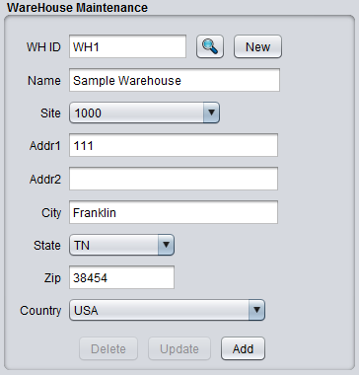

Item Master Maintenance (NavCode: item)
Items can be added to the item master via the Item Master Maintenance Menu. You can access the item master menu by enter 'item' in the navigation textbox. You can also access the menu by choosing the "Inventory" main menu and then go to "Item Menu"-->"Item Master Maintenance" menu. Some of the fields in this menu are merely descriptive, and some are used to categorize the items. However a few of the fields have a broader role and may control the functionality and behavior of other modules as they pertain to the specified item. The item number is by default automatically generated for you upon clicking 'new'. You can alternatively choose to enter your own item as well. You will have to uncheck the toggle in the inventory control menu labeled 'auto item number assignment'. This will prevent the systems from generating the item numbers, and you can then enter your own nomenclature for the items. Assuming you are entering your own numbers, to enter an item, simply enter a value in the part number field (do not use spaces) and choose the "class code" for which this item belongs. The class code governs whether or not the item is a manufactured item or a purchased item. There are only two class options, "M" and "P". If the item you are entering is a manufactured item, choose "M". If it is a purchased component (or raw material), choose "P". You can now click the 'Add' button, and the item will be added to the item master table. If you click 'Add' without adjusting any other data fields, you will have entered the item with 'default' attributes. However, you will probably want to enter additional fields to assign the appropriate attributes to your item. You can either adjust the fields prior to clicking the 'Add' button, or add the item and then use the 'edit' button to adjust the fields after the item has been entered. You can retrieve the item by entering the item in the part number field. If the item is legitimate, the foreground color will change to blue and the field itself will be deactivated once the record is retrieved. This will populate the maintenance window with the previously assigned attributes of the target item. If you enter an unknown item, the field foreground color will change to red indicating that the item is unknown.
You can also review a list of the items in the item master or search for item that have previously been added by clicking the "Item Menu"-->"Item Master Search" menu under the Inventory main menu. You can click 'Search' as is for a complete list of items, or you can enter the first couple of characters to narrow the search before clicking 'Search'. A list of items based on your search will be shown, and you can click the 'Select' button associated with the target item to view all the detail of the target item in the Item Master Maintenance Window.
As indicated earlier, most of the fields in the item master maintenance screen are informational only. However, there are a few key fields that need to be discussed. The Product Code selection box assigns the appropriate product code to the item. Product Code Maintenance maintains the collection of product codes to choose from. This menu must be previously addressed before any product codes will appear in the product code selection box. The product code governs which GL accounts are chosen during specific transactions for the target item. If you have multiple products that can be grouped due to similarities in processes, markets, costs, etc., you will most likely want to add these items to the same product code. At a minimum, it is recommended to create two product lines, one for purchased items (raw components) and one for finished goods.
The "type" field in the item master menu is purely informational. The choices provided in the selection box can be added (or deleted) by using the Generic Code Maintenance menu to add or delete records with the "ItemType" code / key pair. For example, you can enter a new type called 'mytype' by going to Generic Code Maitenance and entering 'ItemType' in the code field and 'mytype' in the key field. When you go back to the Item Master screen, you will see a new option in the Type drop down selection labeled 'mytype'.
The unit of measure drop down selection box currently only supports "EA". A maintenance screen to support more UOMs is under construction.
Both the selling price field and the purchase price field are informational only. You can enter these fields or leave them blank. These fields are generally used when the pricing is a simple specified price regardless of group or discount pricing and it is helpful to have the price listed here when viewing the other attributes of the target item. The actual pricing (whether it be customer or vendor pricing) is applied in the appropriate menus. See for customer pricing procedures or <xref linkend="vendpricemaint" endterm='vendpricetitle'/> for vendor pricing procedures.
The three cost fields (overhead, outside, and material) are of significant importance to purchased items (item of class "P"). The "material cost" field must be populated with the purchase price of the item. The material cost field is used by the costing module to roll up purchased item costs within a finished good product, so it is imperative that a cost be entered into this field. If there is any overhead or outside costs that apply to this purchased item, you can enter those costs as well in the appropriate fields. These costs will also be rolled up into the finished good cost of any product that consumes this purchased item.
Additional fields such as SafetyStock, MinOrdered, and LeadTime are used primarily by the modules MRP and Scheduling. These need to be set accordingly for the target items. You can choose to not submit the item to processing by MRP or Scheduling by unchecking the appropriate box.

Figure 5.4

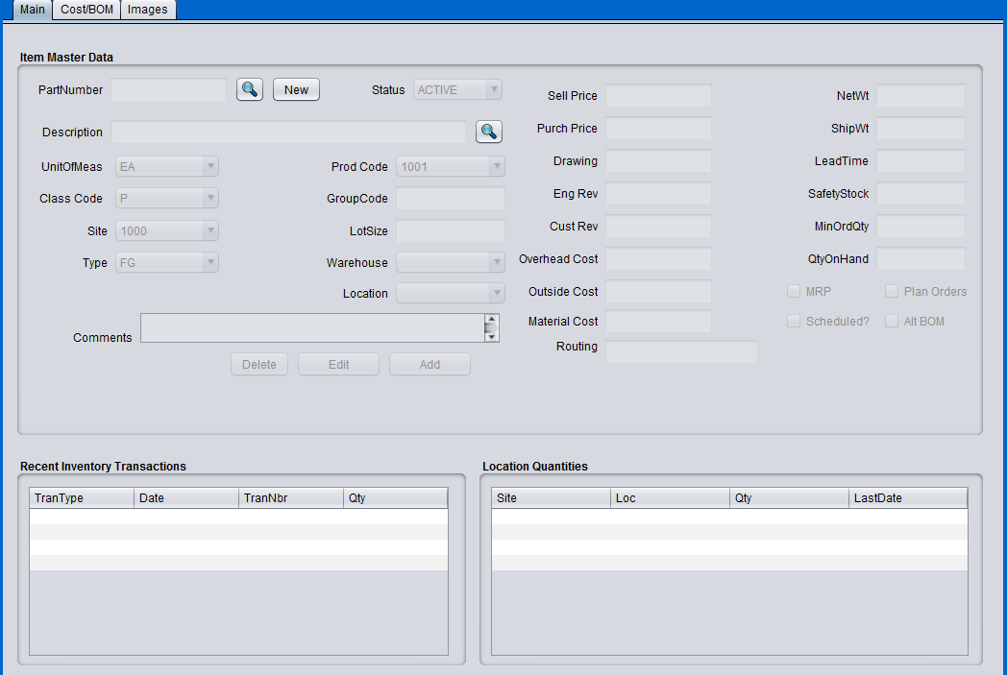

Work Cell Maintenance

The Work Cell maintenance menu provides a place to designate labor and burden costs associated with operations within your business. This menu is key to establishing the cost associated with day to day activities incurred during the operational phases of production. Each operation within the life-cycle of a finished good should be associated with a work cell. The work cell is a means to define the cost of an operation. The work cell can be defined to be as discrete or generic as necessary depending on the level of granularity necessary to capture the cost of the operation. For example, let's assume that a machining company is producing a threaded bolt. The bolt is made from raw bar stock and requires several operations (it is assumed) to produce the finished good bolt. Each of the mulitple operations would be a defined within one routing code (See Routing Maintenance). Let's assume that the threading operation is performed by a single operator who works in the 'threading' department and has a base salary of $35 / Hour. The burden associated with this operation is expected to be $15 / Hour. Note: in this instance, burden is defined as any non-labor and non-material cost associated with running the business divied up by department (work cell). In this instance, we have concluded that the burden cost associated with this operation should be $15 / Hour and is thus assigned to this work cell. Now that we have labor and estimated burden cost, we can define the work cell for this operation. Figure 5.7 shows the screenshot of the creation of this work cell with these variables.

Figure 5.7
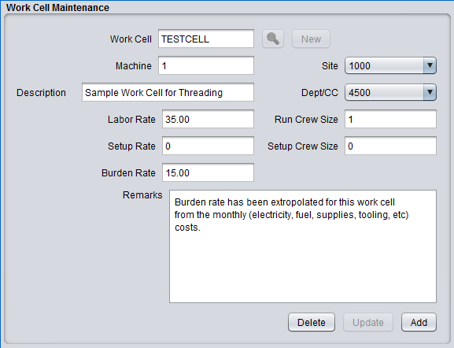

Routing Maintenance
Routing codes define the operations that an item will undergo during it's life cycle. The number of distinct operations within the manufacturing of an item depends on how much detail you require in the cost 'description' of the item. For example, the drilling and threading of a screw can be broken down into two distinct operations, drilling as the first operation, and threading as the second operation. Each operation will have it's own 'run rate' i.e. how many parts can you 'drill' in one hour and other relevant information associated with that specific operation. In turn, each operation will also have a labor rate and/or burden rate associated with that specific operation. On the other hand, you could combine both operations into one operation with a summed value of both operational costs..i.e. summed labor and burden costs and cumalative run rates. However, it is generally good practice to break up the operations into distinct cost cells with unique run rates. This allows for improved cost analysis, better metrics of operational efficiency, and identification of bottlenecks and throughputs. In general, the more discrete reporting points the better.
Routing codes are a 'one-to-many' concept. Each routing code can have multiple operations (and often do). For example, you could have routing code "MYCODE" that has operations A,B,C or 10,20,30. Each operation within the routing code will detail the labor, burden, and overhead cost associated with that operation. The sum of the operational costs will be the cost of manufacturing the item less the material cost and any outside service cost associated with the item. The cost of each operation depends on the work cell (see <xref linkend="workcellmaint" endterm='workcelltitle'/> ) that this operation resides in. The combined information from both the routing code maintenance and work cell maintenance menus define the labor, burden, and overhead cost of the item.
Note: The work cell records must be set up before creating any routing code records. Likewise, Both work cell codes and routing codes (in that order) must be created before creating any items of type "M" (manufactured). This sequence of events ensures the proper information is assigned before cost roll is applied to any items marked as 'manufactured'.
To add a routing code, first make sure you have already created the necessary work cells in the Work Cell maintenance menu. Each routing code can have multiple operations at various work cells, so it is imperative that work cells are defined prior to creating a routing code. Work cells are validated in the process of adding a new routing code. Once you have established your work cells, go to 'Inventory'-->'Routing Menu'-->'Routing Code Maintenance'. Enter a routing code of your choice. In the operation drop down box, enter an operation code for your first operation. For example, your routing code can be 'testroute' and your first operation can be '10'. Then choose the work cell and machine (if applicable) that this first operation resides in. Next, enter the setup hours required to setup this cell to perform the first operation (example 1 hour setup time). Enter '0' for no setup. Then, enter the number of pieces per hour this cell/operation can perform. You will notice that the 'run hours' to the right of 'pieces per hour' is automatically calculated based on your entry in pieces per hour. Once this information is entered, you can click 'Add' to add the new routing code with it's first operation. To add more operations, simply enter the same routing code and enter a second operation code (example: routing code 'testroute' operation: 20). You will repeat this step of 'adding' operations for as many operations with the routing code 'testroute'. Figure 5.5 shows a screenshot of the routing code maintenance menu.
The 'Auto Backflush' check box in the routing code maintenance menu is of particular importance and is used to define whether or not the specific operation within the routing code is reportable or non-reportable. When you manufacture an item at a specific operation, you must either report that operation as complete (Auto Backflush toggle=checked) or allow the system to automatically report it when a subsequent 'reportable' operation is complete. (See production and scrap entry menus). The last operation should always have it's Auto Backflush box checked. For example, suppose you have five operations, 100, 200, 300, 400, 500 and we set both 200 and 500 as Auto Backflush toggle=checked. In this scenario, you do not have to post production at operations 100, 300, and 400, but you do have to post production at operations 200 and 500. When you post production at 200, the system will automatically post production at operation 100. Similarly, when you post production at 500, the system will 'backflush' operations 300 and 400. The system will always backflush (on your behalf) all previous operations that are not marked backflush...up to the most recent reportable operation which in this case was 200. All operations within a routing code, once posted, will provide visiblity of inventory movement and financial cost absorption. Therefore it is imperative that either you post production (or scrap) for each operation or you allow the system to post on your behalf. The final operation should always have Auto Backflush check box checked.

Figure 5.5

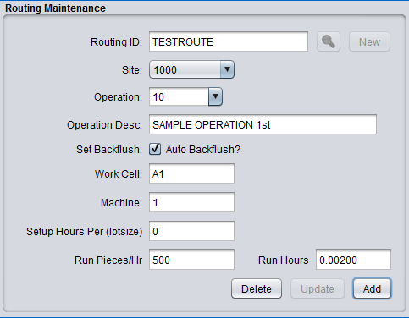

Bill Of Material Maintenance

Bill of Material (BOM) is a phrase used to describe the components that comprise a finished good (FG) item or a work in progress (WIP) item. The components that make up the FG or WIP item are maintained in the Bill of Material Maintenance menu. In order to establish a BOM of a FG or WIP item, it is first necessary to make sure that FG or WIP item is defined in Item Master as well as any components that are included. All components must be defined in the item master as well before including them in the BOM of an item. Furthermore, the parent item that is to have the BOM must have a routing defined in the 'routing' field in the item master. This is necessary to establish the operations where the BOM components will be consumed. At a minimum, every FG or WIP item that is to have a BOM must have at least one operation within a predefined routing code (See Routing Maintenance). Once these pre-requisites are established, you can then proceed to create the BOM of an item. The creation of a BOM for an item will change the 'actual' cost of the item, but not the standard cost. The actual and standard cost of the item can be viewed in the 'cost tab' of the item master maintenance menu of the parent item in question. You will notice that establishing a BOM or changing the BOM of a parent item will change the actual cost of the item. The standard cost will only change once you roll the standard with the Cost Maintenance Menu under Inventory → Item Menu → Cost Maintenance.
To add a BOM component to a parent item, go to the BOM Maintenance menu under Inventory → BOM Menu → BOM Maintenance. Click 'New' and enter the parent item in the field labeled 'parent item'. This field is validated against the item master, so this parent item must be a record in the item mainentance table. Then choose the component from the list of items in the component drop down selection box. Note: All items in the item master 'except' the parent item will be available for choosing in the selection box. Once you choose the component, then enter the 'qty per' field with the quantity of this component that will be consumed by this BOM. Then, enter the operation where this component will be consumed. Note: The parent item must have a routing defined in the routing field in order for the operation drop down selection box to have operation numbers available. You can then enter an optional reference text note. Once all fields are correctly entered, click the 'Add' button to commit this component to the BOM of the parent item. You will repeat this process as necessary for each component that is needed to complete the parent item. See Figure 5.8 for a screen shot of the BOM Maintenance menu.
You can create BOMs with multiple depth levels by adding a WIP item as a component of the parent item. This WIP item will have it's own BOM, and therefore the BOM tree will show a multi-level structure to the parent item. WIP items are unique in that you should always ensure that WIP items have their cost rolled (as a parent) before including them in the BOM of a parent. Note: for new parent items, you should always roll standard once the entire BOM is complete.
To Update a BOM, choose the parent item in BOM Maintenance, and then choose the component item in the 'component item list box' by clicking on the item. The event of clicking the component item will retrieve this parent – child record and update the qtyper, operation, and reference fields with the retrieved values. You can then change anyone of these fields and click 'Update'. This will update this record with the new values and the tree structure will automatically adjust in the view. Note: Once you update a BOM record, the actual cost of the parent may change depending on the nature of the update. The standard cost of parent will not change until you roll cost in Cost Maintenance.

Figure 5.7 BOM Maintenance Menu

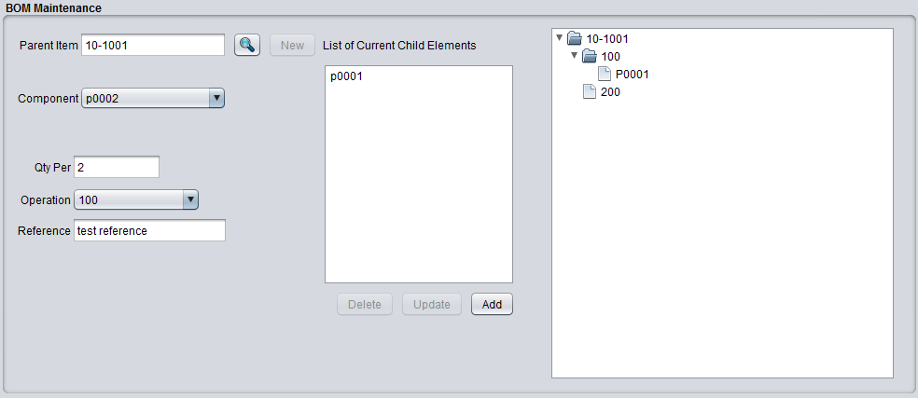

Cost Maintenance
Standard and Actual costing are the only cost methods supported within BlueSeer as of this version. There are several maintenance screens that must be set up to correctly apply stand costing, however, most of these menus are generically applied to many items and once created, are applicable for any new items introduced. The cost of any given item is dependent on whether it's a manufactured part, (finished good or WIP) or a purchased component. This distinction is set in the item maintenance menu with the "Class Code" field for every item. Items of code 'M' usually have processes and routing instructions along with Bill of Material. The cost of an item of code 'M' therefore is a product of the cost of it's BOM and it'sprocesses rolled up in the final item as well as the processes (operations) to manufacture the final item. In the following sections, the process to create the cost of an item (both standard and actual) will be discussed.
Once a Work Cell and a Routing Code have been established, the next step is to add the item master record for the costed item. See <xref linkend="itemmaint" endterm='itemmainttitle'/> for details on how to add items to the item master. Assuming the item to be costed has bill of material, it will be necessary to add both the Finished product item of class 'M' and one or more raw items of class 'P' to the item master. Once these items have been entered into the item master, the bill of material for the costed item will need to be entered into "BOM Menu" -> "BOM Maintenance". The BOM will will dictacte how the cost is rolled up from raw components and processes into the final product that is to be costed.
The easiest way to understand the costing module is to walk through an example of of the costing procedures. Let's create a hypotetical scenario usually found in the machining job shop environment. The following example assumes that there is a finished product (a rivet for example) called 'myRivet' that is comprised of a single bar of material (raw material) called 'myRAW'. The myRivet final product has but one process to machine the part (turning) in the completion of the final product. This process (or operation) will be labeled 'OP1' and will be comprised of a Work cell where the machining occurs and a routing code that describes the nature of the process of the machining.
First, let's create the Work Cell for the turning operation to be done on MyRivet. Go to 'Routing Menu'-->'Work Cell Maintenance' and enter 'WC1' as the Work Cell. Enter a machine code of '1' and choose the default site. You can leave desc blank and choose the default Dept from the drop down list. Now let's assume our labor rate (how much we pay our machinist) to be $10.00)...so enter '10.00' in the labor rate field (do not put the dollar sign). ALso enter 1 for the run crew size and enter 0 for both setup rate and setup crew size (We will assume there is no setup). Let's further assume that we've calculated our burden rate (electricity, rent, etc) to be $15.00 per item we produce. Enter 15.00 into the burden rate field. Then click 'Add' to create the WC1 work cell.
Second, go to 'Routing Menu'-->'Routing Maintenance' and enter 'RC1' in the Routing ID field and enter '1' in the operation field. This will be our routing code (RC1) that describes our one operation (turning) which we have labeled operation '1'. Enter the previously created work cell 'WC1' into the Work Cell field along with machine '1' in the machine field. For simplicity, we will assume no setup by entering setup hours as '0'. Now, the "Run Pieces/Hr" field should be entered as the average number of items we can 'turn' within one hour. Let's assume we can 'turn' 30 items per hour by entering '30' in the run pieces field. You will notice the 'run hours' field is automatically populated with the inverse of the 30 pieces per hour...or (1 / 30) to provide the hours per part. (This field is non-editable and is governed by the "Run Pieces/Hr" field.) Once the above info is provided, click 'Add' to enter the new routing code 'RC1'.
Third, let's now enter our two items (myRivet and myRawBar) to the item master. You can use the default fields in the creation of the item master for both items. However, you will need to distinguish the 'class' field for both. For 'MyRivet', choose class 'M'. For 'myRawBar' choose class 'P'. Let's enter the final product first. Enter 'MyRivet' in the part number field and choose 'M' for it's class code. In addition, enter the newly created routing code in the routing field as 'RC1'. That is all you need to enter for MyRivet. Click 'Add' to add this part. Now, enter 'MyRawBar' in the part number field for the raw component and choose 'P' for the class code. Also, Enter 20.00 in the 'Material Cost' field. (We will assume our material cost per one bar is $20.00). Then click 'Add' to add this raw component.
Lastly, let's create the bill of material association between the MyRivet parent and the MyRawBar child. Go to 'BOM Menu'-->'BOM Maintenance' and enter 'MyRivet' for the Parent Item and choose 'MyRawBar' as the component. Tab down to 'Qty Per' and enter '.05'. (We are effectively saying that we can get 20 pieces of MyRivet per one bar of 'MyRawBar'...i.e. 1 / 20 = .05). Now, enter '1' in the operation field...(this is the operation within RC1 that we previously defined). Then click 'Add' to create this BOM record between MyRivet and MyRawBar.
You have now effectively created an 'actual' cost of MyRivet (not a standard cost yet). You can view the actual cost in the item master for MyRivet by going to the Item Maintenance screen and entering 'MyRivet' and then clicking 'Get'. You will see the info you entered previously. In the 'Cost' Panel, there are two sets of costs...standard and Current. Click the 'Current' button to see the final cost of the item you just created.

Production Entry (Generic)

Production can entered in one of two ways. It can be recorded via the Production Entry menu or the Production Entry By Plan menu. A description of the generic production entry method is provided here. The production entry menu allows you to record production of your WIP or FG items at each of the operations of that item. This menu does not validate how many times you post production for a given item and given operation (you will want to use Production Entry By Plan if that is an issue). This menu does however validate that the item you enter is a legitimate item and that the item has a legitimate routing with at least one operation. Under most circumstances, reporting production of a finished good or wip at each operation is performed within the Work Cell of that operation. It is therefore possible to lock the allowed operation of reporting to just the operation that is performed at it's associated Work Cell. This will prevent unintended posting of a quantity at the wrong operation. Note: reporting of operations other than the last operation is optional. However, you must report production quantities of the last operation. If the previous operations are not marked as milestones, then the act of posting the last operation will auto-backflush the previous (non-milestone) operations at the quantity posted for the last operation. This functionality is provided for situations where it is inconvenient and unnecessary to post at each operation.
To enter production for a WIP or FG item, go to Inventory → Production Menu → Production Entry. The userid, site, and effective date are pre-defined in the text fields. Enter the item to be posted, and tab to the operation drop down selection box. If the item entered is unknown or the item does not have at least one operation, an alert will be generated. Choose the appropriate operation that is being posted. Then enter the quantity to be posted. The serialno and reference fields are optional. Once all required fields have been entered, click 'Submit' to commit the production to the database. An alert will be generated indicating a successful entry, and the cursor will return to the item field for the next entry. Figure 5.9 shows a screen shot of the Production Entry Menu.
Figure 5.9
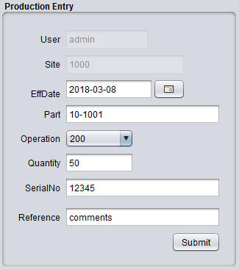

Production Entry By Plan
Production can entered in one of two ways. It can be recorded via the Production Entry menu or the Production Entry By Plan menu. A description of the production entry by plan method is provided here. The production entry by plan menu is the preferred method of posting production of your WIP and/or FG items because it allows you to better control the data entry by providing scanable job tickets with specific quantities. These 'planned' job tickets are typically generated by the scheduling menu where quantities and production dates are scheduled through a master schedule. However, you can generate plan tickets from the miscellaneous plan menu.
When a plan ticket is printed (See Scheduling Menu), a bar code is provided on the ticket that contains the value of the plan number. See Figure 5.11 for a sample ticket. Each ticket has a unique plan number. Typically, each operation is provided a copy of the plan ticket. This ticket will inform them of the part, quantity, date required, and other info necessary for the production of the specified item on the ticket at that operation. Once production at that operation is complete, the operator will scan the bar code on the ticket, choose their appropriate operation, enter the quantity that they produced, and click commit. Constraints are provided at the scanning event that prevent an operator from reporting more production than is reported on the ticket. You can scan post 'multiple' times, as long as the quantity at each reporting does not exceed the quantity on the ticket. Also, once the posted quantity reaches the ticket quantity for a specified operation, no further posting will be allowed for that operation. If the last operation post quantity reaches the ticket quantity, the ticket will close and the scheduler will see the ticket as closed in the scheduling reports.

Figure 5.10
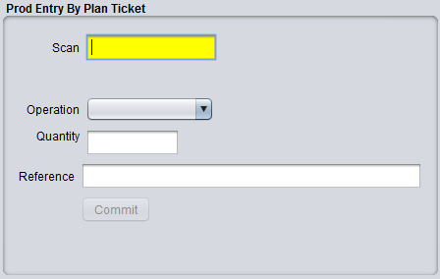

Figure 5.11 Plan Ticket for Work Order

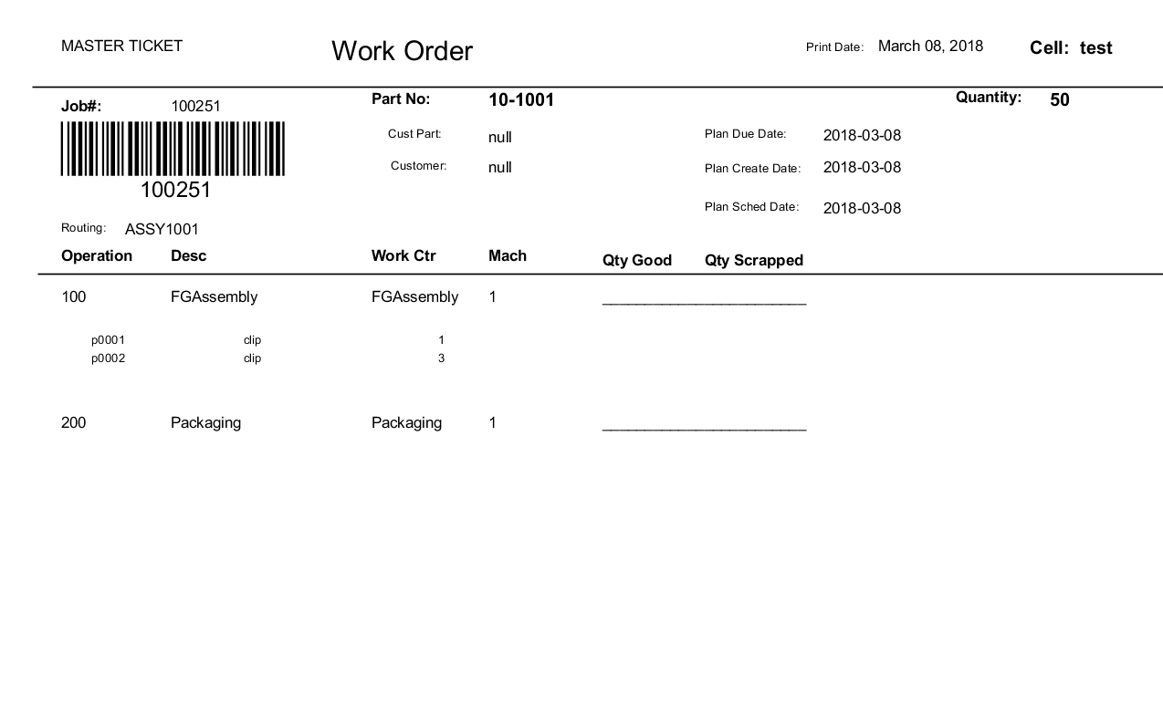

Forecast Maintenance

The Forecast Maintenance menu provides a method for maintaining expected weekly production values per item per year. Forecast schedules are best used in environments where the order to ship cycle is relatively short and you are able to extrapolate the expected ship volume of your items from historical information. These forecasted volumes can be translated into plan tickets by the forecast to plan menu, thus allowing you to create plan tickets based on these expected volumes.
To enter a forecast record, enter the item, site, and year in the forecast maintenance menu and then enter each of quantity fields representing the 52 weeks of the specified year. Once the quantity fields have been entered, click 'Add' to commit the item forecast record. See Figure 5.11 for a screen shot of the forecast maintenance menu.
Once you have entered your forecast records, and you wish to create plan tickets for these records, go to Inventory → Schedule Menu → Forecast to Plan Sync. In this menu, you can select a range of sites and items to create plan tickets from forecast records. Choose your range, and click commit. You should then go to Inventory → Schedule Menu → Scheduler to see your newly created plan records in the scheduler.
The Forecast To Plan Sync will only process forecast records that have a date that is greater than the day of execution. It will not create plan records for previous weeks earlier than the day of execution. Also, only forecast records 13 weeks out from the day of execution will create plan records. If you run it multiple times within a 13 week period, only forecast records that have a quantity change or newly added quantities will create/adjust plan records. All plan records previously created from forecast records that do not exhibit a forecast quantity change for that specific due date will not be adjusted.
You can review your forecast records per item by going to Inventory → Schedule Menu → Forecast Browse or Forecast View 13 Weeks. The Forecast Browse will simply display all items including a select button to toggle between browse and the Forecast Maintenance Screen. The Forecast View /13 weeks will allow you to see all item forecast records, but also any plan record generated for that item regardless of type. There are three types of plan records. Miscellaneous (MISC), Forecast (FCST), and Order (ORD). This latter menu will allow you to see all plan records generated for this item along with type and status of each plan record as well as the forecasted quantities for this item up to 13 weeks.

Figure 5.11a Forecast Maintenance Menu
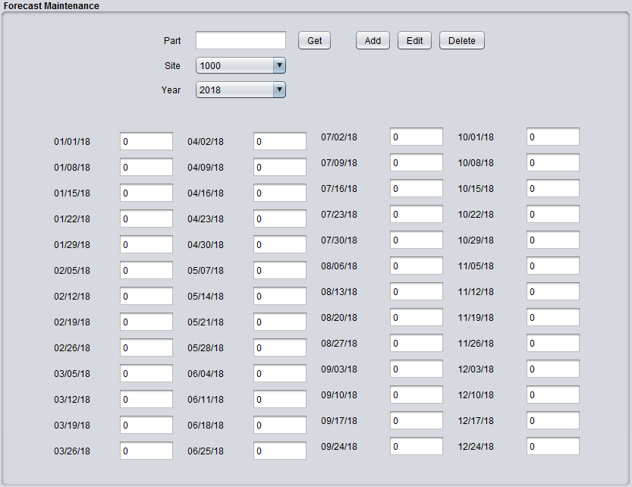
Figure 5.11b Forecast to Plan Sync
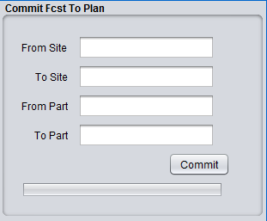

Inventory Adjustments

MRP Maintenance

Scheduling Maintenance

Administration

Class (Panel) Maintenance
The central design theme behind BlueSeer is 'JPanel' centric. Each maintenance panel (and most reports) have a unique JPanel that the display and logic reside in. Each JPanel is a separate java class, and it is necessary to register each panel 'class' within the BlueSeer database. This is by design to make it as simple as possible to add new functionality or new customization to BlueSeer. Adding a new 'maintenance menu' is as simple as adding a new JPanel class with appropriate fields and logic, compiling and dropping it in the BlueSeer source directory, and registering the new class with in the Class Maintenance Menu. For example, if you wanted to add a menu called 'Job Data Entry Maintenance' for end users to enter data for a particular job, you would create the JPanel with the appropriate fields and logic and include in the BlueSeer directory. From NetBeans, you would most likely right click one of the other 'maintenance panel' .java files, copy, right-click the parent 'BlueSeer' directory, click 'Paste' → 'Refactor Copy', Rename to 'JobEntry.java' and NetBeans will include your new class in the BlueSeer Source directory. You then simply have to register 'JobEntry' in the Class Maintenance registration menu.
To add a new class (JPanel), go to 'Class Register' under the Admin master menu, click on 'New' and enter the 'class id' field with the new JPanel class name (leave off the .class or .java extention). You can add an optional description as well. If this is indeed a GUI JPanel to be used as an interactive maintenance menu, you will need to check the 'BlueSeer Core Panel' box. If it is an arbitrary utility class, then leave that field unchecked. A screenshot of the Class Maintenance menu is provided below in Figure 5.1.

Figure 5.1
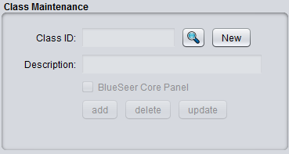

Menu Maintenance
All of the maintenance, browse, and report menus within BlueSeer are stored in the database by menu name. Each menu parent and menu item in the master menu bar are stored in the database by name. This setup facilitates the creation of new menus and/or the customization or regrouping of menus under different hierarchies. The one exception to this is the master menu bar. All the parent menus on the master menu bar are permanent by design and cannot be changed. All inherited sub menus of the master menus can be added, updated, deleted, and/or re-positioned. The registration of a menu into the database is a simple step. To add (or update) a menu, click the Menu Maintenance menu under the Admin master menu. You can either add a new menu or update an existing menu by clicking on the search button and browsing for the menu to be updated. To add a new menu, click 'New' and enter a menuID value. This can be any value (you will assign to the tree in Menu Tree Maintenance) up to 30 characters. You can then optionally add a description if necessary to describe the menu. You must enter a ClassID, which is the JPanel class that is used by the menu for interaction. JPanel Class were registered previously in Class (Panel) Maintenance. You do not have to enter a ClassID if this menu is a 'parent' menu and is for navigational use only. If a 'parent' menu only, check the 'Parent Menu Only?' toggle box. In this case, you can leave ClassID blank. Once this is complete, click 'Add' to commit the new menu to the database. Figure 5.2 shows the screenshot of the Menu Maintenance screen.

Figure5.2
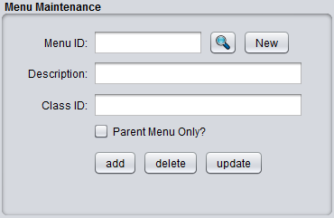

Menu Tree Maintenance
The menu tree maintenance routine maintains the menu registration and positioning within the master menu bar in BlueSeer. To place a new menu within the tree (assign to a parent within the master menu bar), you must first confirm that you have registered the menu in Menu Maintenance, and therefore registered the Class that the menu is associated with in Class (Panel) Maintenance. Once these two items are complete, you can then proceed to insert the menu within the Tree. Click on the Menu Tree Maintenance menu within the 'Admin' menu. This will bring up the Menu Tree Maintenance screen. The screen shot below (Figure 5.3) shows the menu when it is first initiated.
Figure 5.3
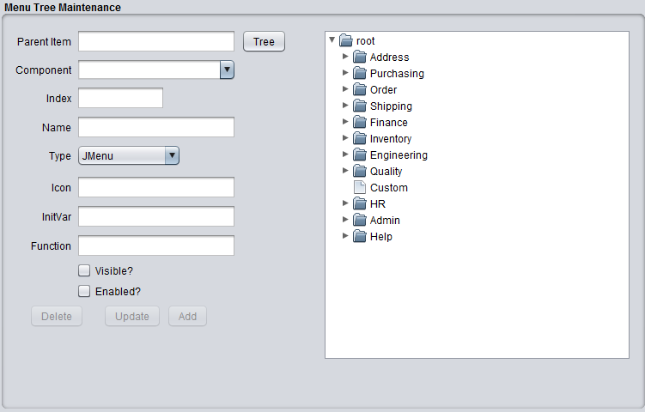
The 'root' node of the tree is fixed as are the immediate children of the root node (I.e...Address, Purchasing, etc). These menus cannot be changed or adjusted. You can, however, add, update, delete, or re-position submenus to these parent menus. You can click on any menu in the right panel and the fields on the left will be occupied with the tree position information for that menu. For example, clicking on the Address menu in the right panel will produce Figure 5.4.

Figure 5.4
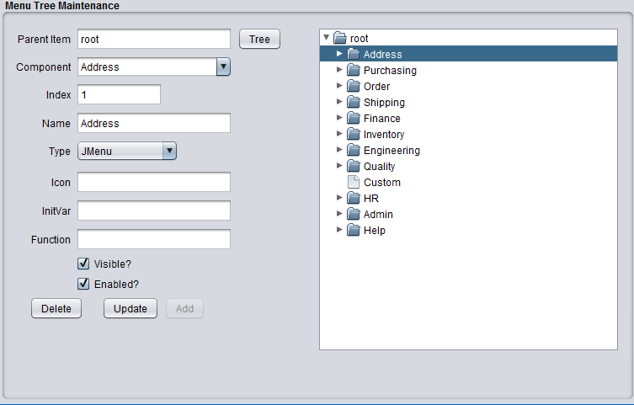
You will notice that the Parent Item of the 'Address' is valued as 'root'. The component is the active menu in question 'Address'. The 'Name' field is the name of the Address menu that you see when you open BlueSeer and view the Master Menu Bar. You can change the value in the 'Name' Text Box to be whatever you want. The 'Component' drop down text box is the exact MenuID that was registered in Menu Maintenance. There are two types to choose from with regards to the menu type (Jmenu and Jmenuitem). If it is a navigational parent (as Address is indeed so) then the type should be “Jmenu”. Otherwise the type should be “Jmenuitem”.
So, as an example of adding a menu, let's add a 'test' menu item (jmenuitem type) to the 'Address' parent menu. Right-click on the Address Tree to open it's children. Then click on the last child item under the Address menu (“LabelMenu”). This will place 'Address' in the 'Parent Item' text box. See Figure 5.5 below.

Figure 5.5
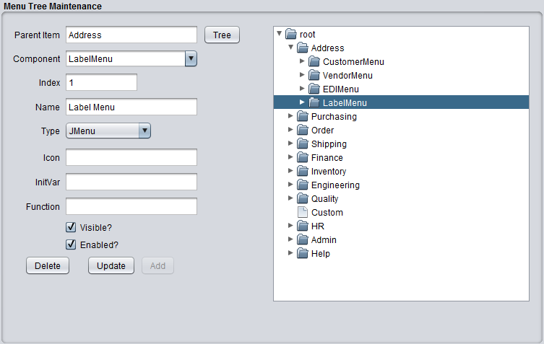
With the screen active as witness in figure 5.5, click inside the Component drop-down list and add the MenuID of the menu you wish to add (assume you registered the menu 'TEST' in Menu Maintenance). After entering 'TEST' in the Component drop-down list, press the Tab key. You will notice that the Index field converts to '-1' and is disabled as it should be. You can then enter the 'Name' of the menu that you wish to be visible on the Menu Bar. You can enter 'TEST' or 'TEST SCREEN' or whatever you wish. Then, choose JmenuItem from the 'Type' drop-down list. You can leave Icon, Initvar, and Function blank (these are discussed below). Check the 'visible?' and 'enable?' boxes with a check mark for both. You can then click 'Add' to insert the new menu item into the tree. Figure 5.6 below shows a screen shot of the menu just after clicking 'Add'.
Once you've inserted the new menu, the Menu Tree Maintenance window will refresh with the new information. However, the actual menu 'TEST SCREEN' will not appear under the 'Address' menu until after you have closed BlueSeer and restarted. The menus (and security access thereof) is assigned once at startup of the BlueSeer application. Any changes to the menus (or security) must be accompanied by a restart of the application.

Field Definitions:
- Icon: The icon text box is reserved for providing an icon image file instead of 'verbiage' for the menu name. The 'Home' (little blue house icon) is an example.
- InitVar: This text box is used for intializing a function within each menu class “initvars(string var). This function should be assigned in every menu class created. Assigning a value of '1' in InitVar will execute the initvars function within the class. If the value is blank, it will not be executed.
- Function: A few of the menu items are functions only...i.e. They do not have interactive Panels for which data is entered or retrieved. These type of menus simply perform a simple function or similar background activity. Assigning a '1' in the Function text box will flag this menu item as a 'function' with no visible panel for interaction.
- Visible: Checking this box will ensure that this menu item is visible at startup (assuming you have permissions).
- Enabled: Checking this box will ensure that this menu item is enabled. The menu item can be visible yet disabled as an option.

Figure 5.6
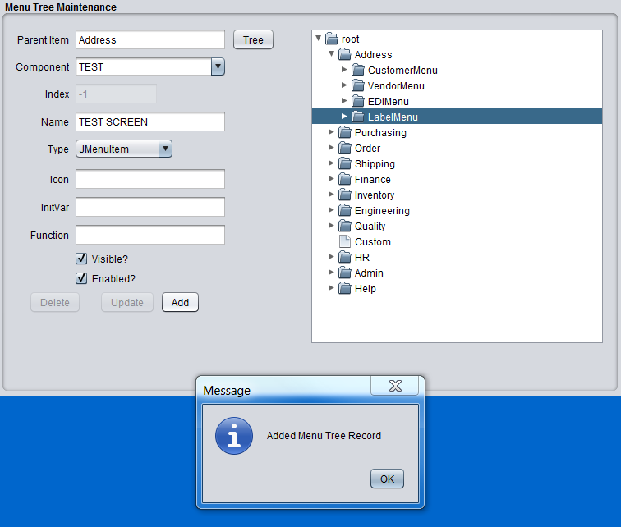

Site Maintenance
A default site is created during the installation of BlueSeer. The site code is '1000'. You can view this site under the Admin Menu by clicking on Site Browse and then clicking the appropriate select option from the table. You will be redirected to the Site Maintenance Screen. You can also enter your own Site code by going to the 'Admin' menu and then choosing Site Maintenance. Click 'New', and enter a site code of your choice. The site code can be a maximum of 10 characters. Enter the appropriate information for the site address and then click 'Add'. Figure 5.7 shows a screen shot of adding a new site code. Once this code is entered, if you choose to use this code as your default site code, then you must enter this code in Default Maintenance under the 'Admin' menu. Go to the Default Maintenance menu, enter the code, and click 'Update'. This will commit your new site code as the default site code for all functionality within BlueSeer. Figure 5.8 shows the updating action within the default maintenance menu.

Figure 5.7
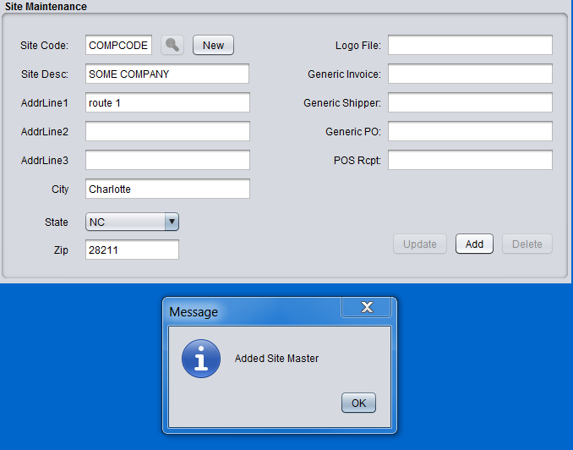

Figure 5.8
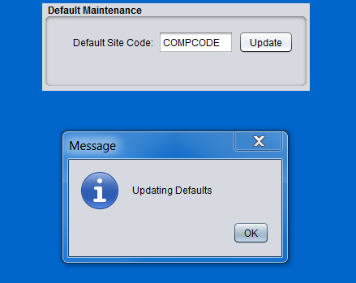

User Maintenance
Adding and updating user accounts is provided for in the User Maintenance menu under the Admin menu. Note: User Ids and Employee Ids are not the same and are independent fields with their own unique purpose. The user maintenance menu allows you to maintain the users ID and associated information with usage of the BlueSeer application. The userid is prevalent through the application in usage and visibility. The majority of the functional modules use the userid field to stamp an id onto each record that is created and/or updated for tracking and change purposes. Each user of BlueSeer should have one and only one userid so that change management can be controlled and audited as necessary.
To create a new user, go to the user maintenance menu under the Admin master menu. Click the 'New' button. This will enable the fields for input. Enter in a unique value for 'userid'. This can be any string up to 8 characters. You can then proceed to enter the associated information including lastname, firstname, email account, etc. The password field is used by the admin to establish and change passwords as necessary. Once the required information has been entered, click the 'Add' button to add the userid to the database. You can then provide the user with the application, userid, and password. However, you still need to add 'permissions' to this userid (which is discussed in the next section). A screen shot of the user maintenance menu is provided in figure 5.9.
Figure 5.9
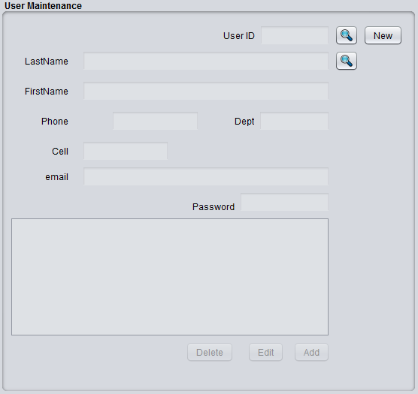

User Permissions Maintenance
Once you have created a unique userid, you can then assign permissions that will allow the userid in question to access certain menus within the application. To assign and/or update menu permissions, click on the User Perms Maintenance menu under the Admin master menu. This will bring up the user perms maintenance screen. There are four panels in this menu screen. The majority of the time, you will assign individual menus to specific userids. This is achieved by the panel marked 'Menu To User Assign/Unassign'. Simply choose the menu in question from the drop-down list and choose the userid from the user drop down list, and then either click the assign or unassign button to associate or unassociate the menu to the userid. You can also copy one userid permissions to another in the panel marked 'Copy All User Permissions'. This is the most feasible for new implementations. The standard practice is to create 'general' userids for groups of functionality...(by Finance, Customer Service, etc) and assign relevant menus to these generic userids. You can then use these ids to copy permissions from and assign to 'real' userids as they are granted access to the system.
Note: the 'admin' userid can not be 'assigned' to in the 'copy all' panel for security purposes. Once a new menu is created/registered in menu maintenance, it is by default assigned to the 'admin' userid automatically.
To view what menus are assigned to what users, you can see this list in 'Menus Assigned to this User' panel. Choose a userid in the drop-down list and click the relevant 'get' button.
To view all users assigned to a certain menu, the far right panel 'Users Assigned to this Menu' will provide that detail. Simply choose a menu in the drop down list and click the 'get' button. A screen shot of the User Perms Maintenance menu is provided in Figure 5.10.
Figure 5.10
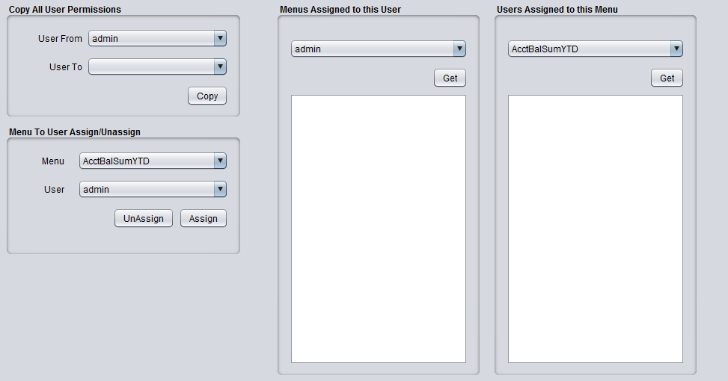

Printer Maintenance

Label Maintenance

Label File Maintenance

Employee Maintenance
BlueSeer provides a human resources module for managing employee information. The employee maintenance record for each employee drives much of the functionality within the HR master menu (including Time and Attendance and work shift associations), and as such should be set up correctly to ensure proper execution. There are two pre-requiste maintenance screens that need to be setup before adding an employee record. You need to add at least one record to each of Department Maintenance and Shift Maintenance . To add or edit an employee record, go to 'HR'-->'Employee Maintenance' menu. Click the 'New' button, and enter a unique employee number. The employee number can be up to 10 characters. The employee number should be unique to each employee. If bar-coded badges are provided to the employees, it is recommended that this number on the bar-coded badge be the same as the employee number for convenience when using the timeclock functionality (scanning in/out). When all fields are completed, click the 'Add' button to commit the employee record.

NOTE: the employee maintenance and user maintenance are two separate menus and are independent of each other. Establishing one does not establish the other.

You will need to choose a type for the employee. BlueSeer currently supports three types (Hourly, Salary, and Temp). The type field is used in timeclock functionality, reports, and other application logic relative to HR functionality. There is also an 'active' versus 'inactive' drop down list to indicate whether the employee is an actual current employee or has been terminated for whatever reason. Some reports use this active/inactive flag to filter records from being displayed.
The Department field is also mandatory. An employee can be assigned to one and only one department/cost center. Choose the appropriate department for each employee.
The last mandatory field in the employee setup is the Shift. You will need to assign the employee to a pre-defined shift. Shift records are defined in 'HR'->'Shift Maintenance' and can be viewed in the Shift Browse Menu. Each employee can be assigned to one and only one shift. You can create as many shift records as necessary to support the various operational hours of the business.
All other fields are optional and will appear on various reports and may be applicable in further HR functional logic. You will need to fill these fields with appropriate values as necessary.
Figure 5.11 shows a screen shot of the Employee Maintenance screen and the fields associated with this menu.

Figure 5.11
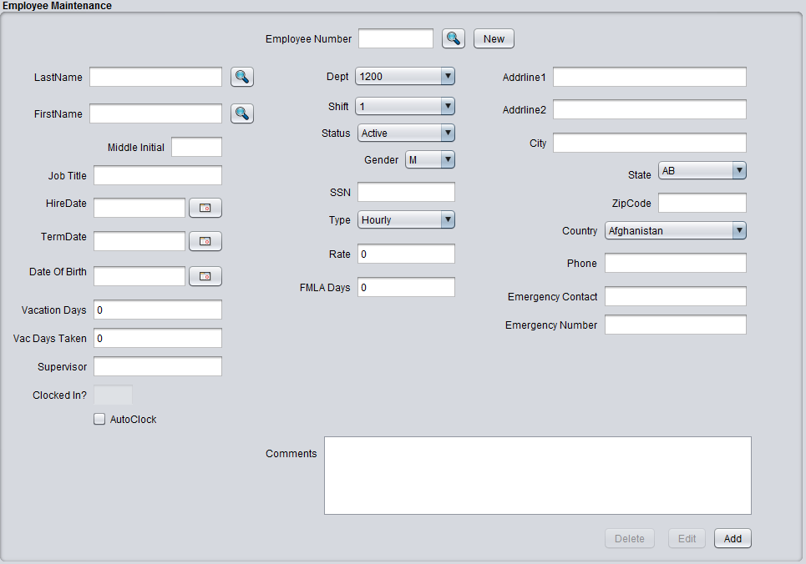

Shift Maintenance

The shift maintenance menu maintains the various shift records that are necessary to support the operational business hours of the business. Each employee is assigned one and only one of the shift records defined here. The timeclock functionality within BlueSeer depends heavily on the defined shifts and the association of the shifts which each employee that utilizes the timeclock menu. Entering a new Shift record is fairly straight forward. Go to the Shift Maintenance menu under the HR master menu. Click the 'New' button, and enter a shift ID. The shiftID can be any value up to 8 characters. Enter a description to go along with the shiftid and then proceed to enter the appropriate time values for each of the 7 workdays. If Saturday and Sunday are not work days, then leave as the default “00:00” for both beginning and ending. Once you have entered these values, click 'Add' to commit the record.
Figure 5.11 shows a screen shot of the shift maintenance menu.

Figure 5.11
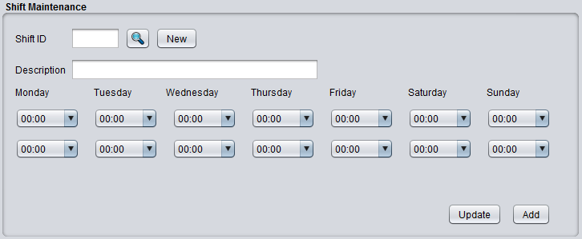

TimeClock Management and Maintenance
BlueSeer provides a timeclock menu to track employee clock in and clock out events. The timeclock menu can be found under the "HR" menu in the menu bar. The timeclock package provides a working "clock entry" screen, a means to adjust timeclock entries, and various reports to support payroll entries and analysis. Each employee's timeclock 'ID' is their corresponding employee ID which must be setup first in Employee Maintenance before the clock entry screen can be used.
As mentioned previously, each employee has to be setup in the Employee Master. The ID associated with the employee is provided to the employee for their use in interacting with the timeclock entry screen. The employee can either enter the ID via a keyboard...or it can be imprinted on an employee ID badge with barcode...and subseqeuntly scanned with a barcode reader. Figure 5.12 shows the timeclock menu that will be visible by the employees.

Figure 5.12.
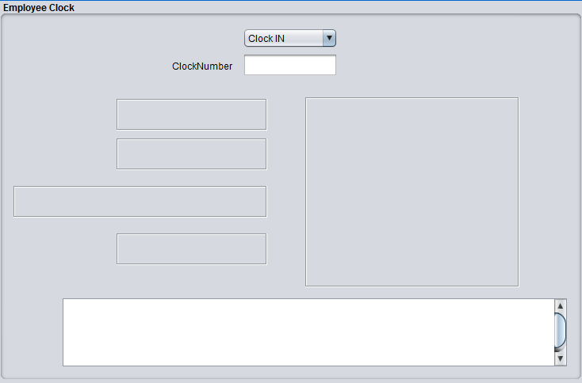

The 'ClockNumber' has focus at all times for either keyboard entry of the employee's clocknumber or bar-code scanning of the clocknumber.

The typical deployment scenario is to deploy BlueSeer on a stand alone PC where it can be appropriately accessed by the employees. The PC should have a keyboard and/or barcode scanner depending on whether or not the employee ID is barcoded on their employee ID card. You can launch BlueSeer on the target PC, click on the TimeClock Entry menu, and leave this menu in the foreground at all times for use by the employees.

The "ID" field always has focus, so all the employee has to do is select in the dropdown list whatever the appropriate event is (Clock In or Clock Out) and enter their ID via the keyboard or scan their card. If it is a 'clock-in' event (and they haven't already clocked in) then a successfull 'image' will appear (see figure 14.1 below).

Figure 14.1
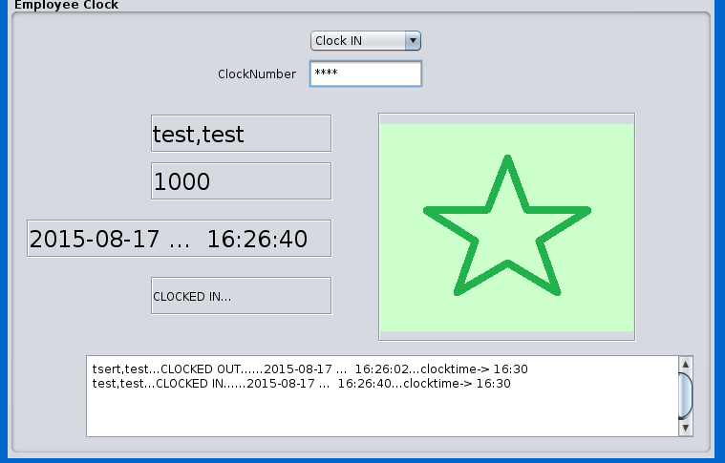

If for any reason the entry was not successful, a message will appear indicating so (example: bad ID, already clocked in, etc) (see figure 14.2 below).

Figure 14.2
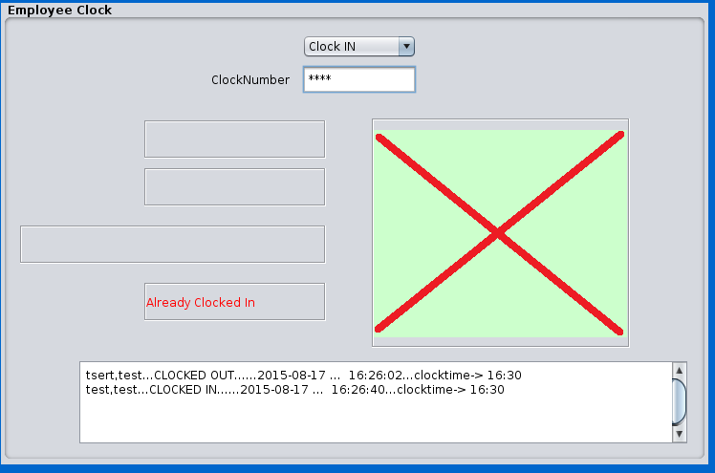

The image notification will pause for 2 seconds before resetting for another entry event. (You generally do not have to reset the dropdown type event since your employees are generally all clocking in or all clocking out depending on shift). A text field below will contain a record of last entries that includes timestamps, ID, and name of employee.

TimeClock Accounting
Each timeclock entry event records the real time (T_{r}) and accounting time (T_{a}) of the entry. T_{a} is recorded on quarter hour intervals. For example, if an employee clocks in at 8:03AM then the (T_{r}) time will be 8:03AM and the (T_{a}) time will be recorded as 8:00AM. However, if the employee clocks in at 8:09AM, then (T_{a}) will be 8:15AM. There is a 7.5 min window within every quarter hour that dictates whether (T_{a}) is assigned forward or backward. (T_{a}) accounting time is provided to make it easier for payroll entries and reporting. However, the real clock time T_{r} can be reviewed any of the TimeClock reporting menus for administrative and management purposes of employees real time labor activity (example: on time versus tardy reporting and disciplinary actions).

AutoClock Maintenance and Procedure
The AutoClock maintenance utility is a procedure that can be executed once a week that will generate exceptions for missing clock records in the absence of an employee specific clock event. This utility is generally ran on a monday following the work week under review. The menu can be found under 'HR'-->'TimeClock Menu'-->'Administration'-->'AutoClock Maintenance'. The procedure is simple. Just enter the number of days 'back' you want to check for missing TimeClock events and click the submit button. If any exceptions are found, time clock records will be generated for any employee that is both active and has the 'autoclock' checkbox checked in their employee master record. The clock records will be compared to the employee's shift schedule and if any periods are found without a corresponding timeclock record, a new record with code '66' will be generated. Supervisors and/or HR can then review these '66' records with employees and ascertain the reason for the absent timeclock record. They will then adjust the '66' records to whatever payable or non-payable code by using the Supervisor Approval Menu (see 'HR'-->TimeClock Menu'-->'Administration'-->'Supervisor Approval'). As stated before, this procedure is typically done on a Monday following the week in review and adjusted in time for the upcoming payroll event. Note: The autoclock procedure should be ran by an administrator or key supervisor. This procedure can also be set as a background service to be automatically executed on a scheduled frequency. (Cron How-To to come)

TimeClock Code Maintenance
TimeClock Code Maintenance (under 'HR'-->'TimeClock Menu'-->'Administration'-->'TimeClock Code Maintenance') allows you to create codes that describe various employee clock events. There are 5 codes that are system codes (these cannot be deleted or edited). The remaining codes are miscellaneous codes that your management team can apply to various scenarios of work scheduling and/or absent explanations. There are reports where you can review the frequency of timeclock events by code which can be used to review employee's consistency in their work schedule or lack there of. You can add codes as necessary. To see a complete list of codes go to 'HR'-->'TimeClock Menu'-->'Administration'-->'TimeClock Code Browse' menu. You can then click on a specific code to edit or review it's description and use. Note: You can set these codes as 'Payable' or 'Non-Payable' depending on the code's usage.

TimeClock Accounting Codes
Code | Descr | System Code
00 | Successful in/out event | yes
01 | Timeclock in event only | yes
02 | Bereavement - Unpaid
04 | Jury Duty - Unpaid
06 | Vacation - UnPaid
07 | Lack of Work - UnPaid
13 | Early | yes
14 | Tardy | yes
16 | Alternate Schedule | yes
20 | Medical Leave
21 | Other UnPaid
23 | Holiday - UnPaid
24 | Holiday - Paid
25 | FMLA - UnPaid
27 | Disciplinary Layoff - UnPaid
66 | Exception Pending Review | yes
96 | Termination

EDI

Quick Guide Chronological Steps

- Create TP ID in Trading Partner Maintenance
  - Example 'ACME'
- Create transaction (doctype) association in TP/DOC Maintenance
  - Example 'ACME' / '850' EDI Purchase Order
- Create Customer / TP / DOC association in Customer TP/DOC Maintenance
  - The doctype transaction for each TP must be assigned to a specific billto. For example, inbound 850 purchase orders from TP = 'ACME' must be associated with a billto code (value is arbitrary) previously defined in Customer Master. For convenience, there is a billto code labeled 'ACME' in the customer master. This must be associated in Customer TP/DOC Maintenance along with the map name that operates the transaction.
- Create appropriate MAP (see Mapping below) for this specific Customer TP/Doc association and assign in step 3 above (Customer TP/DOC Maintenance)

Setup is complete. You can place a test/production file in the default 'in' directory as defined in EDI Control Maintenance. The file should be visible in menu “EDI Inbound Load”. Load and review log file in menu 'EDI_Log'.

Trading Partner Maintenance

EDI functionality is integrated within the BlueSeer application. Unlike other systems where the EDI mechanics is typically a separate translation system, BlueSeer can absorb and transmit EDI X12 directly into/from it's inner tables. Since every customer/vendor EDI mappings are unique, maps are necessary within the BlueSeer framework as well. There exists a hierarchy associating the EDI Trading Partner to specific customers/vendors and to specific maps of customer/vendors. The topmost element of the hierarchy is the Trading Partner ID. Most of the lingo used in this documentation will center around the X12 EDI standard. BlueSeer only supports X12 EDI formatting.
The trading partner id is typically the ID of the customer/vendor found in the Header portion of the EDI document. The segment labeled “ISA” is the envelope segment and provides the sender / receiver identification numbers of who is the sender of the document and who is the receiver of the document. Trading partner ids are typically in the ISA segment element 06 (senderid) and ISA segment element 08 (receiverid). Most of your customers/vendors will provide you with an implementation guideline which details the trading partner ids used along with a lot of useful detail regarding the transactions involved.
Once you've acquired your trading partner's ID, you will need to set it up in Trading Partner Maintenance. To set up a new trading partner ID, go to Trading Partner Maintenance under 'Address'-->'EDI Menu' master menu. Figure 6.1 shows a screenshot of the Trading Partner Maintenance panel.

Figure 6.1
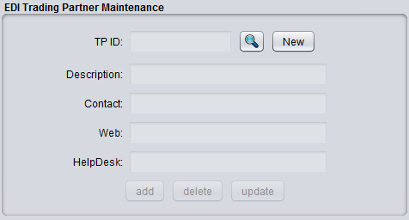
To create a new ID, click 'New' and enter the TPID of your customer/vendor trading partner. Then, proceed to add additional information (optional) of description, contact, and helpdesk info as necessary. Once you've entered the necessary information, click 'Add' to commit your ID to the database.
The primary purpose of the TPID is to establish a list of allowed Ids in the subsequent maintenance screens that are necessary to complete before engaging in EDI document trading with your partner. Creating the EDI trading partner ID is the first step and many associated data records are associated with this ID. BlueSeer comes with a sample ID called 'ACME' which is provided as an example.

TP/DOC Maintenance (Inbound specific)
Once the trading partner ID has been established, you can proceed to create the association between all transaction types that this partner will engage in and it's trading partner ID. The records established here in TP/DOC Maintenance will dictate the inbound map usage for any inbound EDI traffic. These records are maintained in the edi_mstr table. (The Customer/TPDOC Maintenance dictates maps used for the oubound traffic as well as customer to TPID cross references. These are maintained in in the cmedi_mstr table). For example, if trading partner id 'ACME' would like to send the 850 inbound purchase order EDI transaction, then you will need to establish a record in TP/DOC Maintenance with the association of 'ACME' to '850', and you will need to establish a record for the Billto association to the TPID in Customer/TPDOC maintenance (section below). If the customer 'ACME' wants to receive invoices and ASNs (810 and 856 respectively), then you will need to setup two additional records in Customer/TPDOC maintenance for the doctypes 810 and 856 dictating the map to use for these two outbound transactions. Figure 6.2 shows the screenshot of the TP/DOC Maintenance Panel and Figure 6.4 shows Customer/TPDOC maintenance menu.
Figure 6.2
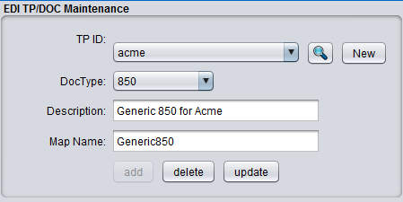

From Figure 6.2, the TP ID drop down list is occupied with the complete list of Ids that have been previously recorded in the Trading Partner Maintenance menu. The DocType drop down list contains records that have been entered in Code Master Maitenance where code = 'edidoctype' and key = <the transaction type> . You can enter as many as you like in Code Master Maintenance with the hardcoded code value = 'edidoctype'. BlueSeer comes with a few default values.
Once both drop down lists have elements within them, you can add a new association by clicking on 'New'. This will enable all the fields for input. Choose the appropriate TPID and DocType from their respective drop down lists, enter a description, and enter the name of the map that is to be applied for this transaction. Note: The map must exists as a somefilename.java class in the “EDIMaps” source directory. For example, you can copy one of the default example java files in EDIMaps, and paste and rename to create a new map file. Figure 6.3 shows a screenshot of the NetBeans IDE which has the BlueSeer project loaded. You can see the .java classes under the “EDIMaps” source directory. You can add, edit, or delete files within this directory depending on your needs. The names of the maps are case sensitive.
Going back to our EDI TP/DOC record, once you have the map created and it is in the proper directory, enter the map name (without the .java extension) into the MapName textbox as shown in Figure 6.2. Then click 'Add' to commit the record (association) to the database. Remember, the Map names are case sensitive, so the value you entered in the MapName textbox must match (case) the map name in EDIMaps source directory (minus the .java extention).
Figure 6.3
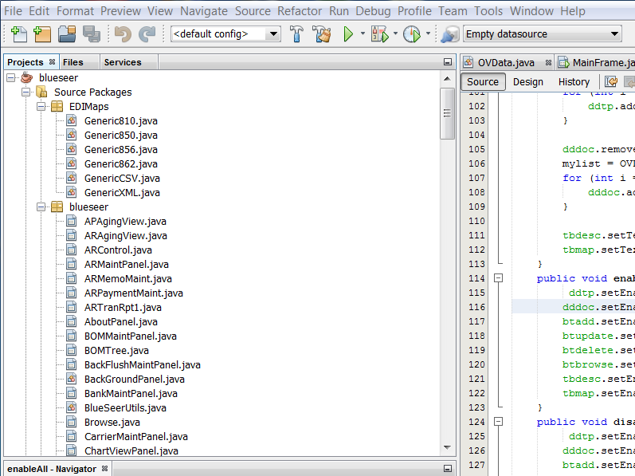

The sample .java map classes in “EDIMaps” are an excellent starting point for any customer/vendor custom mapping requirements. More information regarding inbound / outbound map construction is provided below in the EDI Map Development section.

Customer/TPDOC Maintenance (outbound specific)

The Customer/TPDOC Maintenance panel controls both the inbound EDI cross reference association between ISA ID (TPID) and Customer Billto code and the MAP designation for all Outbound traffic. The records for these associations are stored in the cmedi_mstr table. Each record has three keys that that makes the each record unique. The three keys are Customer Code (cme_code), DocType (cme_doctype), and Direction (cme_dir) indicating the direction of inbound or outbound. Therefore, it is possible to have two invoice (810) records per customer code. For example, you can create one record for “Acme,810,inbound” as well as “Acme,810,outbound”. It is important to note that the 'map' value in this maintenance screen only controls the outbound EDI transactions. All inbound transaction maps are defined in TP/Doc Maintenance. Figure 6.4 shows a screenshot of the Customer/TPDOC Maintenance screen.
Figure 6.4
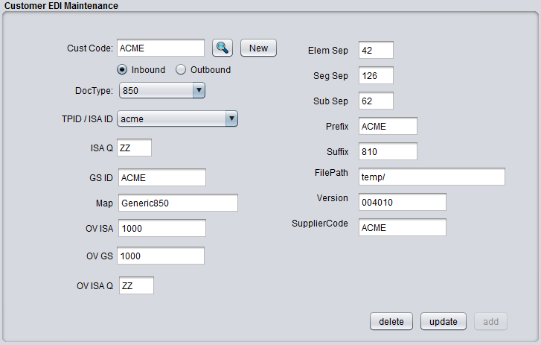
The value of the map in the Map text box is validated with the actual map (.java class) in the EDIMaps source directory. Note that the map value is case sensitive and must match the case of the .java file in the source directory (minus the .java extension).
To create a new Customer/TPDOC record, click 'New' and enter the appropriate customer code (billto). Then choose the direction, doctype, and TPID of the trading partner for which this association is valid. The remaining fields are optional if this is an inbound transaction. However, if this is an outbound transaction, you must complete the remaining fields as they are used in the construction of the envelope segments of the outbound transaction. Click 'Add' when complete to commit the record to the database.

EDI Control File
The EDI Control menu provides a location to store relevant information about the EDI directory environment. All the paths in the control fields are relative to the BlueSeer home folder location. For example, you can create a directory called “your_in_directory/inbound” and place your inbound EDI files within this directory. The loader program will look in the Default In Dir location for the inbound files. In this case, the Default In Dir would be defined as “your_in_directory/inbound”...which should reside within the BlueSeer execution folder. Figure 6.5 shows the screenshot of the default directory values for the EDI environment. Notice there is an EDI folder within the BlueSeer directory. The EDI file has several sub-directories specifically for controlling the EDI traffic.
Figure 6.5
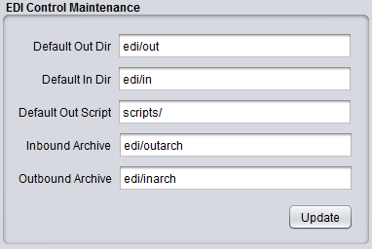

EDI Loader and Audit Log
To load EDI files, go to 'Address'-->'EDI Menu' and click the EDI Inbound Load menu. This will bring up a panel with a list of files that are sitting in the inbound queue. Note: The inbound queue is defined in the EDI Control File. The first column of the file list has the actual file name within the queue. You can click on this filename to show the contents of the file in the text area in the right panel. There is also a 'load' toggle box in the second column of the list. Toggling this box on or off will select or de-select files to be loaded. Any list items with the toggle box checked will load when you click the 'Process' button. After you've processed the files, you should go to the EDI Log menu to see the status of the loaded files (pass/fail/audit information). Figure 6.6 shows the screen shot of the EDI Loader program.
Figure 6.6
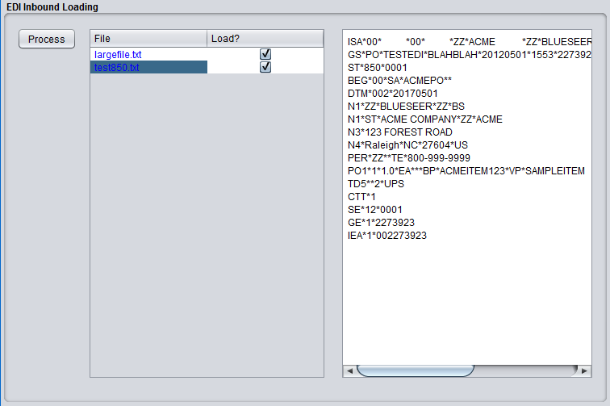

The EDI Log menu is shown in Figure 6.7 below and is accessible from 'Address'-->'EDI Menu'-->EDI Log. The EDI Log menu allows you to audit edi inbound and outbound traffic and load. Various information regarding the control numbers, dates, and trading partner Ids are visible within this reporting tool. You can filter for specific transactions and/or specific trading partners with the options in the left panel. You can also filter by load date as well. This log file essentially audits info type message as well as error type messages, and you have the option to choose either or both in your output. The far right panel allows you to view the raw file by clicking on the file name in column 5. With regards to inbound orders (850), if the order successfully loaded, you will see the actual order number generated in the Ref column. You can click on this column to navigate to the actual order in Order Maintenance.

Figure 6.7
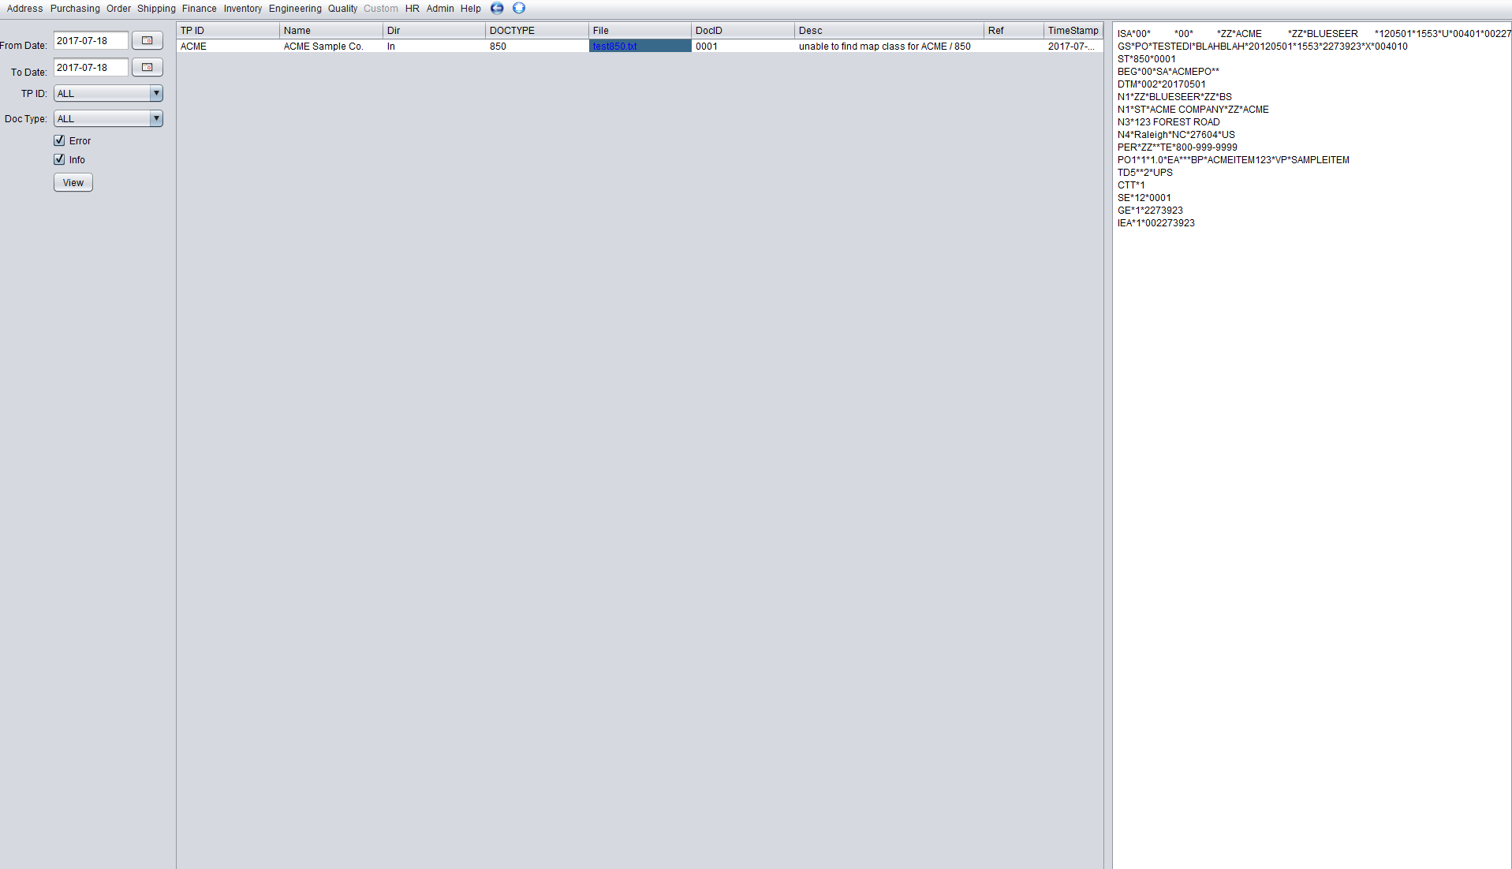

EDI Maps

The EDI maps used by BlueSeer are simple .java files maintained within the “EDIMaps” source directory under the BlueSeer root directory. There are many formats of EDI, however, BlueSeer only supports ANSI X12 EDI formatting. There are hundreds of X12 EDI transactions, but the most prevalent in the ERP use case is the purchase order (850), Ship Notice (856), and Invoice (810). There are generic sample maps for the EDI 850, 856, and 810 transactions. They are located in the EDIMaps source directory. These maps are easily edited and compiled with the NetBeans IDE application, but any IDE or text editor can edit the maps. If a custom map is required, it is suggested to copy, paste, and rename one of the generic sample maps since these already have the imports and structures required to operate with BlueSeer. A screenshot of the NetBeans IDE with BlueSeer EDI classes is shown below:

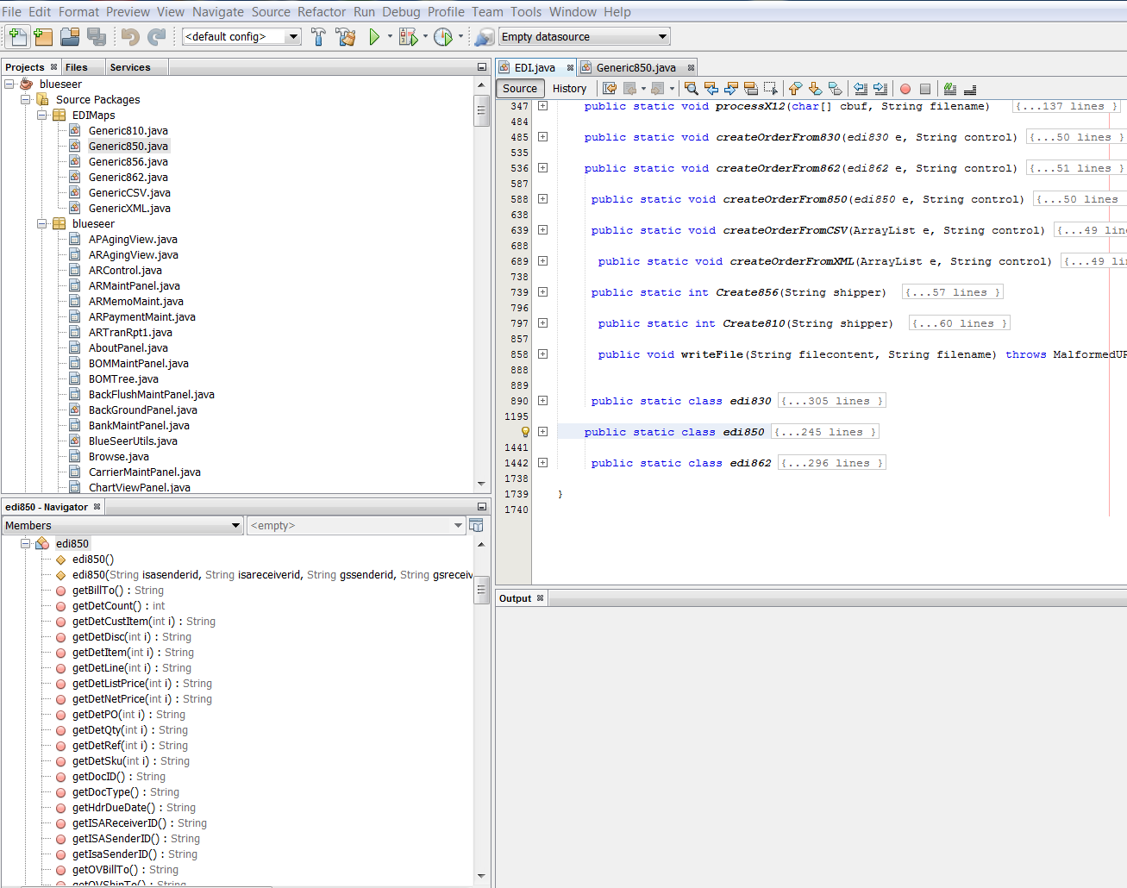

There is a built in class for each transaction type that has a finite number of Header fields and a finite number of Detail fields. These fields are the minimum set of fields to work with with designing your custom maps. As an example, we will discuss the EDI purchase order (850) map and field requirements to load/transform an arbitrary 850 into a legitimate BlueSeer sales order visible within Order Maintenance panel of BlueSeer.
Within BlueSeer, there is an EDI.java class that contains most of the structures and methods that drive the EDI functionality. The EDI 850 class is defined in the EDI.java parent class. The edi850 class contains 25 header fields and 10 details fields (as arrays). The collection of fields is provided in the below table.
EDI850 class member (field) definitions:
Hierarchy | Field | Mandatory/Optional | Format | Looping Occurs
Header | isaSenderID | Mandatory | String(15) | Once
Header | isaReceiverID | Mandatory | String(15) | Once
Header | gsSenderID | Mandatory | String(15) | Once
Header | gsReceiverID | Mandatory | String(15) | Once
Header | isaCtrlNum | Mandatory | String(9) | Once
Header | isaDate | Mandatory | YYMMDD | Once
Header | docid | Mandatory | String(9) | Once
Header | doctype | Mandatory | String(10) | Once
Header | po | Mandatory | String(15) | Once
Header | billto | Optional | String(15) | Once
Header | shipto | Optional | String(15) | Once
Header | ov_billto | Mandatory | String(15) | Once
Header | ov_shipto | Mandatory | String(15) | Once
Header | remarks | Optional | String(15) | Once
Header | shipmethod | Optional | String(15) | Once
Header | duedate | Mandatory | YYYY-MM-DD | Once
Header | podate | Optional | YYYY-MM-DD | Once
Header | st_name | Optional | String(30) | Once
Header | st_line1 | Optional | String(30) | Once
Header | st_line2 | Optional | String(30) | Once
Header | st_line3 | Optional | String(30) | Once
Header | st_city | Optional | String(30) | Once
Header | st_state | Optional | String(2) | Once
Header | st_zip | Optional | String(10) | Once
Header | st_country | Optional | String(3) | Once
Detail | detline | Optional | String(10) | Multiple
Detail | detitem | Mandatory | String(30) | Multiple
Detail | detcustitem | Optional | String(30) | Multiple
Detail | detsku | Optional | String(30) | Multiple
Detail | detqty | Mandatory | String(9) | Multiple
Detail | detref | Optional | String(30) | Multiple
Detail | detpo | Optional | String(30) | Multiple
Detail | detlistprice | Mandatory | String(9) | Multiple
Detail | detnetprice | Mandatory | String(9) | Multiple
Detail | detdisc | Optional | String(9) | Multiple

To map EDI segment/fields to the EDI 850, you need to create an object of the edi850 class at the beginning of your .java map file like so:

edi850 e = new edi850(isaSenderID, isaReceiverID, gsSenderID, gsReceiverID, isaCtrlNum, isaDate, doctype, docid);

This object creation and initialization is at the beginning of every .java map. Once initialized, the 'map' essentially assigns the header and detail fields from the data in the EDI segments/elements of the raw 850 file from the customer. The raw segments/elements from the inbound file are passed to the map .java class as an array called 'Doc'. Essentially, you loop through the Doc array (the elements of the array are the segments of the raw EDI file), and assign (map) the appropriate values to the edi850 class object 'e'. The individual field mappings are specific to the customer's usage and therefore the map created is unique for the specific customer and specific transaction.
The initialization of the new object 'e' requires eight control variables as shown in the above code statement. These 8 are mandatory for the creation of the 'e' object. After looping through all the elements/segments in the Doc array and subsequently mapping the members in the 'e' object, the object 'e' is passed to the BlueSeer processor for creation of the Sales Order as shown here:
blueseer.EDI.createOrderFrom850(e, control);

Once the order has been created, the initial inbound file is archived, and the newly created sales order is visible within Order Maintenance.
The best approach to creating EDI maps for new customers within BlueSeer is to take one of the generic map .java files and clone the original to create a new file with a new filename. Then, proceed to make customized adjustments to the member assignments per the customer's implementation guide.
The Ship Notice (856) and Invoice (810) are created in a similar fashion as the Purchase Order (850) mapping procedure as described above. Use the generic 856 and 810 maps to create a customized version as necessary.

EDI Automation

The typical processing of EDI inbound and outbound files involves some level of automation. A scheduled operation is usually constructed to execute the processing of the files on some repeated event schedule. With BlueSeer, automated setup is easy and can be established relatively quickly with a simple scheduler (either the OS scheduler, cron scheduler, or some other scheduling tool) and bat or shell files to call the BlueSeer executables.

EDI Command-Line Translator

The typical processing of EDI inbound and outbound files involves some level of automation. A scheduled operation is usually constructed to execute the processing of the files on some repeated event schedule. With BlueSeer, automated setup is easy and can be established relatively quickly with a simple scheduler (either the OS scheduler, cron scheduler, or some other scheduling tool) and bat or shell files to call the BlueSeer executables.

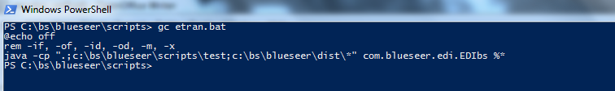

Custom Application Guide

Customization Overview
One of the best features of BlueSeer is it's ability to customize the core package or extend functionality by creating new classes. The parent menu 'custom' is childless by default. You can create your own java JPanel class and include this class under the custom menu. There are a few constraints to observe when adding custom applications, but the functionality you add to your custom JPanel class can be completely independent from the core BlueSeer package albeit a few minor exceptions. The minimum requirements for a custom JPanel class are:
- The class you create must be a JPanel class. BlueSeer is essentially a large collection of JPanel classes. Each Class is associated with a Jmenu option in the parent frame and is 'selected' by clicking on the associated menu. The act of selection essentially pulls the selected JPanel forward (visible = true), and all other JPanels have their visible flags set to false.
- The class you create must exist in a java package called 'custom'. For example, if you create a class called 'myclass', it must reside in a java package as custom.myclass.
- The jar file that contains custom.myclass for example, can be named anything. However, it must be placed in the -cp path prior to the blueseer.jar file. For example, the following java command line statement is legitimate (assuming you called your jar file 'custom.jar' and placed in the dist directory) :
javaw -cp dist\custom.jar;dist\blueseer.jar bsmf.MainFrame
Note: you must ensure that your 'myclass' is defined in the 'custom' package within the 'custom' jar file. You should be able to see your custom class with the following jar
viewer command :
jar tf dist\custom.jar |find “myclass”
This command should return : custom/myclass.class
- You should include bsmf.jar file in your library when you compile your custom package. The bsmf.jar file is the primary JFrame which controls the panels and navigation of the application. Including blueseer.jar is optional, but recommended if you plan to use any classes within the core package.
- Lastly, you will need to update a several Maintenance records within the BlueSeer application once you've launched blueseer to 'include' your custom class within application.
  - Admin → Class Register
  - Admin → Menu Maintenance
  - Admin → User Perms Maintenance
  - Admin → Menu Tree Maintenance

Customization Example
The following steps illustrate the creation and inclusion of a sample Java JPanel Class to the BlueSeer Application :

    - Let's create a simple Java JPanel Class. We will use NetBeans IDE to create a JPanel class.
    - Within NetBeans, create a new Project by clicking on File → New Project and choosing 'Java Application'. Click Next. Enter the name 'myproject' as the name of the project and click Finish. (see screenshots below).
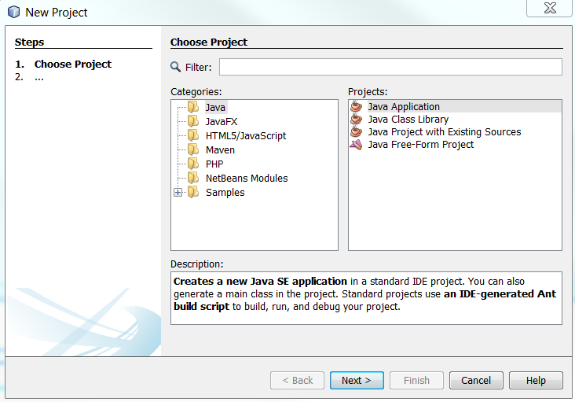

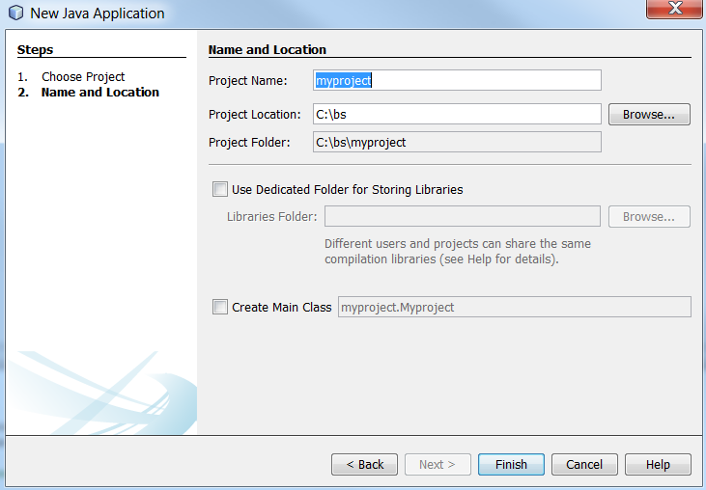
    - Right Click on your newly created project 'myproject' and click 'New' → 'Java Package'. Enter 'custom' as the Package Name and click Finish.
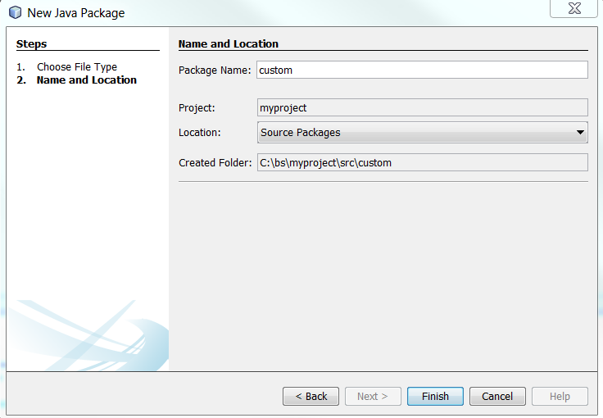

    - You should now have 'custom' as the only package in Source Packages.
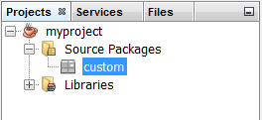
    - Right click on the 'custom' package and click 'New' → JPanel Form, enter 'myclass' as the class name and click Finish.
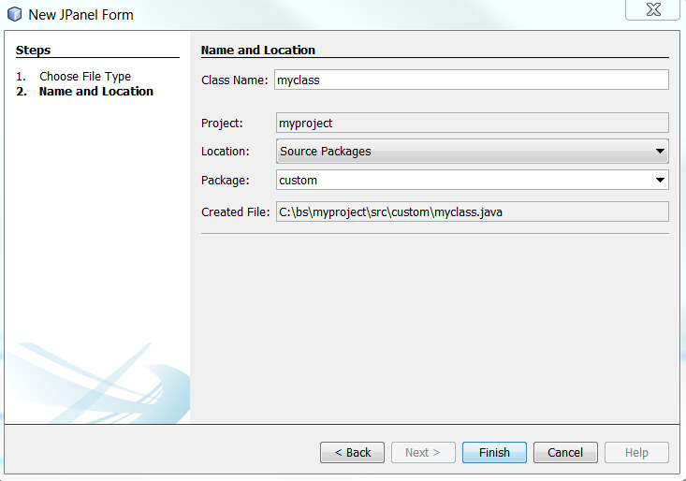
    - Now that you have an empty panel, let's drag a Jbutton and a JtextField over into the panel. Highlight both components and right click and choose 'Enclose In' Panel. This will place the two components within a small panel (jPanel1). Your components should have the following hierarchy in the image below.
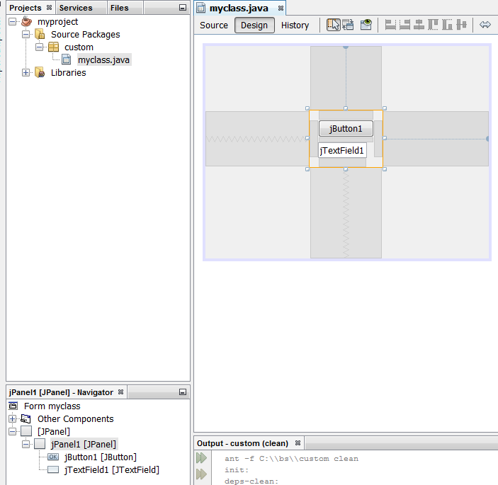
    - Right-click on the outter panel (jPanel) and click 'Set Layout' and choose Flow Layout. Your project structure should look like :

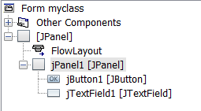

    - You will need to add a single function to your source code called 'initvars(String)'. It just needs to be declared. It is used by bsmf.jar for initialization purposes.
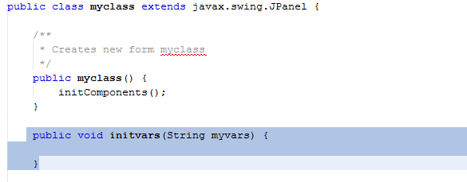
    - Lastly, double click the jButton1. You will be navigated to the jButton1ActionPerformed function. Inside this function write the following statement:
        - jTextField1.setText("BOO");
    - Now that your coding is complete, right click on the 'myproject' icon and click 'Clean and Build'. This will create your jar file for you. The jar file is labeled 'myproject.jar' in your dist directory. You can see the location of the jar file in the Output screen as shown here:
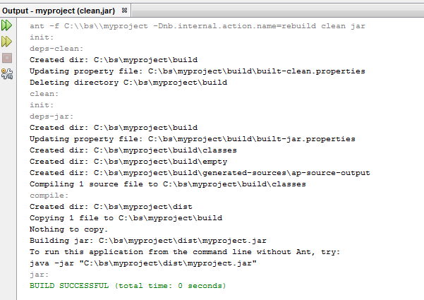
    - Now it's time to insert your newly created class into the BlueSeer application flow by including the jar file in your class path and registering your class with the application.
    - Copy the 'myproject.jar' file and place in the c:\blueseer\dist directory.
    - Adjust your java launch path (in login.bat if you installed the demo) to include this jar file like so (on windows):
javaw -cp dist\myproject.jar;dist\blueseer.jar bsmf.MainFrame
    - Launch Blueseer either with the javaw statement above or from your 'edited' login.bat file.
    - Once launched, click Admin → Class Register. Click 'New' and enter 'myclass' in the class ID field and click 'add'.
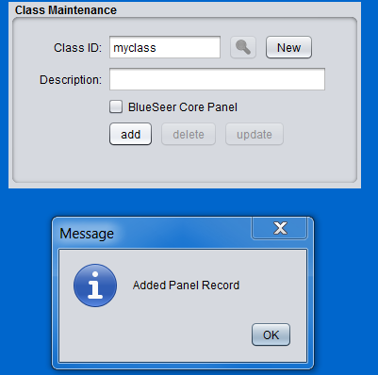
    - Click Admin → Menu Maintenance. Click 'New' and enter 'MyNewMenu' in the Menu ID field and 'myclass' in the Class ID field. Then click 'add'. Do not check parent menu only.

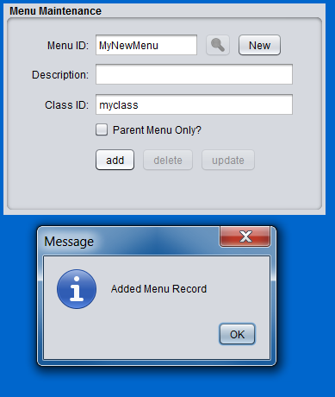
    - If you are using the 'admin' login in BlueSeer, the creation of the menu automatically creates permissions for 'admin' to use that menu so you don't have to do this step. Any other users will have to have their perms adjusted to use the menu in Admin → User Perms Maintenance

    - Finally click Admin → Menu Tree Maintenance to add your new menu to the menu tree. Enter 'Custom' in the Parent Item and tab to the Component field. This drop down box is 'editable'. Enter the 'component' of your new menu 'MyNewMenu' that was previously created in Menu Maintenance. Tab down and enter a descriptive name like 'My New Menu' (this will be visible portion of the menu to the enduser). Choose JmenuItem, check Visible and Enabled and click 'Add'.
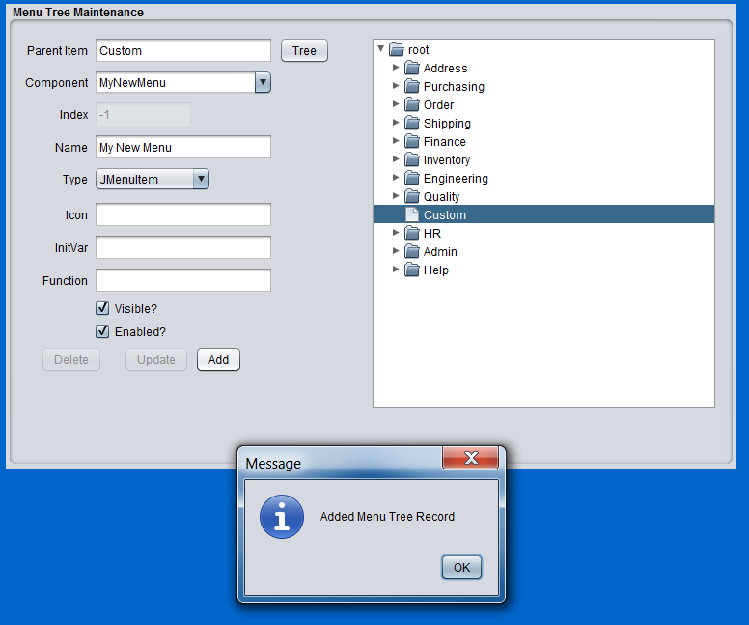

    - Before you will see your new menu under the Custom Menu, you will need to close the application, and re-launch BlueSeer. (Note: BlueSeer registers all menu at time of launch. Changing the menu tree structure will always require a re-launch to see the changes).
You should now be able to click on the Custom Parent menu and your 'My New Menu' to see the results of your new class code. Enjoy! :)
