Predictive CPV Analytics for Tablet Compression
XGBoost Prediction, SHAP Explainability, and Applicability-Domain Control
Professional Project Report
Prepared by: Sri Harsha Chakrapani
September 2026
Version 1.0
Important scope statement: This project uses synthetic data designed for educational and portfolio purposes. No proprietary manufacturing data were used. The model is not validated for GMP release, batch disposition, or autonomous process control.

Project theme: Detect → Predict → Explain → Know when not to trust the prediction

1. Executive Summary
This project extends a continuous process verification (CPV) dashboard from retrospective detection into predictive decision support. The original CPV workflow identifies shifts, statistical signals, and change points. The V3 extension asks a forward-looking question: can material, process, and in-process tablet attributes be used to predict dissolution performance for new API lots, explain the drivers of each prediction, and flag conditions where the model should not be trusted?
A synthetic dataset of 720 tablet-compression batches across 18 API lots was created to support a more realistic modeling exercise. The dataset was divided by API lot rather than by randomly mixing individual rows: 400 training batches from 10 lots, 120 validation batches from 3 unseen lots, 120 independent test batches from 3 unseen lots, and 80 deliberately out-of-domain stress batches from 2 lots. API lot identity was not supplied as a predictor.
Primary result: The tuned XGBoost model achieved MAE 0.60 percentage points, RMSE 0.74 percentage points, and R² 0.646 on the independent unseen-lot test set. These results are encouraging for a synthetic proof-of-concept but do not constitute evidence of real-world GMP performance.

What the project demonstrates
- A manufacturing problem can be translated into a supervised-learning target: predict dissolution at 30 minutes from pre-result material/process information.
- Model tuning should optimize performance on unseen groups, not merely fit historical batches.
- XGBoost can capture nonlinear and interacting relationships while regularization limits unnecessary complexity.
- SHAP can explain which variables pushed a prediction higher or lower without claiming those variables are proven causal root causes.
- Applicability-domain logic can identify observations that are too different from the model-development envelope for the prediction to be treated as reliable.
- A defensible analytics workflow includes failure modes and boundaries, not only accuracy metrics.

Decision-support philosophy
The intended role of the model is to support engineering judgment. An in-domain prediction may help prioritize investigation or monitoring. An out-of-domain prediction should trigger caution, additional evidence gathering, and possibly future model redevelopment. The model is not designed to replace process understanding, deviation management, validation, or quality decision-making.

2. Manufacturing Problem and Project Objectives

2.1 Problem statement
Traditional CPV dashboards are strong at showing what has already happened: a variable moved, a rule was violated, or a change point appeared. A predictive layer attempts to answer a different question: based on material attributes and current process behavior, what product-performance outcome is likely, before the final laboratory result is available?
For this exercise, dissolution at 30 minutes was selected as the target outcome because it provides a clear continuous response for regression modeling. The predictors were chosen to represent a plausible combination of incoming material attributes, process settings, and in-process tablet attributes.

2.2 Project objectives
1. Create a larger, lot-structured synthetic dataset suitable for predictive-model development and stress testing.
2. Establish simple baseline models before introducing XGBoost.
3. Tune XGBoost using API-lot-aware cross-validation to reduce leakage and overfitting.
4. Evaluate performance on API lots never used for model training.
5. Use SHAP to explain global and batch-level prediction drivers.
6. Add an applicability-domain check that can identify conditions outside the training envelope.
7. Document limitations and define what additional work would be required before any real-world operational use.

2.3 Core business question
Question: Can a model trained on historical material and process patterns provide a useful, explainable estimate of dissolution performance for a new API lot while also recognizing when the new conditions are too unfamiliar for the prediction to be trusted?

2.4 What this project is not
- It is not a validated GMP model.
- It is not a replacement for dissolution testing.
- It does not establish causality between SHAP-ranked features and product performance.
- It does not prove that the synthetic relationships represent any specific commercial product or site.
- It does not authorize automatic batch disposition or process adjustment.

3. Dataset Design
The first version of the CPV example contained only a few dozen observations. That was adequate for learning dashboard logic but too small for a credible predictive-model exercise. The V3 dataset therefore increased the sample size to 720 synthetic batches and introduced explicit API-lot structure so model generalization could be evaluated at the lot level.
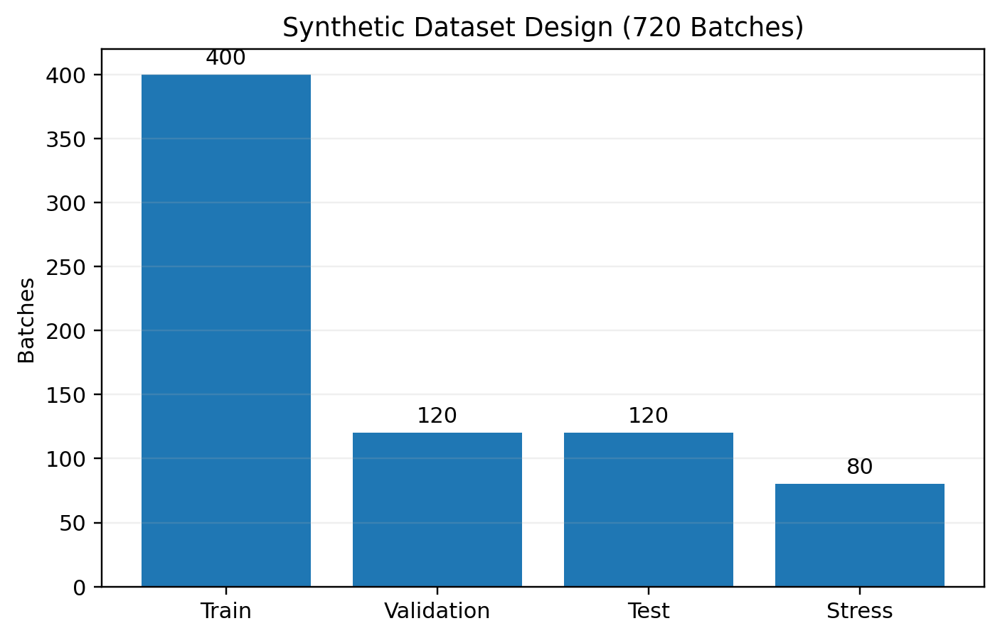
Figure 1. Synthetic dataset split by model-development role.
Split | Batches | API lots | Purpose
Training | 400 | 10 | Fit baseline models and tune XGBoost
Validation | 120 | 3 | Unseen lots used for model selection and error characterization
Test | 120 | 3 | Independent unseen-lot generalization assessment
Stress | 80 | 2 | Deliberately outside the development envelope

3.1 Why split by API lot?
If individual batches from the same API lot are randomly distributed across both training and test sets, the model can benefit from lot-specific similarities that would not be available when a genuinely new lot arrives. Grouping the split by API lot makes the evaluation harder and more aligned with the intended use case: generalization to unfamiliar material lots.

3.2 Synthetic-data rationale
Synthetic data allow the full analytics workflow to be demonstrated without exposing confidential information. Relationships were deliberately designed to include variability, nonlinear effects, interactions, and noise so that the model would not achieve unrealistic near-perfect accuracy. This makes the exercise useful for learning model behavior, but all numerical results remain properties of the synthetic experiment.

4. Feature Strategy and Leakage Control
The target variable was dissolution at 30 minutes. Ten predictors were supplied to the predictive models. API lot identity was used only to define groups for splitting and cross-validation; it was not given to the model as a predictor.
Feature | Category | Role in model
API PSD D90 (µm) | Material attribute | Particle-size characteristic of API
Bulk density (g/mL) | Material attribute | Powder packing / flow-related attribute
Blend moisture (%) | Material / blend | Moisture condition before compression
Lubrication time (min) | Process | Blend lubrication exposure
Press speed (rpm) | Process | Compression throughput setting
Feeder speed (rpm) | Process | Material-feed setting
Compression force (kN) | Process | Compression parameter
Tablet weight (mg) | In-process attribute | Average unit weight
Tablet hardness (kp) | In-process attribute | Mechanical tablet attribute
Thickness (mm) | In-process attribute | Tablet geometry attribute

4.1 Excluded variables
Disintegration time remained available in the broader CPV dataset but was intentionally excluded from the early-warning feature set. Because disintegration is itself a downstream product-performance result closely related to dissolution, including it could make the predictive task artificially easy and weaken the interpretation of the model as an earlier-warning tool.

4.2 Leakage concept in plain language
Leakage example: If a model is asked to predict the final exam score but is given the answer key as an input, high accuracy is meaningless. In manufacturing analytics, leakage occurs when the model is given information that would not legitimately be available at prediction time or is too directly derived from the outcome.

4.3 Prediction timing
The intended analytical sequence is: material and process data become available → model generates a dissolution estimate → SHAP explains the prediction → applicability-domain logic assesses whether the case is sufficiently similar to the training space → an engineer decides how the information should influence monitoring or investigation.

5. Modeling Architecture

5.1 Baselines first
Two baseline models were established before tuning XGBoost: linear regression and random forest. This prevents the project from assuming that a more complex algorithm is automatically better. A complex model should justify itself through improved generalization or interpretability value.

5.2 Why XGBoost?
XGBoost is a gradient-boosted decision-tree algorithm. Rather than fitting one large decision tree, it builds many smaller trees sequentially. Each new tree focuses on errors that remain after the previous trees. This structure can capture nonlinear behavior and interactions among variables while still allowing explicit controls on model complexity.
Simple mental model: XGBoost answers “What outcome do I predict?” SHAP answers “Which variables pushed that prediction up or down?” The applicability-domain check answers “Is this batch similar enough to the training experience for the prediction to be treated as supportable?”

5.3 Three-layer design
1. Prediction layer — tuned XGBoost estimates dissolution at 30 minutes.
2. Explainability layer — SHAP quantifies the contribution of each feature to the prediction.
3. Trust-boundary layer — a nearest-neighbor distance check compares the new batch with the training envelope and flags out-of-domain cases.

5.4 Why this architecture matters in manufacturing
A prediction alone is rarely sufficient in a regulated manufacturing context. Users need to understand the main drivers, the uncertainty or error range, and whether the new observation is similar to situations represented in model development. The V3 architecture therefore treats explainability and applicability as first-class outputs rather than optional visualizations.

6. XGBoost Model Tuning
Model tuning adjusted the algorithm’s complexity, learning speed, sampling behavior, and regularization. The goal was not to minimize training error. The goal was to identify a configuration that generalized better to unseen API lots.
Hyperparameter | Values explored | Plain-language role
n_estimators | 200, 350, 500, 700 | Number of sequential trees
max_depth | 2, 3, 4 | Maximum complexity of each tree
learning_rate | 0.02, 0.035, 0.05, 0.07 | Size of each boosting correction
min_child_weight | 3, 5, 8, 12 | Evidence required before creating finer splits
subsample | 0.70, 0.85, 1.00 | Fraction of training rows used by a tree
colsample_bytree | 0.70, 0.85, 1.00 | Fraction of predictor variables used by a tree
reg_lambda | 1, 3, 6, 10 | L2 regularization strength
reg_alpha | 0, 0.05, 0.2, 0.5 | L1 regularization strength
gamma | 0, 0.05, 0.15 | Minimum gain before a split is accepted

6.1 Search method
RandomizedSearchCV evaluated 40 parameter combinations. Each combination was scored using five-fold GroupKFold cross-validation, with API lot used as the grouping variable. This prevents batches from the same API lot from being split across the training and checking portions of a fold.

6.2 Final selected recipe
Setting | Selected value
Trees | 500
Maximum depth | 2
Learning rate | 0.05
Minimum child weight | 12
Row sampling | 85%
Feature sampling | 70%
L2 regularization | 6
L1 regularization | 0.2
Gamma | 0

Interpretation: The winning model used many shallow trees, learned gradually, saw slightly different subsets of rows and variables, and applied meaningful regularization. This is a conservative recipe designed to reduce overfitting.

7. Overfitting and Generalization
The training-error curve illustrates why the model with the lowest historical error is not necessarily the best model. As tree depth increases, the model becomes increasingly capable of reproducing the training data. However, the validation error on unseen API lots does not improve in parallel.
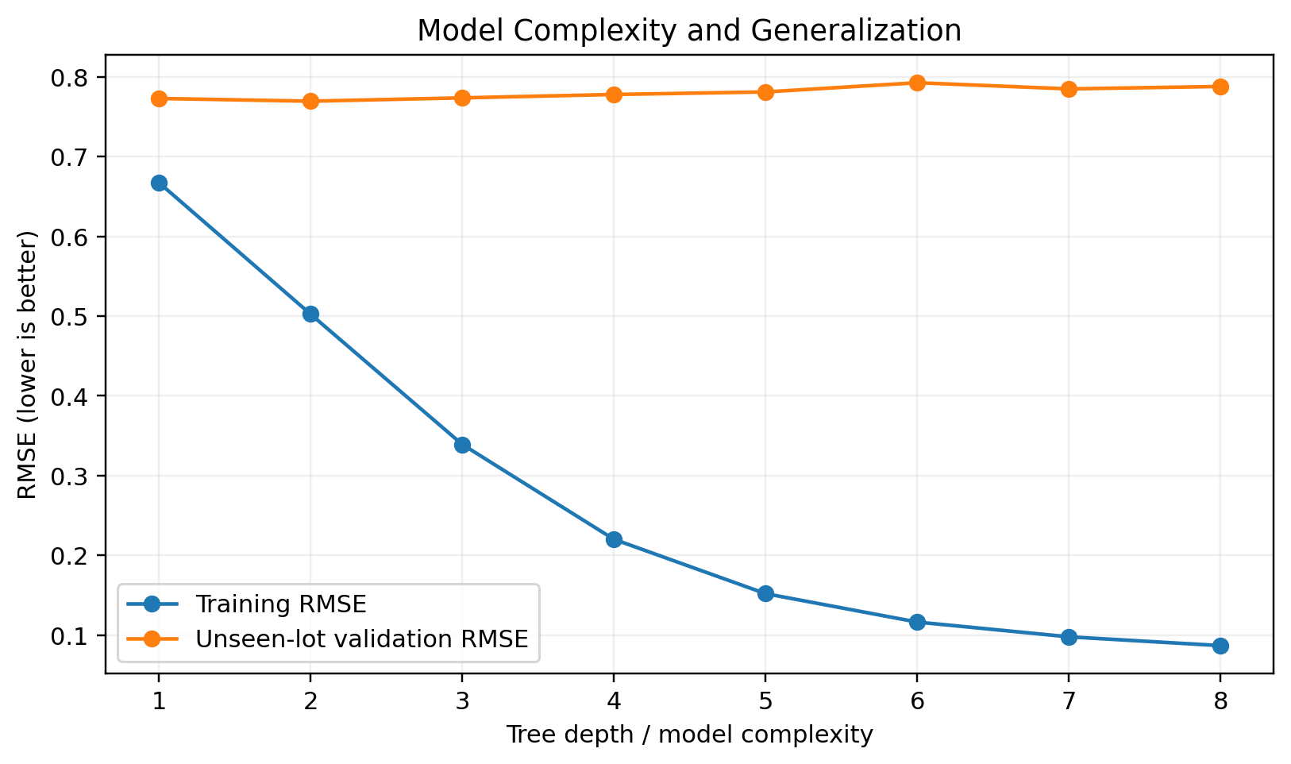
Figure 2. Training error continues to fall as model complexity increases, while unseen-lot validation error is lowest around shallow depth.

7.1 What the graph means
- Depth 1 is relatively simple and leaves more training error.
- Depth 2 gives the best unseen-lot validation result in this sensitivity check.
- At deeper settings, training RMSE falls sharply, but validation RMSE gradually increases.
- The widening gap between training and validation performance is a classic sign of overfitting.

7.2 Practical lesson
Key lesson: The best manufacturing model is not the model that remembers historical batches most perfectly. It is the model that remains useful when a new lot arrives.

This finding supports the tuned max_depth value of 2. The result also demonstrates why model-development reports should show both fit and generalization rather than only reporting training accuracy.

8. Model Performance Results
Model | N | MAE | RMSE | R²
Linear Regression | 120 | 0.581 | 0.756 | 0.630
Random Forest | 120 | 0.594 | 0.778 | 0.609
Tuned XGBoost | 120 | 0.602 | 0.740 | 0.646

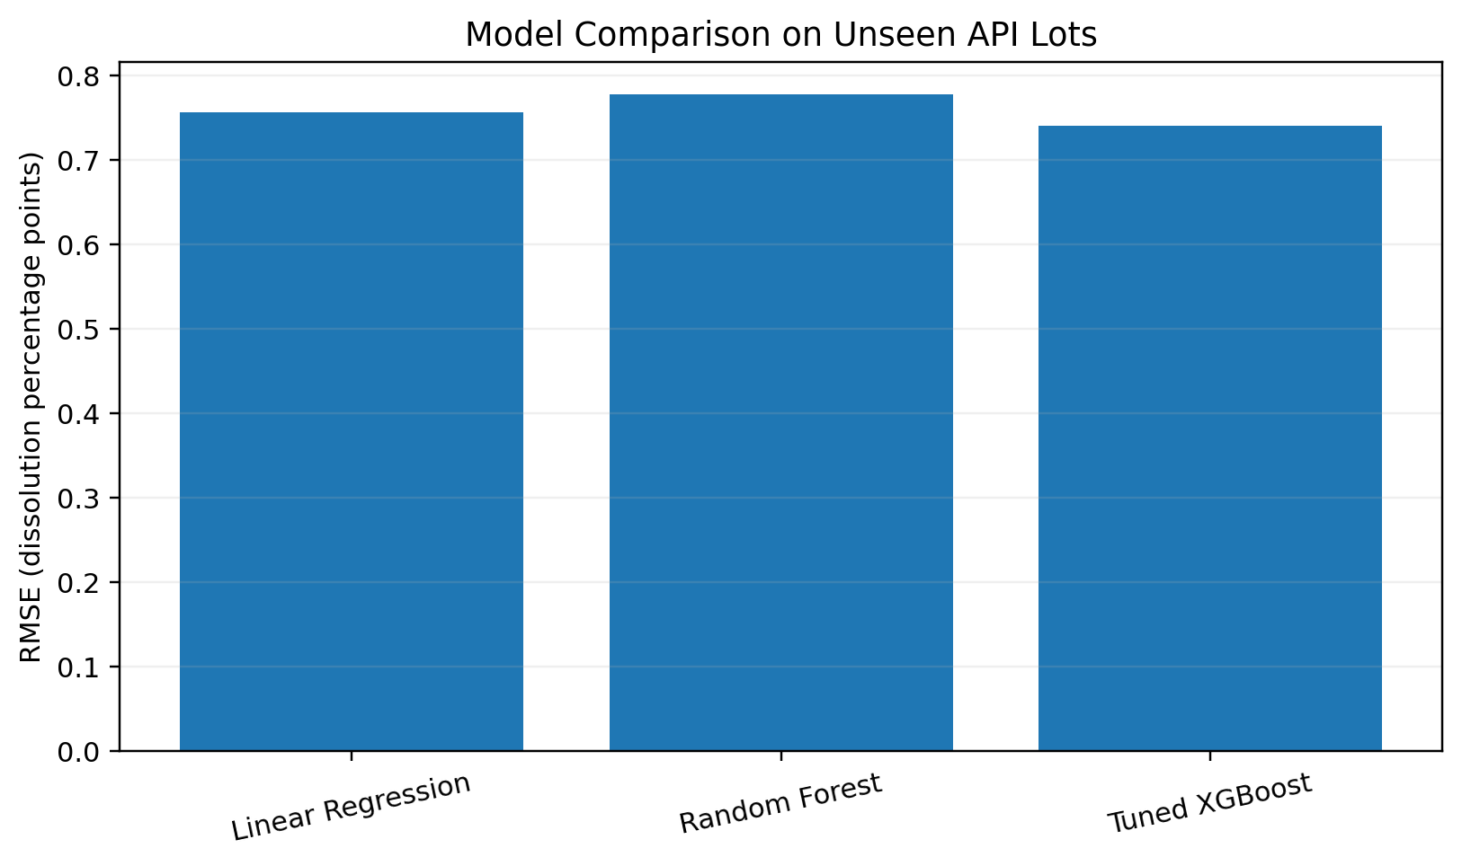
Figure 3. RMSE comparison on the independent unseen-lot test set. Lower RMSE is better.

8.1 Main test-set result
On the independent unseen-lot test set, tuned XGBoost achieved MAE 0.602 percentage points, RMSE 0.740 percentage points, and R² 0.646. Linear regression achieved RMSE 0.756 and random forest 0.778 on the same set. XGBoost therefore produced the lowest RMSE in this synthetic test, although the improvement over linear regression was modest rather than dramatic.

8.2 Why modest improvement is acceptable
A robust analysis should not force a narrative that the most sophisticated algorithm must dominate. In this dataset, much of the signal can also be captured by a linear model. The value of XGBoost comes from its ability to handle nonlinear interactions and provide a flexible platform for future expansion, not from an artificially large accuracy claim.

9. Actual vs Predicted Dissolution
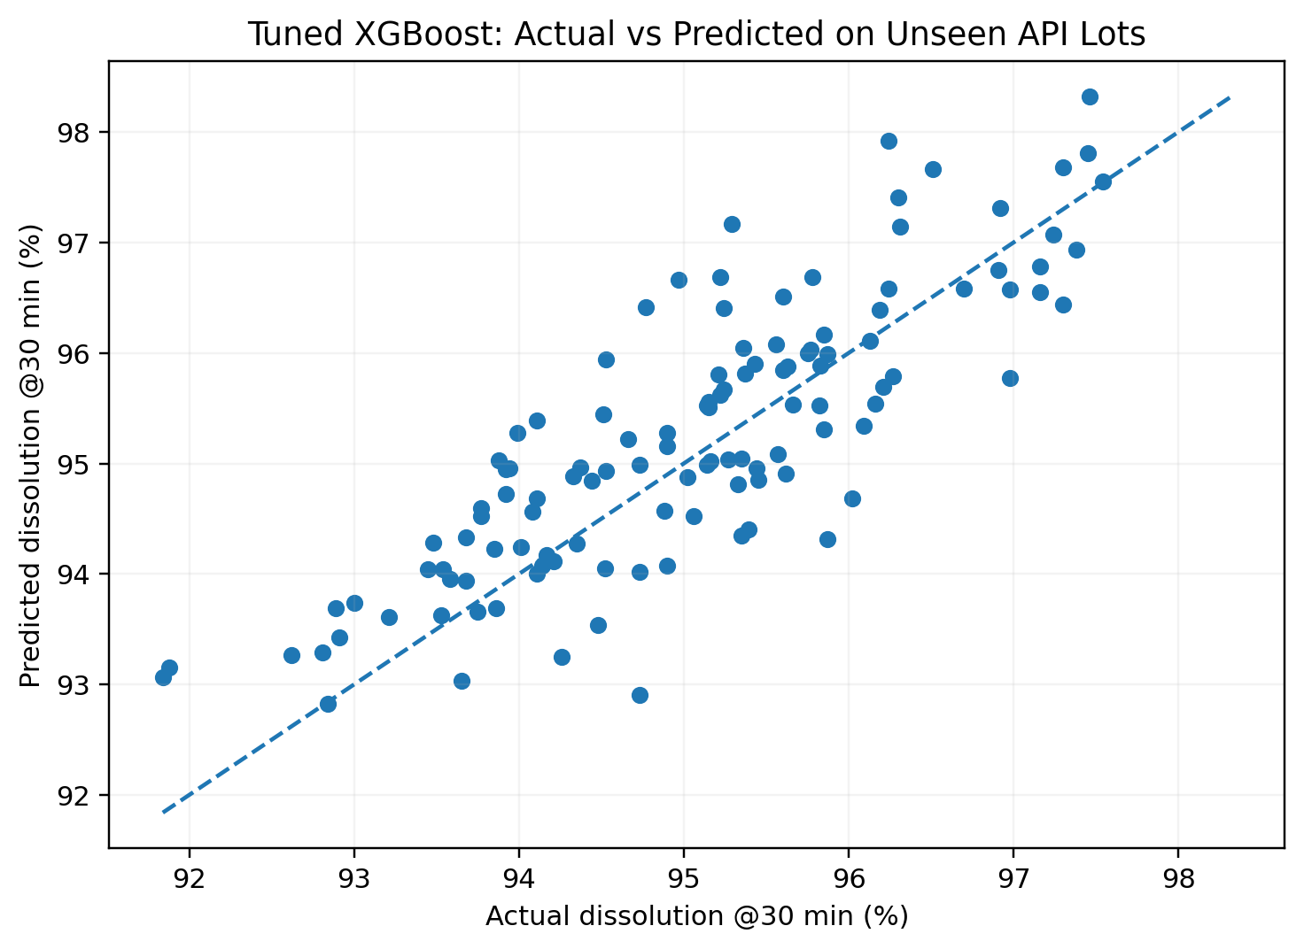
Figure 4. Actual versus predicted dissolution for 120 batches from API lots not used for model training.
Each point represents one unseen-lot test batch. The dashed diagonal represents perfect prediction. Points close to the diagonal indicate good agreement between predicted and actual dissolution, while vertical distance from the line represents prediction error.

9.1 Error interpretation
MAE of approximately 0.60 percentage points means that, across the unseen test batches, the absolute prediction error averaged about six-tenths of a dissolution percentage point. RMSE of approximately 0.74 is somewhat higher because RMSE penalizes larger misses more strongly.

9.2 Empirical uncertainty
Using validation-set absolute residuals, an empirical 90% error radius of approximately 1.23 dissolution percentage points was calculated. In a future operational workflow, an uncertainty statement should accompany the point prediction rather than presenting a single number without context. This simple interval is illustrative and would need more rigorous calibration on representative real data.

9.3 What R² means here
R² of 0.646 indicates that the model explains a meaningful portion of the variation in the synthetic unseen-lot test outcomes, while substantial unexplained variability remains. For this proof-of-concept, that is preferable to an unrealistically perfect result because it leaves room for noise, omitted variables, measurement error, and process behavior that is not fully captured by the feature set.

10. SHAP Explainability
SHAP was used to explain how individual features influenced XGBoost predictions. SHAP does not prove causality. It describes how the fitted model used the available variables when generating its prediction.
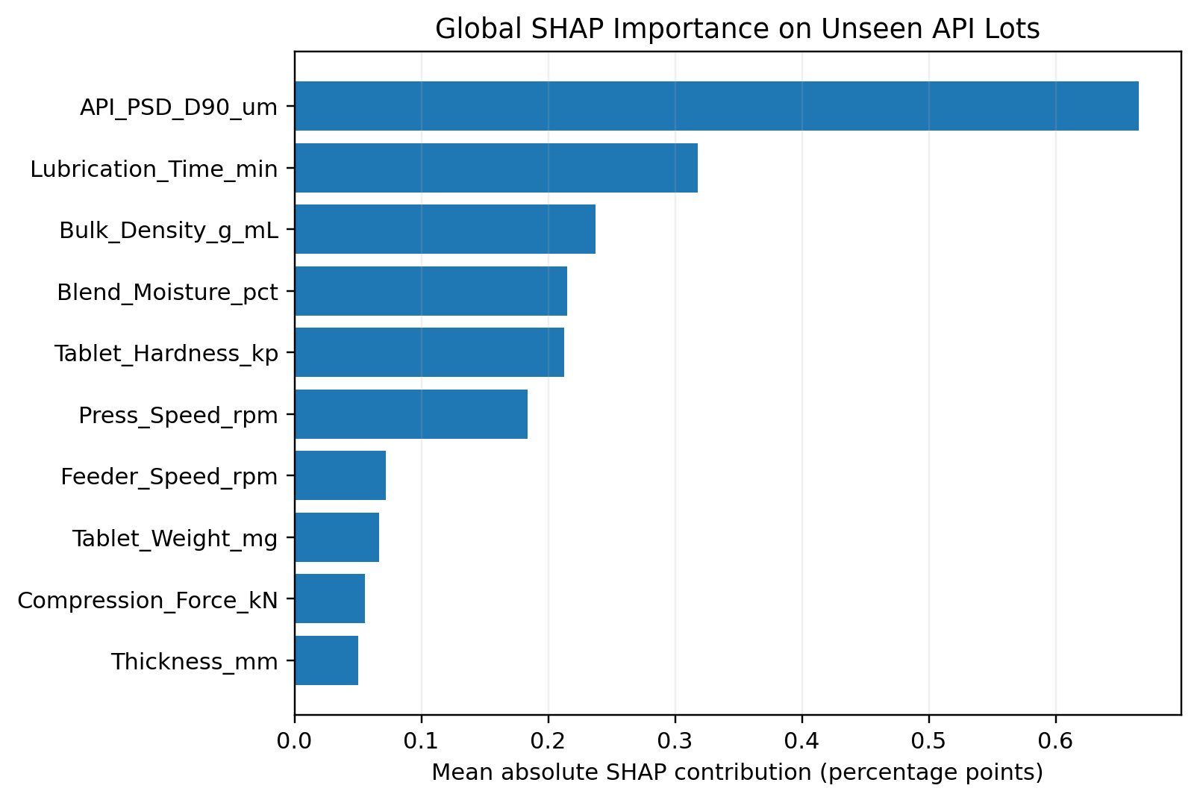
Figure 5. Mean absolute SHAP contribution on unseen API lots. Larger values indicate stronger average influence on model predictions.

10.1 Leading global drivers
Feature | Mean |SHAP| | Bootstrap SD
API_PSD_D90_um | 0.666 | 0.026
Lubrication_Time_min | 0.318 | 0.018
Bulk_Density_g_mL | 0.237 | 0.019
Blend_Moisture_pct | 0.215 | 0.013
Tablet_Hardness_kp | 0.213 | 0.019
Press_Speed_rpm | 0.184 | 0.026

API PSD D90 was the strongest global contributor to model predictions in the unseen-lot test set, followed by lubrication time, bulk density, blend moisture, tablet hardness, and press speed. The model therefore learned that material attributes and process conditions jointly influenced predicted dissolution in the synthetic data-generating system.

10.2 Stability check
SHAP importance was bootstrapped 200 times on the unseen-lot test set. The resulting standard deviations provide a simple indication of ranking stability. This does not establish scientific causality or production robustness, but it is stronger than presenting a single feature-importance chart without any stability assessment.

10.3 Batch-level interpretation
How to use SHAP: If a specific batch is predicted lower than expected, SHAP can identify which variables pushed that prediction downward. The engineering team can then decide whether those signals are scientifically meaningful, require investigation, or simply reflect model correlation.

11. Applicability Domain and Stress Testing
A predictive model will usually return a number even when the new observation is unlike anything seen during model development. To prevent false confidence, V3 adds an applicability-domain check using standardized nearest-neighbor distance from the training data.
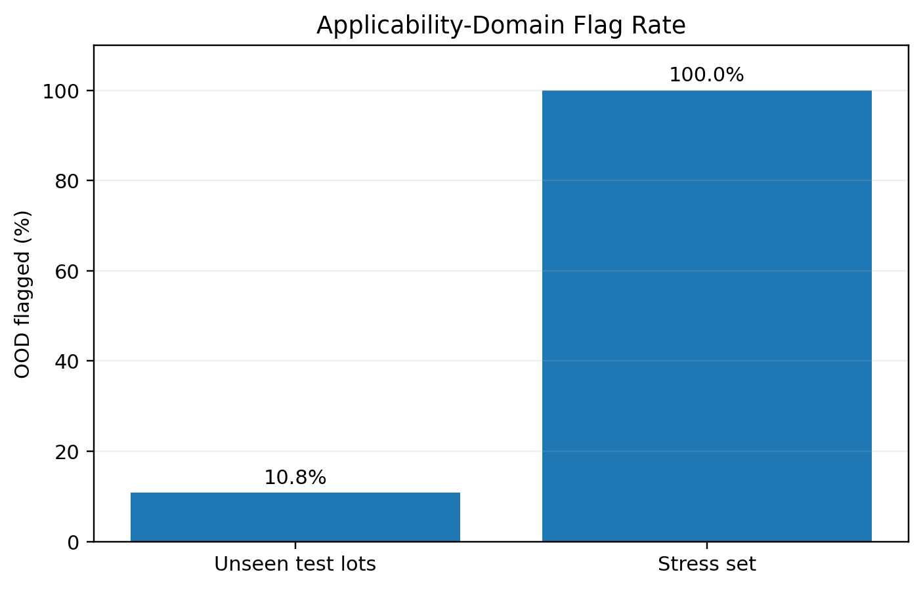
Figure 6. Out-of-domain (OOD) flag rate for normal unseen test lots versus the deliberately extreme stress set.
Dataset | N | OOD flagged | OOD rate
Test - unseen lots | 120 | 13 | 10.8%
Stress - outside envelope | 80 | 80 | 100.0%

11.1 What happened in the stress test?
The stress set was intentionally generated outside the model-development envelope. Predictive performance deteriorated sharply: XGBoost RMSE increased to 3.70 and R² became negative. This is an expected and useful failure because it demonstrates that extrapolation beyond the training space is unsafe.
The applicability-domain detector flagged all 80 of the 80 stress observations as out-of-domain. By comparison, 13 of 120 observations in the normal unseen-lot test set were flagged. The desired behavior is therefore not “the model predicts everything,” but “the system recognizes when prediction support is weak.”

11.2 Recommended user response to an OOD flag
1. Do not treat the numeric prediction as a reliable decision basis.
2. Review which material or process variables moved beyond the learned envelope.
3. Compare with development, tech-transfer, and engineering knowledge.
4. Gather additional evidence through characterization, engineering work, or enhanced monitoring as scientifically appropriate.
5. Only after sufficient representative evidence is available should model redevelopment or retraining be considered.

12. Model Governance and Manufacturing Use

12.1 Proposed decision-support workflow
1. Data-quality check: confirm required inputs are complete, plausible, and traceable.
2. Applicability check: determine whether the new batch lies inside the model-development envelope.
3. Prediction: calculate the estimated dissolution outcome and an uncertainty statement.
4. Explanation: review SHAP drivers for the specific batch.
5. Engineering interpretation: decide whether the drivers are scientifically plausible and whether additional evidence is needed.
6. Action: continue monitoring, investigate, or escalate according to established quality/process procedures.
7. Lifecycle review: monitor model performance and data drift over time.

12.2 Controls needed before real operational use
Control area | What would be required
Data lineage | Controlled source systems, definitions, timestamps, missing-data handling
Intended use | Predefined decision-support purpose and prohibited uses
Performance criteria | Pre-specified acceptance thresholds for error and calibration
External / temporal validation | Testing on later batches, different lots, and relevant operating ranges
Change control | Governed retraining, feature changes, code changes, and model versioning
Drift monitoring | Detect changes in input distributions and prediction performance
Human oversight | Defined review responsibilities and escalation triggers
Auditability | Reproducible model version, data snapshot, configuration, and outputs

Governance principle: The model should never silently expand its own operating range. New conditions require evidence, review, and controlled model lifecycle management.

13. Limitations and Future Development

13.1 Current limitations
- All 720 observations are synthetic; performance metrics reflect the simulated relationships, not a commercial process.
- The model was built for one synthetic immediate-release tablet use case and should not be generalized to other products or unit operations.
- Input variables and distributions were selected for demonstration and are not a validated critical-parameter set.
- The applicability-domain method is a simple nearest-neighbor distance rule, not a fully qualified multivariate domain methodology.
- SHAP explains model behavior but does not establish mechanistic causality.
- The empirical uncertainty interval is illustrative and has not undergone formal calibration assessment.
- No prospective manufacturing deployment, user-interface validation, data-integrity assessment, or model lifecycle SOP has been completed.

13.2 Recommended next development stages
1. Replace synthetic inputs with appropriately de-identified, permissioned historical data from a defined product/process use case.
2. Write a formal data dictionary and prediction-time availability map for every feature.
3. Predefine model acceptance criteria before final testing.
4. Use temporal and lot-based validation on representative historical data.
5. Add probability/risk classification for deterioration thresholds in addition to continuous dissolution prediction.
6. Evaluate prediction intervals or conformal-calibration approaches for uncertainty communication.
7. Add data-drift and model-performance monitoring for lifecycle control.
8. Conduct prospective silent-mode testing in which predictions are generated but do not influence batch decisions.
9. Only after governance, validation, and quality review consider a limited decision-support deployment.

13.3 Portfolio value
As a professional portfolio project, V3 demonstrates an end-to-end analytics mindset: problem definition, dataset design, leakage prevention, baseline comparison, model tuning, grouped validation, explainability, stress testing, applicability control, and honest limitation reporting. The technical code is important, but the stronger differentiator is the manufacturing decision logic around the model.

14. Conclusion
The V3 predictive CPV project successfully extends a descriptive monitoring workflow into a structured predictive-analytics proof-of-concept. The tuned XGBoost model generalized reasonably to unseen synthetic API lots, SHAP provided interpretable prediction drivers, and the applicability-domain layer identified deliberately unfamiliar operating conditions where the model should not be trusted.
The project’s most important lesson is not that XGBoost produced the lowest RMSE. It is that predictive manufacturing analytics should be designed as a controlled decision-support system: optimize for unseen data, explain the prediction, quantify uncertainty, recognize model boundaries, and preserve human engineering judgment.
One-sentence project summary: Built a lot-aware predictive CPV proof-of-concept using tuned XGBoost to estimate dissolution, SHAP to explain prediction drivers, and an applicability-domain control to flag cases outside the model’s learned operating space.

14.1 Plain-language glossary
Term | Plain-language meaning
Feature | An input variable used by the model, such as PSD or press speed.
Target | The outcome the model is trying to predict; here, dissolution at 30 minutes.
Training data | Historical examples used to fit the model.
Validation data | Separate examples used to guide model selection and characterize error.
Test data | Independent examples used for the final generalization assessment.
Overfitting | Learning training-specific details that do not generalize well to new data.
RMSE | Prediction-error metric that penalizes larger misses more strongly. Lower is better.
MAE | Average absolute prediction error. Lower is better.
R² | Fraction of outcome variation explained by the model relative to a mean-only baseline.
SHAP | Method for explaining how each feature influenced a model prediction.
Applicability domain | The region of input conditions sufficiently similar to the model-development data.
OOD | Out of domain: an observation sufficiently unfamiliar that the prediction should be treated cautiously.

14.2 Key project artifacts
- CPV_Project_V3_XGBoost_SHAP_Robust.ipynb — reproducible notebook containing the V2 CPV analysis plus V3 predictive extension.
- CPV_Predictive_Modeling_Synthetic_720.csv — synthetic lot-aware predictive dataset.
- CPV_V3_Model_Performance.csv — baseline and tuned-model performance results.
- CPV_V3_SHAP_Importance_Stability.csv — SHAP importance and bootstrap stability results.
- CPV_V3_Applicability_Domain_Summary.csv — out-of-domain flag summary.
- CPV_V3_Unseen_Lot_Test_Predictions.csv — batch-level predictions and error information.

