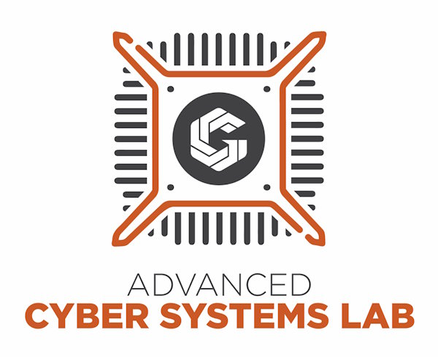

If here for ACSL and the door is locked, please call:

**(602)286-8831**