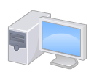

**PC**

**Mobile**

**Web server**

**Designer/**

**End user**



**PageSpeed Insights**



**Test/verification user**

**JMeter**