Steps for Setting up SPI Test:

- Connect two SMDK 6410 device with SPI loopback cable.
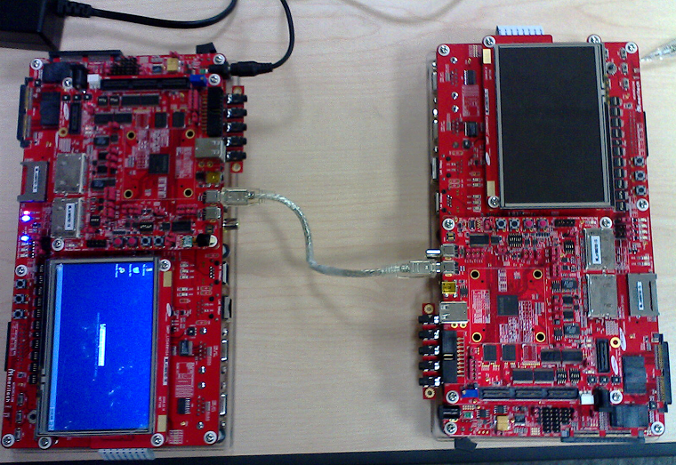

- Run SPIDataLoopback.exe in slave device.
- Connect master device to with PC and start CETK.
- Start SPI CETK test.

SPI Loopback Cable:

The connectors for SPI on the SMDK6410 board is a IEEE1394 (firewire) 4-pin connector. However, a standard IEEE1394 4-pin to 4-pin cable will not work as a loopback cable, due to the crossover that happens in the cable.

A loopback cable can be constructed from a firewire 4-pin to 4-pin cable as follows:

Connections on the original Firewire cable (which will not work):

Master Side |  |  | Slave Side
SMDK Connector Pin | SPI Signal | 1394 Signal | 1394 Signal | SPI Signal | SMDK Connector Pin
1 | CS | D1+ | D2+ | MOSI | 1
2 | MISO | D1- | D2- | CLK | 2
3 | MOSI | D2+ | D1+ | CS | 3
4 | CLK | D2- | D1- | MISO | 4

SPI Loopback cable connections:

Master Side |  |  | Slave Side
SMDK Connector Pin | SPI Signal | 1394 Signal | 1394 Signal | SPI Signal | SMDK Connector Pin
1 | CS | D1+ | D1+ | CS | 1
2 | MISO | D1- | D1- | MISO | 2
3 | MOSI | D2+ | D2+ | MOSI | 3
4 | CLK | D2- | D2- | CLK | 4

Thus a SPI Loopback cable can be constructed from a firewire cable by cutting the cable in the middle and making sure all the pins from one end goes to the same pins on the other end with no crossover.

