X Bot: @free_speech_ref

URL: https://developer.x.com/en/portal/products
Activate: post tweets:

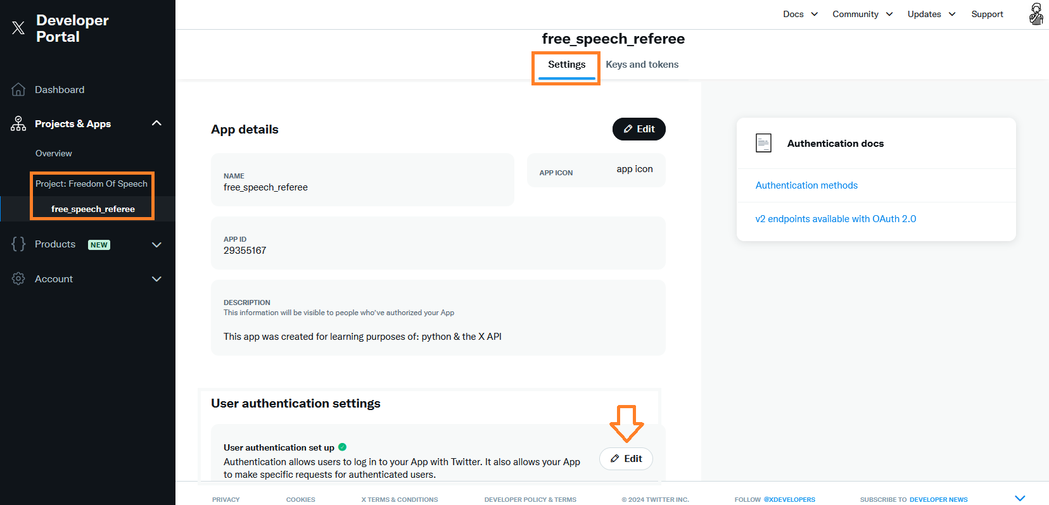

To regenerate the tokens is needed!

