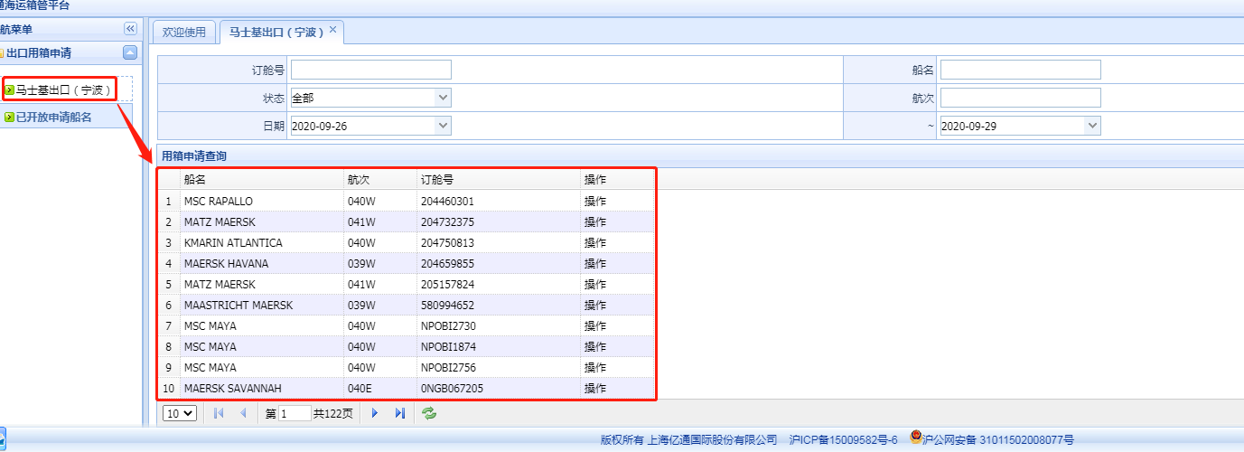

马士基出口（宁波）查询“用箱申请查询”所有船的订舱号信息：

|  |  |
| --- | --- |
| 类型 | post |
| url | http://cloud.easipass.com/mskeir2/mskCarrierApplyCtnr.do/findAppliedBills.do?shipCode=NPO |
| 参数 | param.greateEqual.mskeirBizApply.applyTime: 20200926000000  param.lessEqual.mskeirBizApply.applyTime: 20200929235959  className: com.easipass.business.model.MskeirBizApply mskeirBizApply  page: 1  rows: 10 |



订舱号“提单信息”查询：

|  |  |
| --- | --- |
| 类型 | POST |
| url | http://cloud.easipass.com/mskeir2/mskCarrierApplyCtnr.do/findBillInfo.do?shipCode=NPO |
| 参数 |  |



