LOGIC DESIGN EXPERIMENT 5:
Two’s complement and One’s complement to Decimal Decoder
2022/5
1. Use a 4-bit DIP switch to set 0 or 1 as a 4-bit input binary number. Also use green LEDs to show 1s in inputs.
2. The 4-bit input binary number may represent either two’s complement or one’s complement number. Convert the input binary number to BCD with an additional sign bit. Use red LEDs to indicate 1s in the BCD.
3. Use a quad 2:1 mux to switch between the two’s complement and the one’s complement number representations. A yellow LED must be on to indicate the input is a two’s complement number.
4. Use a 7-segment-display to show the input binary in decimal. The dot LED in the 7-segment-display must be on to indicate the input binary is negative.

Parts:

1. DIP switch (8-bit)*1
2. LED (green) *4
3. LED (red) *4
4. LED (yellow) *1
5. 1Kohm R *5
6. 0.22Kohm R *16
7. 74157 (quad 2:1 mux) *1
8. 7483 (4-bit adder) *1
9. 7446/7447 (BCD-to-7-seg decoder)*1
10. 7-segment display*1
11. 7402 (NOR) *5
12. 7400 (NAND) *5
13. 7408 (AND) *3
14. 7432 (OR) *3
15. 7404 (NOT) *2
16. 7486 (XOR)*1

Common Anode (or Cathode) 7-segment display:
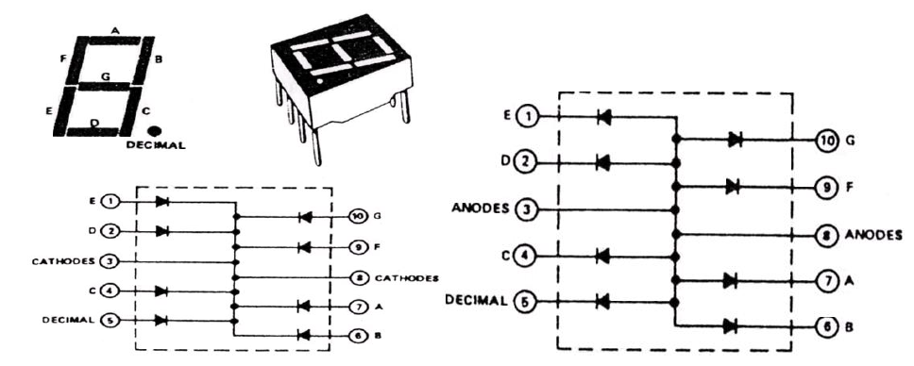
https://sites.google.com/a/ntut.org.tw/jimmyhu/projectlist/othertechnicdata/about-7-segment-display

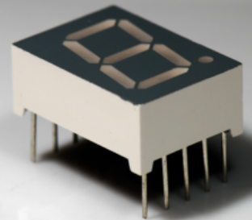

首先選定任一接腳為基準，三用電表撥於RX10檔，任一根測試棒固定接觸此接腳，再用另一根測試棒一一接觸各接腳，當顯示器發光時，紅棒接觸的那腳為陰極，黑棒接觸者為陽極。
http://content.saihs.edu.tw/contentbook/bep2/U1/07/b/b2_2.htm
One’s and Two’s Complement:
Decimal | One’s Complement | Two’s Complement
7 | 0111 | 0111
6 | 0110 | 0110
5 | 0101 | 0101
4 | 0100 | 0100
3 | 0011 | 0011
2 | 0010 | 0010
1 | 0001 | 0001
0 | 0000 | 0000
0 | 0000 | 0000
-1 | 1110 | 1111
-2 | 1101 | 1110
-3 | 1100 | 1101
-4 | 1011 | 1100
-5 | 1010 | 1011
-6 | 1001 | 1010
-7 | 1000 | 1001
-8 |  | 1000

7446/7447 (BCD-to-7-seg decoder):
