User Guide

In this module, an email template named deletecustomer_generaloptions_emailtemplate has been created.

Follow this location to enable this extension and set the email sender and email template as well -
(Magento Admin -> Stores -> Configuration -> BLUETHINKINC -> Delete Customer Account -> General)

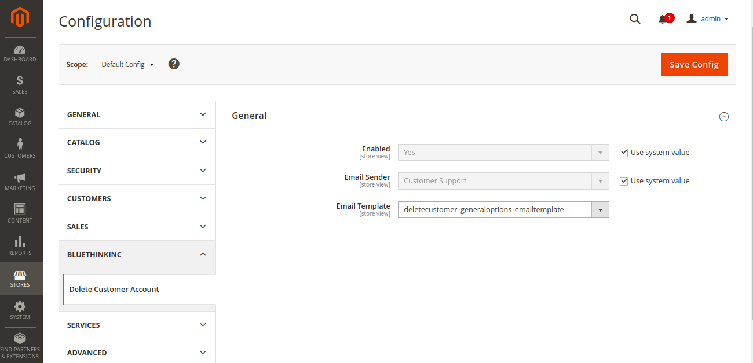

Here you can see that an email template is created automatically
(Magento Admin → Marketing → Email Templates)

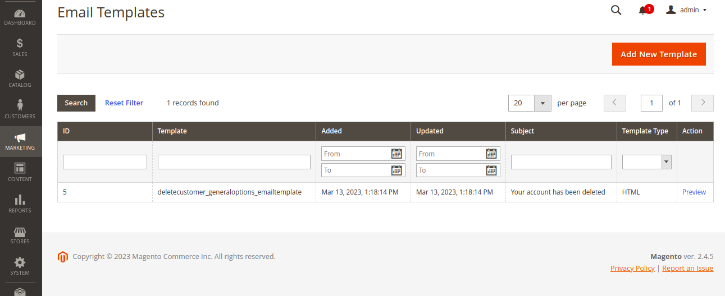

And finally you will be able to see the delete account under the customer’s profile section.

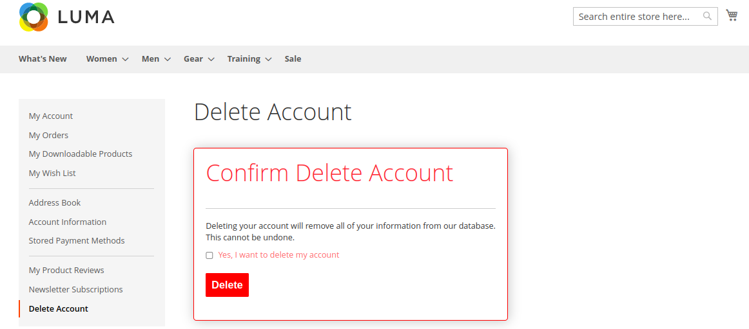

Note : As soon as the customer deletes his account, after that he will be redirected to the home page with a message.

