High Throughput Data Retrieval Help

This application is designed to provide biological researchers a tool to retrieve the number and abstract of corresponding biological literatures from PubMed data repository. The hit count number retrieved will help researchers to understand which protein and how many have or have not been studied before.

1. To run application.

There are three tab pages on the user interface. After user fills in the text boxes on the main tab page, which is first tab page, click “Search PubMed” button. Then, application switches to the next tab page, which is Hit Count Table, to display the numbers of publications according to the query. User can click the number to get information of articles, then application switches to Article Abstraction tab page to display list of articles with their abstractions. If user wants to more search on a specific article, then click the article title to move its PubMed web browser.

2. Input Requirements

Among inputs, protein field is required, and a list of protein/gene identifiers is allowed.

Organism field is optional, and only single input is allowed.

Keyword field is optional, and only single input is allowed.

3. Example Interfaces

3.1 Input Query and search on PubMed.

Import button: Import a text file to load query.

Browse Previous Search button: Load previous query information from database if exists.

“?” button: Show this help document.

“Search PubMed” button: Retrieve the number of articles of the query and switches the tab page to Hit Count Table tab page.

3.2 Display result of number of publication

After user clicks the “Search PubMed” button, Hit Count Table tab page shows.

Number of Publication in the table: click if more article information.

“?” button: Show this help document.

The numbers under the table: It’s page numbers of the result.

“Number of Publication” in the table: It’s clickable to sort numbers in ascending or descending.

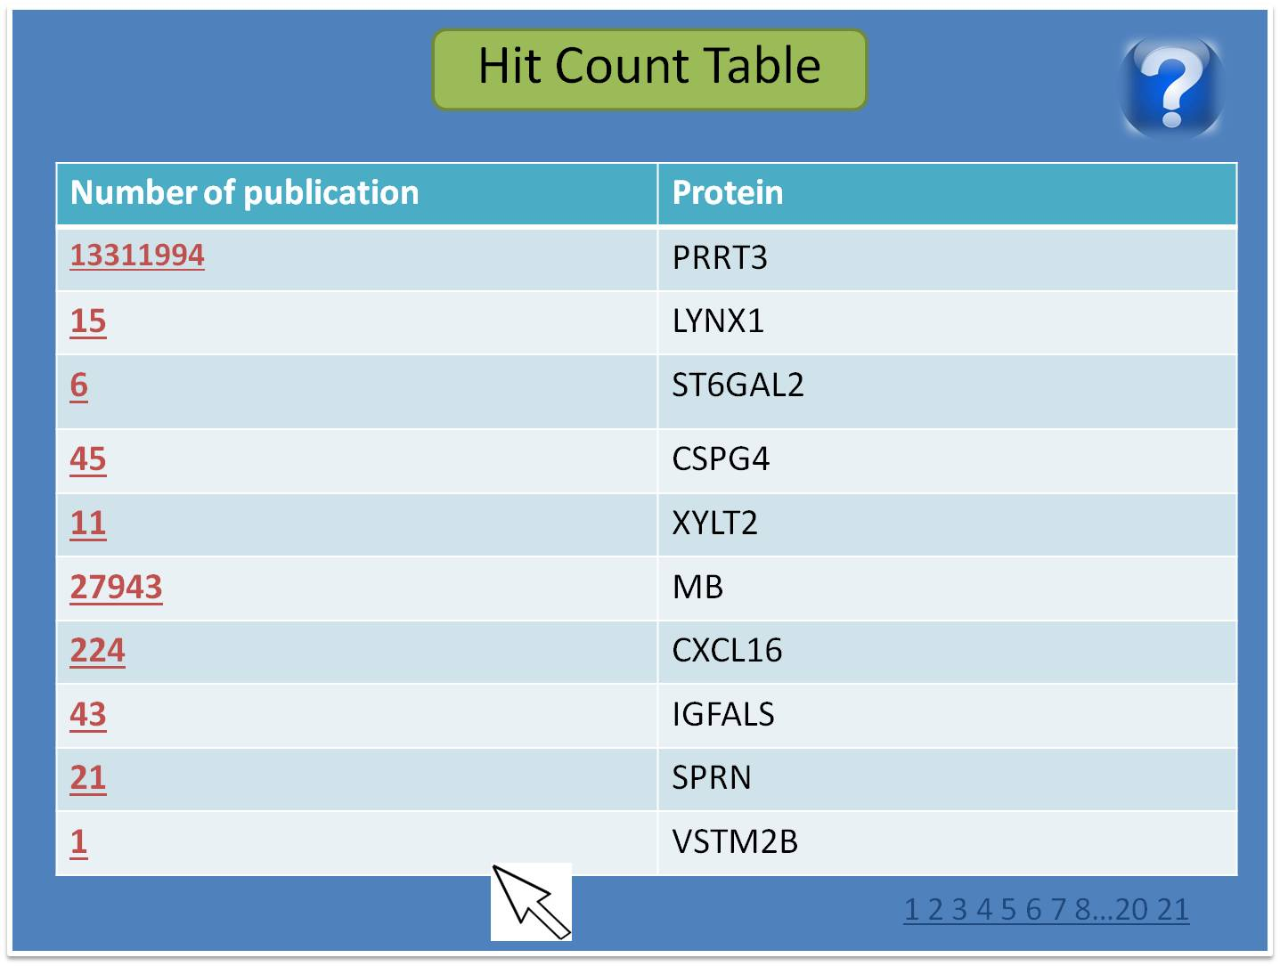

3.3 Display result of Article Information

“Export to Text file” button: Export the result into a text file.

Title in the table: it’s clickable to display PubMed web browser. Before move to the web browser, ask user to make sure that the page moves to the PubMed web browser.

The numbers of under the table: it’s page numbers of article information.

“?” button: display this help document

