# I. Assignment of members:

## Classes/methods:

## Claim clearly if you copy/modify anysource:

# II. Mini – project description

## Describe in detail about your mini-project requirement

## Usecase and explaination:

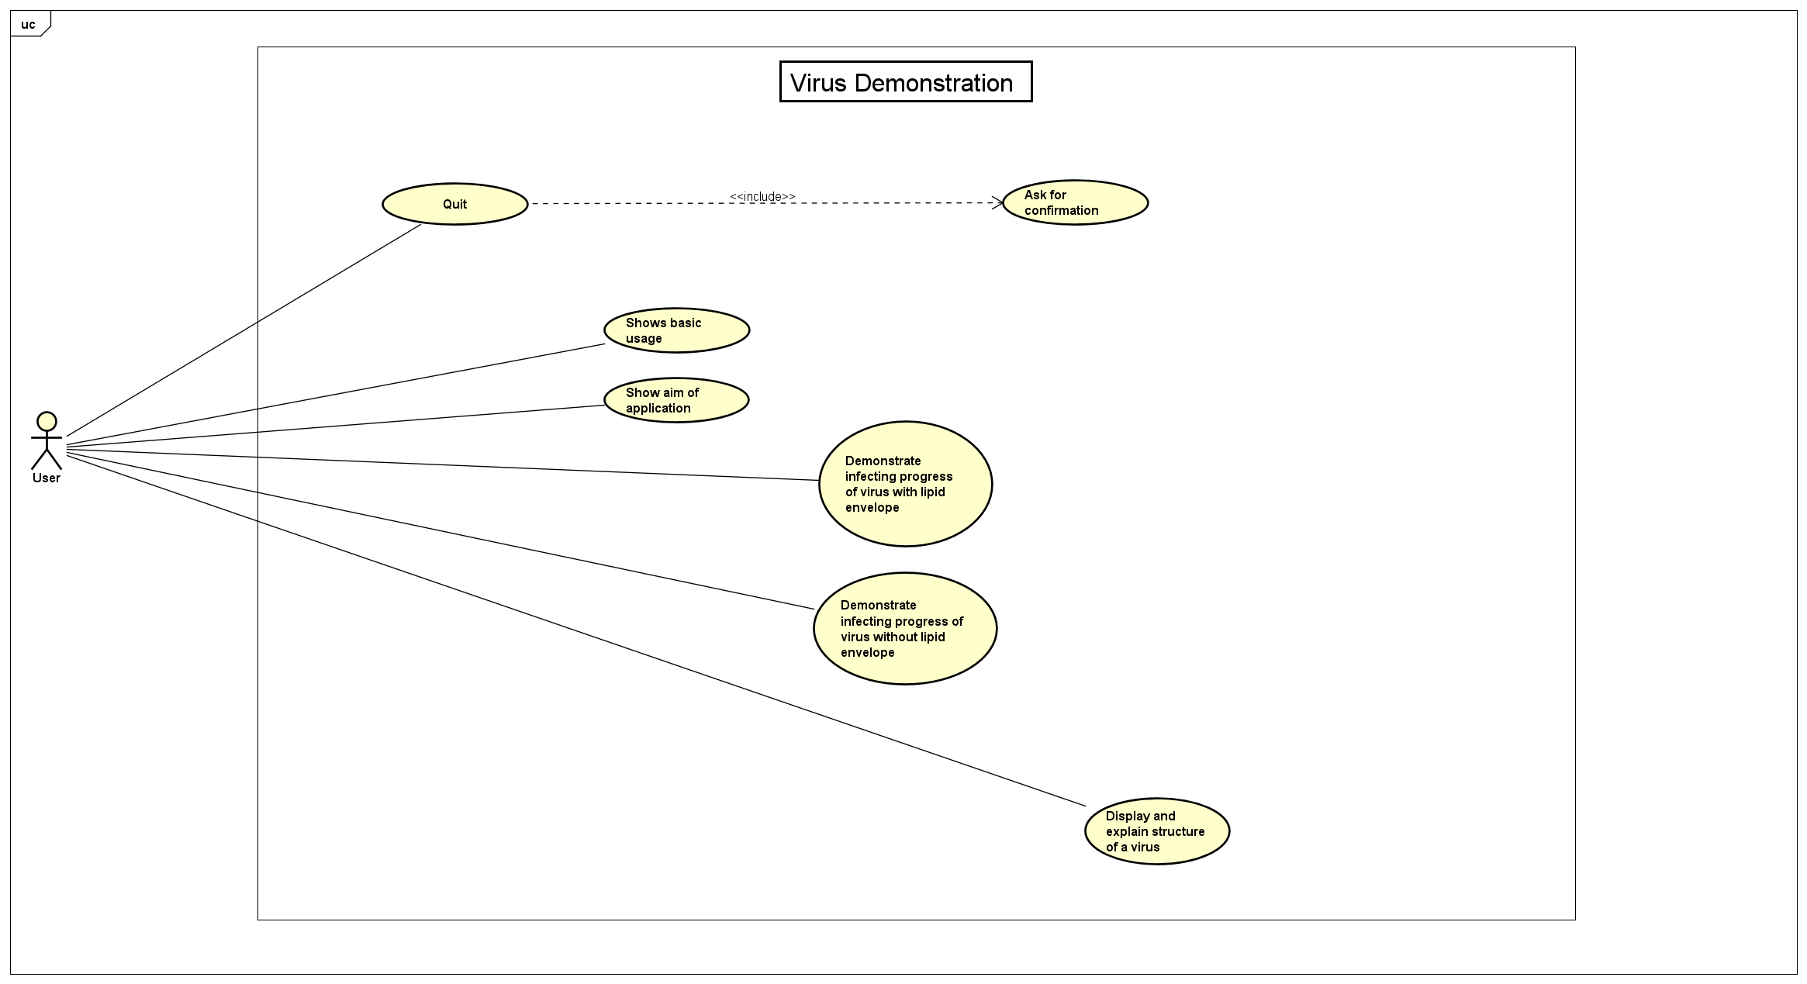

Explanation: First of all, our window always have a quit button with ask for confirmation.

In the main screen, we has “Help” menu which contains “Show basic usage” and “Show aim of application” items on the top of scene. In the center has 2 buttons which are virus “with” or “without” lipid envelop to chose.

Right after you chose the virus type, the 2nd scene will appear to show the list virus of that type. In this scene, we able to demonstrate infecting progress and choose a specific virus to see structure.

# III. Explaination of design ideas

## General class diagram

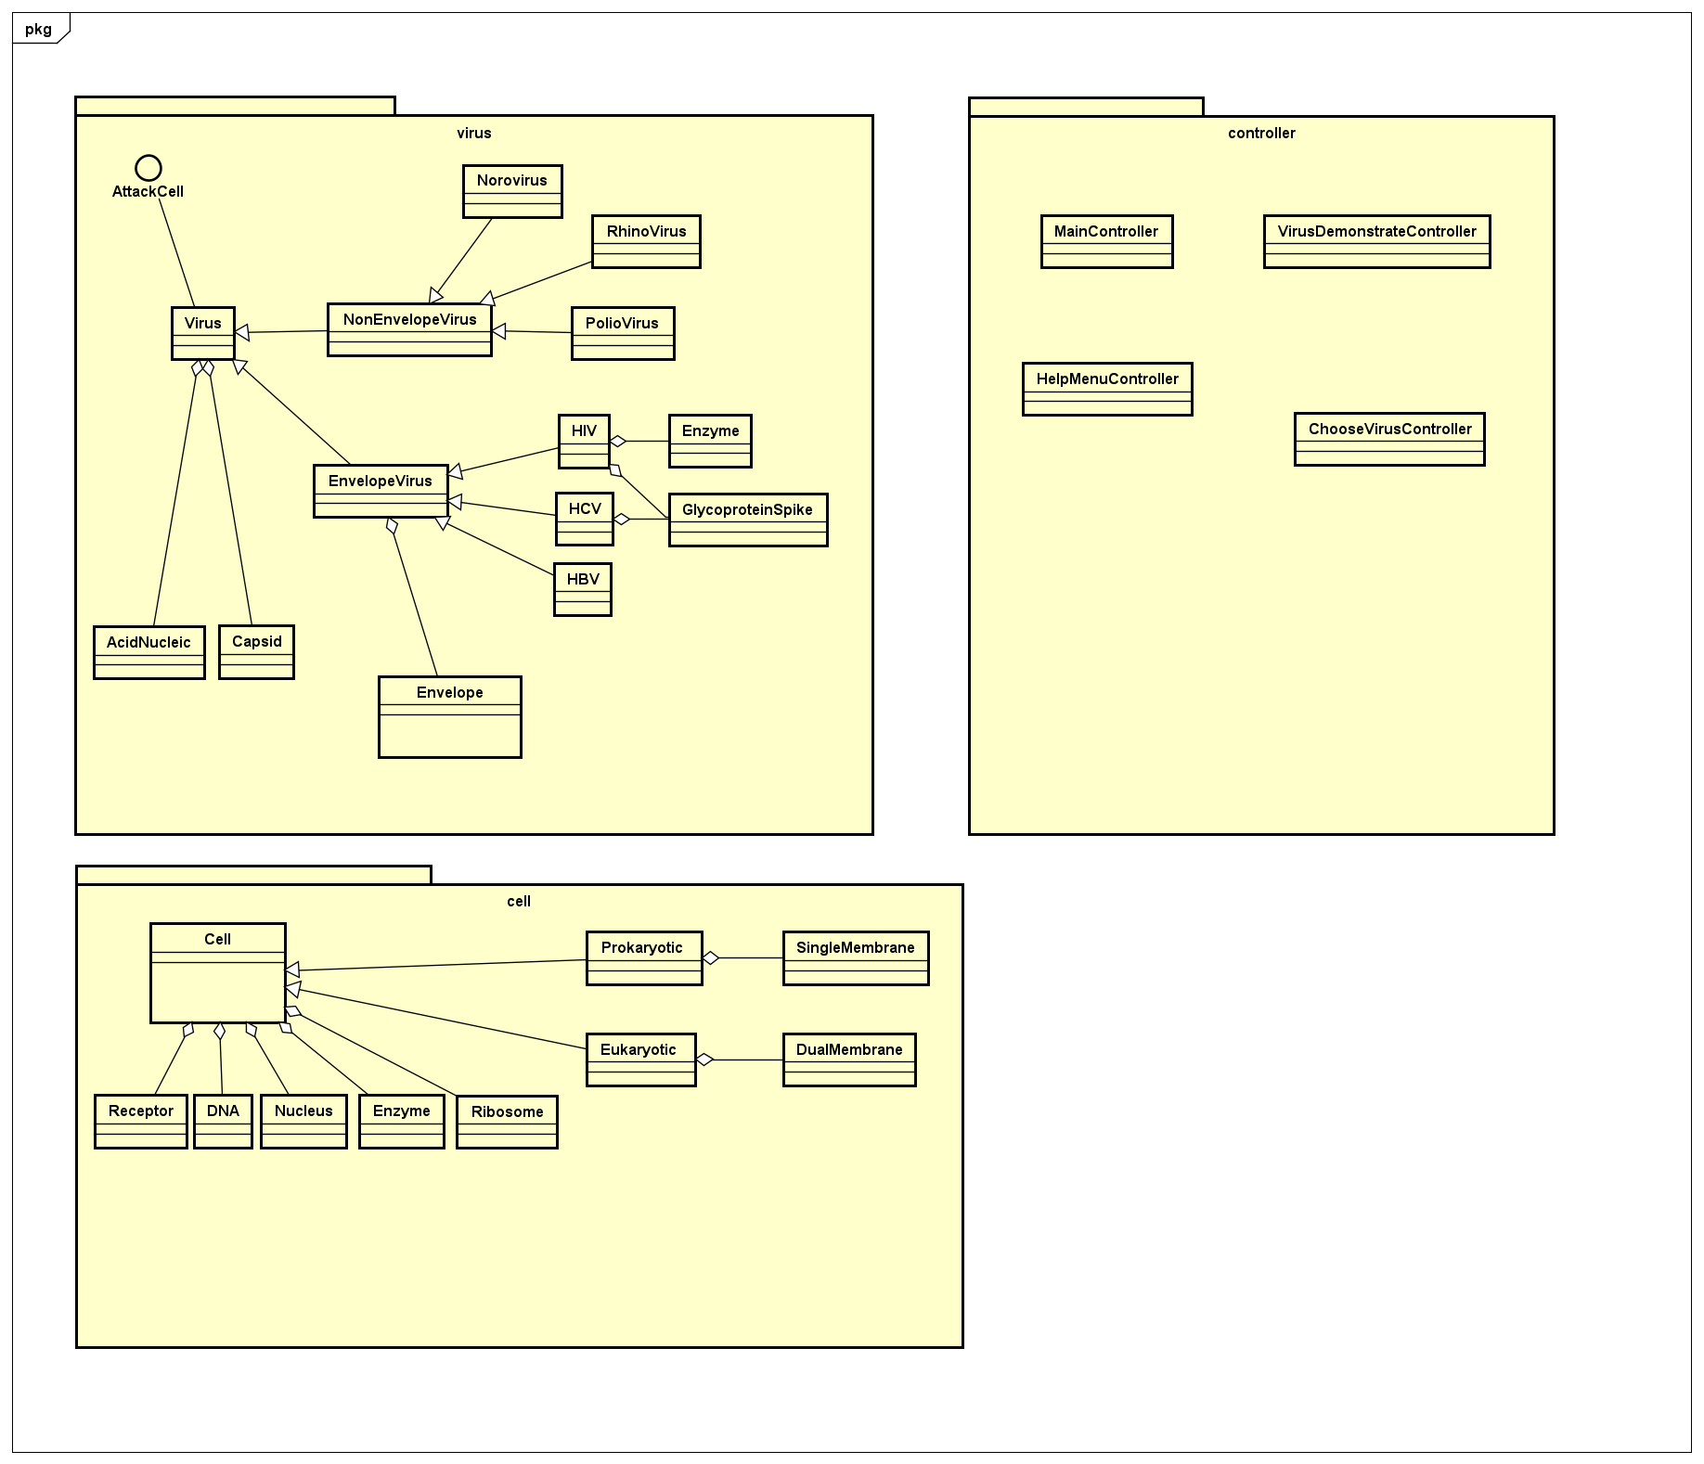

## Class diagrams for each package

## Explanation