USWAG
Unified System for Work and Growth
Project Proposal · Advanced Relational Database Systems
Bryan Jay Lumabas and Claire Pillo
1 · Proposal

Project
Title | USWAG: Unified System for Work and Growth
Proponents | Bryan Jay Lumabas and Claire Pillo
Client | Samahan ng Masisinop, Sustainable Livelihood Program (SLP), Barangay Aniog

- USWAG is a relational database that tracks the stock, sales, receipts and expenses of SLP microenterprises.
- Triggers keep stock and seller capital correct without help from any application.
1 · Proposal

The Problem
- Producers keep stock, sales and costs in notebooks, so mistakes stay hidden until money runs short.
- Stock and capital drift apart because nothing checks them.
- There is no proof of payment, audit trail or cash-flow view for SLP admins.
- Rural signal is weak, so sales must be recordable offline.
1 · Proposal

The Solution
- One normalized database (12 tables, BCNF) is the single source of truth.
- Triggers and procedures enforce the rules, so the data protects itself.
- Offline sales sync without duplicates, and every paid sale gets a JSON receipt.
- Verified inventory and an append-only capital ledger give a full audit trail.
1 · Proposal

Objective and Why It Matters
- Objective: design and prove a rule-enforcing database through modeling, normalization, DDL, triggers, queries and indexing.
- A spreadsheet cannot refuse a bad entry, but the database rejects negative stock, edited balances and empty paid sales.
- Every peso must be traceable, and any interface can change while the database stays reliable.
2 · Modeling

Entities and Cardinality
- Task: model the domain in Crow’s Foot notation with exact cardinalities.
- Result: 12 entities and 16 relationships, generated from the live database.
- Strong entities: Accounts, Sellers, Categories, Products and Sales.
- Weak entities: Sale_Details (identified by Sales) and Capital_Ledger (identified by Sellers).
- Sale_Details is the associative entity that resolves Sales and Products and carries quantity_sold and unit_price_at_sale.
- Optional links (0..1): the buyer on a sale and the verifier on an inventory entry.
2 · Modeling

Business Rules Enforced by the Database
- Stock changes only through admin-verified inventory entries.
- A paid sale credits capital once and issues one receipt, and an empty sale cannot be paid.
- Expenses debit capital, and every money movement is written to the ledger.
- Offline sales carry a client UUID, so syncing never creates duplicates.
2 · Modeling

Entity-Relationship Diagram
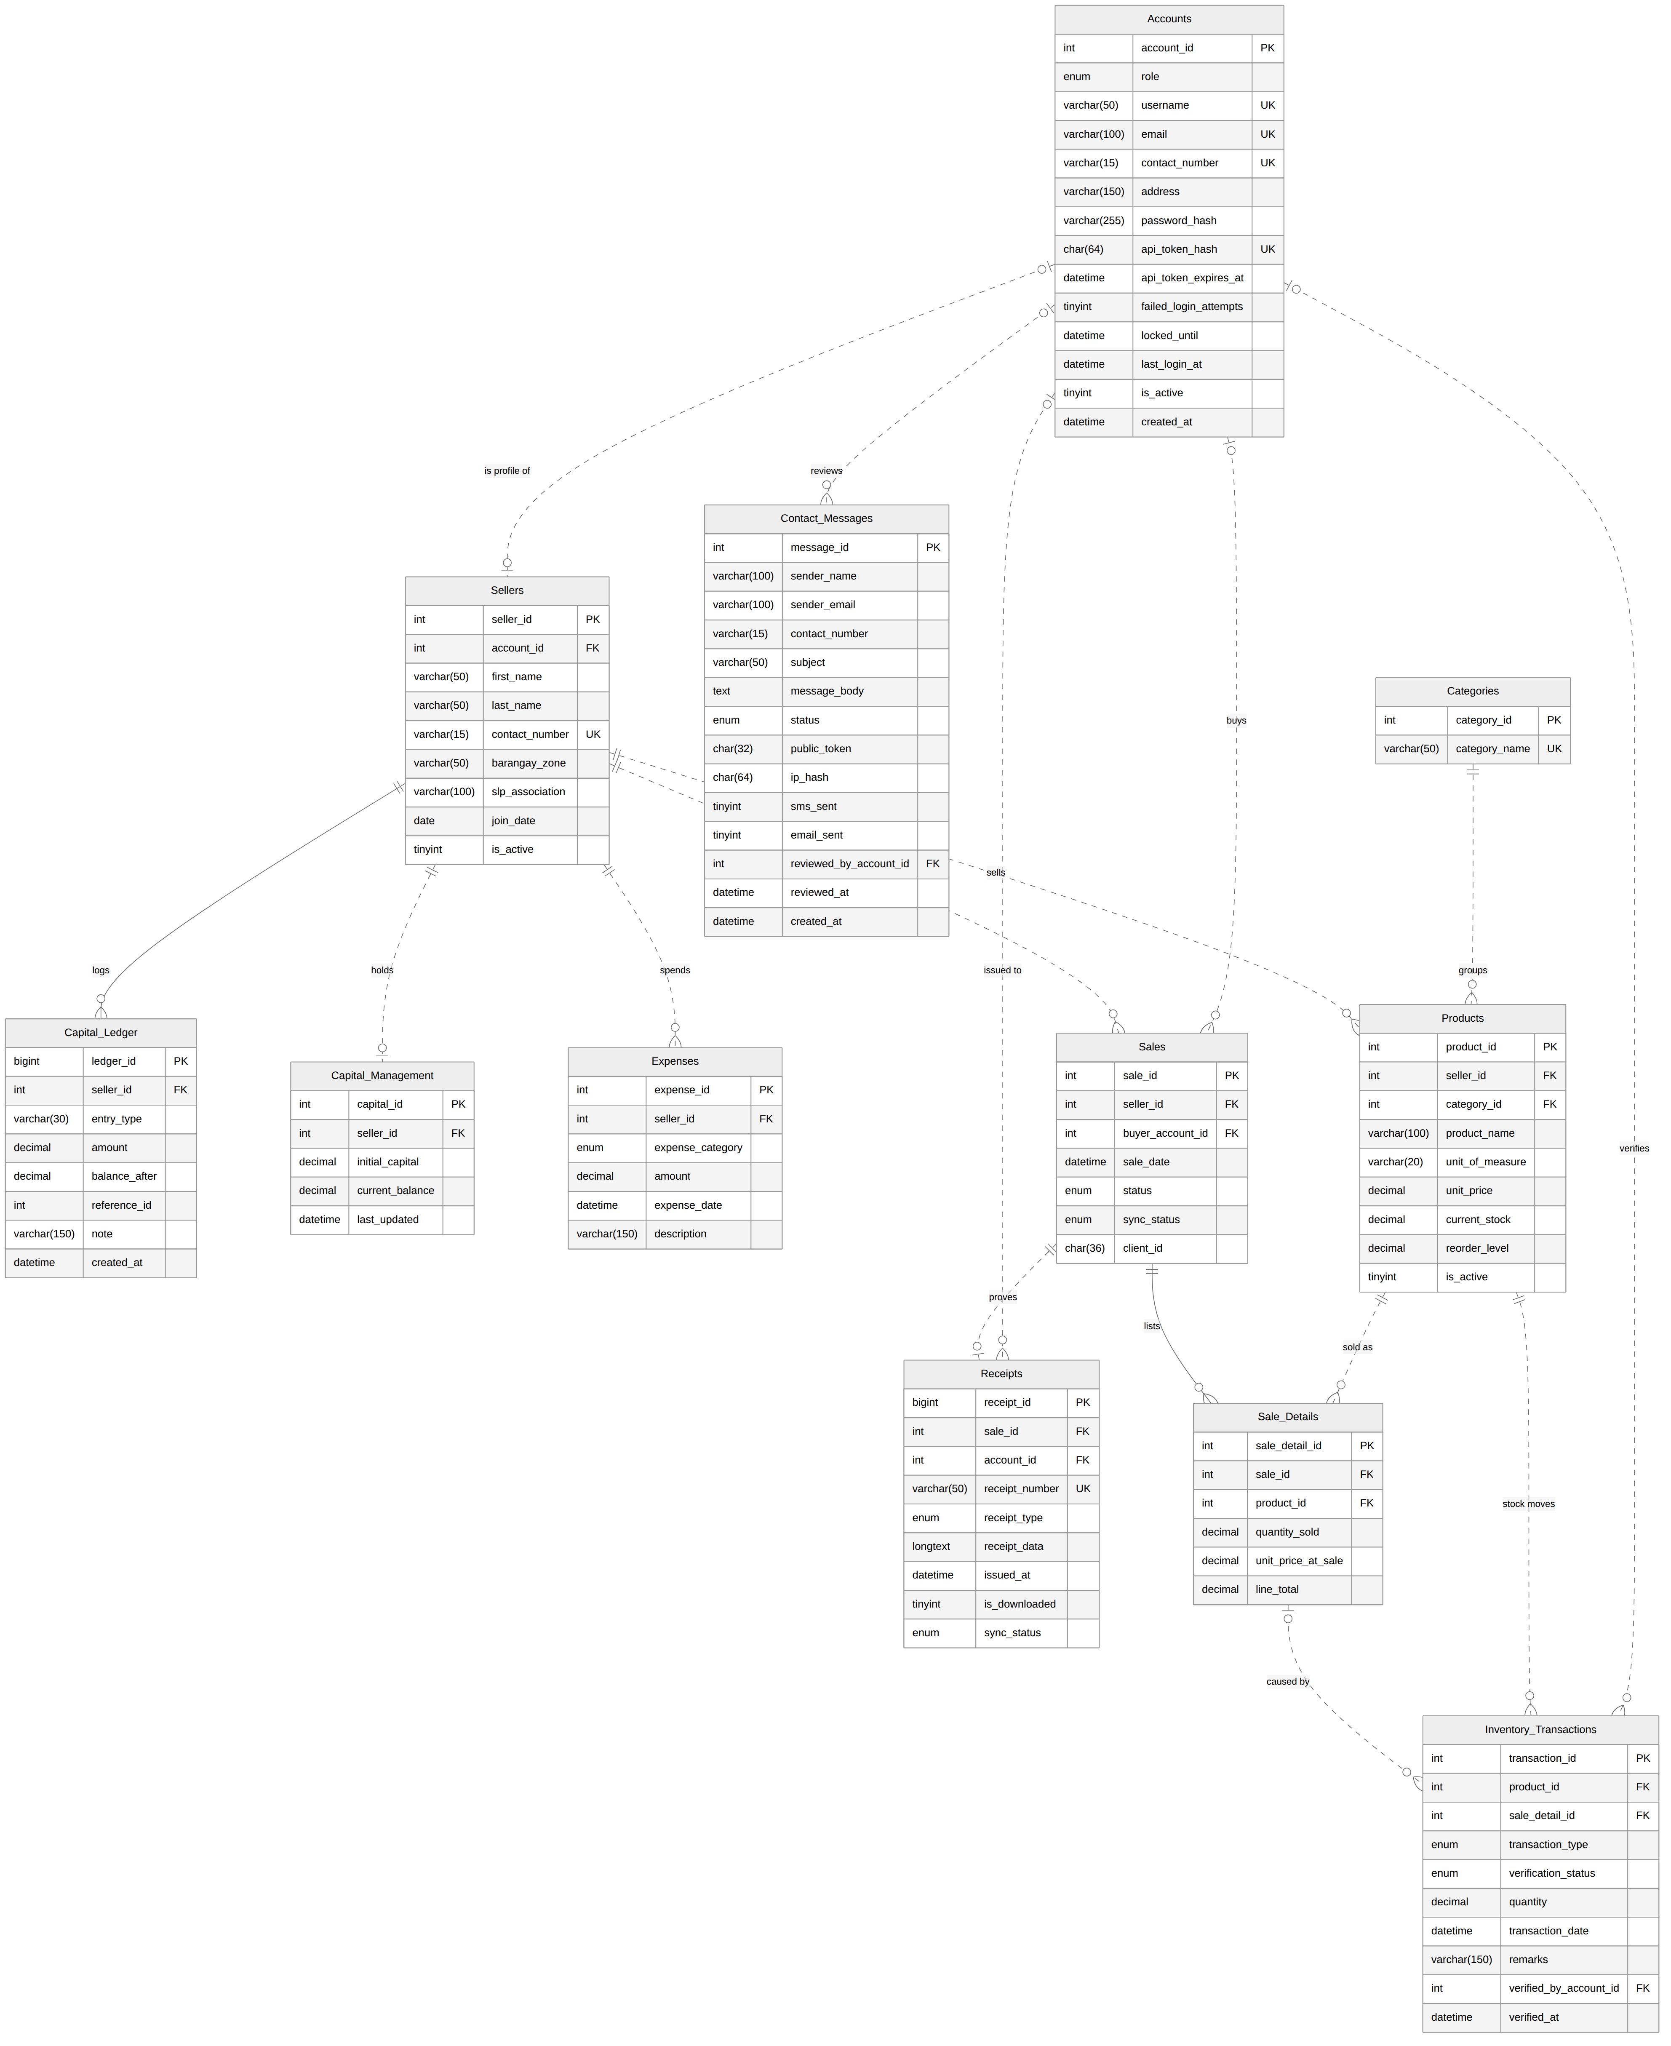
3 · Normalization

Dependencies and Key
- sale_id → seller, buyer, date, status.
- seller_id → name, zone; product_id → name, category, price; category_id → category_name.
- (sale_id, product_id) → quantity_sold, unit_price_at_sale.
- The candidate key of the unnormalized form is {sale_id, product_id}.
3 · Normalization

Decomposition
UNF | 1NF | 2NF | 3NF | BCNF
A sale form with a repeating group of products. | One row per sale and product, with atomic values. | Partial dependencies split into Sales, Products and Sale_Details. | Transitive dependencies split into Sellers, Accounts and Categories. | Every determinant is a superkey, checked on all 12 tables.
3 · Normalization

Proofs
- Lossless: each split joins on the key of one side (Heath’s theorem).
- Dependency-preserving: every dependency sits inside one final table.
- unit_price_at_sale is an intended price snapshot that depends on the sale line, so it is not a violation.
4 · Implementation

Database Structure Gallery
- Tables (12): Accounts, Sellers, Categories, Products, Sales, Sale_Details, Inventory_Transactions, Expenses, Capital_Management, Capital_Ledger, Receipts, Contact_Messages
- Triggers (26): trg_sellers_ai, trg_capital_bu, trg_ledger_bu, trg_ledger_bd, trg_expenses_ai, trg_expenses_bu, trg_expenses_au, trg_expenses_ad, and more
- Procedures (18): sp_capital_move, sp_create_sale, sp_add_sale_item, sp_finalize_sale, sp_sync_offline_sales, sp_register_account, sp_get_login, and more
- Views (9): vw_seller_cash_flow, vw_inventory_audit, vw_offline_queue, vw_category_sales, vw_low_stock, and more
- Queries (14): cash flow, inventory audit, offline queue, category sales, low stock, integrity checks.
4 · Implementation

Strengths
- The script imports with 0 errors and rebuilds safely: 12 tables, 9 views, 18 procedures and 26 triggers.
- Data protects itself: negative stock is rejected, verified inventory cannot be deleted and line totals are generated.
- Stock and capital update automatically, and the ledger balances: 5,000 + 2,600 − 1,500 = 6,100.
- Offline sync is idempotent, and each paid sale builds an 80 mm JSON receipt.
- It runs on MySQL 8 and MariaDB 10.11, whatever frontend sits on top.
4 · Implementation

Weaknesses Found and Handled
- Fixed: a direct UPDATE could set a balance to 999,999 without a ledger entry, so balances now change only through sp_capital_move.
- Open: registration leaves Sellers.first_name and last_name unfilled, so reports show the username.
- Fixed in the final schema: the lab version created receipts too early, had no buyer foreign key and let CASCADE erase history.
- Trade-off: 26 triggers add write cost and hide logic inside the database.
4 · Implementation

Performance
- Query: cash flow per seller, joined to sale lines.
- Before: a full scan of 100,000 rows took 146 ms.
- After idx_sales_seller_status and idx_saledetails_sale: 250 index probes took 2.5 ms, about 58 times faster.
5 · Deliverables

Softcopy Documents
.SVG | ERD (Crow’s Foot) | Live Mermaid diagram of all 12 entities.
.MMD | ERD Mermaid Code | The source that draws the ERD.
.PDF | Business Rules | The 10 rules the schema enforces.
.PDF | Normalization Proofs | Dependencies from UNF to BCNF.
.PDF | Performance Report | Index test: 146 ms to 2.5 ms.
.SQL | uswag_db.sql | Tables, triggers, procedures, views and queries.
.DOCX | Proposal (Word) | The presentation as a Word file.
.PDF | Proposal (PDF) | The presentation as 16:9 PDF slides.
.PPTX | Slides (Plain) | Editable PowerPoint slides.
.PPTX | Slides (Interface) | Screenshots of this site as slides.
.MD | READ.md | What is inside and how to run it.

